FLIGHT TICKET PRICE PREDICTION
Submitted by

VIVEK S (711524MMC050)

Of

KIT – KALAIGNARKARUNANIDHI INSTITUTE OF TECHNOLOGY
(An Autonomous Institution)

OPEN LABORATORY PROJECT REPORT

Submitted to the

FACULTY OF INFORMATION AND COMMUNICATION ENGINEERING
In partial fulfilment of award of the degree
of

MASTER OF COMPUTER APPLICATIONS


ANNA UNIVERSITY: CHENNAI – 600 025
DEC – 2024

BONAFIDE CERTIFICATE
Certified that this Open Laboratory Project report “FLIGHT TICKET PRICE PREDICTION” is the bonafide work of Mr. VIVEK S (711524MMC050) who carried out the project work under my supervision.

Dr. E. Vijayakumar MCA., Ph.D., Dr. E. Vijayakumar MCA., Ph.D.,

Associate Professor & Project Guide Associate Professor & Head, Master of Computer Applications, Master of Computer Applications,
KIT – Kalaignarkarunanidhi Institute of KIT – Kalaignarkarunanidhi Institute of

Technology, Technology,
Kannampalayam, Kannampalayam,

Coimbatore (Dt.). Coimbatore (Dt.).

Submitted to the Anna University Viva-Voce held on

Internal Examiner External Examiner

DECLARATION
I affirm that the project work titled “FLIGHT TICKET PRICE PREDICTION” being submitted in partial fulfilment for the award of MCA is the original work carried out by me. It has not formed the part of any other project work submitted for award of any degree or diploma, either in this or any other University.

(Signature of the Candidate)
VIVEK S

(711524MMC050)

I certify that the declaration made above by the candidate is true

Signature of the Guide,

Dr. E. Vijayakumar MCA., Ph.D., Associate professor & Project guide, Master of Computer Applications.

ACKNOWLEDGEMENT
My heartfelt gratitude and thanks to the Almighty God, my parents and other family members and friends for providing the opportunity to undergo this project successfully in this esteemed institution.

At the outset, I would like to thank our Founder and Chairman Thiru. PONGALUR N. PALANISAMY, KIT - Kalaignarkarunanidhi Institute of Technology, who has given me an opportunity to undergo this Project Work, successfully in this esteemed Institution.

I express my sincere thanks to Mrs. P. INDU MURUGESAN, Vice Chairperson, KIT - Kalaignarkarunanidhi Institute of Technology, who encouraged me by giving her support and constant encouragement.

I extend my grateful thanks and wishes to Dr. N. MOHANDAS GANDHI, ME., MBA. Ph.D., CEO, KIT - Kalaignarkarunanidhi Institute of Technology, for the valuable suggestion in framing my carrier towards the fulfillment of this Project work.

I express my sincere thanks to Dr. M. RAMESH, ME., Ph.D., Principal, KIT- Kalaignarkarunanidhi Institute of Technology, who encouraged me by giving his valuable suggestion and constant encouragement.

I would like to acknowledge the respective Dr. E. VIJAYAKUMAR MCA., Ph.D., Associate and Head, Department of Computer Applications, KIT - Kalaignarkarunanidhi Institute of Technology, for spending the valuable time in guiding and supporting me to make this project a successful one.

I take the privilege to extend my hearty thanks to our project Coordinator and my internal guide Dr. E. Vijayakumar MCA., Ph.D., Associate and Head, Department of Computer Applications for spending her valuable time and energy in guiding, supporting and helping me in preparation of the project.

Finally with great enthusiasm I express my thanks to all the faculty members for providing necessary information and their sustained interest in my part of successful completion.

S.NO TITLE PAGENO

LIST OF TABLES
- Abstract 10
Introduction
- System analysis 12
  - Existing system
    - Drawbacks
  - Proposed System
    - Advantages
- System specification 15
  - Hardware Specification
  - Software Specification
- Software description 16
  - Front end 4.1.1Features
  - Back end
    - Features
- Project description 18

  - Overview of the project

  - Modules

    - Modules Description

  - Data Flow Diagram

  - Database Design

  - Input Design

  - Output Design

- System testing 28
  - Unit Testing
  - Integration Testing
  - Functional Testing
  - Performance Testing
- System implementation 32
- Conclusion & Future Enhancement 34
  - Conclusion
  - Future Enhancement
- Appendix 35
  - Source Code
  - Screenshot
- References 42
  - Book References
  - Web References

TABLE NO | LIST OF TABLES  TABLE NAME | PAGE NO
5.4 | DATABASE TABLE | 24
6.5 | TEST CASE | 28

CHAPTER 1

ABSTRACT

In today's fast-paced world, air travel has become an essential mode of transportation, facilitating business, tourism, and personal connectivity on a global scale. However, the volatile and non-linear pricing structure of flight fares poses a substantial challenge for passengers seeking to make cost-effective travel plans. Airlines utilize complex, dynamic pricing algorithms that continuously adjust fares based on various parameters such as demand, timing, seat availability, market competition, and more. As a result, travelers often struggle to identify the optimal time and conditions for booking affordable tickets.

This project, titled "Flight Fare Prediction," aims to mitigate this uncertainty by leveraging the power of machine learning to develop a robust predictive model capable of estimating airline ticket prices with a high degree of accuracy. The primary objective is to design an intelligent system that can analyze historical and real-time flight data to forecast future fare trends, thereby empowering users with actionable insights for making informed travel decisions.

To achieve this, the study begins with the comprehensive collection and curation of a diverse dataset comprising historical flight information, including parameters such as departure and arrival locations, journey dates, booking lead time, airlines, duration, number of stops, and additional travel- related features. Extensive preprocessing is performed to cleanse the data, handle missing values, encode categorical variables, and transform date-time information into meaningful numerical features. Feature engineering techniques are employed to extract valuable patterns and improve model performance.

.

INTRODUCTION
A person who already has reserved a ticket for a flight realizes how powerfully the price of the ticket switches [1]. Airline utilizes progressed techniques considered Revenue Management to accomplish a characteristic esteeming technique [2]. The most affordable ticket available changes over a course of time. The expense of the booking may be far and wide. This esteeming technique normally alters the cost according to the different times in a day namely forenoon, evening, or night. Expenses for the flight may similarly alter according to the different seasons in a year like summers, rainy and winters, also during the period of festivals. The buyers would be looking for the cheapest ticket while the outrageous objective of the transporter would be generating more and more revenue. Travelers for the most part attempt to buy the ticket ahead of their departure day. The reason would be their belief that the prices might be the highest when they would make a booking much nearer to the day of their flight but conventionally this isn't verifiable. The buyer might wrap up paying more than they should for a comparable seat. Considering the challenges faced by the travellers for getting an affordable seat, various strategies are utilized which will extract a particular day on which the fare will be the least. For this purpose, Machine Learning comes into the picture. Gini and Groves developed a model using PLSR, to predict the appropriate time to book the seats [3]. They extracted their data from well-known booking websites from 22/06/2025 to 23/08/2025.

CHAPTER 2 SYSTEM STUDY

EXISTING SYSTEM
The current landscape of flight fare prediction and ticket booking primarily relies on either traditional travel websites or third-party platforms that offer fare tracking and alert features. However, these systems are often limited in terms of accuracy, flexibility, and real-time adaptability. Most existing systems do not fully utilize the capabilities of modern machine learning algorithms and predictive analytics to offer dynamic, personalized, and data-driven forecasts.The core characteristics and limitations of the existing systems are as follows:

Static Pricing Information:
Traditional flight booking platforms such as airline websites, travel agencies, and booking portals (e.g., MakeMyTrip, Expedia, Cleartrip) display prices fetched in real-time but do not predict future prices. Users only see the current fare without insights into whether the price might rise or drop in the near future.

Basic Fare Alerts:
Some platforms like Google Flights, Skyscanner, and Hopper offer fare tracking features that alert users when prices change. However, these systems rely on rule-based logic or basic statistical models, lacking the robustness and personalization of modern machine learning approaches.

DRAWBACKS

No Accurate Fare Prediction
Existing systems only show current prices or basic trends; they do not use machine learning to forecast future ticket prices accurately.

Rule-Based and Not Data-Driven
Most fare alerts rely on simple rules (e.g., price drop alerts) and do not adapt to complex pricing patterns or real-time market changes.

Lack of Personalization
Recommendations are generic and do not consider user preferences, travel dates, routes, or booking behavior to tailor suggestions.

PROPOSED SYSTEM

The proposed system aims to overcome the limitations of existing fare tracking tools by implementing a machine learning-based predictive model that can accurately forecast flight ticket prices. This system leverages historical flight data, applies intelligent feature extraction techniques, and utilizes supervised learning algorithms to deliver real-time, data-driven predictions. The goal is to provide travelers with reliable insights into when and where to book flights at the lowest possible cost.

FEATURES
Utilizes machine learning algorithms to predict future flight fares accurately

- Extracts key features such as booking time, airline, stops, duration, and travel date

- Provides real-time fare predictions based on historical and current input data

- Suggests the best time to book flights for maximum cost savings

- Displays fare trends and comparisons through visual graphs and charts

- Offers a user-friendly interface for easy input and result interpretation

- Scalable and adaptable across different airlines, routes, and travel seasons

- Continuously improves through retraining with updated flight data

FEASIBILITY STUDY

A feasibility study is an assessment of the practicality of a proposed project or system A feasibility study aims to objectively and rationally uncover the strengths and weaknesses of an existing business or proposed venture, opportunities and threats present in the natural environment, the resources required to carry through, and ultimately the prospects for success.

LEGAL AND ETHICAL FEASIBILITY

- Identify and legal or ethical considerations related to student data privacy, security, and consent.
- Ensure compliance with relevant laws and regulations.

TECHNICAL FEASIBILITY

Data Availability
Assess the availability and accessibility of relevant health data for model training and validation. Consider issues related to data privacy and security.

Model Complexity
Evaluate the technical feasibility of implementing machine learning models, considering the available computational resources.

Software and Hardware Requirements
Identify the software and hardware infrastructure needed for model development, deployment and maintenance.

CHAPTER 3 SYSTEM SPECIFICATION

HARDWARE CONFIGURATION
This section gives the details and specification of the hardware on which the system is expected to work.

    - Processor : Intel Core i5.

    - RAM : 4 GB of RAM or more.

    - Hard Disk : 360 GB of disk space.

    - Keyboard : Standard keyboard.

    - Monitor : 1280x720 resolution or higher recommended.

SOFTWARE CONFIGURATION
This section gives the details of the software that are used for the development.

    - Operating System: Windows 10 or Ubuntu

    - Programming Language: Python

    - Database: MySQL (for storing flight data)

    - Frontend Technologies:HTML ,CSS,Java Script

    - Python Libraries Used: Pandas, NumPy ,Matplotlib, Seaborn Scikit-learn,

  - FRONT END HTML, CSS, JS

CHAPTER 4 SOFTWARE DESCRIPTION

The front-end of the Flight Ticket Price Prediction System has been meticulously crafted with a strong focus on user experience. Its user-centric design ensures that users of all backgrounds can easily navigate the interface to check and predict flight ticket prices based on their preferences. The interface is not only intuitive but also visually appealing, making the process of checking flight prices both seamless and engaging.

HTML serves as the backbone of the web pages, forming the structure of the entire interface. Regardless of the number of technologies involved, HTML remains a foundational skill for any web developer. CSS, or Cascading Style Sheets, defines how these HTML elements are styled— controlling the visual presentation to ensure a polished and responsive design. If HTML forms the structure, CSS provides the visual appeal. JavaScript, a more complex and dynamic language, brings the frontend to life with interactive elements such as dropdowns for locations, date pickers, and real- time validation. Supported by all modern browsers, JavaScript ensures a powerful and smooth user experience across devices.

FEATURES
      - HTML provides the basic structure of sites, which is enhanced and modified by other technologies like CSS and JavaScript.
      - CSS is used to control presentation, formatting, and layout.
      - JavaScript is used to control the behavior of different elements.
      - Now, let's go over each one individually to help you understand the roles each plays on a website and then we'll cover how they fit together. Let's start with good of' HTML.
It encompasses various application types, including web-based applications, and it excels at facilitating communication in a distributed environment.

BACKEND

Python,Django
To develop an understanding of how Python-based web applications work, it's helpful to first explore what happens when a web page is served to a user's browser. When a user visits a website or clicks on a link, the browser sends a request to the web server. In a Python-powered web application—often built using frameworks like Flask or Django—the server receives the request and invokes the corresponding Python code to handle it. The server may dynamically generate HTML content based on logic or database queries, and then sends the response back over the internet to the user's browser. This dynamic approach allows for highly interactive and personalized web experiences.

Lightweight Database (SQLite with Python)
SQLite, first released in August 2000, is a self-contained, serverless, and zero-configuration SQL database engine. Unlike more complex systems like PostgreSQL or MySQL, SQLite is a lightweight and embedded solution, making it ideal for use in Python applications, mobile apps, and small to medium-sized projects. It doesn't require a separate server process—instead, it integrates directly into your Python code using libraries like sqlite3, which is included in Python’s standard library. One of SQLite's most attractive features is its zero-setup requirement and the ability to store an entire database in a single file, making it extremely easy to deploy and manage. This makes SQLite perfect for local development, prototyping, and applications with limited resources or portability requirements.

FEATURES
SQL is widely popular because it offers the following advantages
      - Allows users to access data in the relational database management systems.
      - Allows users to describe the data.
      - Allows users to define the data in a database and manipulate that data.
      - Allows embedding within other languages using SQL modules, libraries & precompilers.
      - Allows users to create and drop databases and tables.
      - Allows users to create view, stored procedure, functions in a database.

CHAPTER 5 PROJECT DESCRIPTION

OVERVIEW OF THE PROJECT
The "Flight Ticket Price Prediction" application involves analysis and prediction techniques to help users choose the best time to book flights using their Mobile phones or Tablets. It creates awareness among travelers about the fluctuations in ticket prices, airline trends, seasonal fare patterns, and available discounts. Users can search and select their desired travel routes based on their own preferences and budgets. To help plan trips in a cost-effective and efficient manner, this application proves highly beneficial. It aggregates a wealth of information including historical fare data, airline ratings, airport options, fare class comparisons, and more. Users can easily obtain a list of the most affordable or preferred flights based on the criteria they define.

To provide accurate and timely guidance on flight bookings, including routes, fares, and airlines, this system is made available as a web app, ensuring broad accessibility on smartphones and tablets. With the increasing use of web-based mobile devices among travelers, the application is designed to be intuitive and user-friendly.

In contrast to traditional manual methods of flight booking and fare checking, such as visiting physical ticket counters or relying on agents, the "Flight Ticket Price Prediction" app offers a more convenient, intelligent, and secure alternative. User data is safely stored in an SQL database, ensuring privacy and protection from unauthorized access.

  - MODULES

The system is a computerized Web-based Flight Ticket Price Prediction System. The following are the modules in the project:

- USER ACCOUNT

- PROFILE MANAGEMENT

- FLIGHT SEARCH

- PRICE PREDICTION

- RECOMMENDATION ENGINE

- NOTIFICATION SYSTEM

MODULE DESCRIPTION USER ACCOUNT
The User Account Module of the "Flight Ticket Price Prediction System" includes fields for email and password where users must enter their credentials for verification to log in to the system. Different users, such as travelers or administrators, may be directed to different interfaces based on their roles. If a user forgets their password, they can click on the "Forgot Password" option to reset it securely.

PROFILE MANAGEMENT
In the "Flight Ticket Price Prediction System", the Profile Management module allows users to create and manage their travel profiles. This includes adding preferred destinations, setting travel dates, and selecting budget ranges. Users can edit and view their profiles at any time through a user- friendly interface.

USER MANAGEMENT
This module enables administrators to manage user accounts within the "Flight Ticket Price Prediction System". It provides functionality to add new users, update login credentials, assign roles, or delete users from the system, ensuring secure and organized access control.

FLIGHT SEARCH
The Flight Search module allows users to input departure and arrival locations, travel dates, and travel class to retrieve available flight options. It interacts with live or historical data sources to provide users with real-time or near-real-time results for flight availability and fare estimates.

PRICE PREDICTION
The Price Prediction module is the core of the "Flight Ticket Price Prediction System". It uses machine learning algorithms to analyze historical flight fare data and predict future ticket prices. Based on user search parameters, the system forecasts whether ticket prices are likely to increase or decrease, helping users decide the best time to book.

RECOMMENDATION ENGINE
Based on user preferences, travel patterns, and prediction results, the Recommendation Engine suggests the best flights, optimal booking times, and alternative travel dates or routes to help users save money and travel more efficiently.

NOTIFICATION SYSTEM

This project focuses on predicting flight ticket prices using machine learning based on various features such as airline, departure time, stops, and duration.

DATA FLOW DIAGRAM

The Data Flow Diagram is a graphical representation which depicts the information regarding the flow of control and the transformation of the data from the input to the output. The DFD may be used to represent the system or software at any level of abstraction. In fact DFD’s may be partitioned into levels. A Level 0 DFD, also called a context model, represents the entire software element as a single bubble with input and output arrows. DFD is a graphical tool used for requirement analysis. DFD depicts information flow without explicit representation procedural logic. DFD also depicts real time systems with the help of some extended notation.

Basic DFD Notations
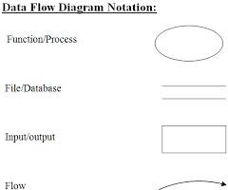

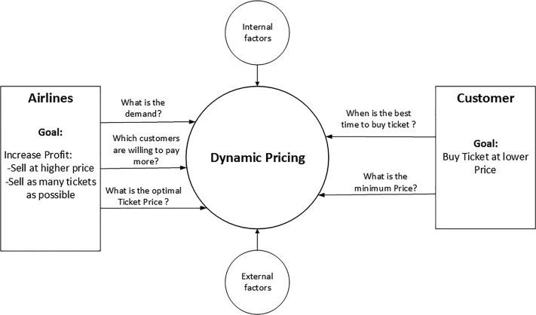
Level - 0

Level - 1

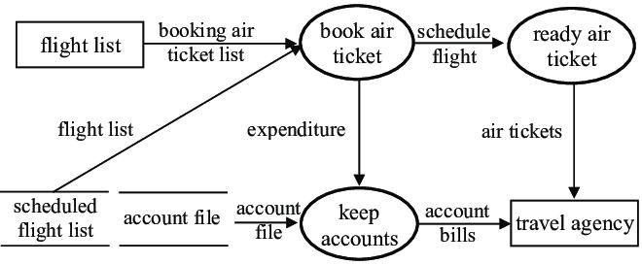

Level-2
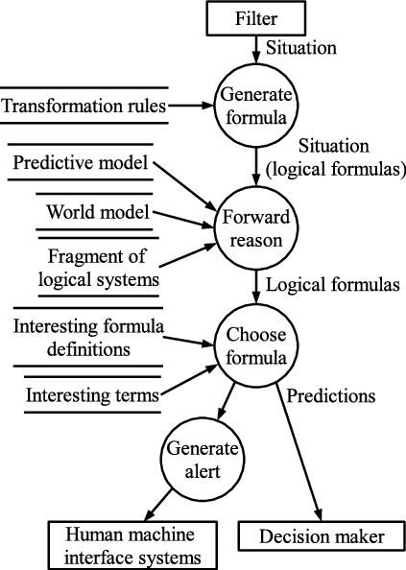v

DATABASE DESIGN
A database design is a collection of inter-related data stored with a minimum of redundancy to serve many applications”. To develop a database that satisfies the information needs of today as well as for tomorrow, it is necessary to understand the database conceptually. The first task of the designer is to develop the conceptual model. The steps in the development of the conceptual model are

- Data Analysis

- Relational Identity

- Graphical Representation

- Design Process

The database design is an important factor both in system testing and maintaining. It minimizes the artificial embedded in using separate files. The primary objective of the database design is fast response in less time. The database has three major aspects.

STRUCTURES
Structures are well-defined object that store the data of the database.

OPERATORS
The integrity rule is a law that governs which operation are allowed on the data structures of a database.

DATABASE TABLE
- Users Table

Field Name | Data Type | Size | Constraints | Description
user_id | INT | 10 | Primary Key, Auto Increment | Unique ID for each user
username | VARCHAR | 50 | Unique, Not Null | Unique login name for the user
first_name | VARCHAR | 50 | Not Null | User’s first name
last_name | VARCHAR | 50 | Not Null | User’s last name
email | VARCHAR | 100 | Not Null | User’s email address
password | VARCHAR | 100 | Not Null | Encrypted or hashed password
date_joined | DATETIME | — | Not Null | When the user registered
profile_pic | VARCHAR | 50 | Not Null | Filename/path of profile image

- flights Table

Field Name | Data Type | Size | Constraints | Description
flight_id | INT | 10 | Primary Key, Auto Increment | Unique ID for each flight
airline | VARCHAR | 50 | Not Null | Name of the airline
source | VARCHAR | 50 | Not Null | Starting location
destination | VARCHAR | 50 | Not Null | Destination location
departure_time | DATETIME | — | Not Null | Scheduled departure datetime
arrival_time | DATETIME | — | Not Null | Scheduled arrival datetime
duration | INT | 5 | Not Null | Flight duration in minutes
total_stops | INT | 2 | Not Null | Number of stops

Field Name | Data Type | Size | Constraints | Description
price | DECIMAL | 10,2 | Not Null | Ticket price

- Booking Table

Field Name | Data Type | Size | Constraints | Description
booking_id | INT | 10 | Primary Key, Auto Increment | Unique ID for each booking
user_id | INT | 10 | Foreign Key → users(user_id) | Reference to the user who booked
flight_id | INT | 10 | Foreign Key → flights(flight_id) | Reference to the flight booked
booking_date | DATETIME | — | Not Null | When the booking was made
seat_no | VARCHAR | 10 | Not Null | Seat number assigned to the booking

- Payments Table

Field Name | Data Type | Size | Constraints | Description
payment_id | INT | 10 | Primary Key, Auto Increment | Unique ID for each payment
booking_id | INT | 10 | Foreign Key → bookings(booking_id) | Reference to the booking being paid
payment_method | VARCHAR | 50 | Not Null | Mode of payment (Card, UPI, etc.)
amount | DECIMAL | 10,2 | Not Null | Payment amount

Field Name | Data Type | Size | Constraints | Description
payment_date | DATETIME | — | Not Null | Date and time of payment
status | VARCHAR | 20 | Not Null | Payment status (Paid, Pending,  Failed)

INPUT DESIGN
The input design is the link between the information system and the user. It comprises the developing specification and procedures for data preparation and those steps are necessary to put transaction data in to a usable form for processing can be achieved by inspecting the computer to read data from a written or printed document or it can occur by having people keying the data directly into the system. The design of input focuses on controlling the amount of input required, controlling the errors, avoiding delay, avoiding extra steps and keeping the process simple. The input is designed in such a way so that it provides security and ease of use with retaining the privacy. Input Design considered the following things:
- What data should be given as input?
- How the data should be arranged or coded?

- The dialog to guide the operating personnel in providing input.

- Methods for preparing input validations and steps to follow when error occur.

OBJECTIVES

- Input Design is the process of converting a user-oriented description of the input into a computer-based system. This design is important to avoid errors in the data input process and show the correct direction to the management for getting correct information from the computerized system.
- It is achieved by creating user-friendly screens for the data entry to handle large volume of data. The goal of designing input is to make data entry easier and to be free from errors. The data entry screen is designed in such a way that all the data manipulates can be performed.

- When the data is entered it will check for its validity. Data can be entered with the help of screens. Appropriate messages are provided as when needed so that the user will not be in

OUTPUT DESIGN
A quality output is one, which meets the requirements of the end user and presents the information clearly. In any system results of processing are communicated to the users and to other system through outputs. In output design it is determined how the information is to be displaced for immediate need and also the hard copy output. It is the most important and direct source information to the user. Efficient and intelligent output design improves the system’s relationship to help user decision-making.

- Designing computer output should proceed in an organized, well thought out manner; the right output must be developed while ensuring that each output element is designed so that people will find the system can use easily and effectively. When analysis design computer output, they should Identify the specific output that is needed to meet the requirements
.
- Select methods for presenting information.

- Create document, report, or other formats that contain information produced by the system.

The output form of an information system should accomplish one or more of the following objectives.
  - Convey information about past activities, current status or projections of the Future.
  - Signal important events, opportunities, problems, or warnings.

CHAPTER 6 SYSTEM TESTING

TESTING DESCRIPTION

After the source code has been completed, documented as related data structures. Completion of the project has to undergo testing and validation where there is subtitle and definite attempt to get errors. The project developer treats lightly, designing and execution of the project test that will demonstrates that the program works rather than uncovering errors, unfortunately errors will be present and if the project developer doesn’t found errors, the user will find out.

The project developer is always responsible for testing the individual units i.e. modules of the program. In many cases, developer should conduct the integration testing i.e. the testing step that leads to the construction of the complete program structure.
This project has undergone the following testing procedures to ensure its correctness.

    - UNIT TESTING
    - INTEGRATION TESTING
    - FUNCTIONAL TESTING
    - PERFORMANCE TESTING

UNIT TESTING

Unit testing involves the design of test cases that validate that the internal program logic is functioning properly, and that program inputs produce valid outputs. All decision branches and internal code flow should be validated. It is the testing of individual software units of the application .it is done after the completion of an individual unit before integration. This is a structural testing, that relies on knowledge of its construction and is invasive. Unit tests perform basic tests at component level and test a specific business process, application, and/or system configuration. Unit tests ensure that each unique path of a business process performs accurately to the documented specifications and contains clearly defined inputs and expected results.

INTEGRATION TESTING

Integration tests are designed to test integrated software components to determine if they actually run as one program. Testing is event driven and is more concerned with the basic outcome of screens or fields. Integration tests demonstrate that although the components were individually satisfaction, as shown by successfully unit testing, the combination of components is correct and consistent. Integration testing is specifically aimed at exposing the problems that arise from the combination of components.

FUNCTIONAL TESTING

Functional tests provide systematic demonstrations that functions tested are available as specified by the business and technical requirements, system documentation, and user manuals.

Functional testing is centered on the following items:
Valid Input : identified classes of valid input must be accepted. Invalid Input : identified classes of invalid input must be rejected. Functions : identified functions must be exercised.
Output : identified classes of application outputs must be exercised.
Systems/ Procedures: interfacing systems or procedures must be invoked.
Organization and preparation of functional tests is focused on requirements, key functions, or special test cases. In addition, systematic coverage pertaining to identify Business process flows; data fields, predefined processes, and successive processes must be considered for testing.

PERFORMANCE TESTING

System testing ensures that the entire integrated software system meets requirements. It tests a configuration to ensure known and predictable results. An example of system testing is the configuration-oriented system integration test. System testing is based on process descriptions and flows, emphasizing pre-driven process links and integration points.

TEST CASE

Flights

Column Name | Data Type | Description
flight_id | INT (PK) | Unique flight identifier
airline | VARCHAR | Airline name
source | VARCHAR | Departure city
destination | VARCHAR | Arrival city
total_stops | INT | Number of stops

    - Schedules
Stores dynamic information about flight timings.

Column Name | Data Type | Description
schedule_id | INT (PK) | Unique schedule ID
flight_id | INT (FK) | Reference to Flights table
date_of_journey | DATE | Date of flight
departure_time | DATET IME | Scheduled departure time
arrival_time | DATET IME | Scheduled arrival time
duration_mins | INT | Total duration in minutes

Prices
Stores price information for each flight schedule.

Column Name | Data Type | Description
price_id | INT (PK) | Unique price ID
schedule_id | INT (FK) | Reference to Schedules table
base_price | DECIM AL | Basic fare
tax | DECIM AL | Tax component
total_price | DECIM AL | Total price (base + tax)

TestCases
Stores test case data for validating price predictions.

Column Name | Data Type | Description
testcase_id | INT (PK) | Unique test case ID
schedule_id | INT (FK) | Reference to Schedules
expected_price | DECIMAL | Manually set or expected price
predicted_price | DECIMAL | Model’s predicted price
result | VARCHAR | 'Pass' / 'Fail' / 'Pending'
notes | TEXT | Optional notes for test explanation

CHAPTER 7
SYSTEM IMPLEMENTATION

The Flight Price Prediction System was developed to provide a smart solution that bridges the gap between complex airfare dynamics and users seeking accurate, real-time ticket pricing guidance. The system enables users — including frequent travelers, travel agents, and airlines — to make better- informed decisions using data-driven predictions.

System testing was thoroughly conducted, covering interface design, usability, functionality, and user acceptance. Tests included validating prediction accuracy, response time, ease of data input, and user navigation through the web and mobile interfaces.

While the current version provides core functionalities, there is significant room for enhancement, given the rapidly evolving field of machine learning and data science. The following are potential areas of improvement and future research directions:

Web-Based Access for Broader Reach
Develop a web application module that enables users to access the system from any device or location — particularly beneficial for users without access to mobile platforms.

Cross-Platform Mobile Development
Extend support to iOS and other mobile platforms to allow non-Android users to utilize the application, ensuring maximum accessibility and user inclusivity.

Premium Features & Monetization Model
Introduce premium features such as price trend analysis, prediction accuracy ratings, historical fare comparisons, and personalized travel alerts. These features can be offered on a subscription basis to generate sustainable revenue.

Expand System Scope
Enhance the system by integrating additional modules, such as hotel price predictions, multi-leg trip planning, or flight delay forecasting. The platform can also support travel agencies or airline operators for strategic pricing and customer targeting.

Discovery & Kick-off Phase
Before full implementation, a Project Kick-off Work-session was conducted. It included:

- Demonstration of the application prototypes
- Review of data input formats and prediction workflows
- Identification of key technical documentation
- Consultation with stakeholders on possible data process re-engineering (e.g., improving the collection of airline schedules, tax rules, and fare classes)

The session introduced the Project Team to the client organization and helped define internal responsibilities, align expectations, and confirm configuration needs.

System Implementation Activities
The implementation of the Flight Price Prediction System involved six major activities:

- Requirement Analysis & Dataset Collection
- Model Development and Training (ML Algorithms)
- User Interface Design (Web & Mobile)
- API and Backend Integration
- Testing (Unit, Integration, System, and UAT)
- Deployment & Maintenance Planning

DOCUMENTATION

It is result from the installation process, user guides provide the information of how the use the system and its flow.

TRAINING AND SUPPORT

Training plan is a strategy for training user so they quickly learn to the new system. The development of the training plan probably began earlier in the project. As part of the proven implementation methodology, every customer gets Administrator Training for each of the applications they're implementing. The trainer will deliver the Administrator Training onsite, face-to-face, to a maximum of system administrators, so each learner gets personalized

CHAPTER 8
CONCLUSION & FUTURE ENHANCEMENT

8. 1 CONCLUSION

The "Mobile application for student career guidance "empowers users to Information about career guidance, challenges faced by both students and teachers in the career guidance process and the factors that ought to be considered to improve the process in Kenya were reviewed. From the analysis carried out, the results pointed out that there are a few issues that the potential users wanted to be addressed. The result was the development of a career guidance system which includes a mobile and web application. The key features of the application include: understanding the different personalities, taking a personality test, viewing career possibilities, viewing professional testimonials, etc.

8. 2 SCOPE FOR FUTURE ENHANCEMENT

In the future, this "Mobile application for student career guidance" is designed can still be improved or added upon as there is room for improvement. This is attainable because, research is ongoing and technology is continuously improving the way things are done and more technological tools are being built daily that could further even more discoveries. Implementing AI-driven personalized career assessments and recommendations based on students' skills, interests, and emerging job market trends could enhance student career guidance. Integration with real-time industry data and mentorship platforms could provide valuable insights and connections for informed decision-making. Develop an advanced skills assessment tool that evaluates not only academic strengths but also soft skills, such as communication, problem-solving, and teamwork. Utilize AI to assess and understand students' interests by analyzing their extracurricular activities, hobbies, and preferences. Therefore, the following are areas that could be explored in future to improve on this solution

CHAPTER 9 APPENDIX

SOURCE CODE REGISTRATION

import pandas as pd import numpy as np
import matplotlib.pyplot as plt import seaborn as sns
import joblib

from sklearn.model_selection import train_test_split, GridSearchCV from sklearn.preprocessing import LabelEncoder
from sklearn.linear_model import LinearRegression from sklearn.ensemble import RandomForestRegressor
from sklearn.metrics import r2_score, mean_absolute_error, mean_squared_error import xgboost as xgb
df = pd.read_csv("flight_data.csv") print("Initial Shape:", df.shape) print(df.head()) df.dropna(inplace=True)
print("Shape after dropping nulls:", df.shape)
df['Journey_day'] = pd.to_datetime(df['Date_of_Journey'], dayfirst=True).dt.day df['Journey_month'] = pd.to_datetime(df['Date_of_Journey'], dayfirst=True).dt.month df.drop('Date_of_Journey', axis=1, inplace=True)

df['Dep_hour'] = pd.to_datetime(df['Dep_Time']).dt.hour df['Dep_min'] = pd.to_datetime(df['Dep_Time']).dt.minute df.drop('Dep_Time', axis=1, inplace=True)

df['Arrival_hour'] = pd.to_datetime(df['Arrival_Time']).dt.hour df['Arrival_min'] = pd.to_datetime(df['Arrival_Time']).dt.minute df.drop('Arrival_Time', axis=1, inplace=True)

def duration_to_mins(duration):

duration = duration.replace('h', 'h ').replace('m', 'm ') hours, minutes = 0, 0
for part in duration.split(): if 'h' in part:
hours = int(part.replace('h', '').strip()) elif 'm' in part:
minutes = int(part.replace('m', '').strip()) return hours * 60 + minutes

df['Duration_mins'] = df['Duration'].apply(duration_to_mins) df.drop('Duration', axis=1, inplace=True)

df['Total_Stops'] = df['Total_Stops'].map({ 'non-stop': 0,
'1 stop': 1,
'2 stops': 2,
'3 stops': 3,
'4 stops': 4
})
cat_cols = ['Airline', 'Source', 'Destination', 'Route', 'Additional_Info'] encoders = {}
for col in cat_cols:
le = LabelEncoder()
df[col] = le.fit_transform(df[col]) encoders[col] = le
X = df.drop('Price', axis=1) y = df['Price']
X_train, X_test, y_train, y_test = train_test_split(X, y, test_size=0.2, random_state=0) models = {
"Linear Regression": LinearRegression(), "Random Forest": RandomForestRegressor(), "XGBoost": xgb.XGBRegressor()
}

for name, model in models.items(): model.fit(X_train, y_train)
preds = model.predict(X_test) print(f"\n{name} Performance:") print("R2 Score:", r2_score(y_test, preds))
print("MAE:", mean_absolute_error(y_test, preds)) print("RMSE:", np.sqrt(mean_squared_error(y_test, preds)))
params = {
'n_estimators': [100, 200],
'learning_rate': [0.05, 0.1],
'max_depth': [3, 5]
}
xgb_grid = GridSearchCV(xgb.XGBRegressor(), params, scoring='neg_mean_squared_error', cv=3, verbose=1)
xgb_grid.fit(X_train, y_train)
print("Best XGBoost Params:", xgb_grid.best_params_) joblib.dump(xgb_grid.best_estimator_, "flight_price_model.pkl") joblib.dump(encoders, "label_encoders.pkl")
def predict_custom_input(custom_input_dict): model = joblib.load("flight_price_model.pkl") encs = joblib.load("label_encoders.pkl")

for col in cat_cols:
custom_input_dict[col] = encs[col].transform([custom_input_dict[col]])[0]

input_df = pd.DataFrame([custom_input_dict]) prediction = model.predict(input_df)[0]
return round(prediction, 2)

sample_input = { 'Airline': 'IndiGo',
'Source': 'Delhi', 'Destination': 'Cochin',
'Route': 'DEL → BOM → COK',
'Additional_Info': 'No info', 'Total_Stops': 1,
'Journey_day': 15,
'Journey_month': 3,
'Dep_hour': 7,
'Dep_min': 30,
'Arrival_hour': 10,
'Arrival_min': 45,
'Duration_mins': 195
}

predicted_price = predict_custom_input(sample_input) print("\nPredicted Flight Price (INR):", predicted_price)


  - SCREENSHOTS

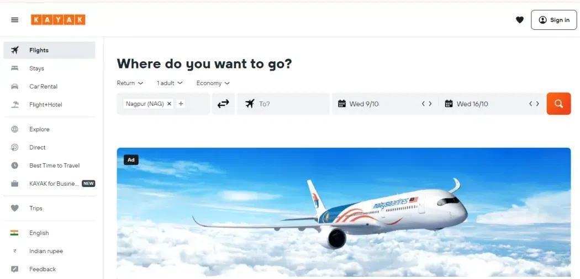

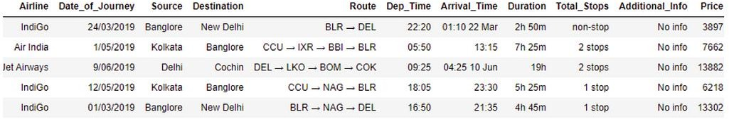

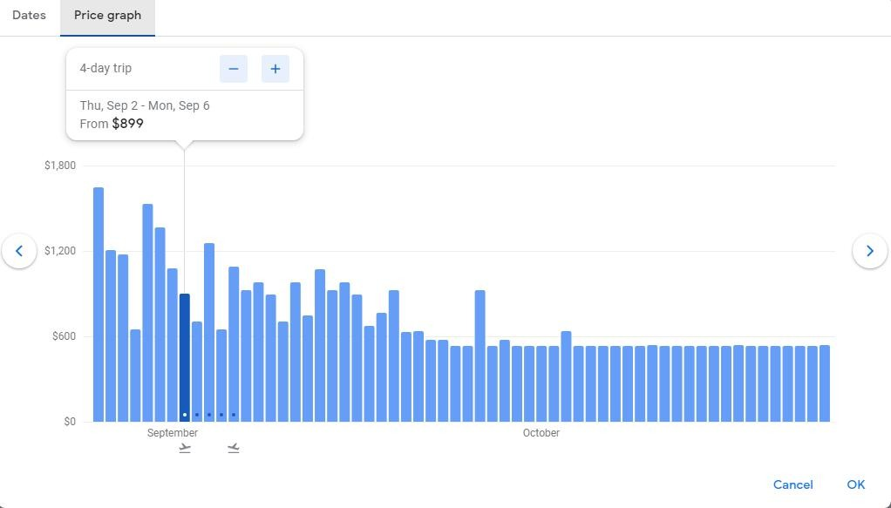

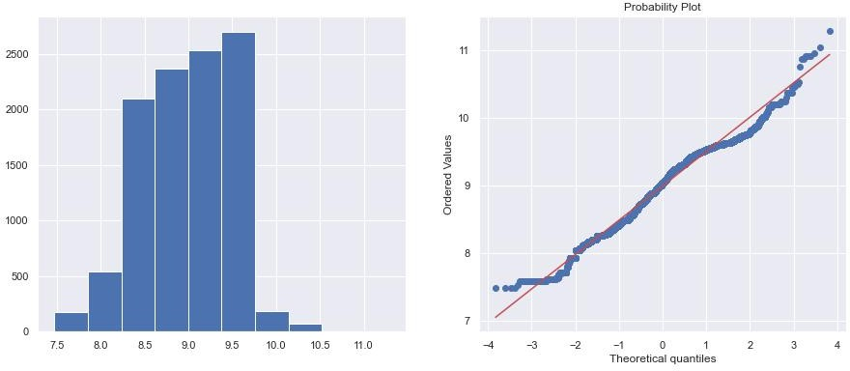

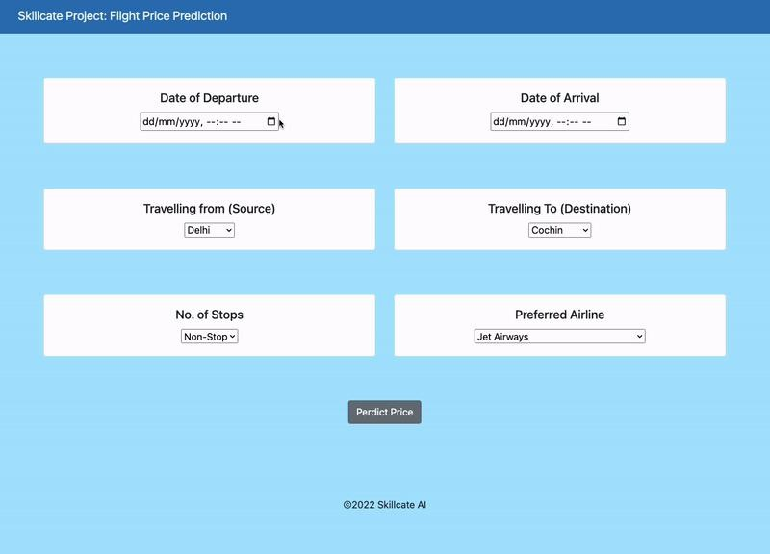

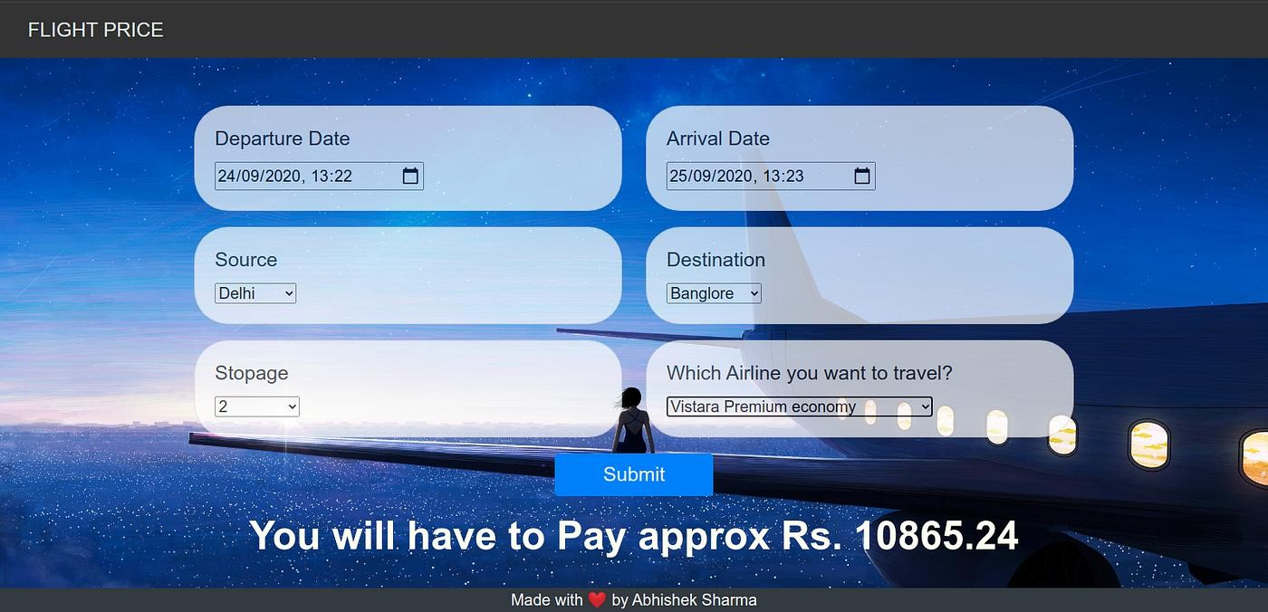

  - BOOK REFERENCES

CHAPTER 10 REFERENCES

    - Rajankar, Supriya, and Neha Sakharkar. "A Survey on Flight Pricing Prediction using Machine Learning." Internatıonal Journal Of Engıneerıng Research & Technology (Ijert)
    - Smith, Barry C., John F. Leimkuhler, and Ross M. Darrow. "Yield management at American airlines." interfaces 22.1 (1992): 8-31.
    - Groves, William, and Maria Gini. "An agent for optimizing airline ticket purchasing." Proceedings of the 2013 international conference on Autonomous agents and multi-agent systems. 2013.
    - Janssen, Tim, et al. "A linear quantile mixed regression model for prediction of airline ticket prices." Radboud University (2014).
    - Wohlfarth, Till, et al. "A data-mining approach to travel price forecasting." 2011 10th International Conference on Machine Learning and Applications and Workshops. Vol. 1. IEEE, 2011.
[6] Papadakis, Manolis. "Predicting Airfare Prices." (2014).
- Ren, Ruixuan, Yunzhe Yang, and Shenli Yuan. "Prediction of airline ticket price." University of Stanford (2014).
- Tziridis, Konstantinos, et al. "Airfare prices prediction using machine learning techniques." 2017 25th European Signal Processing Conference (EUSIPCO). IEEE, 2017.
- Boruah, Abhijit, et al. "A Bayesian Approach for Flight Fare Prediction Based on Kalman Filter." Progress in Advanced Computing and Intelligent Engineering. Springer, Singapore, 2019. 191-203.
- S. Chakravarty, B. K. Paikaray, R. Mishra and S. Dash, "Hyperspectral Image Classification using Spectral Angle Mapper," 2021 IEEE International Women in Engineering (WIE) Conference on
- https://www.kaggle.com/nikhilmittal/flight-fare-prediction-mh/
- https://github.com/rishabdhar12/Flight-Price-Prediction/tree/main/Dataset

