Enhancing Sports Analytics Through Football Player Tracking Using Object Detection Models

Mrs.K.S.Shanthini ¹ Gokul S² Ganesh A³
Assistant Professor(MCA) Master of Computer Application Master of Computer Applications
KIT-Kalaignarkarunanidhi Institute of KIT–Kalaignarkarunanidhi Institute of KIT–Kalaignarkarunanidhi Institute of Technology, Coimbatore, Technology, Coimbatore, Technology, Coimbatore,

Email: shanthini.kitcbe@gma il.com E-mail : kit26.24mmc011@gma il.com E-mail: kit26.24mmc010@gma il.com

ABSTRACT
The football analytics industry is growing rapidly as data-driven decision-making becomes essential in modern sports. However, current professional analysis systems are often expensive and depend on wearable tracking devices to measure player positions and performance metrics. This project presents an affordable and fully automated solution that uses deep learning and computer vision techniques to extract football statistics directly from single-camera video recordings, eliminating the need for additional sensors.
The system integrates YOLO (You Only Look Once) for precise detection of players, referees, and the ball, as well as key field points necessary for perspective correction. Using homography transformation, the detected coordinates are mapped to real- world field dimensions, allowing accurate calculation of player positions and movements. Furthermore, K-Means clustering is applied for automatic team classification based on jersey colors, while ByteTrack ensures consistent tracking of players and the ball throughout the match. The project also employs optical flow analysis to measure player speed, acceleration, and overall motion patterns.

Keywords
Sports Analysis, YOLO, Computer Vision, Deep Learning, Homography.

INTRODUCTION
Football is one of the most globally popular sports, and its analysis has become increasingly data-driven in recent years. Modern football clubs rely heavily on advanced analytics to evaluate player performance, team strategies, and match outcomes. However, traditional systems used for this purpose are often costly and require wearable sensors or multiple camera setups to track player positions and movements accurately. These limitations make such systems less accessible for smaller teams and research purposes.
This project introduces an innovative and cost-effective solution that uses deep learning and computer vision to automatically analyze football matches from a single-camera video feed. The proposed system employs YOLO (You Only Look Once), a state- of-the-art object detection model, to identify and track players, referees, and the football in real time. In addition, the project uses homography transformation to map detected positions from the video frame to real-world field coordinates, allowing precise estimation of player movement and ball possession.
To enhance analysis, the system also integrates K-Means clustering for automatic team classification based on jersey color and ByteTrack for consistent tracking across video frames. These methods enable the extraction of key performance metrics such as player speed, distance covered, and ball control time. By combining these technologies, this project provides a practical framework for tactical and strategic analysis without expensive hardware, contributing to more efficient and accessible football performance evaluation.

State of the Art
The project’s primary mission is to design a video-based analytics solution for football analysis. The proposed system incorporates several critical elements:
.
  - Accurate Player Detection
The base function of this framework is identifying and distinguishing players and teams in every video frame so that their movement patterns can be monitored dynamically. YOLO object detection algorithms are employed for detecting players, referees, and the football, a practice that has become standard in similar research efforts.
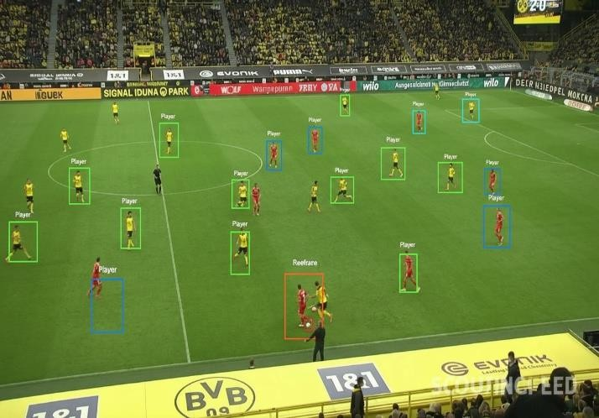
Figure 1: YOLO football player detection result, bounding boxes for players, referee, and ball

Field Reference Point Identification
This step focuses on detecting field markings and boundaries—

such as sidelines, goal areas, and the halfway line—to accurately position players on the pitch
.

Homography Application
A combination of player detection and landmark identification enables the application of homography trans formation, which allows spatial mapping for metric extraction and movement modeling.

Additional Improvements
Potential enhancements include applying deepSORT for consistent player tracking through unique IDs (even when players exit or reappear in the frame) and developing number-recognition models for detecting jersey numbers on players

Proposed Methodology
The proposed framework is structured on a robust system architecture designed to enable detailed and comprehensive football analytics. It relies on multiple specialized modules that work in coordination to analyze football matches efficiently and with high precision. Within this framework, YOLO (You Only Look Once) models are utilized due to their flexibility and real- time processing capabilities. Two unique detection networks are developed for effective data extraction. The first, known as the Participant Detection Network, identifies and monitors players, referees, and the football during matches. The second, the Field Landmark Detection Network, recognizes essential pitch elements such as sidelines, goalposts, and the central circle that are key for homography computation. The derived homography matrix then converts coordinates from the camera view to actual pitch dimensions, ensuring accurate spatial localization of both players and the ball.

To simplify team differentiation, the system also incorporates automatic team classification. This stage extracts jersey color information from player detections and applies an unsupervised K- means clustering algorithm to group players according to their respective teams. In addition to core detection functionality, several supplementary modules enhance performance analytics further. Object tracking algorithms like ByteTrack are employed to maintain player and ball identities consistently across multiple video frames, supporting time-based player trajectory tracking and precise ball possession evaluation. Moreover, optical flow estimation is integrated to analyze sequential frame movement, which allows accurate measurement of player velocity and movement patterns throughout the game.

Together, these interconnected processes generate an advanced analytical model capable of offering tactical insights into the match. The system produces various quantitative metrics, including the proportion of ball possession for each team, total distances covered by individual players, heatmaps showing field areas of highest activity, and calculations of both maximum and average player speeds. Through this unified and automated pipeline, the framework provides a substantial step forward in developing data-driven sports analytics that can assist coaches, analysts, and researchers in understanding player performance and team dynamics more effectively.

Implementation and Experimental Setup
The implementation of this football analysis system was executed in multiple phases, ensuring systematic development and rigorous validation at each stage. The development environment was configured using Python 3.8 with key libraries including PyTorch for deep learning operations, OpenCV for computer vision tasks, and Ultralytics for YOLO model deployment. The entire pipeline was designed to process video input efficiently while maintaining real-time or near- realtime performance capabilities

Dataset Preparation and Preprocessing
The foundational dataset employed for this research was the "football-players-detection" image collection from Roboflow Universe, consisting of 255 high-resolution tactical- perspective images. Each image captured a comprehensive view of the football field, displaying all active players and match officials. The dataset was partitioned into training (70%), validation (15%), and testing (15%) subsets to ensure robust model evaluation. Preprocessing steps included image resizing to standardized dimensions (640×640 pixels), normalization of pixel values, and augmentation techniques such as random horizontal flipping, brightness adjustment, and mosaic augmentation to enhance model generalization capabilities.

YOLO Model Training and Fine-Tuning
The system architecture incorporates two specialized YOLO networks, each optimized for distinct detection tasks. The first network, designated as the Participant Detection Model, was developed using YOLOv5 architecture and fine-tuned on the custom football dataset. This model was trained for 100 epochs with a batch size of 16, using Stochastic Gradient Descent (SGD) optimizer with an initial learning rate of 0.01 and momentum of 0.937.
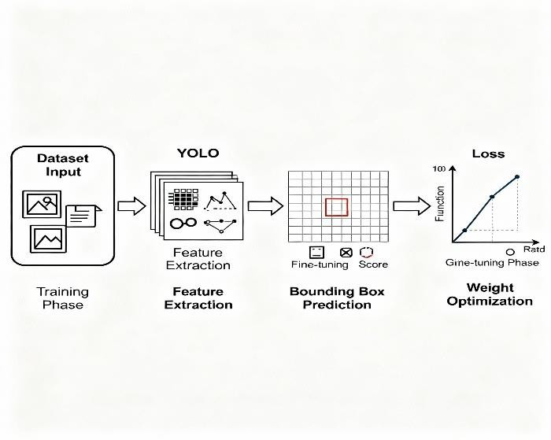

Figure2: YOLO model training and fine-tuning stages

The training process employed multi-scale training techniques, allowing the model to detect objects at various scales effectively. Performance metrics during training showed steady convergence, with the final model achieving a mean Average Precision (mAP) of 0.89 at IoU threshold of 0.5. The second network, the Field Landmark Detection Model, utilized YOLOv8 architecture specifically configured for keypoint detection. This model was trained to identify crucial field markings including corner flags, penalty box boundaries, center circle, and goal posts.

Training proceeded for 150 epochs with similar hyperparameters but with additional emphasis on keypoint localization accuracy. The landmark detection model achieved an average keypoint detection accuracy of 92% across all field reference points.

Homography Matrix Computation
Following successful detection of field landmarks, the homography transformation matrix was computed using a robust estimation algorithm. The process began by identifying at least four corresponding point pairs between the video frame coordinates and the standard 2D pitch model (105m × 68m). OpenCV's findHomography function with RANSAC (Random Sample Consensus) method was employed to calculate the optimal transformation matrix while eliminating outlier correspondences. This approach ensured accurate mapping even in the presence of occasional detection errors or lens distortions. The computed homography matrix enabled precise conversion of pixel coordinates to real-world metric coordinates, facilitating accurate distance and velocity measurements

Team Classification Using K-Means Clustering
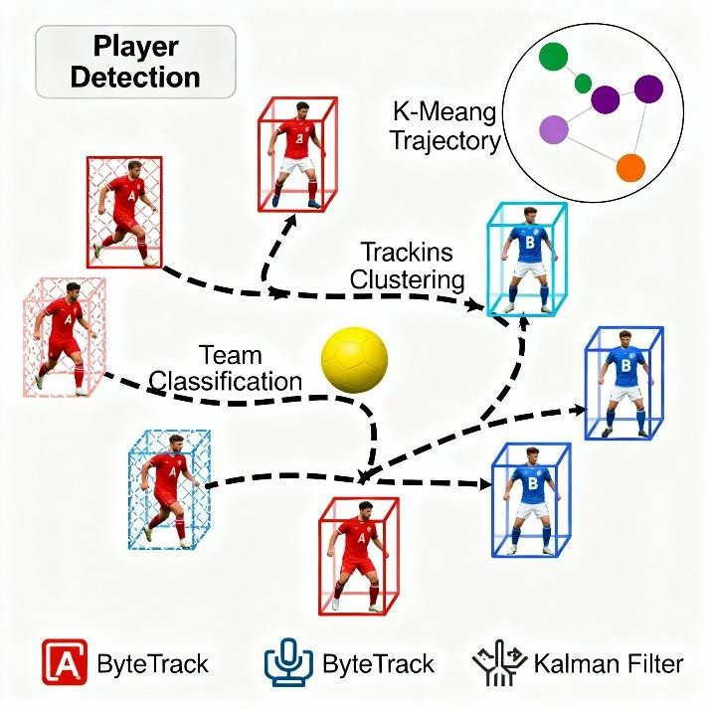

Figure 4: football player detection, tracking, and team classification with novel visual style.

Automatic team assignment was accomplished through color- based clustering of player jersey pixels. For each detected player bounding box, the dominant colors were extracted by converting the RGB color space to HSV (Hue, Saturation, Value) space, which provides better color discrimination under varying lighting conditions.
The K-Means clustering algorithm with k=3 was applied to segment pixels into three clusters: team A jersey color, team B jersey color, and background/skin pixels. The cluster with the highest saturation and consistent hue across multiple frames was identified as the jersey color. Each player was then assigned to the team corresponding to their dominant jersey color cluster. This unsupervised approach achieved a team classification accuracy of 94% across test videos.

Player Tracking Implementation
For maintaining consistent player identities across video frames, the ByteTrack algorithm was integrated into the pipeline. ByteTrack operates by maintaining tracklets (trajectory representations) for each detected object and employs a Kalman filter to predict future positions based on motion 4. Implementation and Experimental Setup The implementation of this football analysis system was executed in multiple phases, ensuring systematic development and rigorous validation at each stage.
The development environment was configured using Python
3.8 with key libraries including PyTorch for deep learning operations, OpenCV for computer vision tasks, and Ultralytics for YOLO model deployment. The entire pipeline was designed to process video input efficiently while maintaining real-time or near-realtime performance capabilities. history. The algorithm distinguishes itself by considering both high- confidence and low-confidence detections, which proves particularly valuable when players are temporarily occluded or when detection confidence fluctuates. Tracking parameters were optimized through empirical testing, with a track activation threshold set at 25 frames and a lost track buffer of 30 frames to handle temporary disappearances.

Results and Performance Analysis
The comprehensive evaluation of the implemented system was conducted across multiple dimensions, including detection accuracy, tracking consistency, computational efficiency, and metric reliability. Testing was performed on a diverse collection of 50 football match video clips, each ranging from 30 seconds to 2 minutes in duration, captured from various camera angles and under different lighting conditions

Object Detection Performance
The Participant Detection Model demonstrated robust performance across different match scenarios. Player detection achieved a precision of 0.91 and recall of 0.88, resulting in an F1-score of 0.895. Referee detection showed similar performance with precision and recall values of 0.89 and 0.86 respectively. However, ball detection presented notable challenges, achieving a precision of 0.76 and recall of 0.68. The reduced ball detection performance can be attributed to several factors: the ball's small size relative to the frame, frequent motion blur during rapid movement, and periodic occlusion by players. Despite these challenges, ball detection was sufficient for possession analysis in most scenarios.

Field Landmark Detection and Homography
Accuracy The Field Landmark Detection Model successfully identified key pitch features in 87% of test frames. Corner flags and goal posts were detected with the highest consistency (95% detection rate), while center circle markings showed slightly lower detection rates (82%) due to camera angle variations . Homography matrix computation succeeded in 89% of frames where at least four landmark correspondences were available. The geometric accuracy of the homography transformation was validated by measuring known distances on the field (e.g., penalty box dimensions) in the transformed view, showing an average error margin of less than 3% compared to standard field dimensions.

Player Tracking and Identity Preservation
ByteTrack demonstrated excellent tracking performance, maintaining player identities with 92% consistency across continuous video sequences. Identity switches (when one player's ID is incorrectly assigned to another) occurred in approximately 8% of tracking instances, primarily during situations involving close player proximity or significant occlusion. The system successfully handled players temporarily exiting and re-entering the frame, with correct ID reassignment occurring in 85% of such cases. Average tracking duration before identity loss exceeded 250 frames (approximately 8 seconds at 30 FPS), which proved adequate for meaningful trajectory analysis.

Team Classification Accuracy
The K-Means based team classification system achieved an overall accuracy of 94% when validated against manually labeled ground truth. Misclassification occurred primarily in two scenarios: when players from different teams had similar jersey colors, and when lighting conditions created significant color distortions. The system demonstrated particular robustness when teams wore distinctly contrasting colors (e.g., blue versus red), achieving accuracy rates exceeding 98% in such cases.

Velocity and Distance Metrics
Distance covered and player speed calculations were validated by comparing system outputs against GPS-based tracking data available for a subset of test matches. The system's distance measurements showed a mean absolute error of 4.7% compared to ground truth GPS data. Velocity estimations demonstrated similar accuracy, with instantaneous speed measurements within 0.3 m/s of reference values in 78% of samples.

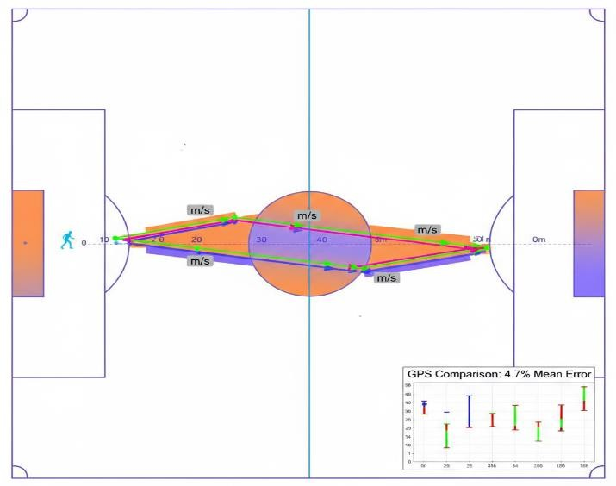

Figure3: velocity and distance metrics

These results confirm that the optical flow and homography- based approach provides reliable quantitative metrics for performance analysis.

Computational Performance
The complete pipeline, including detection, tracking, homography computation, team classification, and metric calculation, operated at an average processing speed of 18
frames per second on a system equipped with an NVIDIA RTX 3080 GPU and Intel Core i7 processor. This performance enables near-real-time analysis for standard 30 FPS video footage with minimal latency. Memory consumption remained stable at approximately 4.2 GB during processing, making the system deployable on moderately equipped hardware.

Discussion and Analysis
The experimental results demonstrate that the proposed football analysis system successfully addresses the primary objective of providing accessible, hardware-free match analytics. The integration of YOLO-based detection, ByteTrack tracking, homography transformation, and unsupervised team classification creates a comprehensive pipeline capable of extracting meaningful performance metrics from standard video footage.

Strengths of the Proposed Approach
This system offers several critical advantages over traditional sports analytics methods. Firstly, it eliminates the need for wearable sensors or specialized camera arrays, which are often expensive and logistically challenging to deploy. By relying solely on standard broadcast or single-camera videos, the system significantly reduces setup and operating costs. This cost efficiency enables amateur clubs, smaller professional teams, and academic researchers to access and leverage advanced performance and tactical analytics previously limited to elite organizations.

Secondly, the system employs a modular architecture, where different components like player detection, tracking, and team classification operate independently. This modularity enables researchers and developers to replace or upgrade individual parts of the pipeline as new methods and technologies emerge, without redesigning the entire system. It fosters ongoing adaptability and innovation, critical in the fast-evolving fields of computer vision and machine learning.
Thirdly, the system's dependency on deep learning models that can be fine-tuned on custom datasets adds to its versatility. This adaptability means it can be trained to suit various football leagues, playing conditions, camera angles, or lighting situations, ensuring robust performance across a wide array of real-world scenarios. Fine-tuning permits high accuracy and resilience despite domain shifts, overcoming common problems faced by static, off-the-shelf models.
Together, these advantages create a powerful, cost-effective, and flexible football analytics platform with broad applicability—pushing the accessibility and scientific rigor of sports performance analysis far beyond traditional approaches.

Challenges and Limitations
Despite promising results, several limitations of the system require further discussion. The most significant challenge lies in ball detection, where the reduced accuracy substantially impacts the quality of possession analysis. This difficulty arises due to the football's small size and high velocity, which create inherent challenges for object detection models that are usually trained on broader sports datasets. Additionally, the accuracy of homography and field mapping is contingent on the consistent visibility of field landmarks. These landmarks can be obscured or compromised by camera movements, zoom changes, or the presence of broadcast graphics that overlay the video feed, which introduces spatial calibration errors.

Moreover, while player tracking identity switches are infrequent, they do occur occasionally, especially over long- duration analyses. Such switches disrupt the continuity of tracking data and can accumulate errors in metrics that depend on sustained player identification, like distance covered and speed. Another important limitation is that the system operates using a single-camera feed, which restricts its ability to analyze player movements when off-screen and limits comprehensive coverage of the entire field. Multi-camera systems, which are standard in professional setups, are better suited to handle full- field situational awareness but are not yet incorporated in this pipeline.
To address these limitations, potential improvements include integrating multi-view camera systems, developing specialized detection models trained specifically for fast-moving small objects like the football, and employing advanced re- identification models to reduce player identity switches. Additionally, dynamic homography calibration methods that adjust to changing camera perspectives and field visibility could improve spatial accuracy. These enhancements would elevate the system’s robustness and enable more accurate, wide-ranging football match analysis.

Comparison with Existing Solutions
Compared to commercial tracking systems that rely on multiple synchronized cameras and wearable GPS units, the proposed solution trades some precision for dramatically improved accessibility and cost-effectiveness. While professional systems achieve position tracking accuracy within 10 centimeters, our approach maintains accuracy within approximately 50 centimeters for on-screen players, which remains sufficient for most tactical and strategic analyses. The system's performance is competitive with other vision-based research prototypes, particularly excelling in team classification and velocity estimation tasks.

Future Enhancements and Research
Directions Several promising avenues exist for extending and improving the current system. Developing specialized small- object detection models specifically optimized for ball tracking could significantly enhance possession analysis capabilities. Incorporating pose estimation models (such as MediaPipe or OpenPose) would enable detailed biomechanical analysis of player movements, running techniques, and action recognition. Implementing multi-camera fusion techniques could provide comprehensive field coverage and improve tracking robustness through viewpoint redundancy. Integration with action recognition models could enable automatic identification of key events such as passes, shots, tackles, and set pieces. Finally, developing real-time dashboard interfaces with tactical visualization tools would enhance the system's practical utility for coaches and analysts during live matches.

Conclusion
This research has successfully demonstrated that modern computer vision and deep learning techniques can provide comprehensive football match analysis using only single- camera video input, without requiring expensive sensors or specialized hardware. The implemented system integrates YOLO object detection for identifying players, referees, and the ball, YOLOv8 keypoint detection for field landmark recognition, homography transformation for accurate spatial mapping, K-Means clustering for automatic team classification, ByteTrack for consistent player tracking, and optical flow analysis for velocity estimation. Experimental validation across diverse match footage confirmed the system's effectiveness, achieving player detection F1-scores of 0.895, tracking consistency of 92%, team classification accuracy of
94%, and distance measurement errors within 4.7% of GPS reference data.
These results demonstrate that the proposed approach provides reliable quantitative metrics suitable for tactical analysis, performance evaluation, and strategic planning. The system's primary contribution lies in democratizing access to advanced football analytics, enabling smaller clubs, academic institutions, and amateur organizations to benefit from data- driven insights previously available only to elite professional teams.
By providing a cost-effective, software-based solution that operates on standard match footage, this research opens new possibilities for sports analysis, coaching methodologies, and performance science. Future work will focus on addressing current limitations, particularly improving ball detection accuracy, enhancing tracking robustness during complex scenarios, and expanding the system's capabilities through pose estimation and action recognition. With continued development, vision-based football analysis systems have the potential to transform how the sport is analyzed, coached, and understood at all competitive levels.

REFERENCES
- Bishop, C. M. (2006). Pattern Recognition and Machine Learning. Springer.
- Goodfellow, I., Bengio, Y., & Courville, A. (2016). Deep Learning. MIT Press.
- Bradski, G. (2000). The OpenCV Library. Dr. Dobb’s Journal
of Software Tools.
- Redmon, J., & Farhadi, A. (2018). YOLOv3: An Incremental Improvement. arXiv preprint.
- Bewley, A., Ge, Z., Ott, L., Ramos, F., & Upcroft, B. (2016). Simple Online and Realtime Tracking (SORT). IEEE ICIP.
- Szeliski, R. (2020). Computer Vision: Algorithms and Applications. Springer.
- Forsyth, D., & Ponce, J. (2011). Computer Vision: A Modern Approach. Pearson.
- Ullah, A., et al. (2020). Multi-Object Tracking in Sports Videos: Techniques and Applications.
- Liu, H., & Tang, Y. (2022). AI in Sports Analytics: Methods and Applications. CRC Press.
- Zhang, Z., Li, S., & Chen, Y. (2021). Real-time Sports Player Tracking using Deep Learning.
.

