1) 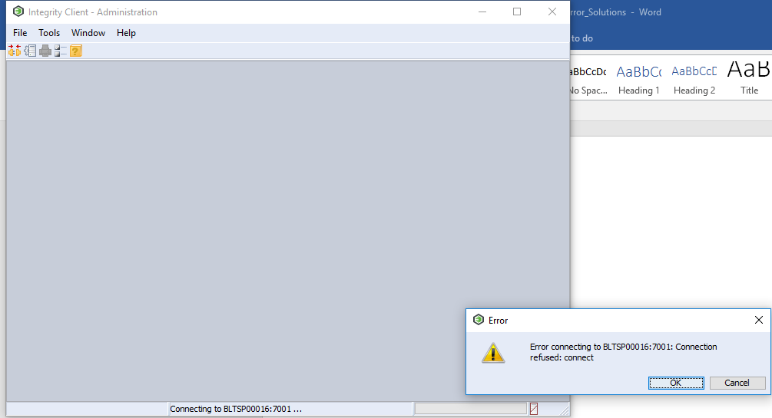
Unable to create temporary file in directory C:\windows\system32\config\systemprofile\AppData\Local\Temp\.

SOLUTION :Create Temp file in the specified directory
2)
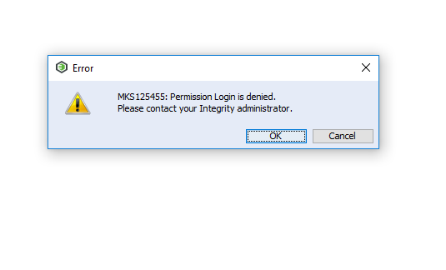
SOLUTION :give log in permission to the user in the admin client.
3)

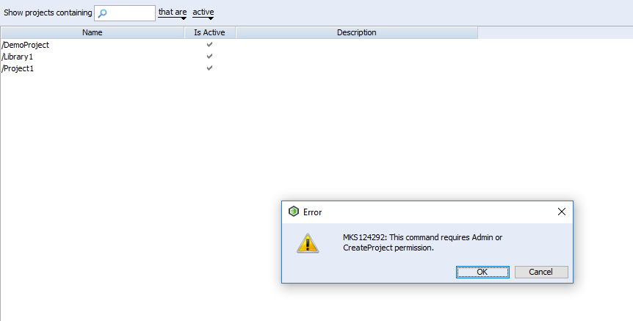

SOLUTION :Give create project permission to the user in the admin client.
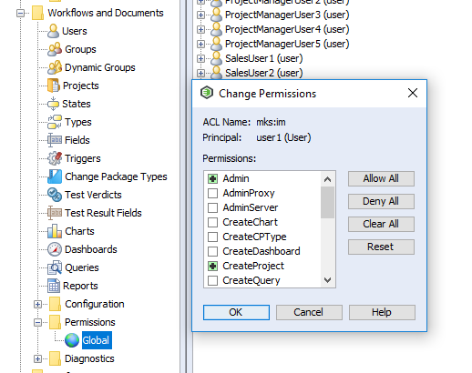

4) This error gets when we try to do trace relationship by drag and drop.

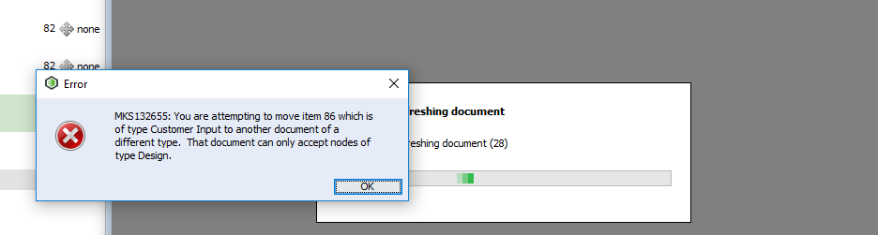
SOLUTION : Instead of simple drag and drop use ALT + Drag and drop.

5)
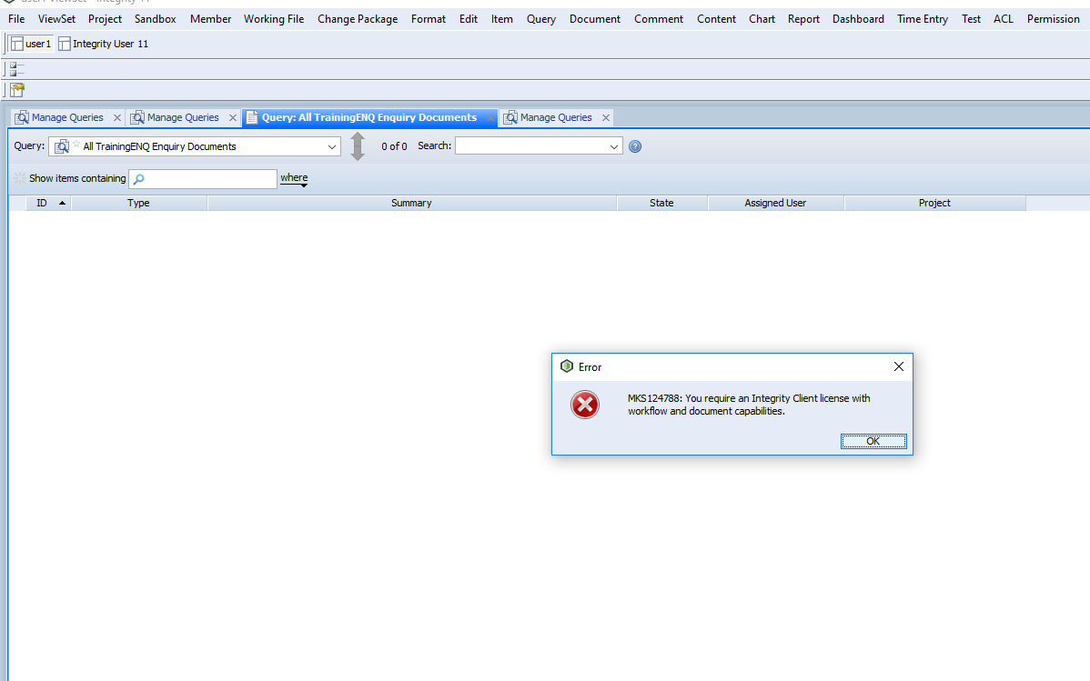
SOLUTION : This is occurring because the number of license limit has reached. So disconnect one other user from the server and connect again.
6)
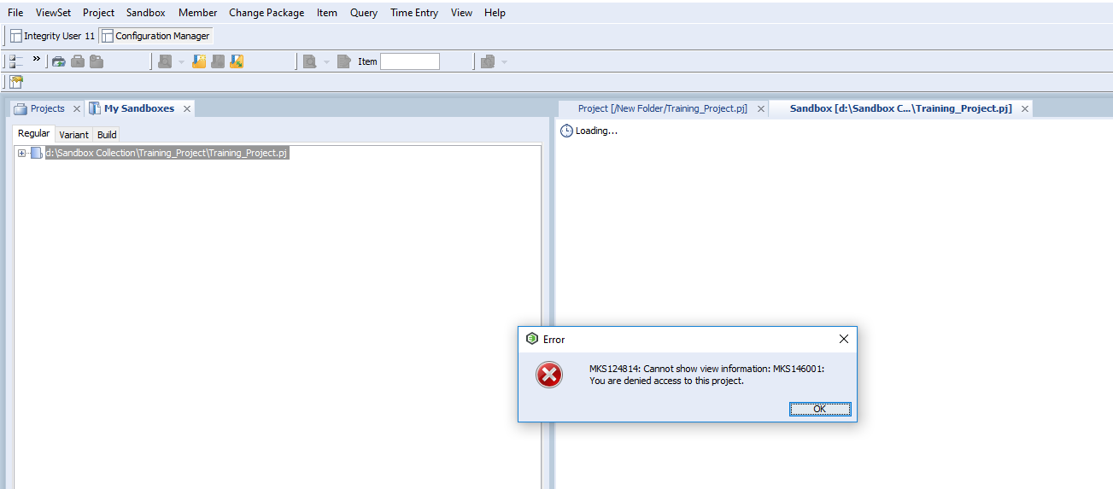
SOLUTION : Give permission in the configuration manager
First create new project ACL, then give permission to this ACL
