**Case Study 4: GoodHealth Hospital Management System**

GoodHealth Hospitals started as a super-specialty hospital in the year 2003. By the year 2006, management at GoodHealth made certain strategic decision and came up with a simple business model of registering smaller clinics and hospitals under their brand at a very nominal licensing cost.

As a result of this partnership, GoodHealth has had its brand name popularized across the country. Smaller clinics, in turn, have benefited by gaining an association with the GoodHealth brand name. GoodHealth’s simple and effective business model has helped it grow into a much bigger organization today, with its corporate office located in San Jose.

GoodHealth today employs more than 300 doctors across its sites and has almost doubled its vast patient database to an astounding 2000+ per year and is growing at an equal rate.

**The Current System**

GoodHealth currently uses a robust document based system at their super-specialty hospital to maintain patient records and activities. Front Desk Officers and medical staff together maintain a list of all the patients registered with the hospital and record all patient related activities such as appointments with doctors, out patient visits, pharmacy and laboratory testing services on traditional ledger based system.

With the strategic actions planned in 2006, the company has grown into a multi location super specialty service organization with state of the art equipment and highly skilled staff.

However, the senior management has been proactive in understanding that they need to enable their super specialty hospital along with rest of their centers by using simple and effective Information Technology systems.

Senior management at GoodHealth understands and has expressed their concerns about having a simple transaction processing system that can handle in and out patient data. The senior management also emphasizes that the system needs to be simple and should offer high performance.

GoodHealth medical officers and directors arranged a discussion and the following points surfaced:

* GoodHealth needs a simple system to maintain patient registration and daily activities.
* The system needs to cater to a high volume of patients. Also as GoodHealth’s centers are located at geographically diverse locations, the system needs to have a central repository to maintain all patient data.
* The system must have a high response time.
* The system should be easy to learn. Most of GoodHealth’s staff is used to working with paper documents and the amount of training involved should be minimal.
* The system should be able to generate invoices/bills to be handed over to the patients at discharge/visit.
* The system should be able to generate various reports for the senior management.

**The Envisioned System**

The management suggests development of a computerized system that can take care of routine activities for a patient management.

The technical staff put across the following guidelines:

* The system will be internet enabled.
* Since transactions are spread across the world, they should be carried with respect to the local time zones.
* A central database will store information for the following entities in the system:
  + Patients
  + Doctors
  + Wards
  + Laboratory Tests
  + Medicines
  + Patient Visits
  + Patient Bills
  + System Users
* The system will comprise of the following functionality:
  + System users will login to the system using a username and a password.
  + System Users should be able create new patients or choose existing patients by providing a patient number/patient name. If multiple patients with similar names are found, the system will display the list of all the patients whose names match the search criteria found and the user should be able to select a patient by clicking on his/her name.
  + The system should support two kinds of patients:
    - **In-patients**: In-patients are admitted in the hospital and are under continuous supervision by medical staff. An In-patient is assigned to a doctor whose treatment is being administered to the patient. Additionally, an alternate doctor and a nurse are assigned for the care of the inpatient. In patients are given a bed in a ward. In-Patients can avail the laboratory services and can buy medicines from the Pharmacy. In-Patients can be discharged and once discharged, their status is converted to out-patient or deceased (in case the patient has expired during the course of treatment)
    - **Out-patients**: Unlike in-patients, out-patients are not under continuous supervision of medical personnel or staff. Instead they can seek an appointment with the medical staff. Out-Patients can avail the laboratory services and can buy medicines from the pharmacy. Out-patients can be admitted and assigned a bed number, and their status is converted to In patient once they’re admitted. A discharge request will be filed for every patient who needs to be discharged. Once a discharge request is filed, all pending bills will be highlighted on the request. The patient can only be discharged after the bills have been settled.
* The site will provide access to different kind of users:
  + **Administrators**: Are responsible for maintaining master data such as the list of doctors, list of patients, list of medicines and laboratory services, list of wards for the hospital.
  + **Desk Officers**: Are responsible for keeping a track of the activities for a patient. This includes admitting/discharging a patient, assigning a doctor and a nurse to the patient, availing lab services/pharmacy medicines for the patient, and carrying out the billing information.
  + **Senior Management**: The senior management can generate reports. The following reports will be available in the system:
    - **Custom Reports**: Custom reports based on selected criteria.
    - **Routine Reports**: Routine reports will be generated on a daily basis and emailed to a pre-specified email address.
* The system will have a central configuration area to store global level settings for the system such as addresses of the mail server, target email addresses for routine reports.
* All users will have a username and a password. Users will have the option of retrieving username/password by providing certain authenticated information, such as the date of birth or the mother’s maiden name.
* The Pharmacy subsystem will provide suitable alerts for medicines that will soon be out of stock.
* The reports generated for tests conducted by the Lab will be available to patients via the internet. Patients should be able to log on and provide the lab number to get the report.
* All events carried out in the system will be logged for audit purposes.

The UI function for different classes of users is described as follows:

* Administrators
* Desk officers/Reception Users
* Senior Management

**Administrators**

* **Description**: Are responsible for maintaining master data such as the list of doctors, list of patients, list of medicines and laboratory services, list of wards for the hospital.
  + **Wards and Beds**: Wards and beds that will be finally assigned to in-patients.
  + **Doctors and Other medical staff**: List of all the doctors, nurses, and ward boys who will be assigned to a patient.
  + **Laboratory Services**: Provides a list of testing services. The following testing services are offered by the laboratory:
    - Complete body profile
    - Partial body Profile
    - Haemoglobin
    - Body antigen profile
    - Blood glucose
    - Minerals (Basic)/Minerals (Advance)
    - Widal
    - Malaria
    - Sonography
    - MRI
    - CT-Scan
    - X-Ray
  + **Medicines**: List of medicines available in the pharmacy.
  + **Users**: List of users of the system.
* **Functions Available**: The following functions are available to administrators for each entity:
  + Create
  + Modify
  + Delete

**Desk officers/Reception Users**

* **Description**: Desk officers are responsible for handling the complete workflow through the system. The following functions can be performed by the desk officers:
  + Register new patients as in/out patients
  + Assign doctors and nurses to the patients
  + Create appointments for out patients
  + Register patients to avail laboratory services or medicines form the pharmacy
  + Raise bills for the patients based on the pharmacy services availed / medicines bought by the patient
* **Functions Available**: The following functions are available to the desk officers for:
  + In Patients:
    - **Avail Lab Service**: Displays a form to avail a lab service.
    - **Pharmacy**: Displays a form with a list of medicines and the quantity for each.
    - **Discharge Request**: Generates a discharge slip for the patient. The discharge slip needs to be signed by the supervising doctor/alternate doctor.
    - **Discharge**: Discharges the patient and changes the status to one of the following:

i. **Out-Patient**: The patient is an out-patient now

ii. **Deceased**: The patient has expired during the course of treatment.

* + - **Billing**: Displays a printable interface specifying the services availed by the patient and the associated charges.
  + Out-Patients:
    - **Visit**: Displays a form interface to create an appointment for the patient with the available doctor during the OPD hours.
    - **Avail Lab Service**: Displays a form to avail a lab service.
    - **Pharmacy**: Displays a form with a list of medicines and quantity for each to be availed.
    - **Admission Request**: Generates a form to admit a patient. The patient will immediately be assigned to a supervising doctor, an alternate doctor, and a nurse. The patient will also be provided with a bed, from the available wards. The type of patient will automatically be converted to in-patient after this function is complete. Additionally, a daily fee for the doctor’s visit will be added to the patient’s bill for the number of days admitted.
    - **Billing**: Displays a printable interface specifying the services availed by the patient and the associated charges.

**Senior Management**

* **Description**: These are indirect users who receive information from the system in the form of reports from the reception users. The following are the reports that can be taken by the senior management:
  + **Daily Collection Report**: Grouped by pharmacy, treatment services and laboratory services.
  + **Occupancy Reports**: Occupancy of patients in the wards.

**System Architecture**

The system follows a three-tier approach along with the MVC - 1 design pattern.

The new system will be designed by using the three-tier architecture, which consists of the following tiers:

* **Presentation layer**: This layer consists of Web pages.
* **Business logic layer**: This layer contains the code used to manage the data.
* **Data layer**: This layer consists of the SQL Server 2005 database used to store the relevant data.

The following pages are quintessential in the system:

* Log on Page
* Administration Pages
* Operational Pages

**Log on Page**

login

* **Description**: Displays a user interface for logging on to the system.
* **Information Available**
  + **Username**: Log on name of the user.
  + **Password**: Password for the user.
* **Functions Available**
  + **Logon**: Fires the logon routine with the user name and password, assigns the required rights, and updates the relevant session variables.
  + **Exit**: Closes the Web page.

**Administration Pages**

medicenter

* **Description**: Displays information about a particular medicenter.
* **Information Available**
  + **Code**: A unique code for the medicenter.
  + **Name**: A unique name for the medicenter.
  + **Timezone**: The timezone in which the medicenter is located.
* **Functions Available**
  + **List All Medicenters**: Lists all medicenters.
  + **Add**: Adds a new medicenter.
  + **Delete**: Deletes a medicenter.
  + **Modify**: Modifies details of the medicenter.

medstaff

* **Description**: Displays a user interface to maintain the list of doctors and allows the addition/deletion/modification of data for medical staff. Medical staff can include doctors, junior/resident doctors, nurses, ward boys/assistants.
* **Information Available**
  + **Name**: Name of the staff.
  + **Address**: Contact address.
  + **Emergency Contact Number**: Contact number of staff.
  + **Work Timings**: Day/Night shift.
  + **Type**: Type of staff (Doctor/Junior Doctor/Nurse/Assistant).
  + **InPatVisitCharges**: The charges for daily visit to in-patients.
  + **OutPatVisitCharges**: The charges for appointment-based visits.
* **Functions Available**
  + **List All**: Lists all medical staff grouped by type.
  + **Search**: Allows searching for a medical staff by name.
  + **Add a New Staff Member**: Allows addition of a new staff member.
  + **Delete a Staff Member**: Deletes a staff member from the database.
  + **Edit Staff Member Details**: Edits a staff member details.

wards

* **Description**: Displays a list of wards in the hospital and allows addition of new wards.
* **Information Available**
  + **Code**: Code for the ward.
  + **Description**: Description for the ward.
  + **DailyCharge**: The charges of a bed in a particular ward.
* **Functions Available**
  + **List All**: Lists all the wards in the hospital.
  + **Add a New Ward**: Adds a new ward to the hospital.
  + **Delete an Existing Ward**: Deletes an existing ward in the hospital.
  + **Modify a Ward**: Allows modification of a ward in the hospital.

beds

* **Description**: Displays a list of beds in the hospital grouped by ward and displays their availability status.
* **Information Available**
  + **Code**: Code for the bed.
  + **Ward**: Ward number of the patient.
  + **Status**: Status of the bed (occupied/unoccupied).
* **Functions Available**
  + **List All**: Lists all beds in the selected ward.
  + **Add a New Bed**: Adds a new bed to the selected ward.
  + **Delete an Existing Bed**: Deletes an existing bed from the ward.
  + **Modify Bed Details**: Allows modification of a bed in the ward.

laboratory

* **Description**: Displays a list of testing services available in the laboratory.
* **Information Available**
  + **Code**: A unique code for the test.
  + **Description**: A textual description of the test.
  + **Charges**: The charges for the test.
* **Functions Available**
  + **List All**: Lists all tests offered by the laboratory.
  + **Add a New Test**: Adds a new test to the lab services.
  + **Delete an Existing Test**: Deletes an existing test from the laboratory.
  + **Modify Test Details**: Allows modification of a test in the laboratory services.
  + **Search**: Allows searching of a particular test.

pharmacy

* **Description**: Displays a list of medicines in the pharmacy.
* **Information Available**
  + **Name**: Name of the medicine.
  + **SaltBase**: Name of the salt in the medicine.
  + **Price**: Price for the medicine.
  + **Stock**: Quantity in stock.
  + **Reorder Level**: The quantity of stock at which the more units of the medicine need to be ordered.
* **Functions Available**
  + **List All**: Lists all medicines offered by the laboratory.
  + **Add a New Medicine**: Adds a new medicine to the pharmacy.
  + **Delete an Existing Medicine**: Deletes an existing medicine from the pharmacy.
  + **Modify Medicine Details**: Allows modification of a medicine in the pharmacy.

patients

* **Description**: Displays a list of patients.
* **Information Available**
  + **Name**: Name of the patient.
  + **Age**: Age of the patient.
  + **Sex**: Gender of the patient.
  + **Type**: Type of the patient (In-patient/Out-patient).
  + **Height**: Height of the patient at the time of registration.
  + **Weight**: Weight of the patient at the time of registration.
* **Functions Available**
  + **List All**: Lists all the patients in the database.
  + **Modify Details**: Modifies the details of the patients.
  + **Delete Patient**: Used in case invalid patients have been entered and reduce duplicity.

configuration

* **Description**: The **configuration** page should be able to change system level settings for the Hospital Management System. This can only be done by administrators.
* **Information Available**
  + **Mail Server Address**: The IP/DNS address of the mail server.
  + **Routine Report Email**: The e-mail id for the routine report.
  + **Inventory Alerts**: Generate inventory alerts for medicines.

logs

* **Description**: Allows viewing of logs.
* **Information Available**: All events in the system are logged by using a central engine. Each event is stored in the system with a timestamp.
* **Functions Available**: This page allows administrators and auditors to view logs and identify the activities carried out in the system.

**Operational Pages**

reception

* **Description**: This is a welcome page for the Hospital Management System.
* **Information Available**: The system provides options to create a new patient or select an existing patient. There are two buttons on the screen that display the functions for new_patient or existing_patient.

new_patient

* **Description**: Allows registering a new patient or selecting an existing patient.
* **Information Available**: A new patient is created with the details provided and the system is redirected to either **inpatient** or **outpatient** based on the type of the patient. The following figure displays a sample snapshot of the new_patient page.

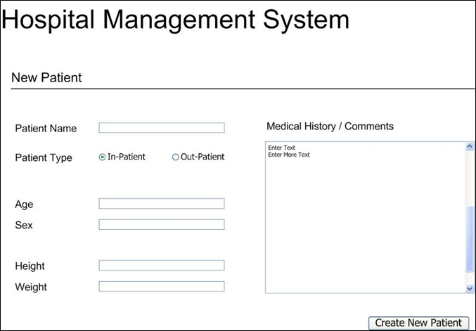

*The new_patient Page*

existing_patient

* **Description**: Allows looking up an existing patient in the system by name/patient number.
* **Information Available**: The details are retrieved from the system and the system is redirected to inpatient or outpatient based on the type of the patient. The following figure displays a sample snapshot of existing_patient page.

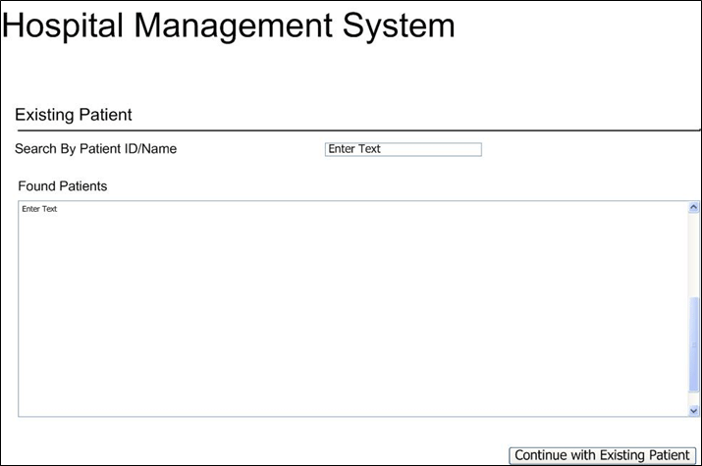

*The existing_patient Page*

inPatient

* **Description**: Provide various functions for an in-patient.
* **Information Available**: This page provides the following functions to an in-patient:
  + **Avail Lab Services**: List the laboratory services provided to an in-patient.
  + **Pharmacy**: List the medicines that can be purchased by an in-patient.
  + **Discharge Request**: Loads the patient_discharge_request module to discharge a patient.
  + **Discharge Patient**: The patient status is updated to Out-Patient or Deceased.
  + **Billing**: Generates a bill for a patient.

The following figure displays a sample snapshot of the InPatient page.

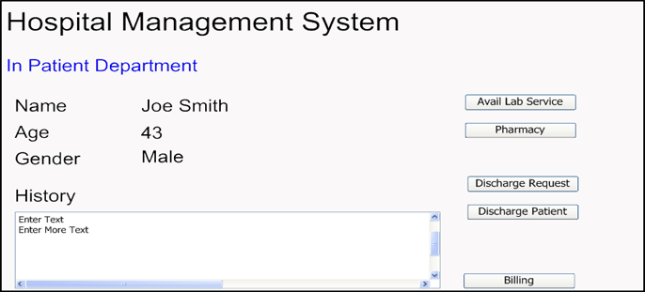

*The InPatient Page*

outPatient

* **Description**: Provide various functions for an out-patient.
* **Information Available**: This page provides the following functions for an out patient:
  + **Avail Lab Service**: List the laboratory services provided to an out-patient.
  + **Pharmacy**: List the medicines that can be purchased by an out-patient.
  + **Admit patient**: Changes the status of the patient from out-patient to in-patient.
  + **Visit**: Creates an appointment with a doctor.
  + **Billing**: Generates a bill for a patient.

The following figure displays a sample snapshot of the outpatient page.

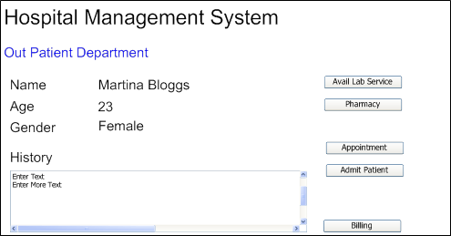

*The outpatient Page*

patient_labservice

* **Description**: Provides functions to enable a patient to avail a lab service.
* **Information Available**: The screen displays the lab services available and the charges for a lab service are added to the bill of the patient.

patient_pharmacy

* **Description**: Provides functions to enable a patient to buy a medicine from the pharmacy.
* **Information Available**: The screen displays the medicines available and the price for the medicine is added to the bill of the patient.

patient_discharge_request

* **Description**: Generates a discharge slip for the patient.
* **Information Available**: The screen calculates the total days from the admission to the discharge and stores the information to calculate the final bill.

patient_admit_request

* **Description**: Allows the user to assign a ward and a bed to the patient.

patient_appointment

* **Description**: Creates an appointment for outpatients with the doctor available.
* **Information Available**: The number of appointments accrued over time is stored in the database and are required to generate the bill.

patient_billing

* **Description**: This screen creates a bill for the patient. Multiple bills can be generated for each patient, based on the service and the time of availing the service.
* **Information Available**: This screen contains processing logic that creates a bill for the patient. Multiple bills can be generated for each patient, based on the service and the time of availing the service.

patient_lab_report

* **Description**: Patient can view the report by entering the lab number and date of birth as a password.
* **Information Available**: The report can only be viewed after the patient has made the payment for the services availed.

The following figure displays a sample snapshot of the patient_lab_report page.

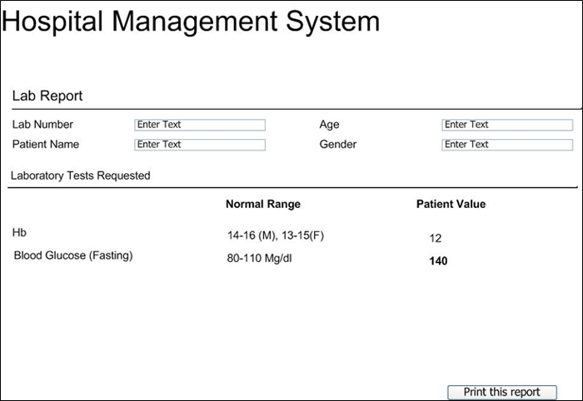

*The patient_lab_report Page*

reports

* **Description**: Allows generating custom reports by providing various options.
* **Information Available**: Users should be able to generate a report by defining their own fields by using a GUI-based system.

The following figure shows the ER diagram for the Hospital Management System.

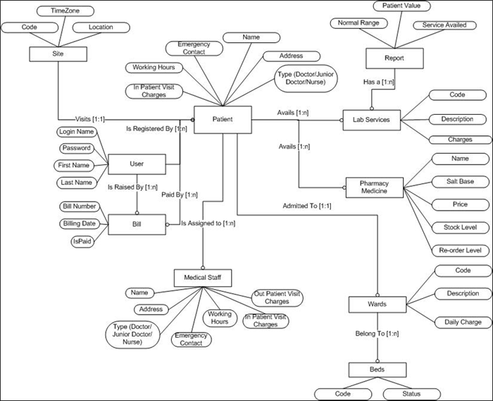

*ER Diagram for the Hospital Management System*

Create an application to demonstrate the skills you have acquired by developing the described solution.