MILESTONE 1

A1. Identify Issues and list it with reasons
- Seat_numbers will have multiple data since 1 person can book multiple seats
- If same user books ticket once again then user_name and user_email repeats (data redundancy)
- Movie_name,theatre_name,theatre_location also repeats (data redundancy)
- user_email determines user_name and theatre_name determines theatre_location (transitive dependency)
- If we delete a booking we might lose important data like user and theatre
- If we have to update data then we have to make changes in many rows

A2. Normalize the Schema
3NF

Tables Attributes
Users user_id (Primary Key)
user_name
user_email

Movies movie_id (Primary Key)
movie_name

Theatres theatre_id (Primary key)
theatre_name
theatre_location

Shows show_id (Primary key)
movie_id (Foreign key)
theatre_id (Foreign key)
show_time

Bookings booking_id (Primary key)
user_id (Foreign key)
show_id (Foreign key)
total_price
payment_status

Booking_Seats booking_id (Foreign key)
seat_number

A3. Assumptions
- Each user,movie,theatre,show is uniquely identified using user_id,movie_id,theatre_id,show_id
- A movie can be shown in multiple theatres and at different show times.
- A booking is made for one show only
- Each seat is booked only once for a particular show
- Total price is calculated for the whole booking, not per seat
- User, movie, and theatre details are stored in separate tables to avoid redundancy

ER Diagram

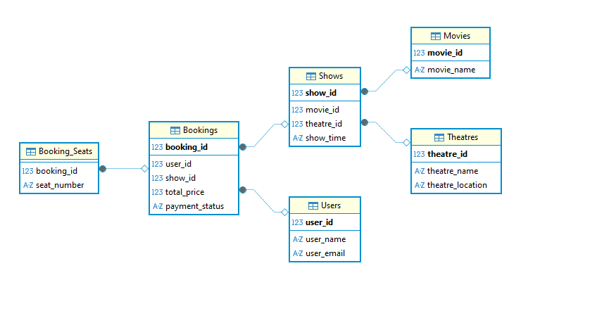

SECTION B — DATABASE DESIGN FROM REQUIREMENTS

B1. Requirement Clarification
- Can a user book multiple seats in one booking?
- Can the same user make multiple bookings for the same show?
- Should seat types like VIP and Regular have different pricing?
- Is seat availability managed by show or by screen?
- Can a screen have two shows at the same time?
- Is cancellation and refund required in the system?
- Can a film be of more than one genre and one language?
- Should user booking history be stored permanently?
- Does each theatre belong to only one city?
- Do we need to store multiple payment methods?
- Will seat selection be manual or automatic?

B2. Design
TABLES ATTRIBUTES

Users user_id (Primary Key)
user_name
user_email

Cities city_id (Primary Key)
city_name

Theatres theatre_id (Primary Key)
theatre_name
city_id (Foreign Key)

Screens screen_id (Primary Key)
theatre_id (Foreign Key)

Movies movie_id (Primary Key)
movie_name
language, genre

Shows show_id (Primary Key)
movie_id (Foreign Key)
screen_id (Foreign Key)
show_time
price

Seats seat_id (Primary Key)
screen_id (Foreign Key)
seat_type

Bookings booking_id (Primary Key)
user_id (Foreign Key)
show_id (Foreign Key)
total_price
payment_status

Booking_Seats booking_id (Foreign Key)
seat_id (Foreign Key)

Payments payment_id (Primary Key)
booking_id (Foreign Key)
payment_status
payment_mode

B3. Normalization
1NF

TABLES ATTRIBUTES
Bookings booking_id (Primary Key),user_id
user_name, user_email
movie_name, theatre_name, theatre_location, show_time
seat_number, total_price
payment_status

2NF

TABLES ATTRIBUTES
Bookings booking_id(Primary Key), user_id
user_name, user_email
movie_name, theatre_name
theatre_location, show_time
total_price, payment_status

Booking_Seats booking_id (Foreign Key)
seat_id (Primary Key)

3NF

TABLES ATTRIBUTES
Users user_id (Primary Key)
user_name
user_email

Movies movie_id (Primary Key)
movie_name
language
genre

Cities city_id (Primary Key)
city_name

Theatres theatre_id (Primary Key)
theatre_name
city_id (Foreign Key)

Screens screen_id (Primary Key)
theatre_id (Foreign Key)

Shows show_id (Primary Key)
movie_id (Foreign Key)
screen_id (Foreign Key)
show_time
price

Bookings booking_id (Primary Key)
user_id (Foreign Key)
show_id (Foreign Key)
total_price
payment_status

Seats seat_id (Primary Key)
screen_id (Foreign Key)
seat_type

Booking_Seats booking_id (Foreign Key)
seat_id (Foreign Key)

Payments payment_id (Primary Key)
booking_id (Foreign Key)
payment_status
payment_mode

Update During Development
A single booking can include multiple users, so the relationship between user and booking becomes many-to-many. To handle this, a new mapping table is added.

TABLES ATTRIBUTES
Users user_id (Primary Key)
user_name
user_email

Bookings booking_id (Primary Key)
show_id (Foreign Key)
total_price
payment_status

Booking_Users booking_id (Primary Key,Foreign Key)
user_id (Primary Key,Foreign Key)

Booking_Seats booking_id (Primary Key,Foreign Key)
user_id (Foreign Key)
seat_id (Primary Key,Foreign Key)

Seats seat_id
screen_id
seat_type

ER DIAGRAM

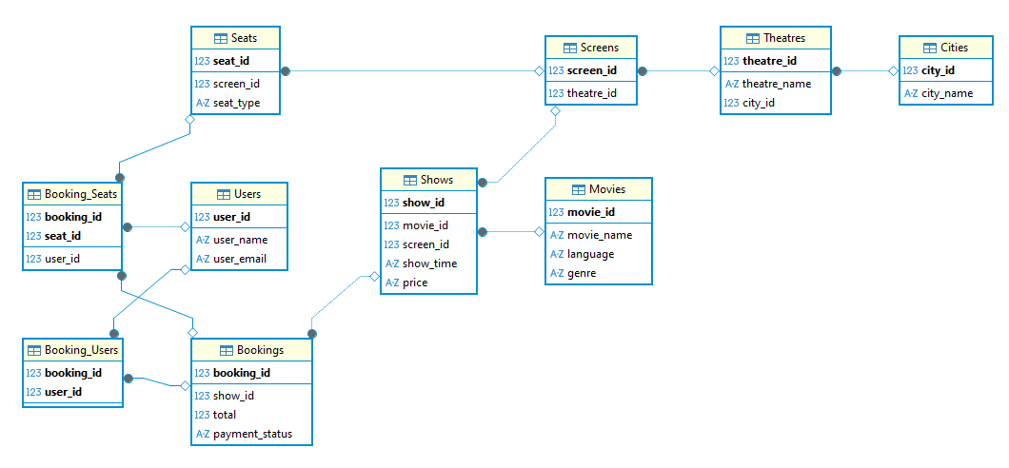

SECTION C — QUERIES AND TRANSACTIONS

1. Retrieve all bookings for a given user within a specified date range, including movie name, theatre, show time, and seats booked.

SELECT
b.booking_id,
m.movie_name,
t.theatre_name,
s.show_time,
se.seat_id
FROM Users u
JOIN Booking_Users bu ON u.user_id = bu.user_id
JOIN Bookings b ON bu.booking_id = b.booking_id
JOIN Shows s ON b.show_id = s.show_id
JOIN Movies m ON s.movie_id = m.movie_id
JOIN Screens sc ON s.screen_id = sc.screen_id
JOIN Theatres t ON sc.theatre_id = t.theatre_id
JOIN Booking_Seats bs ON b.booking_id = bs.booking_id
JOIN Seats se ON bs.seat_id = se.seat_id
WHERE u.user_id = 1
AND s.show_time BETWEEN '2026-04-28 00:00:00' AND '2026-04-28 23:59:59';

2.Identify the most frequently booked movie along with total bookings count.
SELECT
m.movie_name,
COUNT(b.booking_id) AS total_bookings
FROM Bookings b
JOIN Shows s ON b.show_id = s.show_id
JOIN Movies m ON s.movie_id = m.movie_id
GROUP BY m.movie_name;

3.For a given theatre and date, list all shows along with total seats booked and available seats.
SELECT
s.show_id,
s.show_time,
COUNT(bs.seat_id) AS booked_seats,
(3 - COUNT(bs.seat_id)) AS available_seats
FROM Shows s
LEFT JOIN Bookings b ON s.show_id = b.show_id
LEFT JOIN Booking_Seats bs ON b.booking_id = bs.booking_id
GROUP BY s.show_id;

4.Write a transaction to handle a booking operation
BEGIN TRANSACTION;
SELECT COUNT(*)
FROM Booking_Seats bs
JOIN Bookings b ON bs.booking_id = b.booking_id
WHERE b.show_id = 2
AND bs.seat_id IN (3);
INSERT INTO Bookings VALUES (4, 2, 300, 'PENDING');
INSERT INTO Booking_Seats VALUES (4, 2, 3);
UPDATE Bookings
SET payment_status = 'CONFIRMED'
WHERE booking_id = 4;
COMMIT;

