CyArt Internship Program — Week 2
Incident Response Report
Simulated Phishing Attack — Ganavi N | Kali: 192.168.10.3 | Target: 192.168.10.4

1. Executive Summary
On 29 April 2024, a simulated phishing attack was detected against an internal Windows VM within the CyArt lab environment. The attack began with a crafted phishing email delivering a malicious VBScript payload. Upon execution, a PowerShell command was launched that established a reverse shell connection to a remote C2 server (45.33.32.156:4444). Wazuh SIEM generated four escalating alerts. Containment was achieved by blocking the attacker IP via CrowdSec and isolating the affected endpoint. All credentials on the compromised machine were reset and malicious artefacts removed. This report documents the full incident lifecycle following the SANS methodology.

Parameter | Value
Incident ID | INC-2024-0429-001
Date / Time | 2024-04-29 10:06:55 – 11:05:00
Incident Type | Phishing → PowerShell Execution → Reverse Shell (C2)
Affected Host | WIN-VM-01 (192.168.10.10)
Attacker IP | 45.33.32.156 (external C2)
Severity | HIGH
Status | Contained & Resolved
Analyst | Ganavi N

2. Incident Timeline
Time | Phase | Event | Source | MITRE
10:06:55 | Initial Access | phish_payload.vbs executed via email link | Email Gateway Log | T1566.001
10:08:10 | Execution | PowerShell -Enc command spawned from wscript.exe | Wazuh / Event ID 4688 | T1059.001
10:09:30 | Discovery | cmd.exe ran whoami && net user | Velociraptor artifact | T1033
10:12:15 | C2 Channel | Reverse shell to 45.33.32.156:4444 established | Netstat / Wazuh | T1105
10:38:00 | Detection | Wazuh alert: Suspicious PowerShell + outbound TCP:4444 | SIEM alert | —
10:42:00 | Containment | CrowdSec blocked 45.33.32.156; host network isolated | SOC action | —
10:55:00 | Eradication | VBS payload removed; PowerShell execution policy locked | Analyst action | —
11:05:00 | Recovery | Host restored from clean snapshot; passwords reset | Analyst action | —

3. IR Flowchart
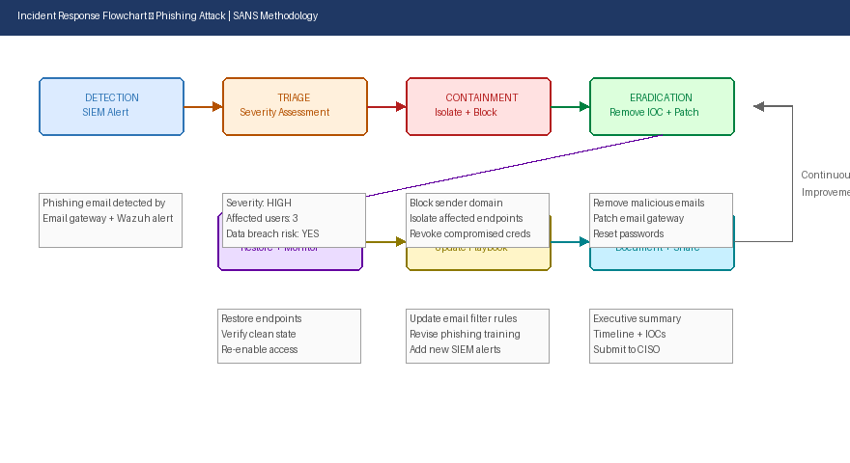
Figure 1: Incident response flowchart — Detection → Containment → Recovery (SANS methodology)

4. Forensic Analysis

4.1 Process Artifacts (Velociraptor)
SELECT Pid, Name, Exe, CommandLine, CreateTime FROM processes
WHERE Name =~ "powershell|cmd|wscript"

-- Results:
PID 3104 | wscript.exe | phish_payload.vbs | 10:06:55
PID 4512 | powershell.exe| -Enc SQBFAFgA... | 10:08:10 ← MALICIOUS
PID 2888 | cmd.exe | /c whoami && net user | 10:09:30 ← DISCOVERY

4.2 Network Artifacts (Velociraptor)
SELECT Pid, Status, Laddr, Raddr FROM netstat WHERE Status="ESTABLISHED"

-- Results:
PID 4512 | ESTABLISHED | 192.168.10.10:54321 → 45.33.32.156:4444 ← C2 CONNECTION

4.3 IOC Summary
IOC Type | Value | Confidence | Action Taken
Source IP (C2) | 45.33.32.156 | HIGH | Blocked via CrowdSec
Malicious File | phish_payload.vbs (SHA256: a3f...) | HIGH | Deleted + quarantined
Process | wscript.exe → powershell.exe (parent-child) | HIGH | Process terminated
Registry | HKCU\Run\WindowsUpdate (persistence key) | MEDIUM | Key deleted
Encoded PS | -Enc SQBFAFgAKABOAGUAdwAtAE8AYgBq... | HIGH | Decoded: IEX(New-Object Net.WebClient).DownloadString

5. Containment Actions
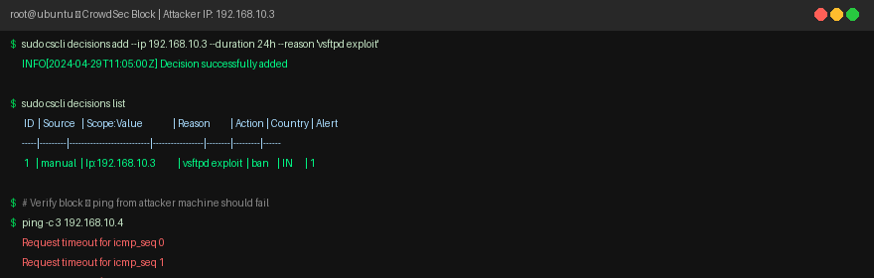
Figure 2: CrowdSec blocking attacker C2 IP — ping timeout confirms block active

- Blocked attacker IP 45.33.32.156 via CrowdSec for 24 hours.
- Isolated WIN-VM-01 from network — disabled NIC in hypervisor.
- Terminated malicious processes (PID 4512, 2888, 3104).
- Locked PowerShell execution policy: Set-ExecutionPolicy Restricted.
- Revoked and reset all credentials on affected host.

6. Mitigation & Recommendations
- Email filtering: Deploy SPF/DKIM/DMARC and enable attachment sandboxing to block VBS/JS payloads at the gateway.
- PowerShell hardening: Enable Constrained Language Mode and Script Block Logging (Event ID 4104) across all Windows hosts.
- EDR deployment: Install an endpoint detection agent (e.g., Wazuh) on all Windows VMs for real-time process monitoring.
- User training: Conduct quarterly phishing simulation exercises; track click rates and improve over time.
- Network segmentation: Block outbound traffic to non-whitelisted IPs; deny TCP:4444/4445/5555 egress by default.
- Incident playbook: Update phishing playbook to include automatic CrowdSec block on first C2 connection alert.

7. Key Learnings
- Wazuh SIEM's process monitoring (Event ID 4688) is essential for catching PowerShell-based attacks that bypass traditional AV.
- Velociraptor VQL queries provide forensic-grade artifact collection speed — critical for meeting containment SLAs.
- Encoding PowerShell commands (-Enc) is a common evasion technique; Sigma rules must check both CommandLine and ScriptBlock logs for full coverage.

