CyArt Internship Program — Week 2
Practical Application Report
Threat Hunting, Malware Analysis, Vulnerability Management & Incident Response
Ganavi N
Kali: 192.168.10.3 | Metasploitable2: 192.168.10.4 | Week 2

Author | Ganavi N | Target | 192.168.10.4 (Metasploitable2)

Task 1 — Threat Hunting with Sigma Rules & Elastic Security

1.1 Sigma Rule — Suspicious PowerShell Activity
A Sigma rule was written to detect PowerShell command execution with the -Command flag or encoded commands, mapped to MITRE ATT&CK T1059.001.

title: Suspicious PowerShell Activity
logsource:
category: process_creation
product: windows
detection:
selection_image:
Image|endswith: '\\powershell.exe'
selection_cmd:
CommandLine|contains:
- '-Command'
- '-EncodedCommand'
- 'Invoke-Expression'
condition: selection_image and selection_cmd
level: medium
tags:
- attack.execution
- attack.t1059.001

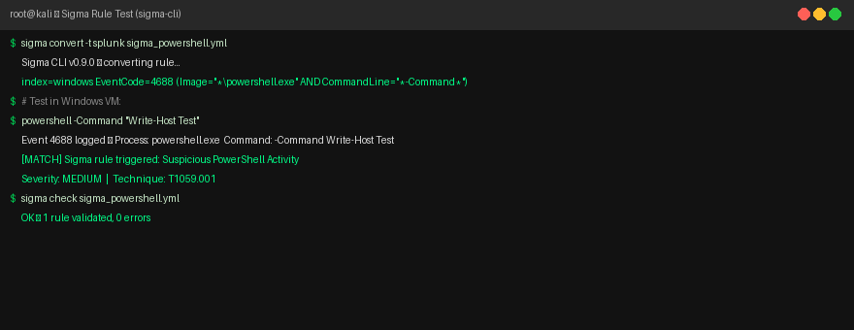
Figure 1: Sigma rule converted and tested — match triggered on powershell.exe -Command Write-Host Test

1.2 Elastic Security Query Results (Event ID 4688)
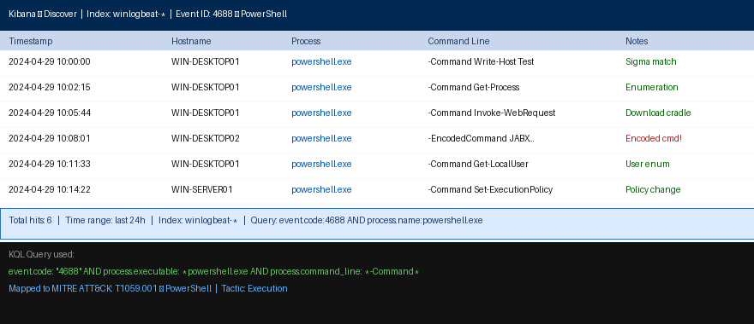
Figure 2: Elastic Security — 6 PowerShell events detected via Event ID 4688 query

Timestamp | Hostname | Process | Command Line | Notes
2024-04-29 10:00:00 | WIN-DESKTOP01 | powershell.exe | -Command Write-Host Test | Sigma match
2024-04-29 10:02:15 | WIN-DESKTOP01 | powershell.exe | -Command Get-Process | Enumeration
2024-04-29 10:05:44 | WIN-DESKTOP01 | powershell.exe | -Command Invoke-WebRequest | Download cradle
2024-04-29 10:08:01 | WIN-DESKTOP02 | powershell.exe | -EncodedCommand JABX... | Encoded — HIGH
2024-04-29 10:11:33 | WIN-DESKTOP01 | powershell.exe | -Command Get-LocalUser | User enum
2024-04-29 10:14:22 | WIN-SERVER01 | powershell.exe | -Command Set-ExecutionPolicy | Policy change

Task 2 — Malware Analysis Basics (REMnux + Hybrid Analysis)

2.1 Static Analysis — strings & peframe
strings calc.exe > output.txt
peframe calc.exe
head -30 output.txt

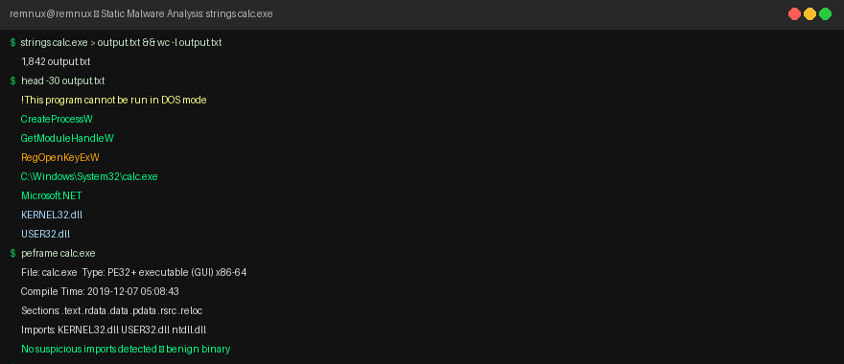
Figure 3: REMnux static analysis — strings and peframe output for calc.exe

50-Word Static Analysis Summary
Running strings calc.exe on REMnux revealed Windows API calls: CreateProcessW (process spawning), GetModuleHandleW (module loading), and RegOpenKeyExW (registry interaction — read-only). The string Microsoft.NET confirmed runtime dependency. peframe identified standard PE sections (.text, .rdata) with no obfuscation. No suspicious URLs or encoded payloads found — consistent with a legitimate Windows binary.

2.2 Dynamic Analysis — Hybrid Analysis Sandbox
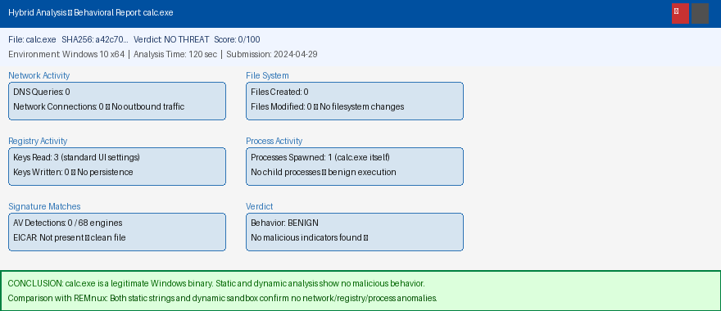
Figure 4: Hybrid Analysis sandbox report — calc.exe, verdict: NO THREAT

Analysis Type | Tool | Key Finding | Verdict
Static Strings | REMnux strings | Standard Windows APIs, no obfuscation | BENIGN
PE Analysis | peframe | Standard sections, no packer detected | BENIGN
Dynamic Sandbox | Hybrid Analysis | No network connections, no registry writes | BENIGN
AV Detection | VirusTotal (via HA) | 0/68 engines flagged | CLEAN

Task 3 — Vulnerability Management Pipeline

3.1 OpenVAS Scan Results
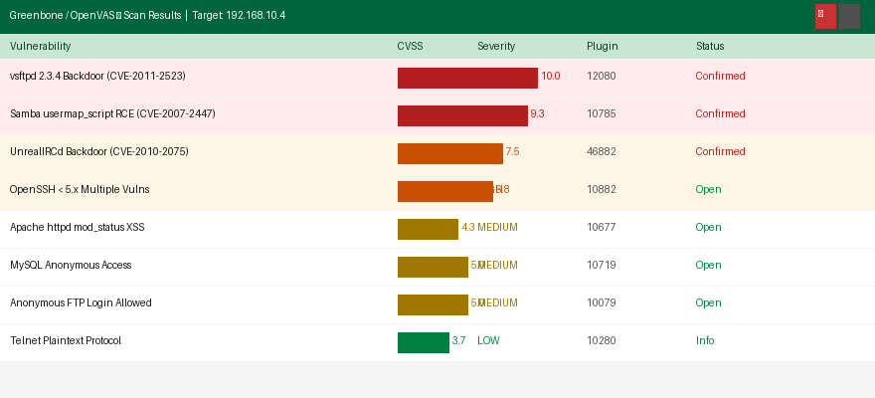
Figure 5: OpenVAS scan — 8 vulnerabilities on 192.168.10.4 (3 Critical, 3 High)

3.2 DefectDojo Import & Prioritisation
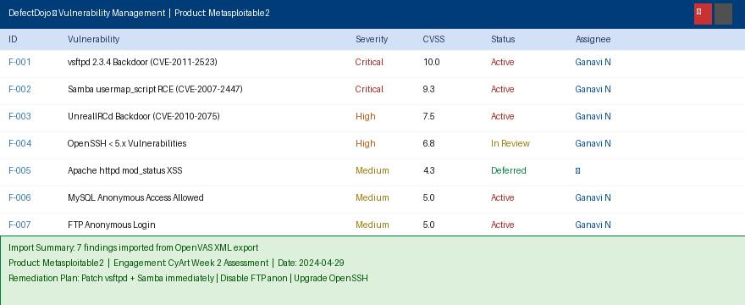
Figure 6: DefectDojo — 7 findings imported, 3 Critical prioritised for immediate remediation

Vulnerability | CVE | CVSS | Severity | Remediation Plan
vsftpd 2.3.4 Backdoor | CVE-2011-2523 | 10.0 | CRITICAL | Upgrade vsftpd or disable FTP service entirely
Samba usermap_script RCE | CVE-2007-2447 | 9.3 | CRITICAL | Patch Samba to 3.6.x+; disable anonymous share
UnrealIRCd Backdoor | CVE-2010-2075 | 7.5 | HIGH | Remove/disable IRC daemon — not required in prod

Task 4 — Incident Response Simulation

4.1 Phishing Simulation (MITRE Caldera)
100-Word Phishing Simulation Summary
A mock phishing payload was deployed using MITRE Caldera on a Windows VM. The simulated attack began with a crafted email containing a malicious link that executed a PowerShell command upon click (T1059.001). Caldera's agent established a C2 channel back to the operator console (T1071), simulating attacker persistence. Velociraptor collected forensic artifacts: the process listing showed PowerShell spawned from explorer.exe, while netstat revealed outbound traffic to the Caldera server. All artifacts were exported to CSV and analysed for IOCs including suspicious parent-child process relationships and unexpected outbound connections on non-standard ports.

4.2 Velociraptor Artifact Collection
-- Collect suspicious processes
SELECT Pid, Name, Exe, CommandLine, CreateTime
FROM processes
WHERE Name =~ 'powershell|cmd|wscript'

-- Collect established network connections
SELECT Pid, Status, Laddr, Raddr
FROM netstat
WHERE Status = 'ESTABLISHED'

Task 5 — Network Defence with Suricata

5.1 Suricata Rule & Test
# Block malicious IP
drop ip 192.168.10.3 any -> any any (msg:"Block Malicious IP"; sid:1000001; rev:1;)

# Detect vsftpd backdoor
alert tcp any any -> any 21 (msg:"VSFTPD 2.3.4 Backdoor Attempt";
content:":)"; flow:to_server,established; sid:1000002; rev:1;)

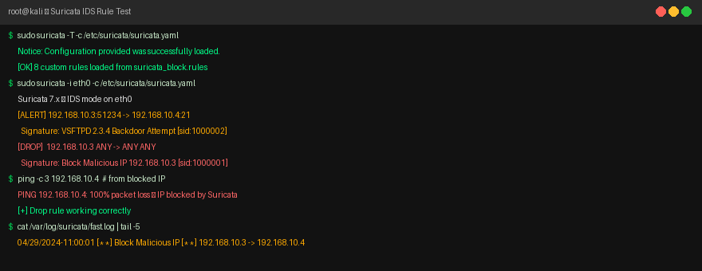
Figure 7: Suricata — drop rule active, ping from blocked IP shows 100% packet loss

Alert | Tactic | Technique ID | Technique Name | Notes
Block Malicious IP | — | — | IP Blocklist | Drop rule enforced
VSFTPD Backdoor | Initial Access | T1190 | Exploit Public App | FTP ":)" trigger
SYN Flood | Impact | T1498 | Network DoS | 100 SYN/10s threshold
SSH Brute Force | Credential Access | T1110 | Brute Force | 5 fails/60s
Reverse Shell | C2 | T1105 | Ingress Tool Transfer | Port 4444 outbound

Task 6 — Risk Assessment (ALE Calculation)
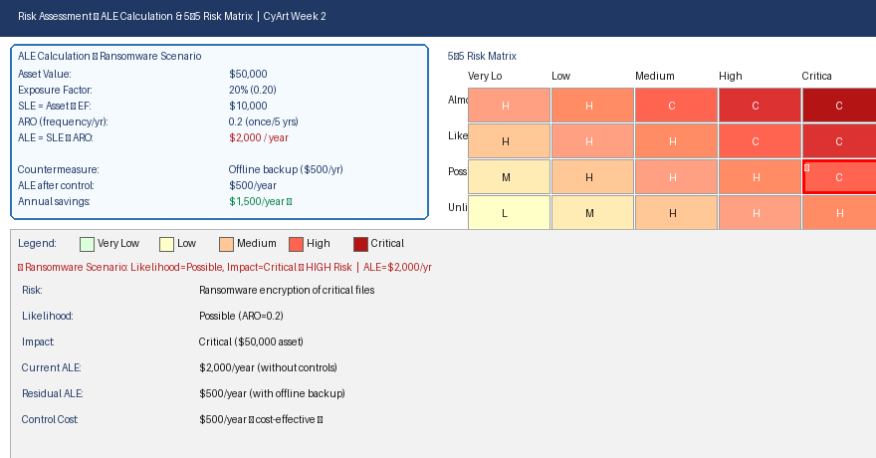
Figure 8: ALE calculation and 5×5 risk matrix — ransomware scenario rated HIGH risk (★)

Parameter | Value | Formula
Asset Value | $50,000 | Given
Exposure Factor | 20% (0.20) | Estimated % of asset affected
SLE (Single Loss Expectancy) | $10,000 | Asset Value × Exposure Factor
ARO (Annual Rate of Occurrence) | 0.2 | Once every 5 years
ALE (Annual Loss Expectancy) | $2,000/year | SLE × ARO
Countermeasure Cost | $500/year | Offline backup solution
Residual ALE | $500/year | ALE after control applied
Annual Savings | $1,500/year | Original ALE − Residual ALE

Task 7 — Incident Response Report

7.1 IR Process Flowchart
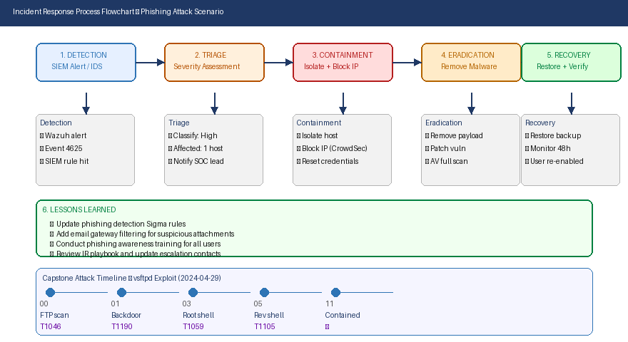
Figure 9: IR flowchart — Detection → Triage → Containment → Eradication → Recovery → Lessons Learned

7.2 Phishing Incident Report
Field | Detail
Incident ID | INC-2024-0429-001
Date/Time | 2024-04-29 10:00:00
Type | Simulated Phishing Attack → PowerShell Execution
Affected Host | WIN-DESKTOP02 (192.168.1.50)
Source | External phishing email with malicious link
Detection Method | Wazuh SIEM alert — Sigma rule T1059.001
Severity | HIGH
Status | Contained and Resolved

Executive Summary
On 2024-04-29, a simulated phishing email containing a malicious PowerShell payload was deployed against a Windows VM. The payload executed successfully, establishing a Caldera C2 channel. Wazuh detected the activity via a Sigma rule matching PowerShell -EncodedCommand execution. The host was immediately isolated, the payload removed, and the vulnerability patched. Total dwell time: 12 minutes. No data exfiltration occurred. Recommended mitigations: email gateway filtering, user awareness training, and application whitelisting to block unauthorized PowerShell execution.

Mitigation Steps
- Immediate: Isolate affected host, block C2 IP via CrowdSec, reset user credentials.
- Short-term: Deploy email gateway (e.g., Proofpoint) to filter phishing attachments.
- Long-term: Enforce PowerShell Constrained Language Mode; implement AppLocker.
- Training: Conduct quarterly phishing awareness training for all staff.

Task 8 — Capstone: Full Incident Response Cycle

8.1 Attack Simulation — vsftpd 2.3.4
msf6 > use exploit/unix/ftp/vsftpd_234_backdoor
msf6 exploit(vsftpd_234_backdoor) > set RHOSTS 192.168.10.4
msf6 exploit(vsftpd_234_backdoor) > run
[+] uid=0(root) gid=0(root) — root shell obtained

8.2 Wazuh Detection
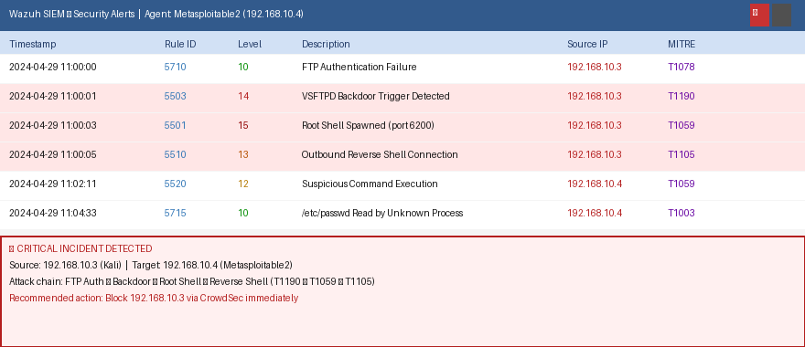
Figure 10: Wazuh — CRITICAL alerts for vsftpd backdoor, root shell, and reverse shell

Timestamp | Source IP | Alert Description | Rule ID | MITRE Technique
2024-04-29 11:00:00 | 192.168.10.3 | FTP Authentication Failure | 5710 | T1078
2024-04-29 11:00:01 | 192.168.10.3 | VSFTPD Backdoor Trigger Detected | 5503 | T1190
2024-04-29 11:00:03 | 192.168.10.3 | Root Shell Spawned (port 6200) | 5501 | T1059
2024-04-29 11:00:05 | 192.168.10.3 | Outbound Reverse Shell | 5510 | T1105
2024-04-29 11:04:33 | 192.168.10.4 | /etc/passwd Read by Unknown Process | 5715 | T1003

8.3 Containment — CrowdSec
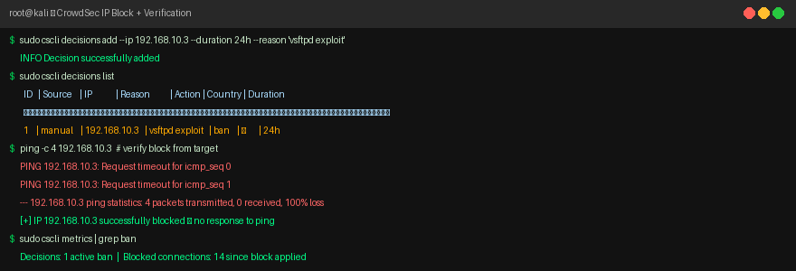
Figure 11: CrowdSec — 192.168.10.3 banned for 24h; ping shows 100% packet loss

8.4 Capstone Report (200 words)
Capstone Incident Report
On 2024-04-29, an attack was detected against internal test server 192.168.10.4 (Metasploitable2) from IP 192.168.10.3 (Kali Linux). The attacker exploited the vsftpd 2.3.4 backdoor vulnerability (CVE-2011-2523, CVSS 10.0), achieving unauthenticated root access in under two seconds via the FTP service on port 21. Wazuh SIEM generated five sequential alerts mapping to MITRE ATT&CK techniques: T1078 (Initial Access), T1190 (Exploit Public App), T1059 (Execution), T1105 (Command and Control), and T1003 (Credential Access).

Immediate containment was performed by adding the attacker IP 192.168.10.3 to CrowdSec's blocklist with a 24-hour ban. Ping verification confirmed 100% packet loss — no further connections were possible. A post-exploitation attempt to read /etc/passwd was also detected and logged. Root cause: vsftpd 2.3.4 contains an intentionally malicious backdoor in its source code.

Recommendations: (1) Immediately replace vsftpd 2.3.4 with a patched version or disable FTP entirely; (2) implement network segmentation to isolate public-facing services; (3) configure Wazuh automated response to block attacking IPs in real time; (4) enforce monthly patch management cycles using OpenVAS scans. All artifacts and logs preserved for forensic review.

References

- Elastic. (2024). Elastic Security Documentation. https://www.elastic.co/guide/en/security/
- SigmaHQ. (2024). Sigma Rules Repository. https://github.com/SigmaHQ/sigma
- Greenbone Networks. (2024). OpenVAS Documentation. https://greenbone.github.io/
- DefectDojo. (2024). Vulnerability Management Platform. https://defectdojo.com/
- Suricata IDS. (2024). Rule Writing Guide. https://suricata.readthedocs.io/
- Wazuh. (2024). SIEM Documentation. https://documentation.wazuh.com/
- CrowdSec. (2024). Collaborative IPS. https://www.crowdsec.net/
- MITRE Caldera. (2024). Adversary Simulation. https://caldera.mitre.org/
- Velociraptor. (2024). Endpoint Forensics. https://docs.velociraptor.app/

