CyArt Internship Program — Week 2
Theoretical Knowledge Report
Advanced Threat Analysis, Security Frameworks & Risk Management
Ganavi N
CyArt Internship Program — Week 2

Author | Ganavi N | Week | Week 2 — Theoretical Knowledge

1. Advanced Threat Analysis

1.1 STRIDE Threat Modeling
STRIDE is a threat modeling framework used to systematically identify security threats by category. It maps threats to assets, entry points, and trust boundaries within a system. Applied to a web application, STRIDE helps identify risks at every layer of the architecture.

Category | Full Form | Threat Example | Web App Risk
S | Spoofing | Attacker impersonates a user with stolen credentials | Weak authentication on login page
T | Tampering | MITM attack modifies data in transit | No input validation on API endpoints
R | Repudiation | User denies performing an action; no audit log | Missing audit logging for admin actions
I | Information Disclosure | Sensitive data leaked via S3 misconfiguration | Verbose error messages expose stack traces
D | Denial of Service | SYN flood overwhelms the web server | No rate limiting on login endpoint
E | Elevation of Privilege | Low-privileged user exploits SUID binary for root | Broken access control on admin panel

1.2 MITRE ATT&CK Framework
The MITRE ATT&CK framework documents adversary tactics, techniques, and procedures (TTPs) based on real-world observations. It provides a common language for describing attacker behavior and aligning defensive measures.

# | Tactic | Key Technique | Technique ID
1 | Reconnaissance | Active Scanning | T1595
2 | Initial Access | Phishing / Exploit Public App | T1566 / T1190
3 | Execution | Command & Scripting Interpreter (PowerShell) | T1059.001
4 | Persistence | Scheduled Task / Account Manipulation | T1053 / T1098
5 | Privilege Escalation | Exploitation for Privilege Escalation | T1068
6 | Defense Evasion | Obfuscated Files or Information | T1027
7 | Credential Access | Brute Force / OS Credential Dumping | T1110 / T1003
8 | Lateral Movement | Remote Services (SMB/SSH) | T1021
9 | Collection | Data from Local System | T1005
10 | Command & Control | Web Protocols / Application Layer | T1071

Phishing → ATT&CK Mapping
Tactic: Initial Access → Technique: T1566.001 (Spearphishing Attachment)
The attacker sends a crafted email with a malicious attachment. Upon opening, a PowerShell dropper executes (T1059.001) and establishes C2 (T1071). This chain maps directly to the Execution → C2 tactics in ATT&CK.

1.3 Advanced Attack Vectors

Advanced Persistent Threats (APTs)
- Long-term, stealthy intrusions by well-funded, highly skilled threat actors (often nation-states).
- APTs maintain persistence for months/years, moving laterally to collect intelligence.
- Example: APT29 (Cozy Bear) — Russian state-sponsored group targeting government entities.

Supply Chain Attacks
- Compromise software, hardware, or services before they reach the target organisation.
- Extremely difficult to detect because the malicious code comes from a trusted source.
- SolarWinds 2020: Attackers inserted SUNBURST malware into the Orion software build process, affecting 18,000+ organisations including US government agencies.

Zero-Day Exploits
- Exploit an undisclosed, unpatched vulnerability — no signature exists for detection.
- High value on black market; used by APTs and nation-state actors for targeted attacks.
- Example: Stuxnet (2010) used four zero-days to sabotage Iranian nuclear centrifuges.

2. Security Frameworks in Depth

2.1 NIST Cybersecurity Framework (CSF)
The NIST CSF provides a policy framework of computer security guidance for organisations. It is organised around five core functions that represent a continuous cycle of cybersecurity activity.

Function | Purpose | Example Activity | ISO 27001 Mapping
Identify | Asset inventory, risk assessment | Catalog all servers and data classification | A.8.1 Asset Management
Protect | Access controls, encryption, training | Enable MFA, encrypt drives, security awareness | A.9 Access Control
Detect | Monitoring, anomaly detection | Deploy Wazuh/ELK Stack SIEM for log analysis | A.12.4 Monitoring
Respond | Incident handling, communication | Follow IR playbook, notify stakeholders | A.16.1 Incident Mgmt
Recover | Restoration, lessons learned | Restore from backup, update controls | A.12.3 Backup

Implementation Tiers
Tier | Name | Description
1 | Partial | Ad hoc, reactive; no formal cybersecurity processes
2 | Risk-Informed | Risk-aware but inconsistent; limited external collaboration
3 | Repeatable | Formally approved policies; regular updates based on risk
4 | Adaptive | Continuously improving; adapts to threat intelligence in real time

2.2 ISO 27001 Key Controls
ISO 27001 defines 114 controls across 14 domains. The goal is to establish, implement, maintain, and continually improve an Information Security Management System (ISMS).

Control | Domain | Description | Ransomware Application
A.12.3 | Operations Security | Information backup policy | Regular encrypted offline backups
A.12.4 | Operations Security | Logging and monitoring | SIEM alerts on encryption activity
A.8.2.1 | Asset Management | Classification of information | Prioritize recovery of critical data
A.14.2 | System Acquisition | Security in development | Code review prevents supply chain risk
A.16.1 | Incident Management | Reporting security events | Report within defined SLA window
A.9.4 | Access Control | System and app access control | Limit admin privileges (least privilege)

3. Incident Response Fundamentals
The SANS incident response lifecycle provides a structured approach to handling security incidents. Each phase has defined objectives, tools, and outputs.

Phase | Objective | Key Actions | Tools
Preparation | Build readiness | Playbooks, tools, training, contacts | Wazuh, ELK, IR templates
Detection | Identify incident | SIEM alerts, IDS/IPS, user reports | Suricata, Sigma rules
Containment | Limit spread | Isolate host, block IP, disable account | CrowdSec, firewall
Eradication | Remove threat | Delete malware, patch vulnerability | AV, OpenVAS
Recovery | Restore operations | Restore backup, monitor for re-infection | Backup tools, Wazuh
Lessons Learned | Improve posture | Update playbooks, report, debrief | Google Docs, JIRA

4. Risk Management — Advanced Concepts

4.1 Quantitative vs. Qualitative Risk Assessment
Method | Approach | Output | Best For
Quantitative | Mathematical calculation using financial values | Dollar amounts (ALE, SLE, ARO) | Executive reporting, ROI decisions
Qualitative | Subjective scoring (High/Medium/Low) | Risk matrix, heat map | Quick assessments, prioritisation

4.2 ALE Calculation — Ransomware Scenario
ALE = SLE × ARO

Asset Value = $50,000
Exposure Factor = 20% (0.20)
SLE = $50,000 × 0.20 = $10,000

ARO = 0.2 (once every 5 years)
ALE = $10,000 × 0.2 = $2,000 / year

Countermeasure: Offline backup ($500/year)
ALE after control = $10,000 × 0.05 = $500/year
Annual savings = $2,000 - $500 = $1,500 / year ✓ Cost-effective

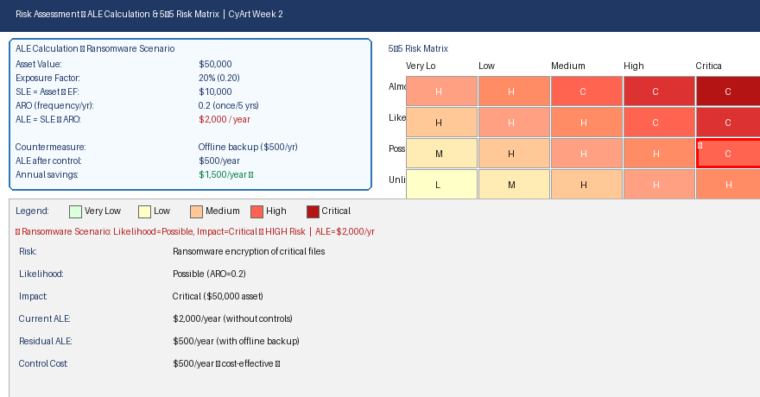
Figure 1: ALE calculation and 5×5 risk matrix — ransomware scenario (★ = High Risk)

References

- MITRE Corporation. (2024). ATT&CK Framework. https://attack.mitre.org/
- NIST. (2018). Cybersecurity Framework v1.1. https://www.nist.gov/cyberframework
- ISO/IEC 27001:2022. Information Security Management Systems. https://www.iso.org/
- SANS Institute. (2024). Incident Response Papers. https://www.sans.org/
- FAIR Institute. (2024). Risk Quantification Guide. https://www.fairinstitute.org/
- OWASP. (2024). Threat Dragon — STRIDE Modeling. https://owasp.org/

