**FOODLORE:**

Andhra Pradesh ,known for it’s spicy and flavourful cuisine ,has a rich foodlore deeply rooted in its history and culture .

Some iconic dishes include spicy biryani , tangy and hot pickles , aromatic pulihora(tamarind rice) , fiery curries like chicken or mutton curry , and a variety of chutneys and pachadis made from the locally grown vegetables and herbs .The state’s coastal region also offer delicious seafood specialties like fish curry and pawn fry .Andhra Pradesh’s cuisine is known for its use of indigenous spices like red chillies , tamarind ,and curry leaves , creating a unique culinary experience.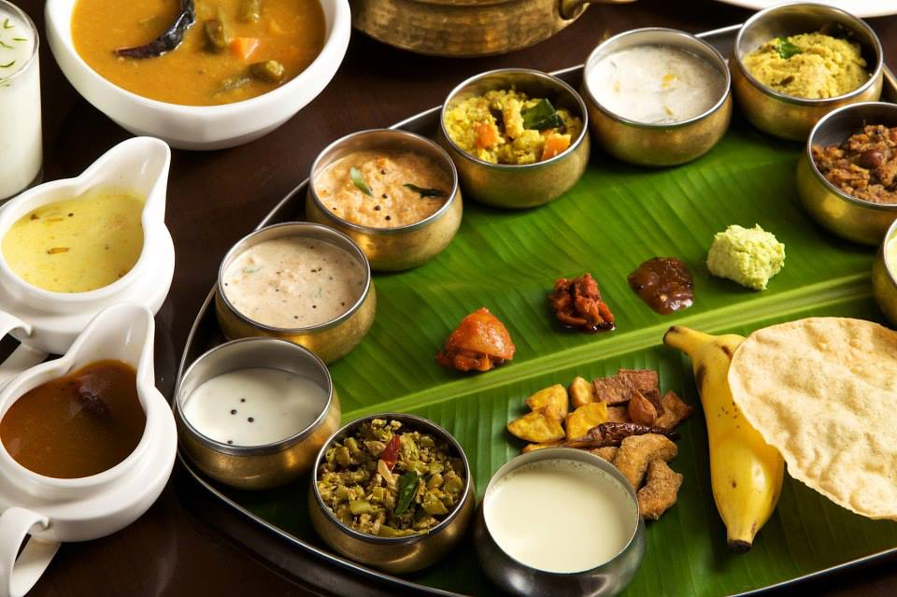

Andhra Pradesh boasts a rich culinary heritage known for its spicy and flavorful dishes. Some iconic dishes include Hyderabadi biryani, Gongura pachadi (sorrel leaf chutney), Andhra-style chicken curry, and Pesarattu (moong dal dosa). The cuisine often features a blend of tangy, spicy, and aromatic flavors, influenced by Telugu, Mughlai, and Persian cuisines. Additionally, pickles, chutneys, and spicy powders called podis are staples in Andhra cuisine. 