İZMİR
Design and Implementation of a Mobile Inspection Management Platform (Teftişistan)

A Thesis Submitted to the
Dokuz Eylül University, Department of Computer Engineering
In Partial Fulfilment of the Requirements for the Degree of B.Sc.

by
Muharrem Pehlevan
Hasan Furkan Güney

Advisor
Dr. Özlem Öztürk

October 2025

CONTENTS
Page
CHAPTER ONE
INTRODUCTION 1
  - . Background Information 1
  - Problem Definition 2
  - Motivation 2
  - Goal and Contribution 3
  - Project Scope 4
  - Standards, Ethics, Constraints and Conditions 5
CHAPTER TWO
LITERATURE REVIEW 7
2.1. Introduction 7
  - . Digital Transformation in Quality Assurance 8
    - Inefficiencies in Traditional Audit Methods 8
    - The Shift to "Paperless" Inspection Systems 8

  - Architectural Analysis of Modern Web Technologies 9
    - Client-Side Rendering and Virtual DOM (React) 9
    - Asynchronous I/O and Event-Driven Backend (Node.js) 9

  - Security Models and Access Control 10
    - Role-Based Access Control (RBAC) 10
    - Stateless Authentication (JWT) 10

  - Summary 11

CHAPTER THREE
REQUIREMENTS ...........................................................................................12
3.1. Functional Requirement..........................................................................12
3.2. Non-Functional Requirements ................................................................13
3.3. User Roles & Permissions ......................................................................14
CHAPTER FOUR
DESIGN .............................................................................................................16 4.1. System Architecture .....................................................................................16
4.2. Database Design .......................................................................................17
4.3. API Design ...............................................................................................18
4.4. Frontend Design .......................................................................................20
4.5. Security Design ........................................................................................23
4.6. Scoring System Design ............................................................................24
REFERENCES .................................................................................................26

LIST OF FIGURES Page
Figure 1: System Architecture Diagram .....................................................20
Figure 2: Activity Diagram ..........................................................................22
Figure 3: ER Diagram ..................................................................................24

CHAPTER ONE
INTRODUCTION
This report is about “DenetimApp”. It is a simple web app for store and field audits. The app helps teams move from paper, Excel, and chat tools to one place. People can do all audit steps online. It works in the browser on a normal computer.In this app, an admin or planner creates an audit. Field staff goes to the branch and answers a clear checklist. They can add short notes for each question. They can also upload photos as proof. When they finish, they submit the audit for review.A reviewer opens the audit and sees answers, notes, and photos on one screen. The system shows an automatic score for the audit. The rule is easy: Yes = 1, Partly = 0.5, No = 0, Out of Scope = 0. The reviewer can approve or reject and write a short reason. The app saves the decision and the time.The app uses React for the user interface. The server uses Node.js with Express, Prisma, and a SQLite database. We use JWT for login and roles for access control. We add basic security with Helmet, CORS, and rate limiting. We validate inputs with Zod and log requests with Morgan.This document explains the background and the main problem. It shows the goals, scope, and the value of the project. It describes standards, ethics, and limits for safe use. It lists the system conditions to run the app in development. At the end, it gives references for the tools we use.

1.1. Background Information
Many companies do regular audits in stores, factories, and offices. They check safety, quality, and service. Branches are in different cities and regions. Teams collect answers and photos from many places. Managers need clear and fast information to act.Today many teams still use paper, Excel, email, and WhatsApp. Data is split across files and chats. Photos are not linked to the right questions. File names and versions are different. Some data is lost or comes late. Scores change by person, so results are not fair. It is hard to see history and trends for each branch.Digital tools are now common and not expensive. People have internet and cameras on every phone. Web apps run in the browser and need no install. Privacy and security rules are stronger today. Companies want clean data and clear tracking logs. For these reasons, one simple audit app is a good choice. It can give standard forms, safe storage, and real-time reports for all branches.

1.2. Problem Definition
The current audit process is slow and hard. People use paper, Excel, and chat apps. Answers and photos are in many places, so some data is lost. File names and versions are different. Photos are not linked to the right question, so checks are weak.Reports take a long time. They are not the same each time. There is no clear scoring rule, so scores change by person. There is no live status. Managers cannot see draft, submitted, approved, or rejected in one screen.There is no safe login and no clear roles. Data and photos are not well protected. Branch history is not easy to see. Trends by category are missing. Teams need one simple place to create forms, answer with notes, upload photos, get auto score, and send for review. The system must show clear status, standard rules, and fast reports.

1.3. Motivation
We want to save time and reduce errors in daily audits. Today people spend many hours to collect photos and write reports. With one app, they can work faster and feel less stress. Clean and standard data gives fair results. It is easier to compare branches and time periods. The process becomes simple and clear for everyone.
Field staff need a friendly screen. It must work on normal laptops with a browser. The app should guide them step by step. They can add short notes and upload photos with one click. The system makes an automatic score from each answer. This helps staff understand the result during the visit.
Managers need quick review and clear status. They want to see draft, submitted, approved, or rejected in one list. They need simple reports and CSV export for meetings. One tool improves teamwork between field and office. It builds trust, keeps rules the same for all, and supports better and faster decisions.

1.4. Goal and Contribution
The main goal is to build a simple and secure audit system for daily work. The app replaces paper and many files. It puts all audit steps in one place. It should be easy to learn and use. It should work in a normal browser with no install.

Main goals:
- Give safe login with roles (admin, planner, field, reviewer).
- Let users start an audit, answer questions, add short notes, and upload photos.
- Use a clear rule for score: Yes=1, Partly=0.5, No=0, Out of Scope=0.
- Show total score and score by category on the screen.
- Allow reviewers to approve or reject and write a short reason.
- Save a digital signature for the audit.
- Let admins manage companies, regions, branches, categories, and questions.
- Provide list, filters, and CSV export for reports.
Project contribution:
- A working web app with a clean UI and simple steps.
- One standard form and one scoring rule for all branches.
- Photo proof linked to each question, so audits are clear and fair.
- Fast review page with answers, notes, photos, and score in one view.
- Share and print options to use in meetings.
- A clean REST API built with Node.js, Express, and Prisma.
- Basic security: JWT auth, hashed passwords, Helmet, CORS, and rate limit.
- Input validation with Zod and simple logs with Morgan.
- A small database (SQLite) and local file storage for photos for easy setup.
With these goals and results, the app saves time and reduces errors.
It gives transparent data and the same rules for all. It helps managers make faster and better decisions.

1.5. Project Scope
This section tells what we build now and what we do not build now. The scope is small because time and team are limited. We focus on the core audit flow and simple reports. The goal is a useful tool that works in a browser and is easy to use.

- In scope:
- Login with JWT; passwords are hashed; tokens have expiry.
- Roles: admin, planner, field, reviewer; simple permissions.
- Company, region, and branch management: create, list, and basic edit.
- Category and question CRUD with points for each question.
- Create audits and assign to a user and a branch.
- Answer audits: pick U/YP/UD/DD, write short notes, upload multiple photos.
- Auto scoring rule; show total percent and score by category.
- Save as draft and submit when finished; clear status on the list.
- Review page: approve or reject with a short note; store reviewer and time.
- Signature capture and store as an image file.
- Audit list with filters (status, owner, date), sorting, and pagination.
- Export the list to CSV for meetings and reports.
- Basic security: Helmet, CORS, rate limit; request logs with Morgan.
- Input validation with Zod and simple error messages.
- SQLite database and local file storage for photos; health check endpoint.

- Out of scope:
- Native iOS/Android apps; offline mode and sync.
- Push or email notifications; task assignment and reminders.
- SSO/LDAP/OAuth login; full password reset and 2FA.
- Complex permission models and multi‑level approval flows.
- Multi‑tenant setup with billing and subscriptions.
- Advanced analytics dashboards and BI integrations.
- Cloud storage (e.g., S3), CDN, and at‑rest encryption with KMS.
- Disaster recovery plan, high availability cluster, and autoscaling.
- Multi‑language UI and right‑to‑left support.
- Full accessibility audit to WCAG AA level.
- Full automated tests, CI/CD pipeline, Docker/Kubernetes deployment.
- Large‑scale performance and load testing.

1.6. Standards, Ethics, Constraints and Conditions
We follow simple web standards and basic ethics. We protect personal data and photos. We keep the system small due to time and resources. Below are details.

1.6.1. Standards
- RESTful JSON API with proper HTTP status codes.
- JWT based auth, password hashing with bcrypt.
- Input validation with Zod; error messages are simple.
- Basic OWASP Top 10 care: rate limit, Helmet, CORS, no secrets in code.
- Code style with ESLint; simple logs with Morgan.
1.6.2. Ethics
- Respect privacy; collect only needed data.
- Get consent before taking and storing photos.
- Do not store sensitive personal data in notes or photos.
- Allow data delete on request when possible.
- Use test data in development.

1.6.3. Constraints
- Time and team are limited.
- SQLite is used in development; file storage is local.
- Photos may grow fast and need disk space.
- Works on modern browsers; internet is required.
- API key JWT_SECRET must be set; without it, security is weak.

1.6.4. Conditions
- Environment: Node.js 18+, npm, macOS or Linux.
- API runs at http://localhost:8080; frontend at http://localhost:5173.
- Required env vars: JWT_SECRET.
- Users need a modern browser and basic training.
- Backups for database file and uploads/ folder are needed.

CHAPTER TWO
LITERATURE REVIEW
2.1. Introduction
In the contemporary business landscape, Field inspections and audits serve as the backbone of Quality Management Systems (QMS), playing a pivotal role in ensuring operational safety, regulatory compliance, and standardization across distributed organizations. Whether in retail, manufacturing, or logistics, the ability to monitor field operations accurately is directly linked to organizational efficiency and brand reputation. Historically, these critical processes were managed through traditional, labor-intensive methods relying on manual data entry, physical archiving, and disparate communication channels. While these methods served their purpose in the past, they are increasingly becoming bottlenecks in an era that demands agility and precision.
The emergence of the Industry 4.0 paradigm has necessitated a significant shift towards the digitization of these workflows. This "Digital Transformation" is not merely about replacing paper forms with electronic ones; it represents a fundamental change in how data is collected, processed, and utilized. Modern organizations require systems that offer real-time data analysis, immediate feedback loops, and data-driven decision-making capabilities to maintain a competitive edge. Consequently, the transition from legacy, paper-based audit trails to centralized, web-based platforms has become a critical area of study and implementation in software engineering.
In this context, the development of robust web applications requires a careful selection of architectural patterns and technologies. The adoption of modern stacks, such as the MERN stack (MongoDB/SQL, Express, React, Node.js), enables developers to build scalable, high-performance Single Page Applications (SPAs) that mimic the fluidity of native mobile apps while remaining accessible via standard web browsers. Furthermore, as these applications handle sensitive corporate data, the implementation of rigorous security protocols—such as Role-Based Access Control (RBAC) and stateless authentication via JSON Web Tokens (JWT)—becomes paramount.
This chapter provides a comprehensive review of the existing literature and technical standards relevant to the design and implementation of the "DenetimApp" project. Section 2.2 explores the digital transformation in audit management, highlighting the limitations of manual methods and the benefits of automation. Section 2.3 analyzes the architectural advantages of modern web technologies, specifically focusing on the component-based structure of React and the event-driven nature of Node.js. Finally, Section 2.4 discusses the essential security standards required to protect data integrity and user privacy in enterprise-grade web applications.

2.2. Digital Transformation in Quality Assurance
2.2.1. Inefficiencies in Traditional Audit Methods
Conventional auditing practices in many organizations still rely heavily on physical, paper-based checklists and decentralized spreadsheet software. In the literature, these disparate methods are frequently described as "disconnected silos of information," where data resides in isolated pockets that are inaccessible to the broader organization. This fragmentation creates significant risks regarding data accuracy. Research highlights that the manual process of collecting data in the field and subsequently transcribing it into digital formats is inherently prone to transcription errors, illegible handwriting, and accidental omissions, all of which fundamentally undermine data reliability [1].
Moreover, the physical logistics of these traditional methods introduce a critical delay in the feedback loop. The time lag between the actual physical inspection and the availability of the digitized data—often referred to in information systems literature as "data latency"—prevents management from making agile, real-time decisions. Consequently, critical safety or quality reports are typically delayed by 24 to 48 hours, by which time the operational context may have already changed [2]. Additionally, the reliance on unstructured communication tools, such as WhatsApp or email, for sharing visual evidence (photos) exacerbates the problem. These platforms store media without metadata or context, complicating historical analysis and making long-term trend tracking effectively impossible.
2.2.2. The Shift to "Paperless" Inspection Systems
The concept of the "Paperless Office" has evolved from an environmental initiative to a central pillar of modern operational efficiency and data governance. Web-based inspection platforms address the shortcomings of legacy systems by centralizing data collection into a single, accessible repository, thereby ensuring data integrity and consistency. One of the primary advantages of these digital systems is the ability to enforce logic at the point of data entry. Studies indicate that digital platforms providing real-time validation rules—such as mandatory fields and logic-based constraints—successfully prevent "incomplete submissions," which remains a pervasive issue in manual paper forms [3].
Furthermore, digital transformation allows for the contextual binding of evidence. By integrating multimedia evidence (e.g., photographs) directly with specific audit criteria and questions, digital systems provide an immutable audit trail. This capability is essential for regulatory compliance and transparency, as it removes ambiguity regarding the state of a facility at the time of inspection. According to recent studies, the holistic adoption of these digital tools in internal audit functions significantly enhances overall operational efficiency, scoring accuracy, and long-term data management capabilities [4].

2.3. Architectural Analysis of Modern Web Technologies
2.3.1. Client-Side Rendering and Virtual DOM (React)
The architectural landscape of web development has witnessed a paradigm shift from traditional Server-Side Rendering (SSR) to Client-Side Rendering (CSR), enabling richer and more interactive user interfaces. To align with this modern standard, the project employs React, a declarative JavaScript library that fundamentally optimizes UI rendering through a mechanism known as the Virtual DOM.
- Theoretical Advantage: In standard web applications, direct manipulation of the Document Object Model (DOM) is computationally expensive and often leads to performance bottlenecks. React addresses this by maintaining a lightweight virtual representation of the UI in memory. Unlike traditional DOM manipulation, the Virtual DOM allows the application to batch updates and re-render only the specific components that have changed state, rather than reloading the entire page layout. This efficient "diffing" and reconciliation algorithm ensures high performance and fluidity for the "DenetimApp" audit checklist, where a user may interact with hundreds of check-boxes and input fields within a single session without experiencing interface lag.

- Component-Based Architecture: React introduces a modular design philosophy where the User Interface is decomposed into independent, reusable pieces called "components." This methodology promotes strict code reusability and modularity, allowing for the development of standardized UI elements (such as rating cards or photo upload buttons) that can be maintained independently. This encapsulation ensures that changes in one part of the application do not inadvertently break functionality in others, thereby enhancing long-term maintainability.
2.3.2. Asynchronous I/O and Event-Driven Backend (Node.js)
On the server-side, the project architecture incorporates Node.js. Literature differentiates Node.js from traditional, thread-based web servers (such as Apache or Tomcat) through its unique single-threaded, event-driven architecture.
- Non-Blocking I/O: This architectural model is specifically optimized for I/O-heavy applications rather than CPU-intensive tasks. By utilizing an event loop to handle requests asynchronously, Node.js prevents the server from halting operations while waiting for input/output tasks to complete. Since the proposed audit application primarily involves frequent database reads/writes and high-volume image uploads, Node.js can handle thousands of concurrent connections with minimal resource overhead compared to thread-blocking alternatives.

- Unified Development Stack: The adoption of Node.js enables the use of JavaScript across the entire technology stack, often referred to as "Full-Stack JavaScript." This unification significantly reduces context switching for developers, as the same language and data structures (JSON) are used for both client-side interfaces and server-side logic. Furthermore, it simplifies the maintenance of the codebase and allows for the sharing of utility functions and validation logic between the frontend and backend.
2.4. Security Models and Access Control
2.4.1. Role-Based Access Control (RBAC)
Security in complex, multi-user environments is fundamentally governed by robust access control models to prevent unauthorized data exposure. To ensure granular security management, the project implements Role-Based Access Control (RBAC).
The National Institute of Standards and Technology (NIST) defines RBAC as a standard method of restricting network access based on the roles of individual users within an enterprise, rather than their individual identity [9].
- Operational Efficiency: By decoupling permissions from specific users and assigning them to defined roles (e.g., Admin, Planner, Auditor), the system minimizes the complexity of access management. When a user's function changes, the administrator simply assigns a new role rather than manually updating a long list of individual permissions. This structure ensures system scalability and significantly reduces the administrative burden of security management as the organization grows [10].

2.4.2. Stateless Authentication (JWT)
The architectural transition towards RESTful APIs has favored stateless authentication mechanisms over traditional, stateful server-side sessions. To align with this standard, the project utilizes JSON Web Tokens (JWT), which provide a compact and self-contained method for securely transmitting information between parties as a JSON object [11].
- Scalability: In a traditional session model, the server must store session IDs in memory or a database for every active user, creating a bottleneck. With JWT, the authentication state is stored on the client side. Since the server does not need to maintain session history, the application can easily scale horizontally across multiple servers without the need for sticky sessions, which is a critical requirement for modern, cloud-native applications [12].

- Security Standards: The implementation strictly adheres to the OWASP Top 10 guidelines to mitigate common vulnerabilities. Specifically, it addresses "Broken Access Control" and "Cryptographic Failures" by ensuring that every API request is validated against a signed token. The use of secure HTTP headers and token expiration policies further fortifies the application against unauthorized access [13].
2.5. Summary
The comprehensive review of the literature presented in this chapter underscores the urgent necessity for the digital transformation of audit workflows. The analysis confirms that traditional, manual methods are fraught with inefficiencies, primarily characterized by data latency, lack of standardization, and susceptibility to human error. Developing a custom web-based audit platform is identified as the optimal solution to address these critical gaps found in legacy systems.
To mitigate these challenges, the architectural decisions for the "DenetimApp" have been grounded in proven software engineering principles. The selection of React is justified by its Virtual DOM capabilities, which ensure the high-performance rendering required for extensive audit checklists. Simultaneously, the adoption of Node.js provides a non-blocking, event-driven backend capable of handling high-concurrency I/O operations, such as media uploads, with minimal resource overhead. Furthermore, the integration of Role-Based Access Control (RBAC) and JSON Web Tokens (JWT) aligns the system with enterprise-grade security standards (OWASP), ensuring both data integrity and scalable user management. In conclusion, the proposed system represents a robust engineering solution designed to bridge the gap between legacy operational practices and the modern requirements of Industry 4.0 in quality assurance.

CHAPTER 3. Requirements
3.1 Functional Requirements

3.1.1 Authentication & Authorization
- User registration and login system (JWT-based authentication)
- Password reset functionality
- Role-based access control (RBAC)

3.1.2 User Management
- User creation, listing, and management
- User profile and account settings
- Notification system

3.1.3 Organization Management
- Company management (creation, listing)
- Region management (regions linked to companies)
- Branch management (branches linked to regions)
- Branch-auditor assignment system

3.1.4 Audit Management
- Audit creation and assignment (by planner/admin)
- Audit list viewing (with status filtering)
- Audit answering (question-answer system)
- Photo upload and attachment
- Digital signature saving
- Audit submission (draft → submitted)
- Audit review and approval/rejection (reviewer role)
- Automatic scoring system

3.1.5 Category & Question Management
- Category creation and management
- Question creation and management (linked to categories)
- Question scoring system

3.1.6 Dashboard & Reporting
- Dashboard view (statistics and summary information)
- Audit report viewing

3.2 Non-Functional Requirements

3.2.1 Performance
- API response time < 500ms (average)
- Page load time < 2 seconds
- Concurrent user support (100+)

3.2.2 Security
- JWT token-based authentication
- Password hashing (bcrypt)
- Rate limiting (API protection)
- CORS policies
- File upload security

3.2.3 Usability
- Responsive design (mobile compatible)
- Intuitive user interface
- Turkish language support

3.2.4 Reliability
- Data consistency (database constraints)
- Error handling and logging
- Data backup (SQLite database)

3.3 User Roles & Permissions

3.3.1 Admin
- Access to all management operations
- User, company, region, branch, category management
- Audit creation and assignment
- Audit review and approval/rejection

3.3.2 Planner (Planlamacı)
- View companies, regions, branches
- Audit creation and assignment
- Branch-auditor assignment management
- Audit list viewing

3.3.3 Reviewer (Gözden Geçiren)
- Audit list viewing
- Audit review and approval/rejection operations
- Audit detail viewing

3.3.4 Field Auditor (Denetçi)
- View assigned audits
- Audit answering (question-answer, photo, note addition)
- Digital signature saving
- Audit submission

CHAPTER 4. Design

4.1 System Architecture

4.1.1 Overall Architecture
The system uses a three-tier architecture (Three-Tier Architecture) suitable for modern web applications:

- Presentation Layer (Frontend): React.js-based Single Page Application (SPA)
- Application Layer (Backend): Node.js/Express.js RESTful API service
- Data Layer: SQLite database (managed with Prisma ORM)

4.1.2 Technology Stack

Frontend:
- React 18.3.1
- React Router DOM 6.30.1 (routing)
- Axios 1.7.7 (HTTP client)
- Vite 7.1.5 (build tool)

Backend:
- Node.js (ES Modules)
- Express.js 4.21.1 (web framework)
- Prisma 5.22.0 (ORM)
- SQLite (database)
- JWT (authentication)
- Multer (file upload)
- Zod (validation)

4.2 Database Design
4.2.1 Entity Relationship Model
The database schema includes the following core entities:

Core Entities:
- User: User information and role relationship
- Role: User roles (admin, planner, reviewer, field)
- Company: Company information
- Region: Region information (linked to companies)
- Branch: Branch information (linked to region and company)
- Category: Audit categories
- Question: Questions (linked to categories, with points)
- Audit: Audit records (status: draft, submitted, approved, rejected)
- Answer: Audit answers (audit-question relationship)
- Photo: Photo records (linked to audit and question)
- BranchAssignment: Branch-auditor assignment table

4.2.2 Key Relationships
- User ↔ Role: Many-to-One (each user has one role)
- User ↔ Audit: One-to-Many (auditor-audit relationship)
- User ↔ Audit (Reviewer): One-to-Many (reviewer-audit relationship)
- Company ↔ Region ↔ Branch: Hierarchical relationship
- Category ↔ Question: One-to-Many
- Audit ↔ Answer: One-to-Many
- Audit ↔ Photo: One-to-Many
- Branch ↔ User (BranchAssignment): Many-to-Many

4.2.3 Database Constraints
- Unique constraints: User.email, Role.name, Company.name
- Foreign key constraints: Referential integrity in all relationships
- Composite unique: Answer (auditId, questionId), BranchAssignment (branchId, userId)

4.3 API Design

4.3.1 RESTful API Structure
The backend is designed according to RESTful principles:

Base URL: `/api`

Endpoint Categories:
- `/auth/*` - Authentication (login, register, me)
- `/categories/*` - Category and question management
- `/branches/*` - Branch listing
- `/regions/*` - Region management
- `/companies/*` - Company management
- `/users/*` - User management
- `/audits/*` - Audit operations (CRUD, submit, review, photos, signature)

4.3.2 Authentication & Authorization
- JWT token-based authentication
- Bearer token format: `Authorization: Bearer <token>`
- User ID and role information stored in token
- Middleware control for protected routes

4.3.3 Request/Response Format
- Request: JSON format body (multipart/form-data for file upload)
- Response: JSON format (with success/error messages)
- HTTP Status Codes: 200 (OK), 201 (Created), 400 (Bad Request), 401 (Unauthorized), 404 (Not Found), 500 (Server Error)

4.3.4 Key API Endpoints
- `POST /auth/login` - User login
- `GET /audits` - Audit list (with status filter)
- `POST /audits` - Create new audit
- `GET /audits/:id` - Audit detail
- `POST /audits/:id/answers` - Save answers
- `POST /audits/:id/photos` - Upload photo
- `POST /audits/:id/submit` - Submit audit
- `POST /audits/:id/review` - Review audit (approve/reject)

4.4 Frontend Design
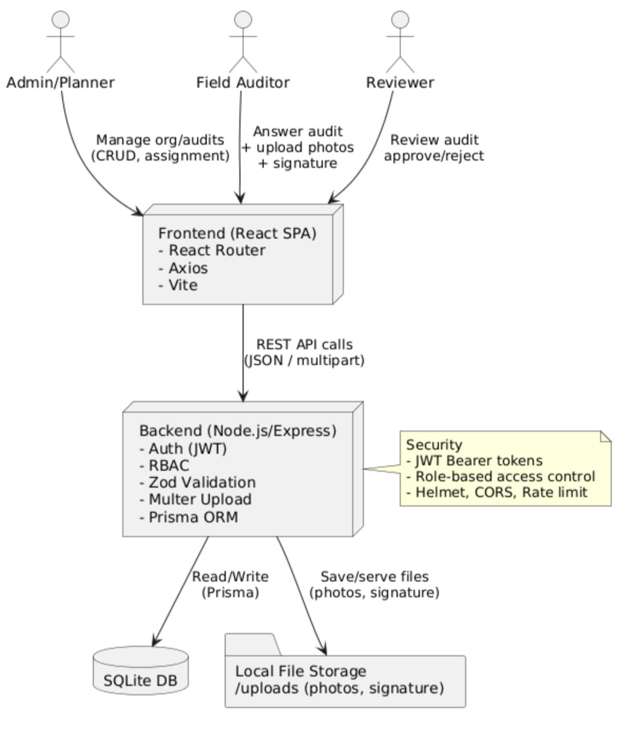
Figure 1 : System Architecture Diagram

4.4.1 Component Structure
The frontend has a modular component structure:

Pages:
- `auth/` - Login, Register, ForgotPassword
- `dashboard/` - Dashboard
- `audit/` - AuditList, AuditConduct, AuditReview
- `management/` - UserManage, CompanyManage, BranchManage, RegionManage, CategoryManage
- `profile/` - Profile, Notifications

Components:
- `Layout.jsx` - Main layout wrapper (navigation, sidebar)
- `NewAuditModal.jsx` - New audit creation modal

4.4.2 Routing
Client-side routing with React Router DOM:
- Public routes: `/login`, `/register`, `/forgot-password`
- Protected routes: All other pages (with token check)
- Dynamic routes: `/audits/:id`, `/reviews/:id`

4.4.3 State Management
- Local state: React useState hook
- Global state: localStorage (token management)
- API calls: HTTP requests with Axios
- Centralized API client: `lib/api.js`
4.4.4 User Interface Flow
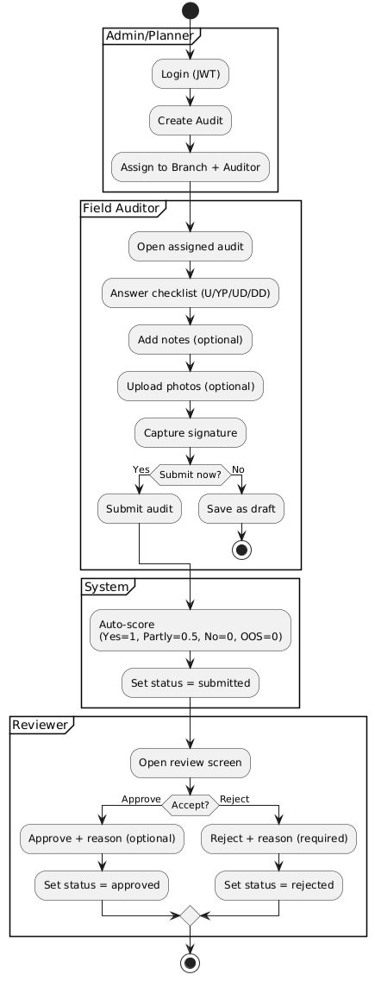

Figure 2: Activity Diagram
1. Authentication Flow:
Login → Save token → Redirect to protected route
2. Audit Flow:
- Planner/Admin: Create audit → Assign to auditor
- Field Auditor: Audit list → Audit detail → Answer → Add photo → Signature → Submit
- Reviewer: Audit list → Audit review → Approve/Reject
4.5 Security Design

4.5.1 Authentication Security
- Stateless authentication with JWT token
- Token expiration check
- Password hashing (bcryptjs, salt rounds)
- Protected route middleware

4.5.2 API Security
- Rate limiting (express-rate-limit)
- Helmet.js (HTTP header security)
- CORS policy configuration
- Input validation (Zod schema validation)
- File upload security (Multer, file type control)

4.5.3 Authorization
- Role-based access control (RBAC)
- Endpoint-level permission checks
- Resource-level authorization (user can only view their own audits)
4.6 Scoring System Design
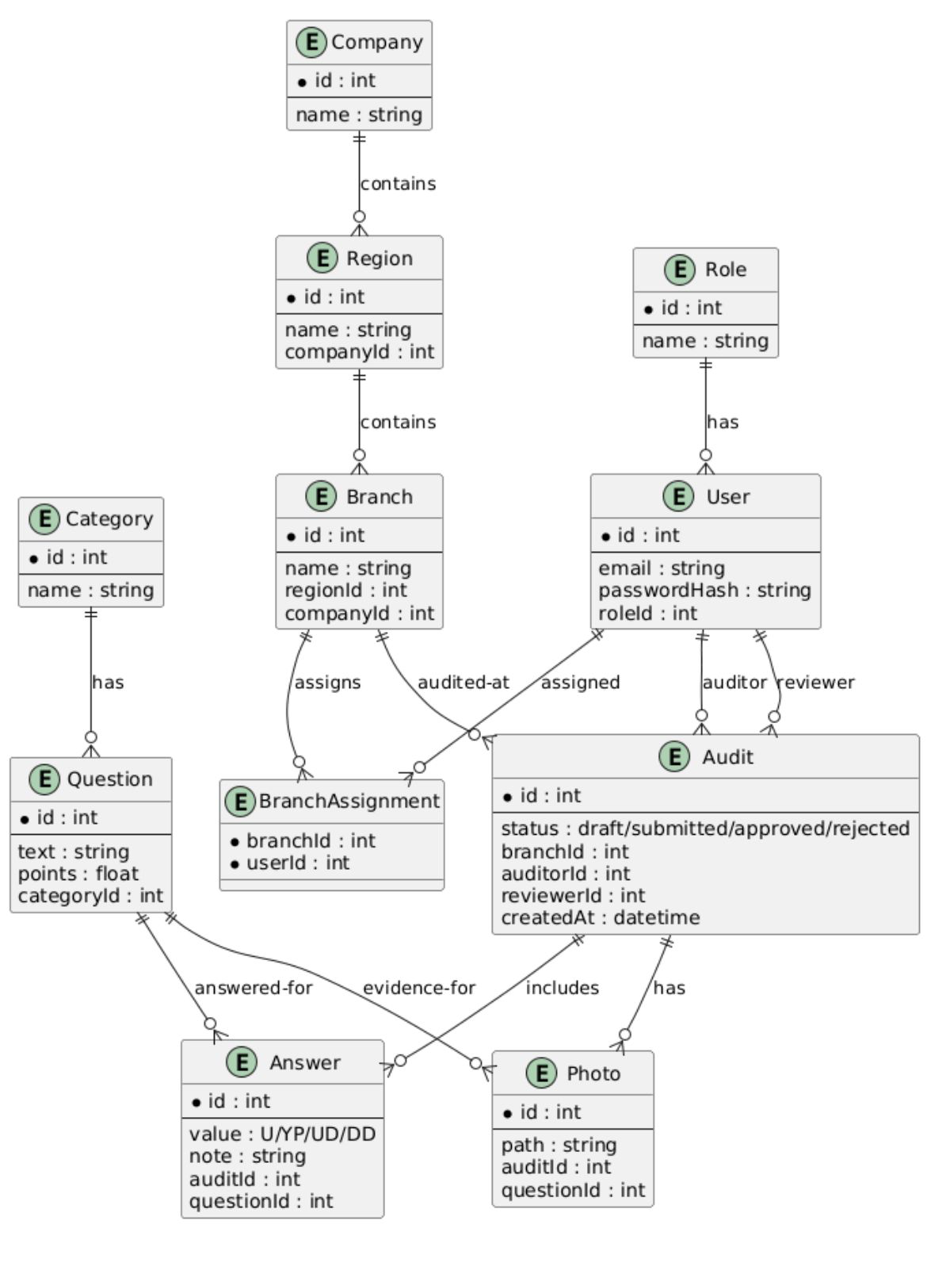
Figure 3 : ER Diagram
The audit scoring system is automatically calculated based on question points and answers:
- Each question has a `points` value
- Answers: U (Suitable), YP (Completed), UD (Not Suitable), DD (Out of Evaluation)
- Score calculation algorithm: Implemented in `utils/scoring.js` module
- Score is displayed in audit list and detail page

CHAPTER 5. Implementation

This chapter describes the implementation details of the Teftisistan platform. The project consists of three main components: a web-based frontend built with React, a RESTful backend powered by Node.js and Express, and a cross-platform mobile application developed with React Native using Expo. In addition, ISO/IEC 27001:2022 security measures have been integrated throughout the system to ensure enterprise-grade data protection.

5.1 Tools and Libraries

The backend is implemented using Node.js with the Express.js 4.21.1 framework. Prisma 5.22.0 serves as the ORM layer interfacing with an SQLite database. Authentication relies on JSON Web Tokens (jsonwebtoken 9.0.2) with bcryptjs 2.4.3 for password hashing. Input validation is handled by Zod 3.23.8 and file uploads by Multer 1.4.5. Security middleware includes Helmet 8.0.0 for HTTP headers, CORS 2.8.5, and express-rate-limit 7.4.0. Request logging is performed using Morgan 1.10.0.

The web frontend uses Vite 7.1.5 as the build tool with Vanilla JavaScript (ES6+) and TailwindCSS delivered via CDN. Material Symbols icons and the Inter font from Google Fonts provide a consistent visual identity.

The mobile application is built on React Native 0.81.5 using the Expo SDK 54 framework and expo-router 6.0.23 for file-based routing. State management is handled by Zustand 5.0.11. Sensitive credentials are stored using expo-secure-store 15.0.8 instead of plain AsyncStorage. Additional libraries include Axios 1.13.6 for HTTP communication, react-native-chart-kit 6.12.0 for dashboard visualizations, expo-image-picker 17.0.10 for camera and gallery access, expo-print 15.0.8 and expo-sharing 14.0.8 for report export, and react-native-view-shot 4.0.3 for screen capture functionality. The project is written in TypeScript 5.9.2.

5.2 Implementation Details

5.2.1 Backend Implementation

The backend server is structured as a RESTful API using Express.js. The database schema is defined through Prisma ORM and includes eleven core models: Role, User, Company, Region, Branch, Category, Question, Audit, Answer, Photo, and BranchAssignment. The Prisma schema enforces referential integrity through foreign key constraints and composite unique constraints (e.g., Answer uses a composite key on auditId and questionId). The database runs on SQLite for development simplicity.

Authentication is implemented as a middleware layer. Upon successful login via POST /auth/login, the server issues a signed JWT containing the user ID and role. A refresh token mechanism allows seamless token renewal without requiring re-authentication. Protected routes validate the Bearer token on every request. Role-based authorization checks are applied at the endpoint level; for example, only admin and planner roles can create audits via POST /audits, while field auditors can only access their own assigned audit records.

The scoring engine calculates audit results automatically. Each answer is mapped through a coefficient: U (Suitable) = 1, YP (Half Point) = 0.5, UD (Not Suitable) = 0, and DD (Out of Evaluation) is excluded from the calculation. The percent score is computed as (earnedPoints / totalPoints) * 100, with category-level breakdowns provided for granular analysis.

5.2.2 Web Frontend Implementation

The web frontend is organized as a multi-page application using Vite as the build tool. Each major feature corresponds to a dedicated HTML page served from the public directory. The page set includes a login page, a central dashboard, audit answering and review pages, audit list with filtering and CSV export, administration panels for companies, regions, branches, categories, and users, a reports page, and a profile settings page.

The UI follows a dark-mode-first design language with a primary green (#13ec5b) accent on a dark background (#102216). All pages share a sidebar navigation component that adapts its menu items based on the authenticated user’s role. Responsive design is achieved through TailwindCSS utility classes, with the sidebar collapsing into a hamburger menu on mobile viewports.

5.2.3 Mobile Application Implementation

The mobile application extends the platform’s reach to iOS and Android devices through a React Native codebase managed by the Expo framework. The routing architecture uses expo-router with file-based conventions: the app directory contains an (auth) group for login screens and a (main) group for authenticated screens including dashboard, audits (with nested [id]/answer and [id]/review routes), reports, admin panels (companies, regions, branches, categories, users), and a profile page.

Navigation is implemented using the @react-navigation/drawer library with a custom drawer component (CustomDrawerContent) that renders role-filtered menu items. The drawer displays the user’s avatar, name, email, and role, and dynamically adjusts available navigation targets based on the RBAC configuration stored in the MENU_ITEMS constant. Each menu item specifies an array of permitted roles, and the filtering logic uses the hasRole method from the Zustand-based authStore.

The API communication layer is centralized in an Axios client (src/services/api/client.ts) that automatically attaches JWT Bearer tokens from expo-secure-store to every request. A response interceptor implements a token refresh queue: when a 401 response is received, the interceptor attempts to obtain a new access token using the stored refresh token via POST /auth/refresh. During the refresh operation, subsequent requests are queued and replayed once the new token is available. Additionally, a CSRF token mechanism protects state-changing HTTP methods (POST, PUT, PATCH, DELETE) by attaching an X-CSRF-Token header fetched from the /auth/csrf-token endpoint.

State management across the mobile application is handled by Zustand stores. The authStore manages user session state including login, logout, token persistence, and role-checking utilities. The themeStore provides light/dark mode switching with theme preferences persisted locally. The auditHeaderStore manages dynamic header titles for the audit detail screens. A ThemeContext wraps the application to provide reactive color values throughout the component tree.

The mobile UI employs a shared component library including Button, Card, Badge, Input, Select, SearchBar, Modal, ConfirmDialog, EmptyState, LoadingScreen, and AuthImage components. These reusable building blocks ensure visual consistency across all screens. The design system is defined in src/configs/theme.ts with standardized spacing, font sizes, and border radius tokens.

5.2.4 ISO/IEC 27001:2022 Security Implementation

A comprehensive security hardening initiative was conducted in alignment with the ISO/IEC 27001:2022 Annex A technological controls. The implementation follows an eight-phase approach addressing the fifteen critical findings identified during the initial security audit.

Phase 1 (Critical Vulnerability Remediation) addressed the hardcoded JWT secret by migrating to environment variables via dotenv, removing the fallback secret so the application refuses to start without a properly configured JWT_SECRET. The CORS configuration was restricted from a permissive origin:true policy to an allowlist loaded from the ALLOWED_ORIGINS environment variable. The JSON body limit was reduced from 50MB to 1MB to mitigate denial-of-service risks, and a centralized global error handler was introduced to prevent stack trace leakage in production (Annex A 8.28, 8.9, 8.24).

Phase 2 (Authentication and Session Security) introduced token expiration enforcement (1 hour for access tokens, 7 days for refresh tokens), a password complexity policy requiring minimum 10 characters with uppercase, lowercase, digit, and special character requirements, and an account lockout mechanism after five consecutive failed login attempts. On the mobile side, tokens are stored in expo-secure-store which leverages the platform’s native keychain (iOS) and keystore (Android) rather than plain localStorage, directly addressing the XSS token theft vulnerability (Annex A 8.5).

Phase 3 (Frontend Security) implemented Content Security Policy headers through Helmet.js configuration to prevent XSS attacks, and a CSRF token mechanism was deployed. The mobile API client automatically fetches and attaches CSRF tokens for state-changing requests, with automatic retry on 403 CSRF errors (Annex A 8.28). Phase 4 (Backend Cryptographic Controls) added file type validation on the Multer upload middleware, restricting accepted formats to JPEG, PNG, and GIF with MIME type verification (Annex A 8.24). Phases 5 through 8 planned for future sprints cover audit logging, CI/CD security testing pipelines, cloud infrastructure hardening, and disaster recovery procedures.

REFERENCES
- [1] Mapex. (2025). "Manual vs automated data collection: pros, cons, and results." Available: https://mapex.io/en/news/manual-vs-automated-data-collection-which-method-wins-the-day/
- [2] SafetyIQ. (2025). "Paper-Based vs Digital Safety Audits in the Workplace." Available: https://safetyiq.com/insight/paper-based-vs-digital-safety-audits-in-the-workplace/
- [3] Nukon. (2025). "Paperless system transforms quality management." Available: https://www.nukon.com/success-stories/paperless-system-transforms-quality-management
- [4] Wissal, H., Nacer, M., & Hafsa, L. (2025). "The Digital Transformation of the Internal Audit Function: A Qualitative Literature Review." Review of Law and Social Sciences, 3(3). Available: https://reviewlawsocialsciences.com/index.php/rlss/article/view/68
- [5] React Documentation. "Optimizing Performance." Available: https://legacy.reactjs.org/docs/optimizing-performance.html
- [6] Aslam, A. (2025). "Why React Is Fast: Virtual DOM vs Real DOM Explained with Examples." Medium. Available: https://medium.com/@a1guy/why-react-is-fast-virtual-dom-vs-real-dom-explained-with-examples-d22b0132578b
- [7] Node.js. "About Node.js." Available: https://nodejs.org/en/about
- [8] Henawy, A. (2024). "Unlocking Node.js Performance: Understanding Offloading, Non-blocking I/O, and Thread Pools." Medium. Available: https://medium.com/@ahmedalimohamed1511/unlocking-node-js-performance-understanding-offloading-non-blocking-i-o-and-thread-pools-39fb70bd21fc
- [9] NIST. "Role Based Access Control (RBAC)." Computer Security Resource Center. Available: https://csrc.nist.gov/projects/role-based-access-control
- [10] Ferraiolo, D.F., & Kuhn, D.R. (1992). "Role-Based Access Control." 15th National Computer Security Conference.
- [11] JWT.io. "Introduction to JSON Web Tokens." Available: https://jwt.io/introduction
- [12] Shah, S. (2025). "Stateless JWT or Stateful Sessions: Why Sessions Sometimes Win Over JWT." Medium. Available: https://medium.com/@sarthakshah1920/stateless-jwt-or-stateful-sessions-why-sessions-sometimes-win-over-jwt-09a07659a1bd
- [13] OWASP. "OWASP Top 10 - 2021: The Ten Most Critical Web Application Security Risks." Available: https://owasp.org/www-project-top-ten
- React Documentation: https://react.dev
- Vite Documentation: https://vitejs.dev
- Express.js Guide: https://expressjs.com
- Prisma ORM Docs: https://www.prisma.io/docs
- SQLite Docs: https://www.sqlite.org/docs.html
- OWASP Top 10: https://owasp.org/www-project-top-ten
- GDPR Overview: https://gdpr.eu
- Axios Docs: https://axios-http.com
- Helmet Docs: https://helmetjs.github.io

