ASSIGNMENT-1

TASK: >>Create a VPC with 2 subnets and 2 route tables and internet gateway

>>Launch an instance and Attach it with EBS

*VPC Concept

à Search for VPC in search space/bar of AWS home page and click on VPC

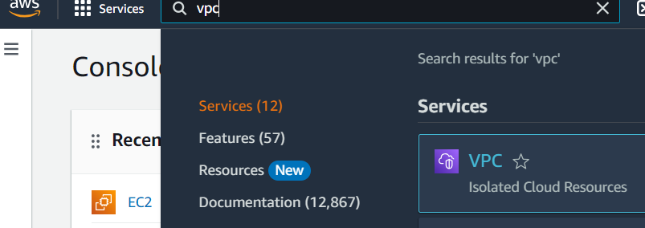

àNow click on **Your VPCs** option under Virtual private cloud

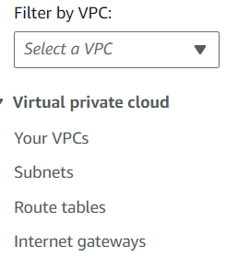

àNow click on Create VPC to create our custom VPC

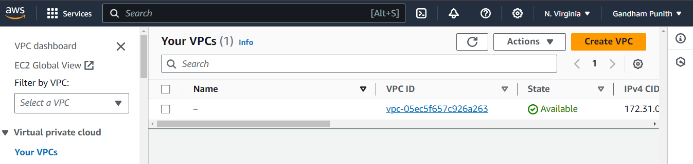

àWe have to fill few details for our VPC (like name, IPv4 CIDR) and finally click on Create VPC

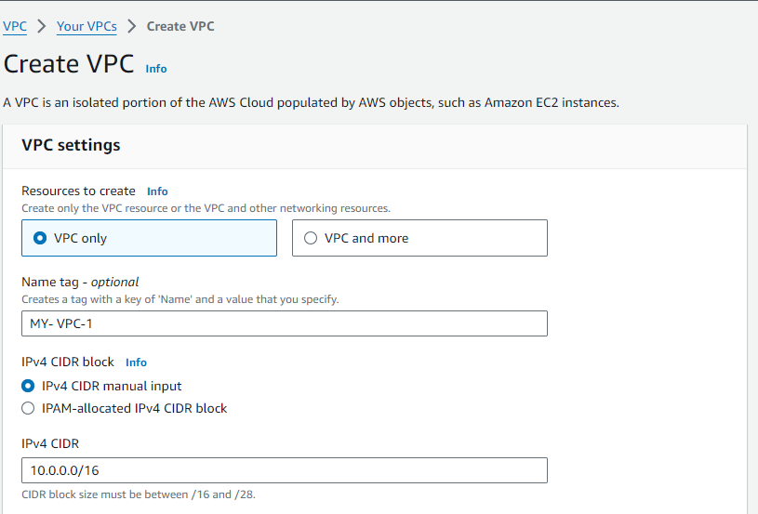

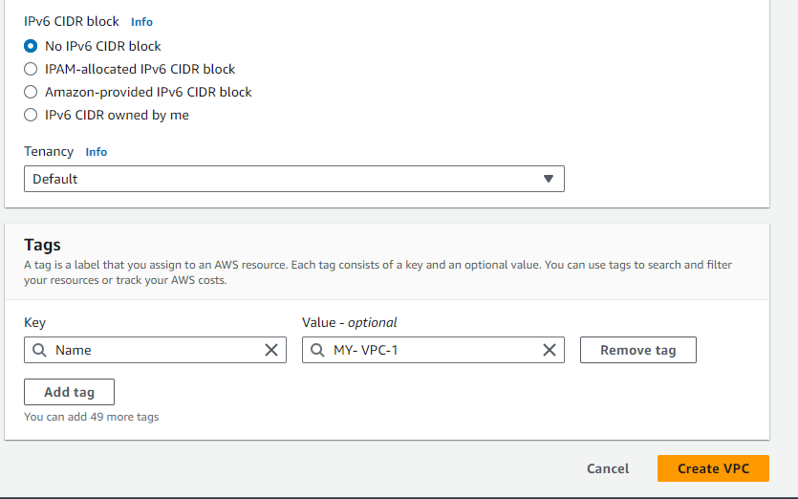  
à We have created our custom VPC successfully. Now click on **Internet gateways** from menu and click on Create internet gateway

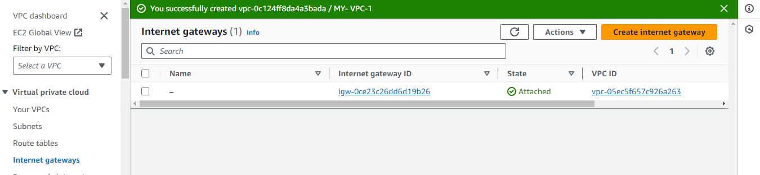

àNow, we have to name our internet gateway (name of our choice) and finally click on Create internet gateway.

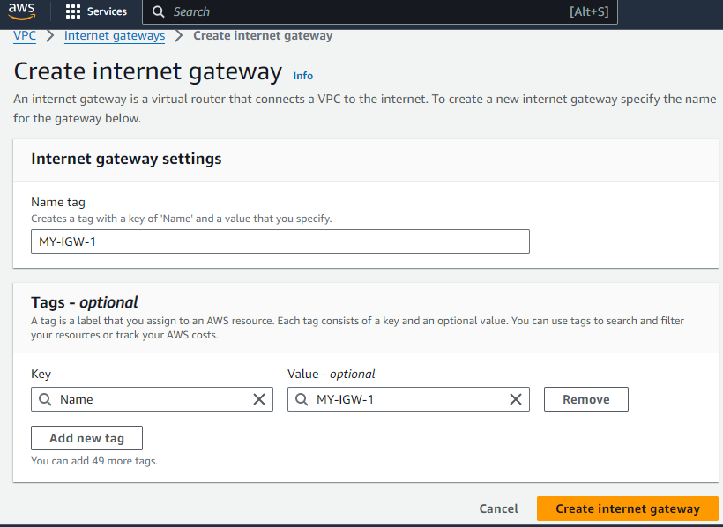

à Now click on **Actions** and click on **Attach to VPC** option

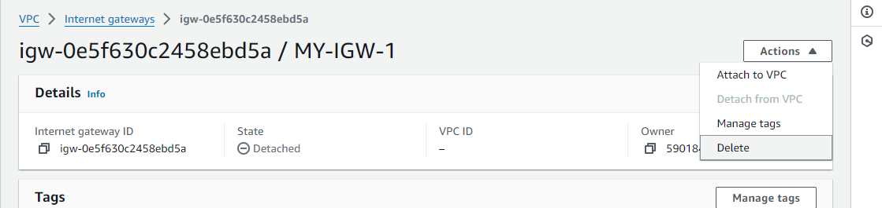

àUnder Available VPCs section, select our custom VPC that we already created and Finally click on Attach internet gateway

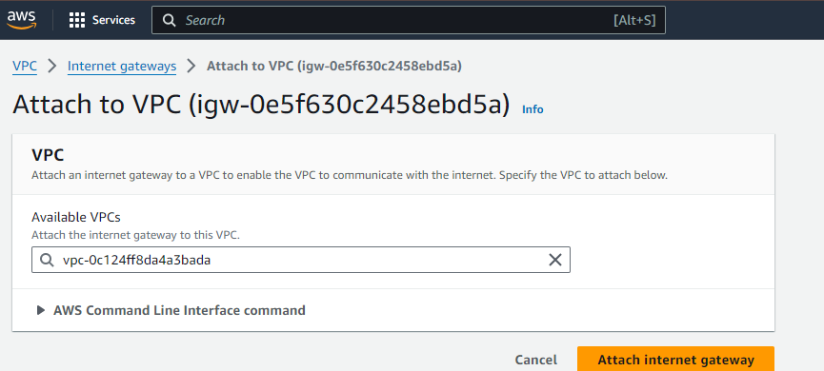

àNow we have to create 2 subnets (one is public and another one is private). For this, click on **Subnets** option from menu and click on Create subnet.

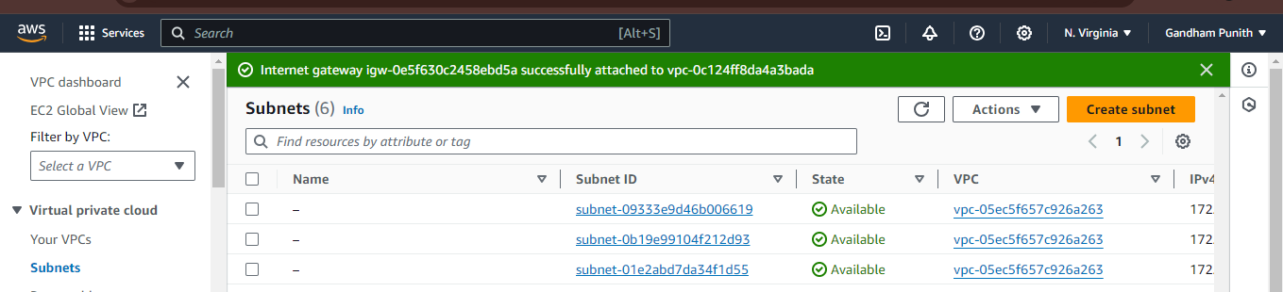

àTO create a subnet, first we have to select our VPC

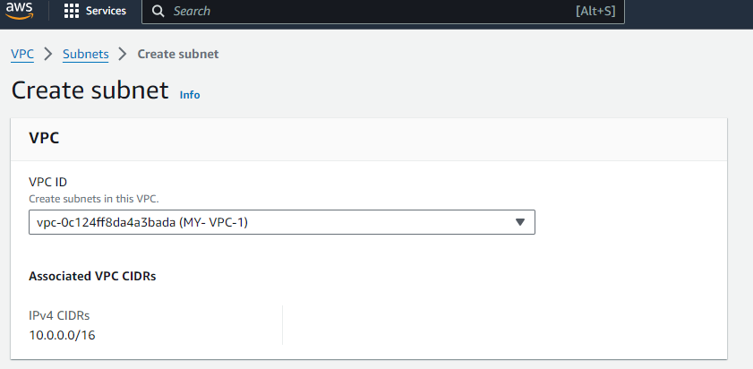

àThen we have to mention some details like we have to name our subnet, we have to select Availability zone and we have to enter CIDR under IPv4 subnet CIDR block and finally click on Create subnet button

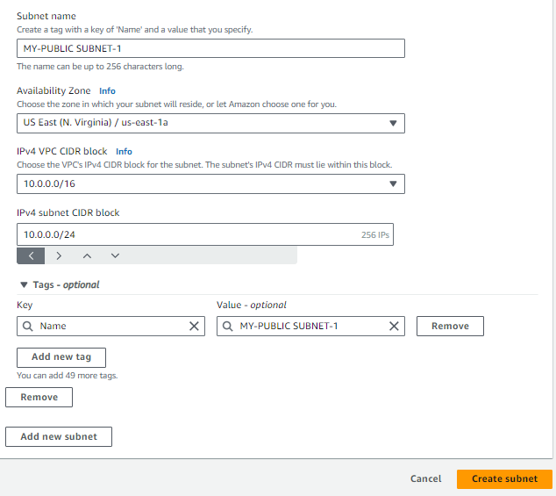

àNow we have to create one more subnet (name: my-private-subnet, Availability zone is 1b and CIDR is 10.0.1.0/24)

à Click on **Route tables** from menu and click on Create route table

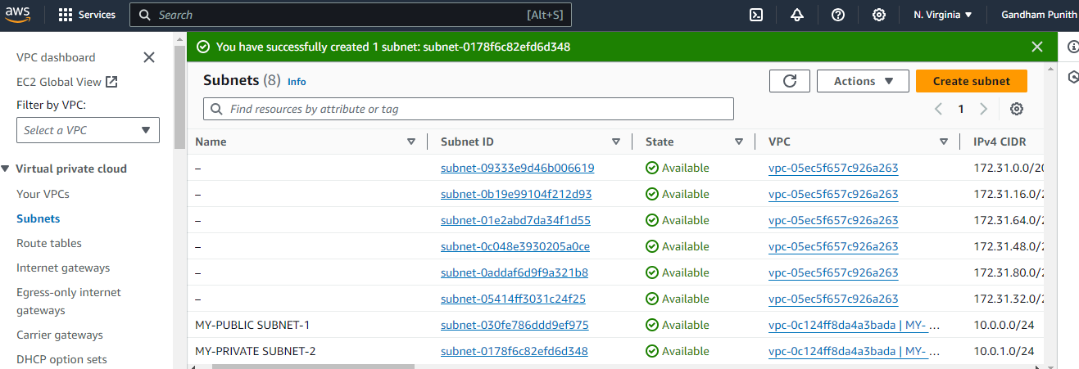

àNow we have to create 2 route tables (one is public and another one is private

à Click on **Route tables** from menu and click on Create route table

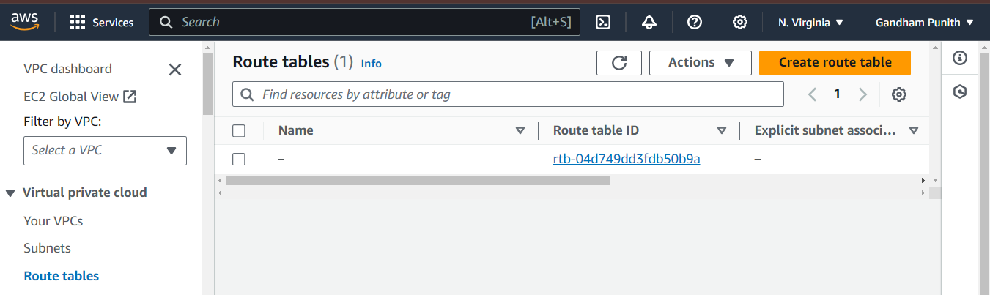

Give name to route table (MY-PUBLIC ROUTE-1) and select our custom VPC and finally click on Create route table

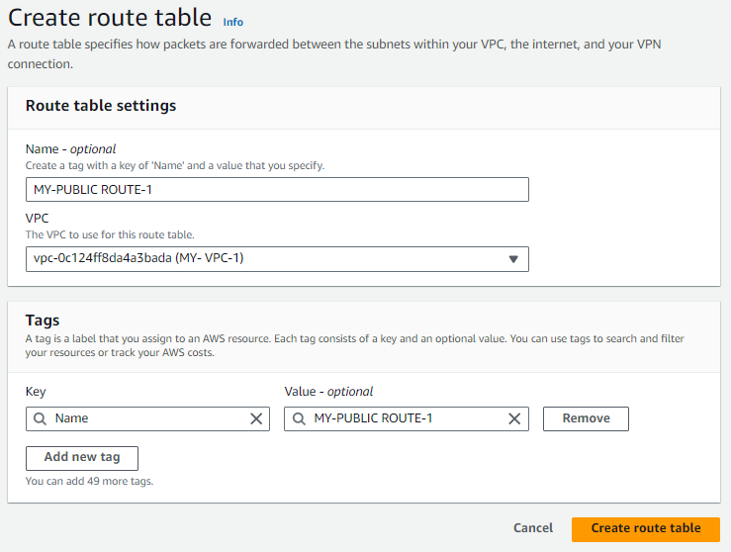

àNow click on **Actions**, click on **Edit routes**

àclick on **Add route**. Select 0.0.0.0/0 as Destination, Select Internet gateway from drop down list and choose our Internet gateway and finally click on Save changes

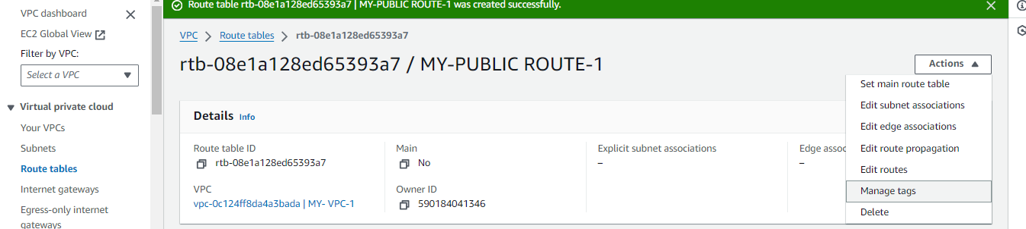

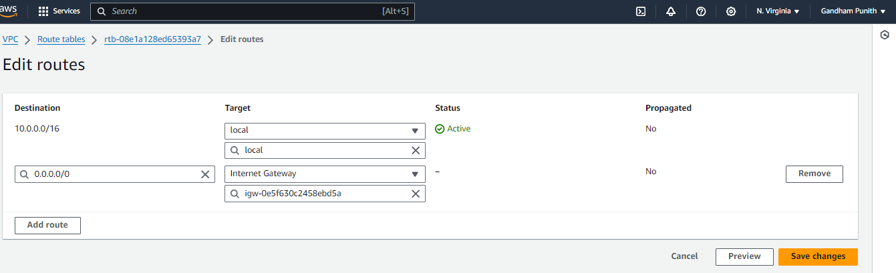

àNow click on **Subnet associations** and **Edit subnet associations**. Select public subnet check box and click on Save associations

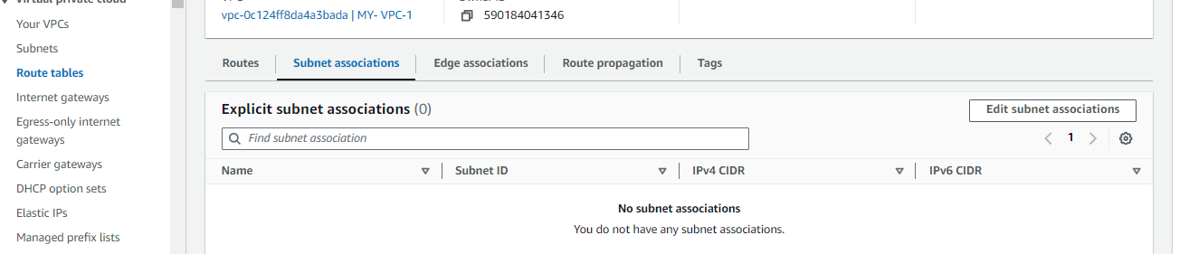

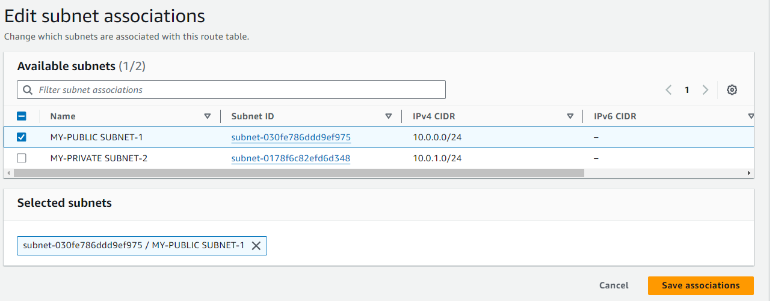

àCreate one more route table (MY-PRIVATE SUBNET-1) and associate with private subnet.

*Note: Here for private route table, we are not going to give internet gateway because we want to make it as private. If we give internet gateway it will become public

*EBS volume

àSearch for EC2 in search bar of AWS home page and click on EC2 and click on **instances** form menu and click on Launch instance

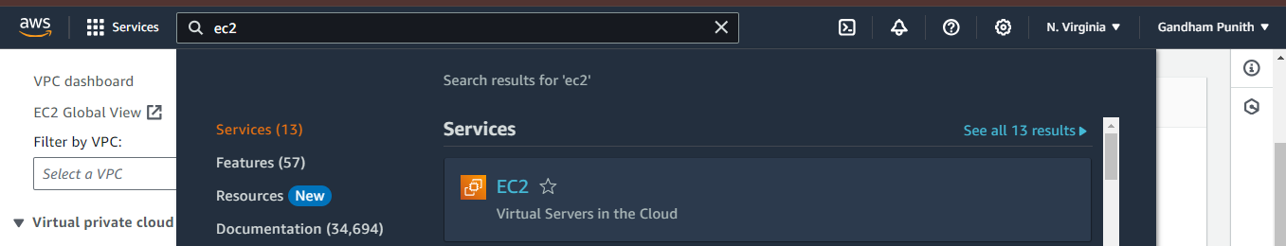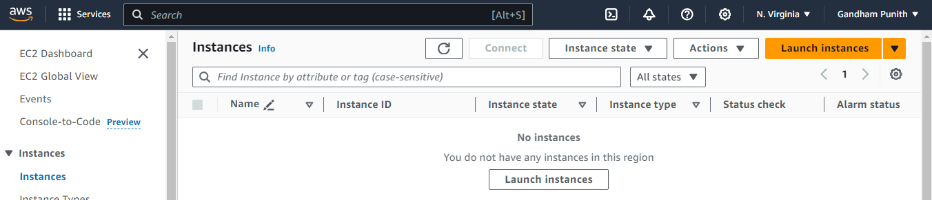

àName our instance of your choice (MY-EBS-1). Select OS of your choice (I have selected Amazon Linux)

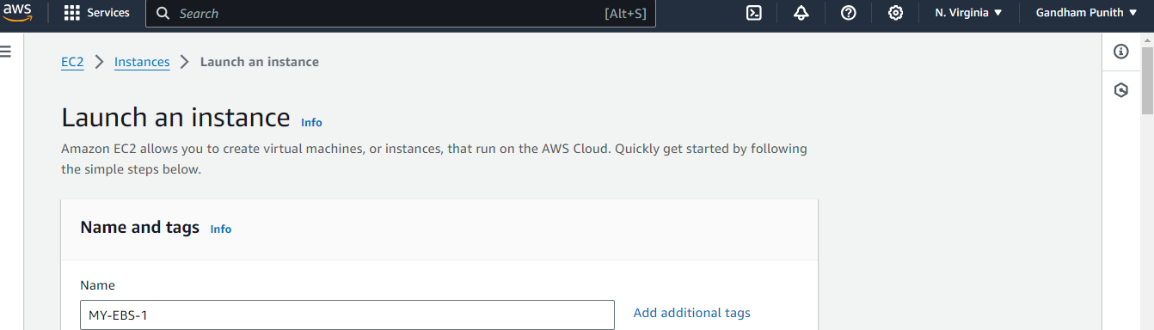

àWe have to create a key pair. So, click on Create new key pair option

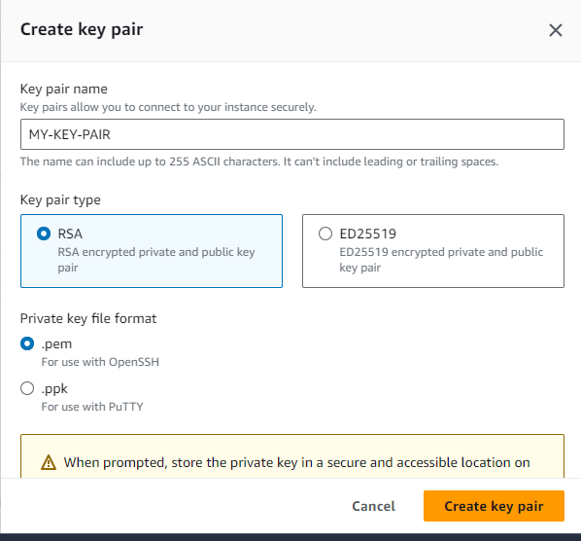

àIn Network settings area, click on **Edit** and configure with our custom VPC.

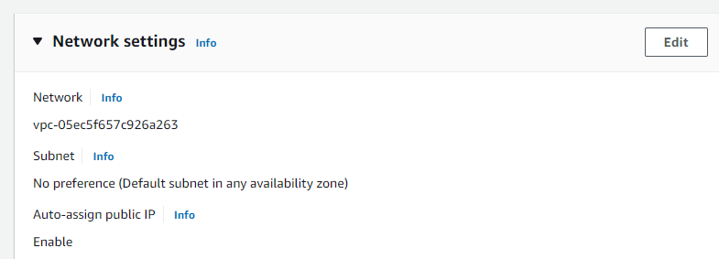

àHere select our custom VPC, select availability zone under subnet, Enable the Auto-assign public IP option and finally Launch instance

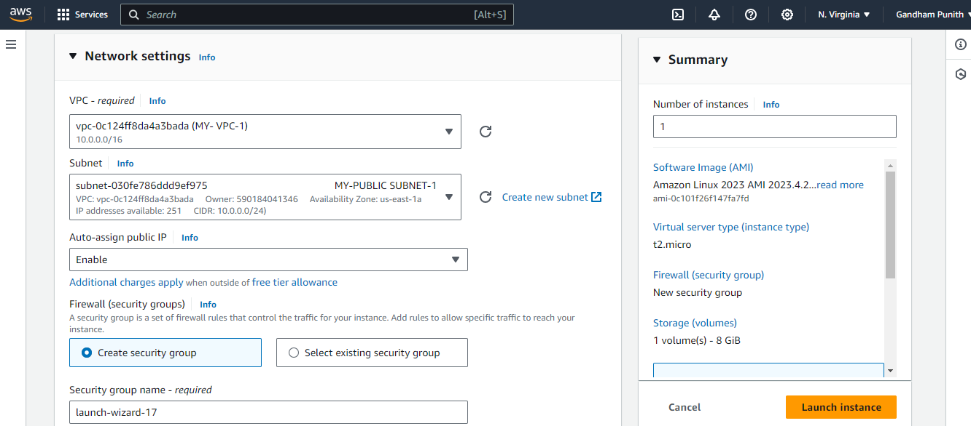

àTo create new volume, click on **Volumes** option from menu under **Elastic Block Store**

àclick on Create volume option

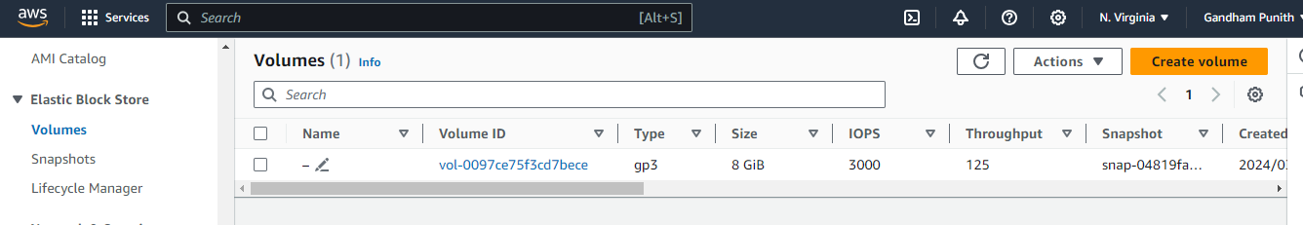

àNow Volume settings page will open and here we have to select Volume type based on our requirement, we have to mention size, we have to specify the availability zone and finally click on Create volume button

*Note: We have to create EBS storage in same availability zone that our instance is running.

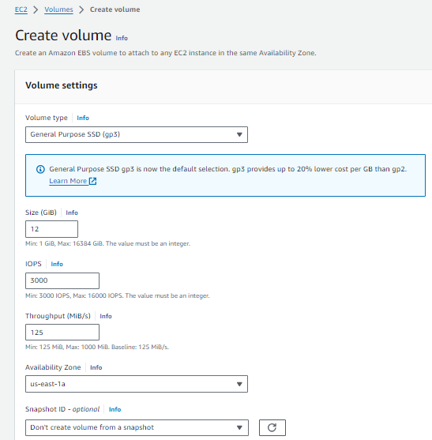

àNow we can see our new volume of 12Gib created successfully Now, select our volume, click on **Actions** and Click on **Attach volume**

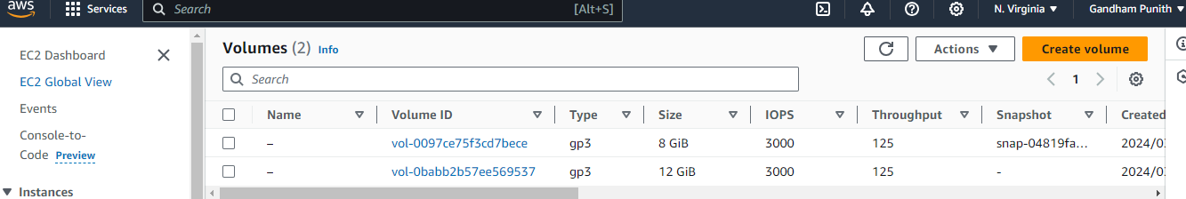

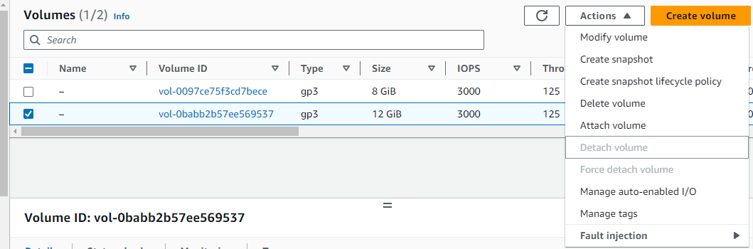

àNow we have to select our instance and finally click on Attach volume button.

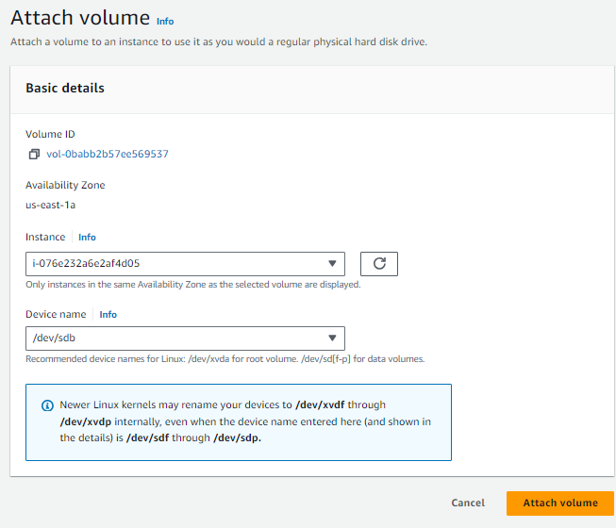

àGo to instances, select our instance and click on **Connect**

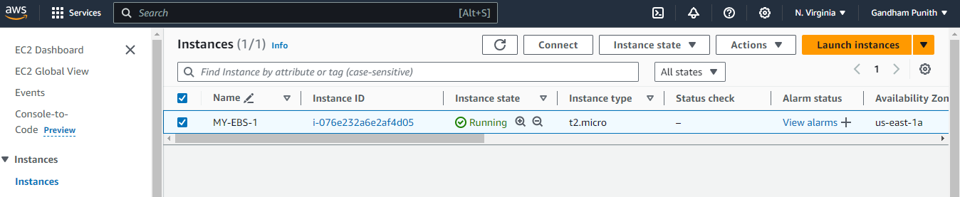

àClick on Connect button in instance connect page

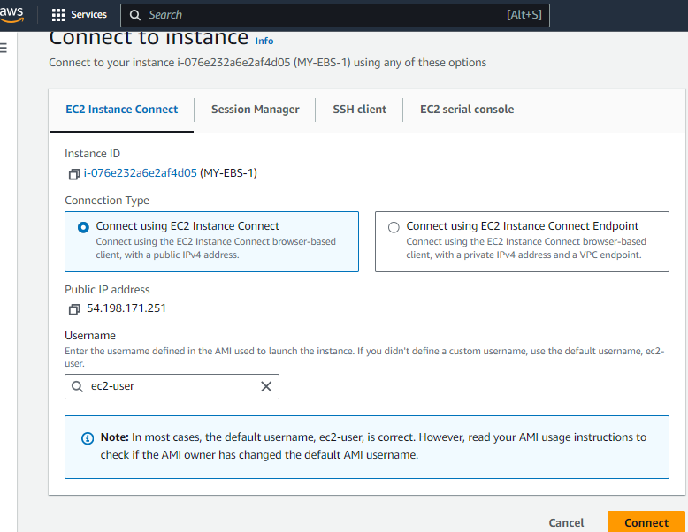

àNow we have connected to our server. Give sudo -i to change to root user

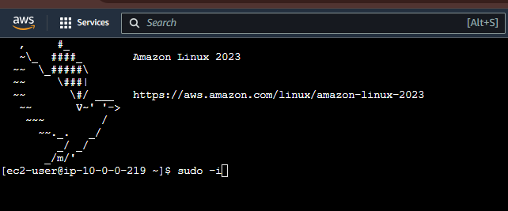

àdf –h to check the disk space

àlsblk to list out block devices (after giving lsblk, it will show our block device. Here it is xvdb)

àfile –s /dev/xvdb to check whether we have file system on this device.

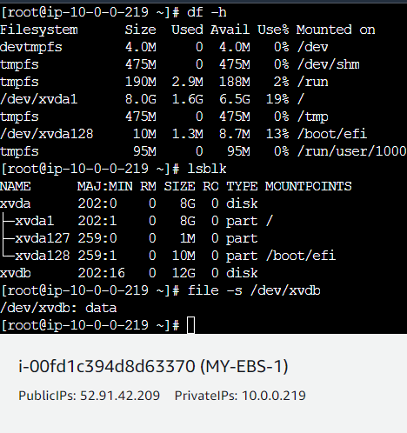

àfrom above its clear that we don’t have a file system. To create file system use below command and check do we have file system or not

àmkfs -t xfs /dev/xvdf

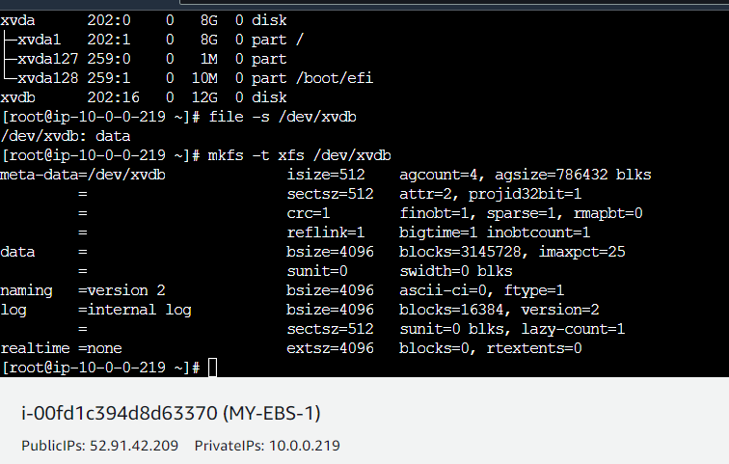

its clear that now we have file system. Now crate one nested directory to mount our volume.

àmkdir –p punith/bittu

àAnd finally mount volume by using below command

àmount /dev/xvdb punith/bittu

àFinally give df –h – to check whether our volume is attached or not.

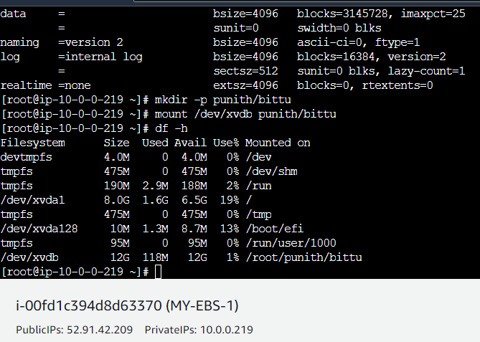

àIn the above pic, we can see /dev/xvdb with Size 12G. So, our EBS volume attached successfully.