ASSIGNMENT-2

Task: Crete 3 VPCs and connect them using Transit Gateway

* Search for VPC in search bar of AWS home page and click on VPC under **Services**

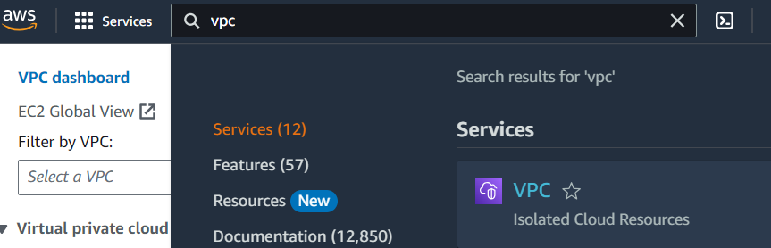

* Click on **Your VPCs** option under **Virtual private cloud** and Click on Create VPC

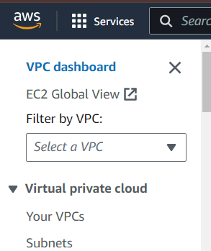

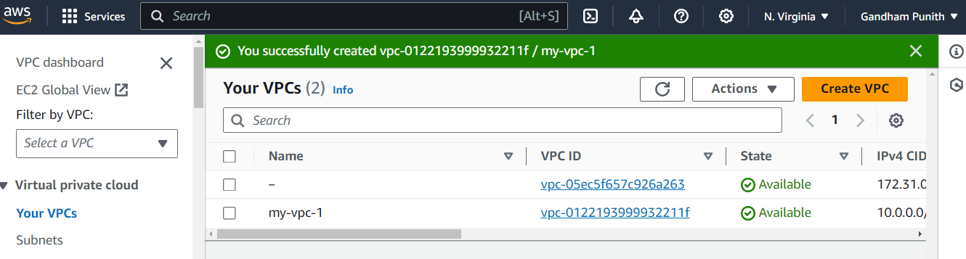

* Fill details like **name** and **IPv4 CIDR** and click on Create VPC button (here I have named (my- VPC-1) as VPC1 and CIDR is 10.0.0.0/16)

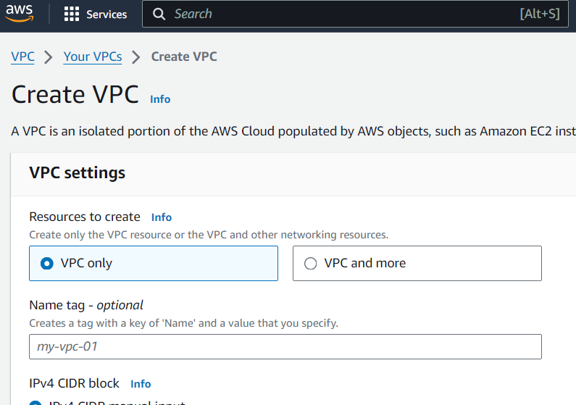

* Now Create 2 more VPCs in the same way (name second VPC as (MY-VPC-2), give IPv4 CIDR as 12.0.0.0/16 and name third VPC as VPC3 and IPv4 CIDR is 14.0.0.0/16)
* Now go to **Your VPCs** and we can see our 3 VPCs
* 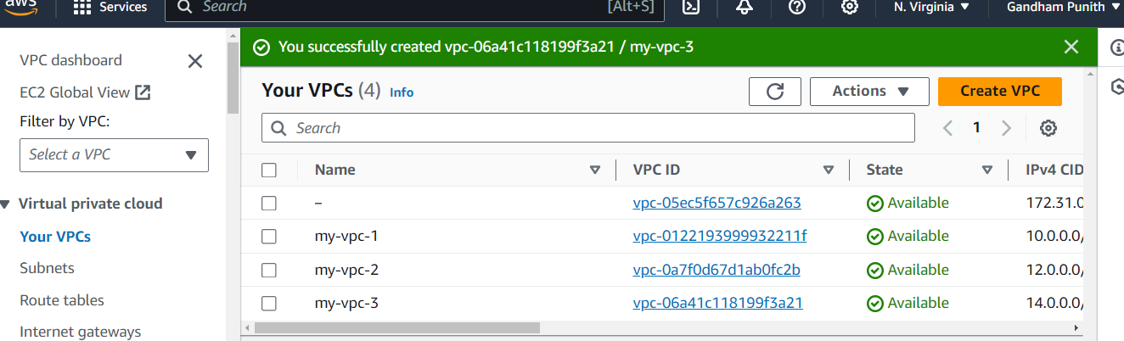
* .
* Click on **Subnets** option under **Virtual private cloud** and click on Create subnet button
* 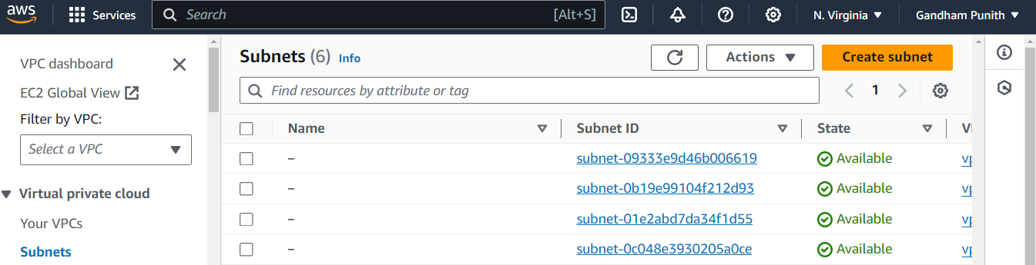

Under **VPC ID**, select our VPC1 from drop down and under Subnet settings, name the subnet (MY-SUBNET-1), select the Availability Zone (us-east-1a) and give CIDR in IPv4 subnet CIDR block (10.0.0.0/16) and finally click on Create subnet button

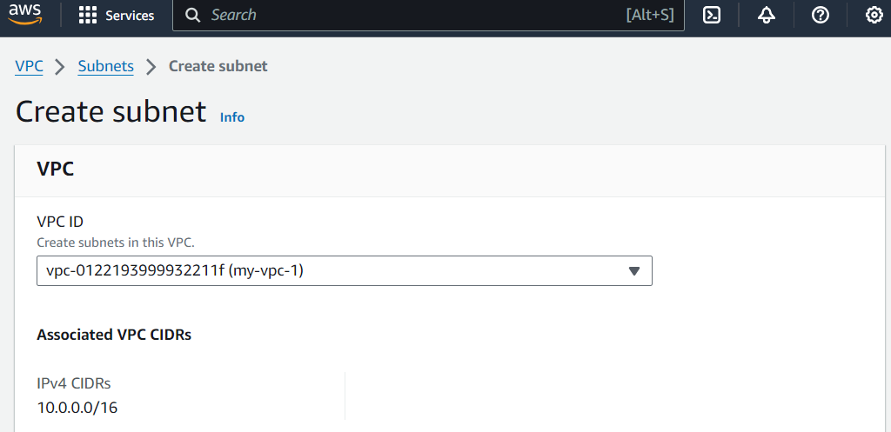

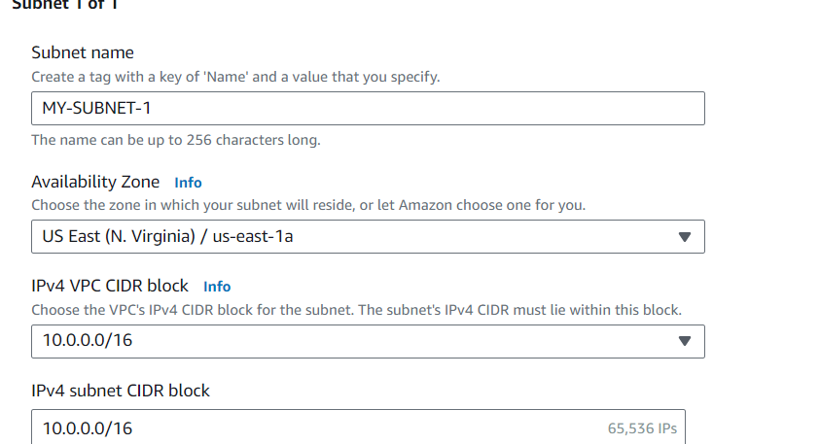

* Create two more subnets

àselect VPC2 for second subnet and name it as (MY-SUBNET-2) select AZ as us-east-1b, IPv4 subnet CIDR is 12.0.0.0/16 and click on Create subnet button.

select VPC3 for third subnet and name it as (MY-SUBNET-3) select AZ as us-east-1c, IPv4 subnet CIDR is 14.0.0.0/16and Create subnet button.

* Have a look on below 2 pictures for clear understanding.

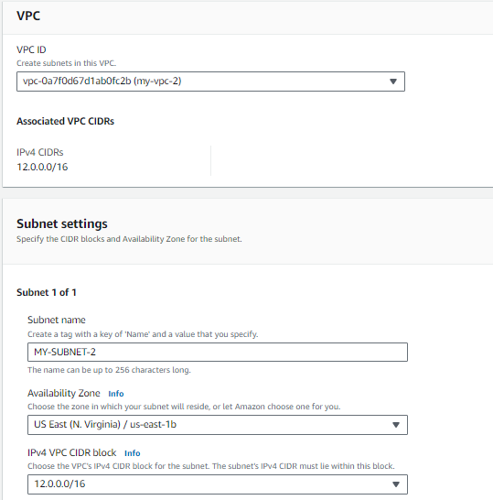

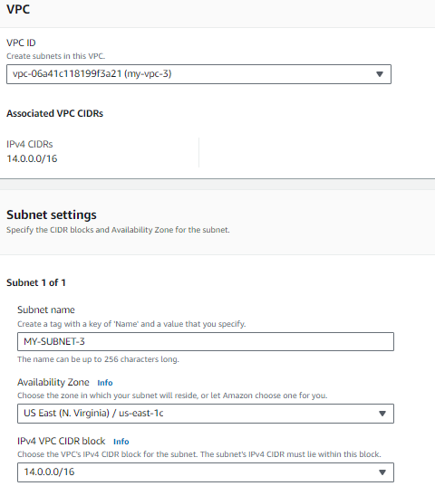

Now go to **Subnets** and see our 3 subnets created

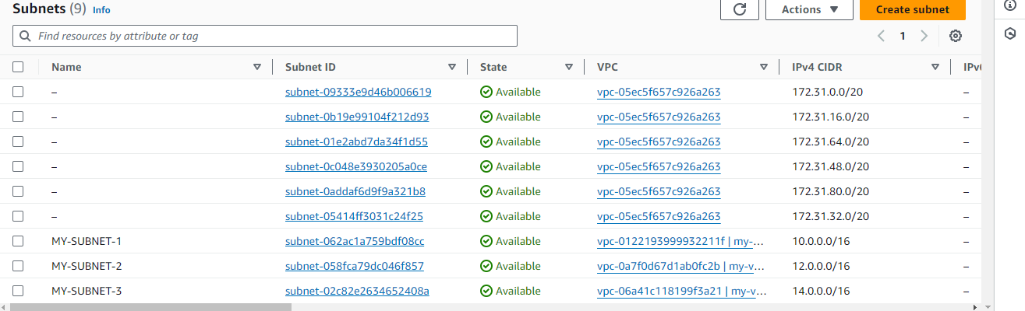

Now create 3 route tables for three subnets.

Click on **Route tables** under **Virtual private cloud** and click on Create route table button.

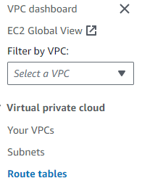

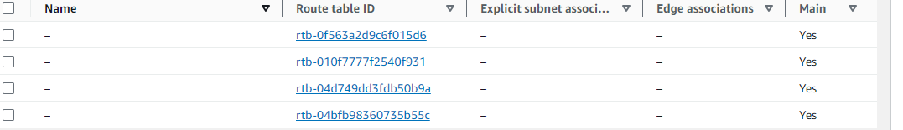

* Name our route table (MY-ROUTE TABLE1) and select our VPC1 under VPC form drop down and finally click on Create route table.

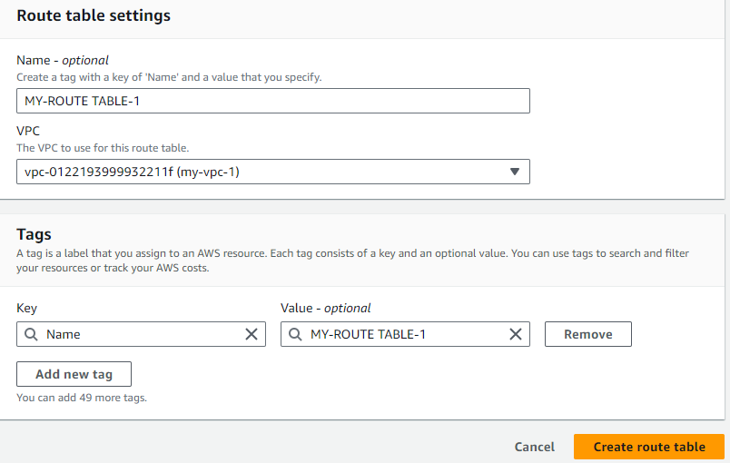

* Create 2 more rote tables

àfor second route table give name as(MY-RT-2 )and select VPC2 and Create route table

àfor third one, give name as (MY- RT-3) and select VPC3 and Create route table

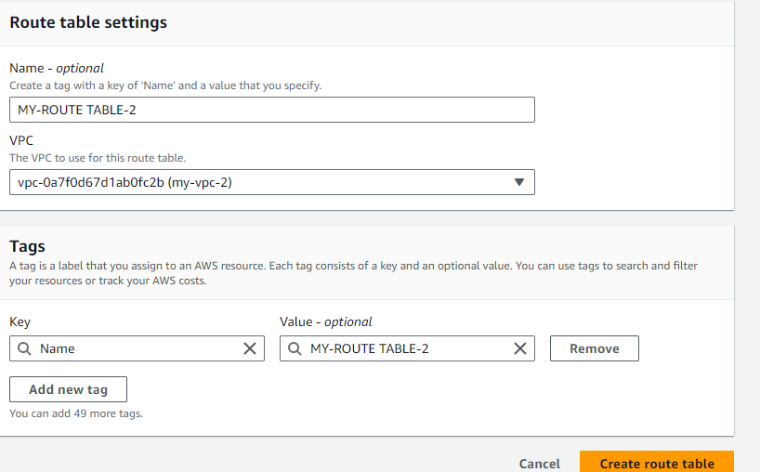

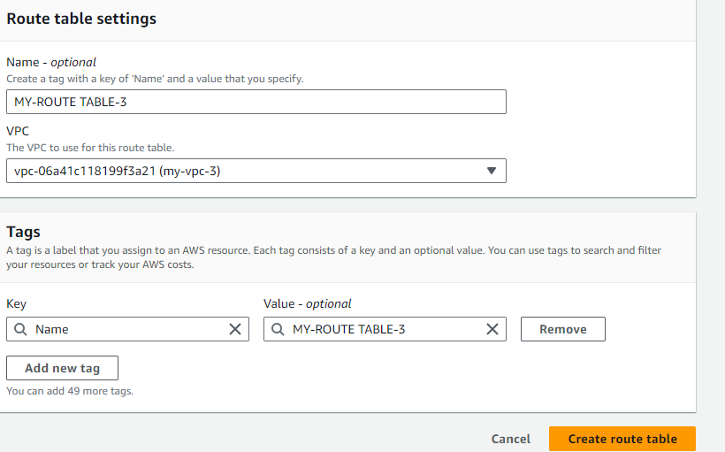

* Now go to **Route tables** and can see our route tables are created.

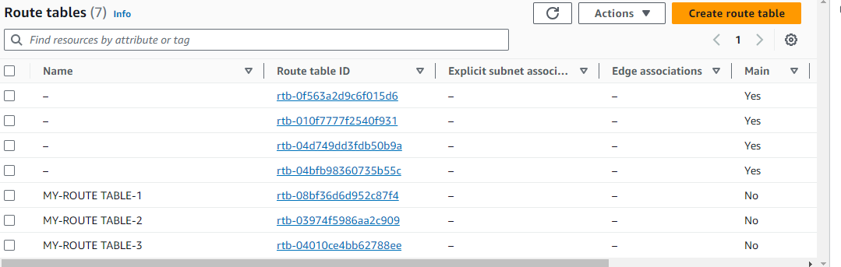

Now go to route table 1 i.e.(MY- RT-1 )(click on RT-1’s Route table ID), click on **Subnet associations** and click on **Edit subnet associations**

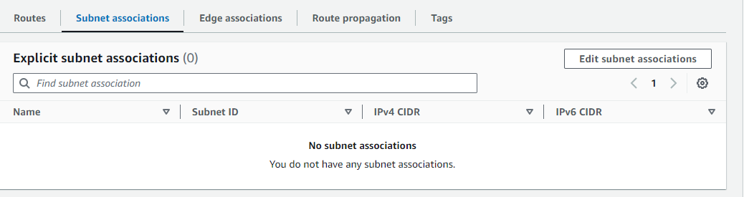

Select subnet-1 and click on Save associations button

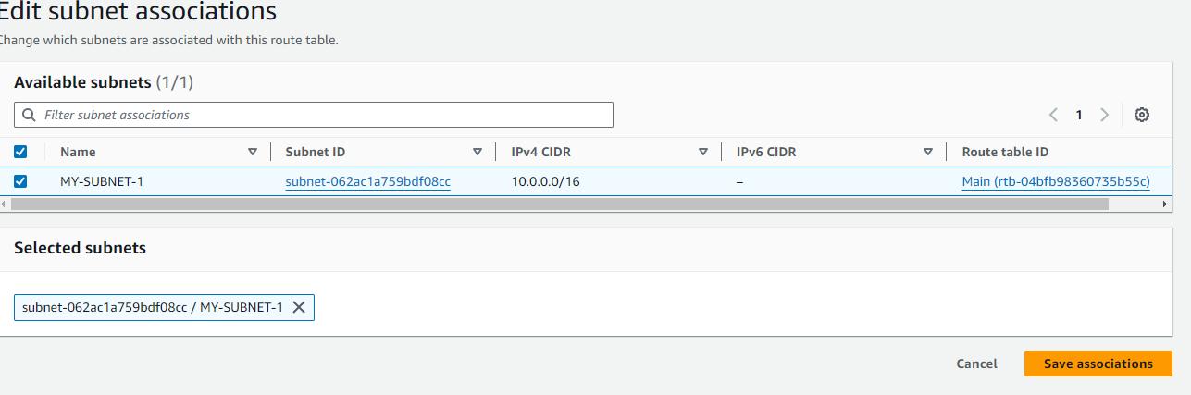

* Now click on **Actions** and click on **Edit routes**

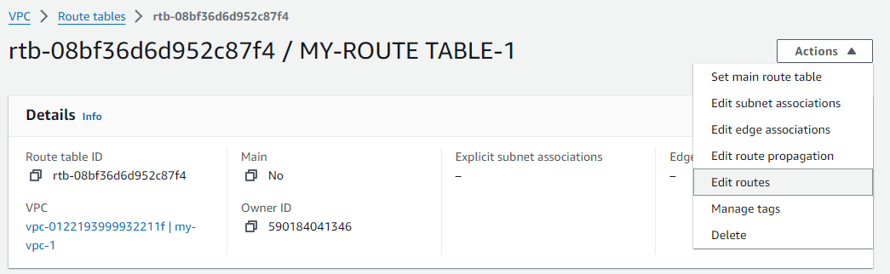

Click on **Add route**, give 0.0.0.0/0 as **Destination** and select **Internet gateway** from drop down under **Target** and select our **IGW-1** and finally click on Save changes button

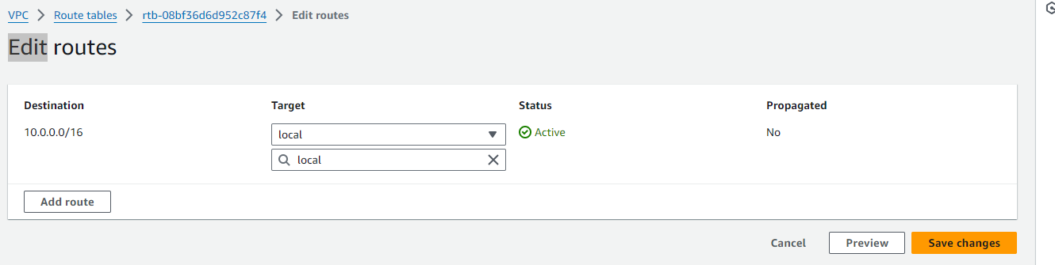

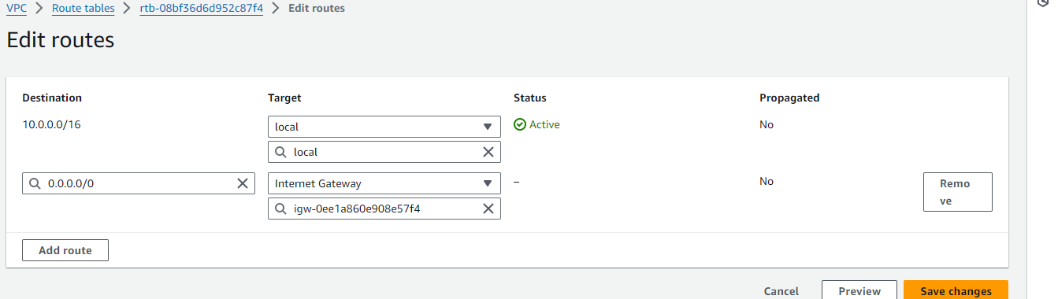

* Now go to **Route tables**, go to second route table (MY-RT-2), click on **Subnet associations** and click on **Edit subnet associations**. Select our **subnet-2** and finally click on Save associations button.

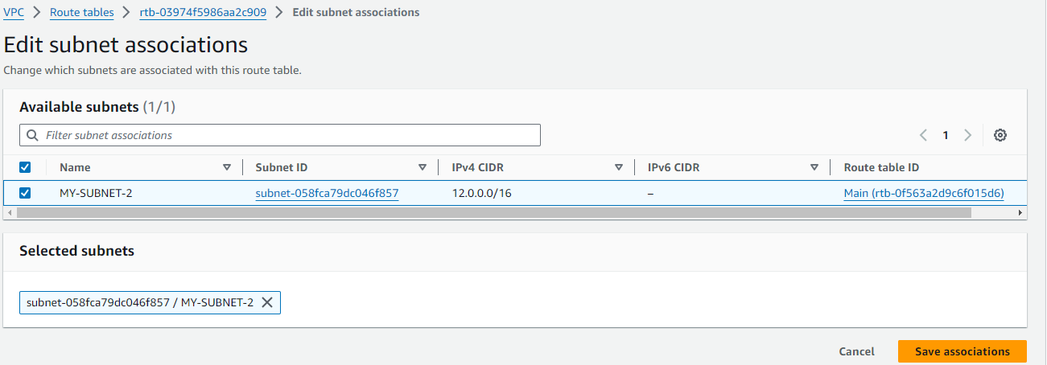

Click on **Actions** and click on **Edit routes** and click on **Add route**, give Destination as 0.0.0.0/0 and under Target, select Internet Gateway option from drop down list and select our IGW-2 and finally click on Save changes.

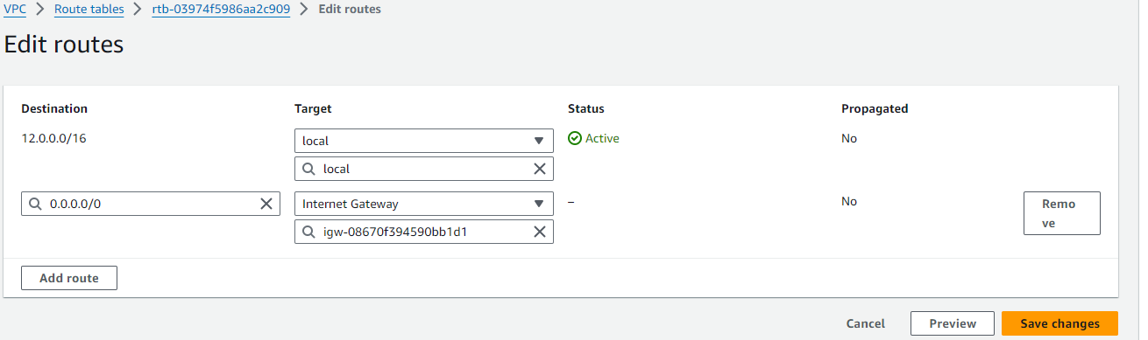

* Now do the same for 3rd route table (MY-RT-3). Associate it with subnet-3. Under Actions, Destination as 0.0.0.0/0, select Internet Gateway (IGW-3) as Target.
* Now we have to create 3 Internet Gateways as we have 3 VPCs. So, click on **Internet gateways** option under **Virtual private cloud** and click on Create internet gateway button.
* 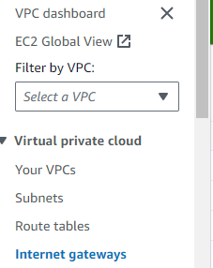
* Give any name to our Internet gateway (ex: MY-IGW-1) and click on Create internet gateway.

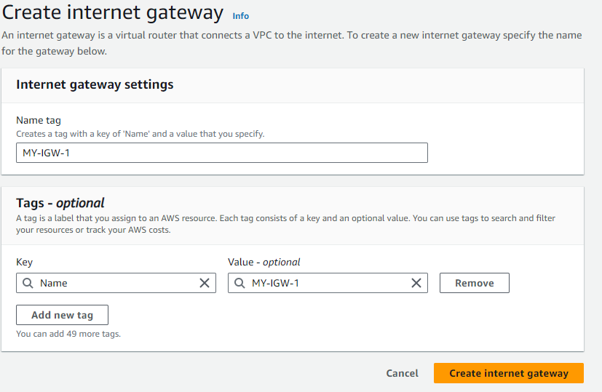

* Create 2 more Internet gateways in the same way (for second Internet gateway give name as(MY- IGW-2) and for third one give name as(MY- IGW-3).
* Now click on **Internet gateways** option and we can see our 3 internet gateways.

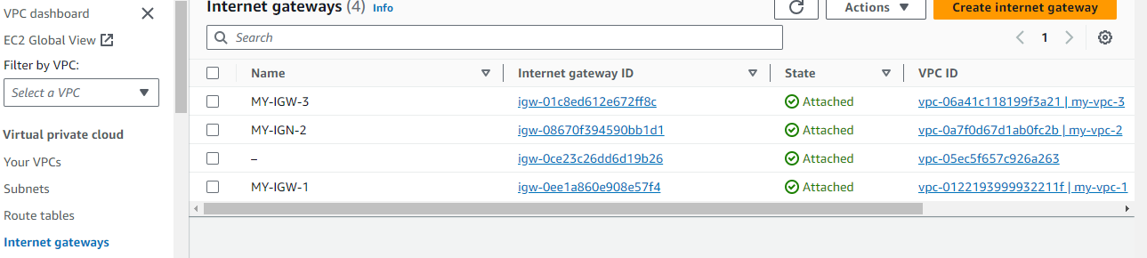

* Now we have to attach our internet gateways with our VPCs. Observe the above picture, we can see the State our internet gateways as Detached.
* So, select IGW-1 à click on **Actions** and click on **Attach to VPC** à Select our VPC1 and finally click on Attach internet gateway.

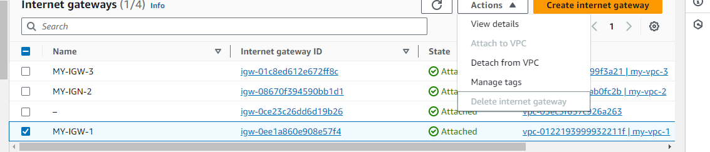

* Now do the same for remaining Internet gateways. (select IGW-2 and attach it with VPC2 and attach IGW-3 with VPC3)
* Now go to **Internet gateways** and we can see our internet gateways in Attached state.

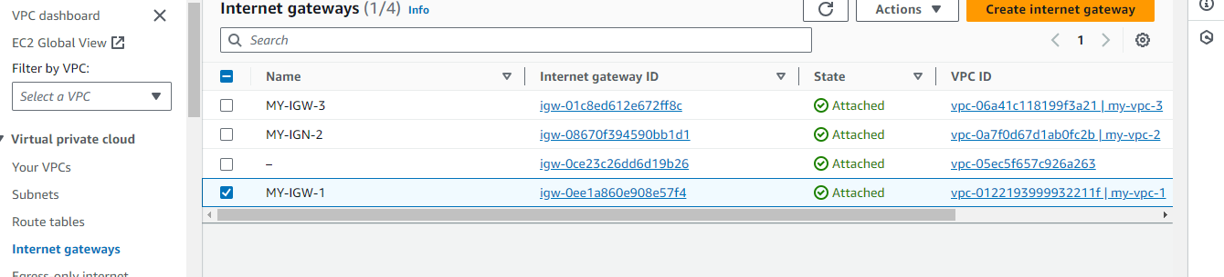

Now we have to create Transit Gateway, for that click on **Transit gateways** and click on Create transit gateway.

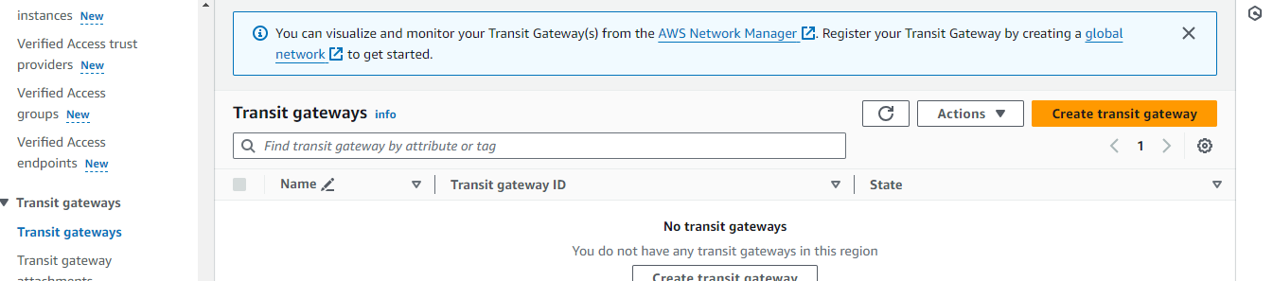

Name our Transit gateway (MY-TGW-1), give Description as nothing and click on Create transit gateway

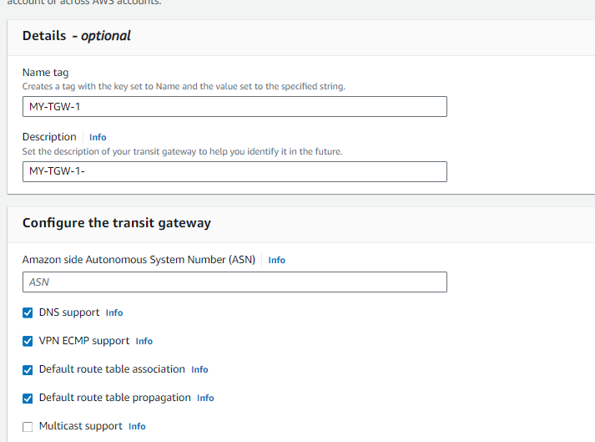

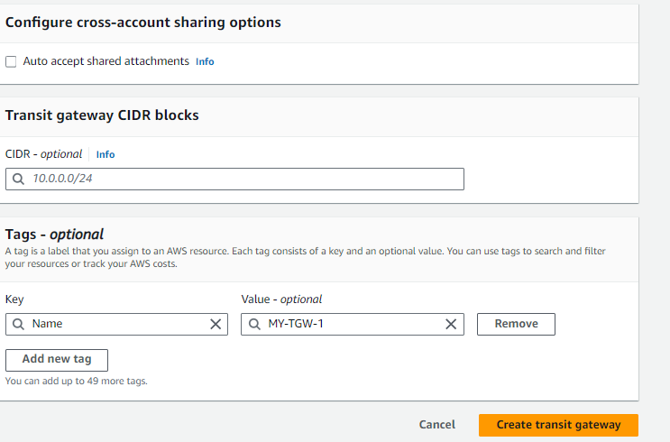

Now click on **Transit gateway attachments** and click on Create transit gateway attachment.

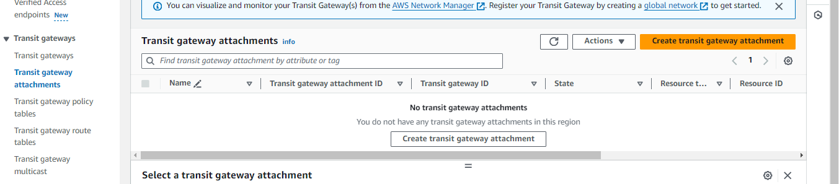

* Give name to attachment (MY-TGW-1), under Transit gateway ID, select our Transit gateway that we already created (my-TGW). Under VPC ID, select our VPC1 and finally click on Create transit gateway attachment.

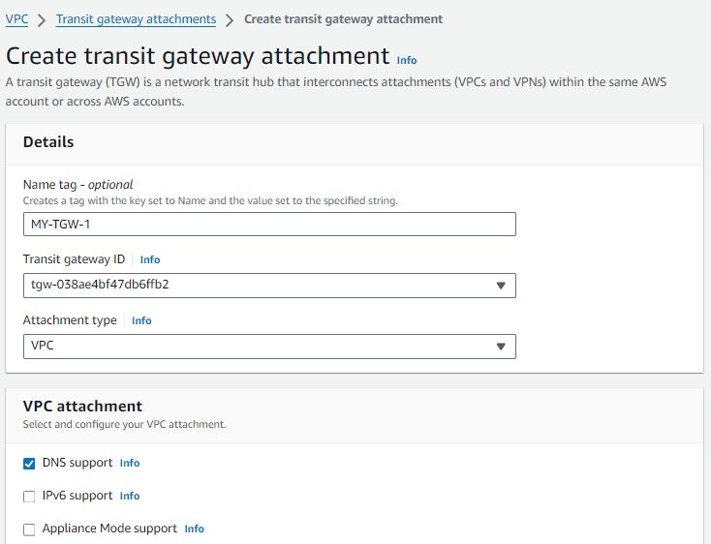

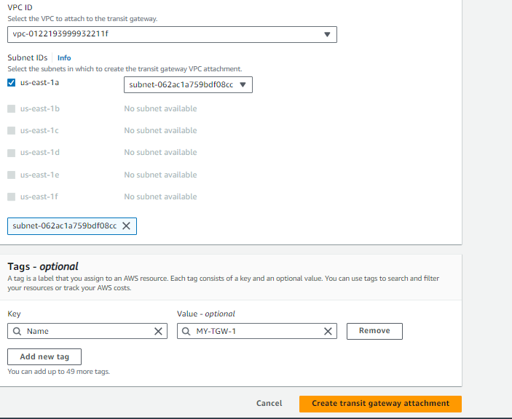

* Again click on Create transit gateway attachment, name the attachment (MY-TGW-2), under Transit gateway ID, select our Transit gateway. Under VPC ID, select our VPC2 and finally click on Create transit gateway attachment.

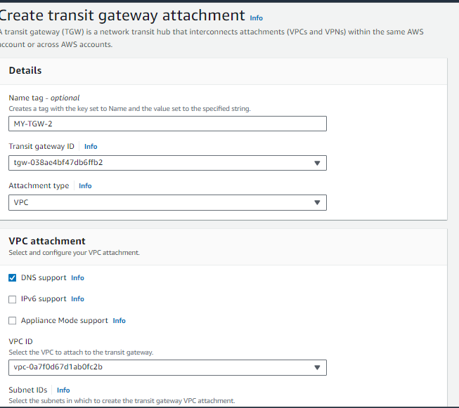

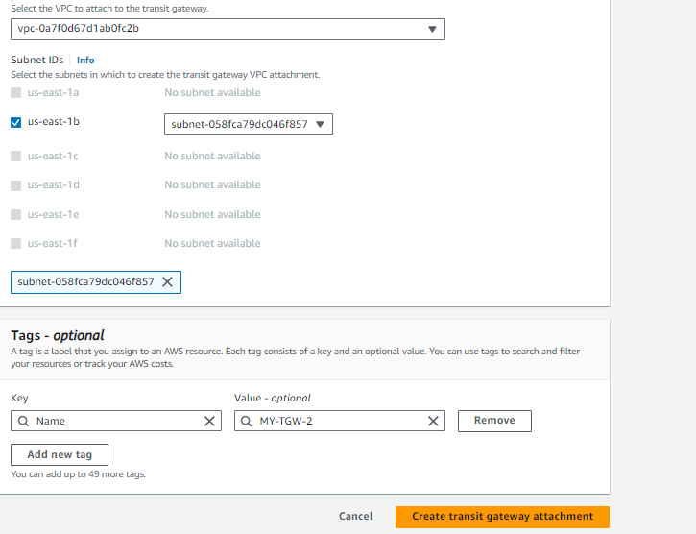

Do the same once more. Click on Create transit gateway attachment, name the attachment (MY-TGW-3), select our Transit gateway, and select our VPC3 Under VPC ID, and Create transit gateway attachment.

Go to **Route tables**, go to first route table (MY-ROUTE TABLE-1), click on **Actions**, click on **Edit routes,**

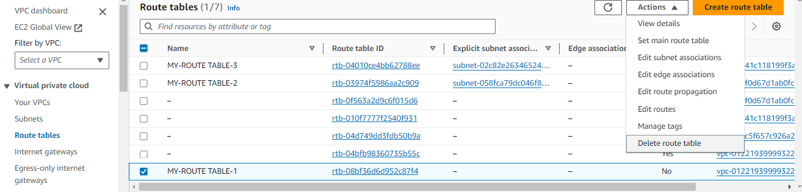

* First click on **Add route**, give Destination as 12.0.0.0/16, under Target, select Transit Gateway form drop down and select our Transit gateway attachment (MY-TGW-1). Again click on **Add route**, give Destination as 14.0.0.0/16, select Transit Gateway form drop down as Target and select our Transit gateway attachment (MY-TGW-1). Finally click on Save changes.

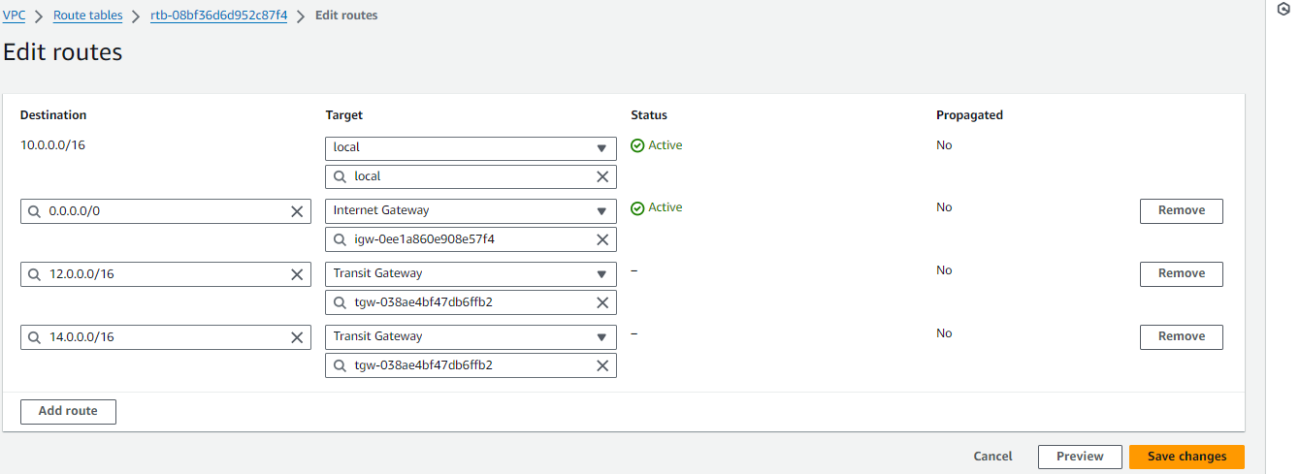

*Note: here we are in rote table one (MY-ROUTE TABLE-1), and its Destination is 10.0.0.0/16. So, we have to give another two IPv4 addresses as Destinations.

Now do the same for remaining two route tables. Go to second route table (MY-ROUTW TABLE-2), click on **Actions**, click on **Edit routes**. click on Add route, give Destination as 10.0.0.0/16, under Target, select Transit Gateway form drop down and select our Transit gateway attachment (MY-TGW-2). Again click on Add route, give Destination as 14.0.0.0/16, select Transit Gateway form drop down as Target and select our Transit gateway attachment (MY-TGW-2). Finally click on Save changes

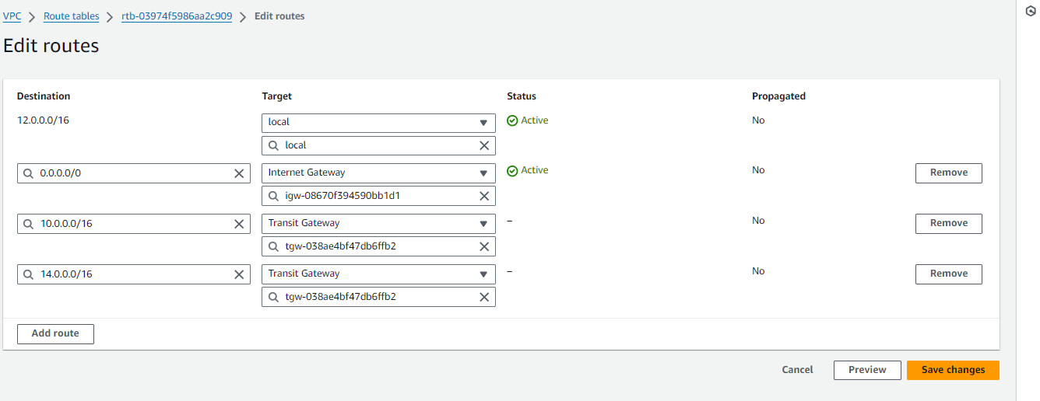

* Now do the same for third route table (gives Destinations as 10.0.0.0/16 and 12.0.0.0/16. And select Transit gateway (MY-TGW- 3). Have a look on below pic.

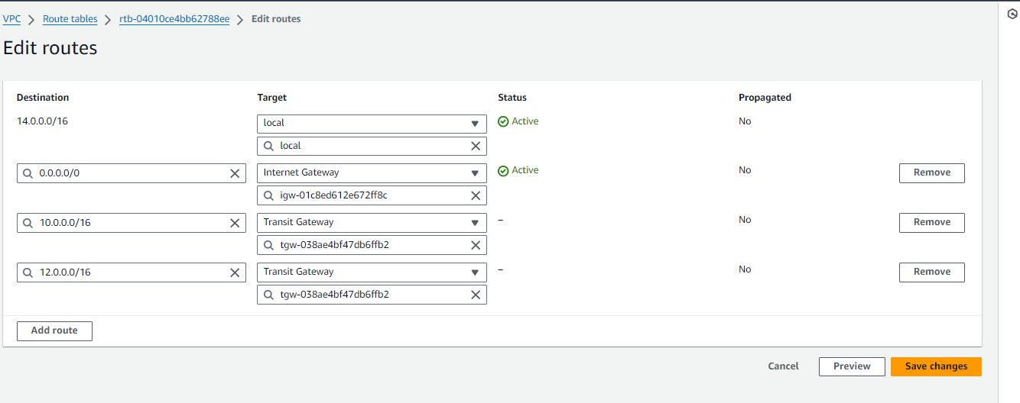

Now we are going launch three (3) instances.

Search for EC2 in search bar in AWS home page, click on EC2 under **Services**. And click on **instances** form menu and click on Launch instance.

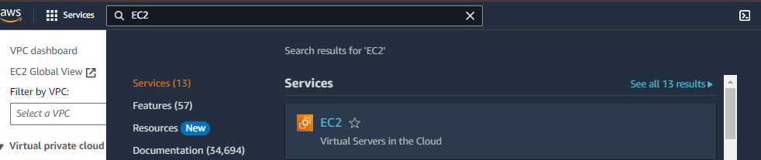

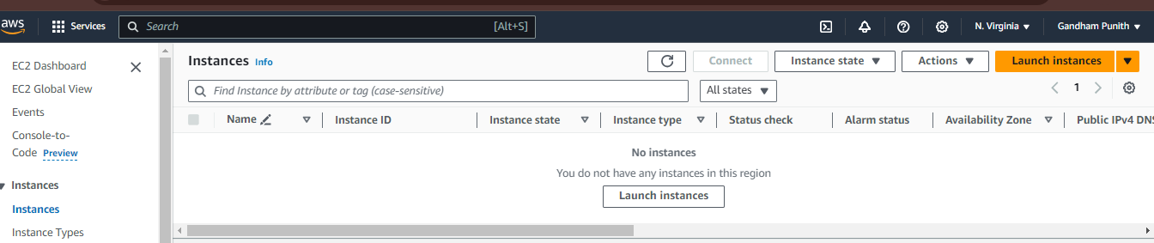

Give any name to our instance (ex: MY-EC2-1). Select OS of your choice (I have selected Amazon Linux) and instance type as t2.micro

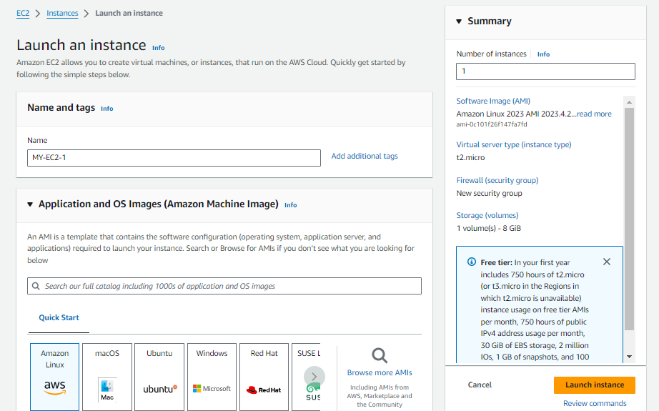

* We have to create a key pair. So, click on Create new key pair option. Give name to our key pair and click on Create key pair button.

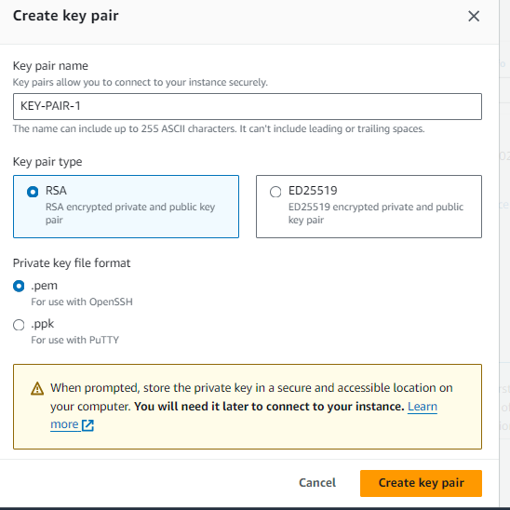

* In Network settings area, click on **Edit** button to configure with our custom VPCs.
* Under VPC section, select our VPC1. Enable Auto-assign public IP. Select Create security group (if we already have a security group, we can select Select existing security group option)

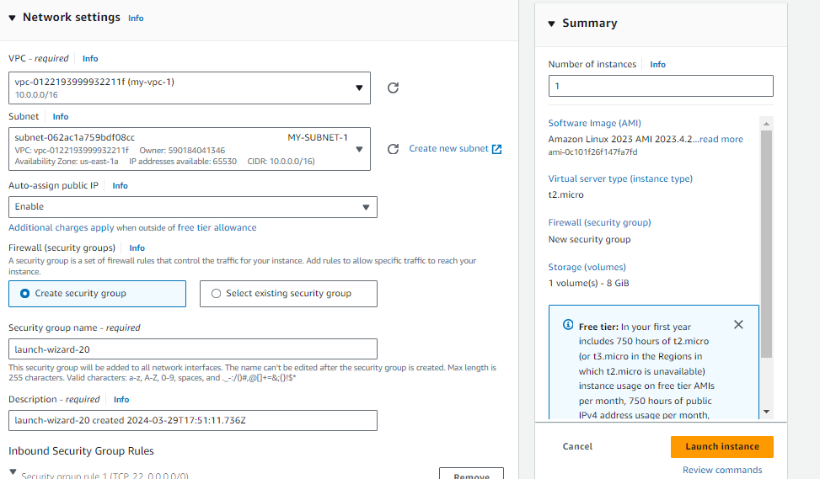

* Now launch two more instances in the same way as we launched our first instance. But we have change few things, observe the points below
* àfor second instance, name (MY-EC2-2), select the key pair under Key pair section that we already created when launching our first instance. Edit network settings, select VPC2, Give HTTP inbound rule and launch instance.
* à for third instance, name (MY-EC2-3), select the key pair, Edit network settings, select VPC3, Give HTTP inbound rule and launch instance.
* We have successfully launched our instances. Now, go to **Instances**

Go to instance one (MY-EC2-1), scroll down and click on **Security**. Now click on the link under **Security groups**

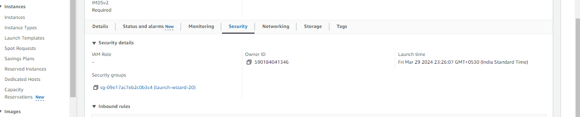

* Click on **Actions**, click on **Edit inbound rules**

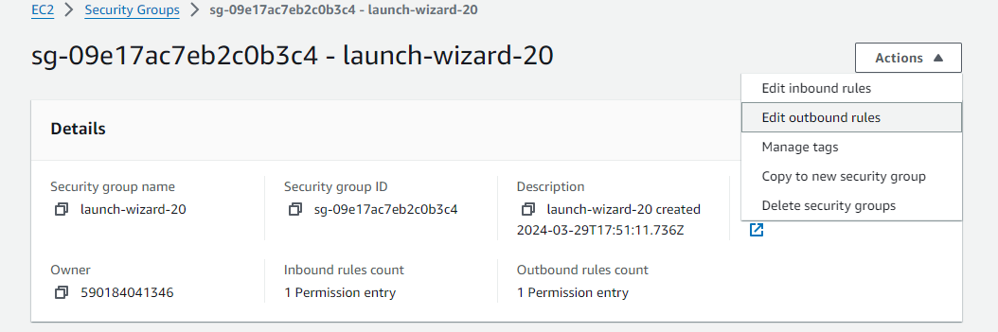

* Click on **Add rule**, select HTTP instead of Custom TCP and give 12.0.0.0/16 as Source. Add one more rule for HTTP and give source as 14.0.0.0/16. And click on Save rules.

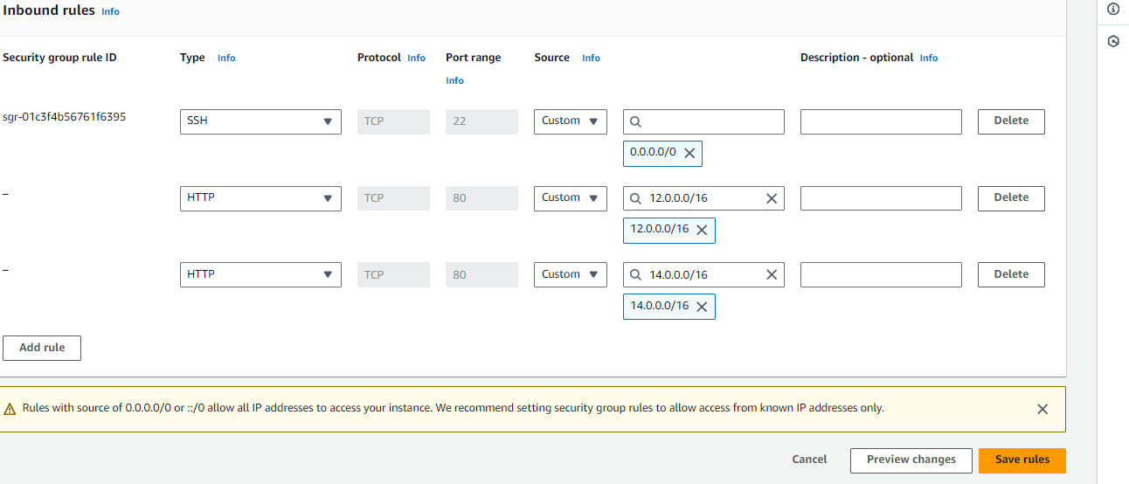

* Now go to second instance and do the same things. (add two rules with HTTP, one for source 10.0.0.0/16 and another one is for 14.0.0.0/16) and Save rules
* Now go to third instance and do the same things. (add two rules with HTTP, one for source 10.0.0.0/16 and another one is for 12.0.0.0/16)

* We have to connect to the instances/servers one by one.
* Go to instances, select first instance (MY-EC2-1) and click on **Connect** option and finally click on Connect button.
* 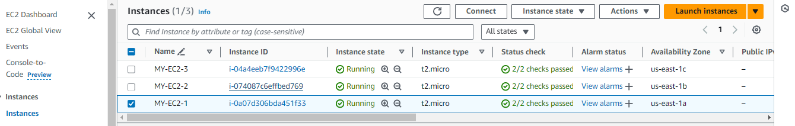
* 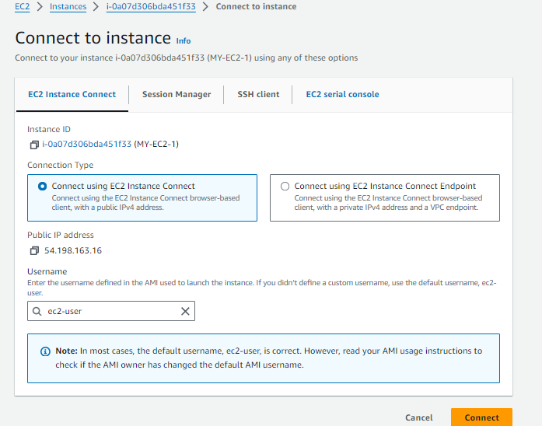
* After successful connection of our instance (server), give sudo -i to change to root user.

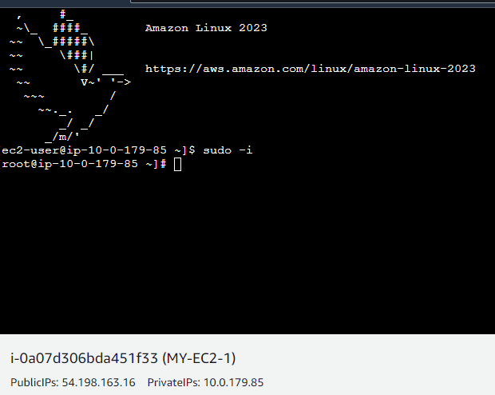

* I’m going to install nginx in connected server.

àyum update –y

àyum install nginx –y

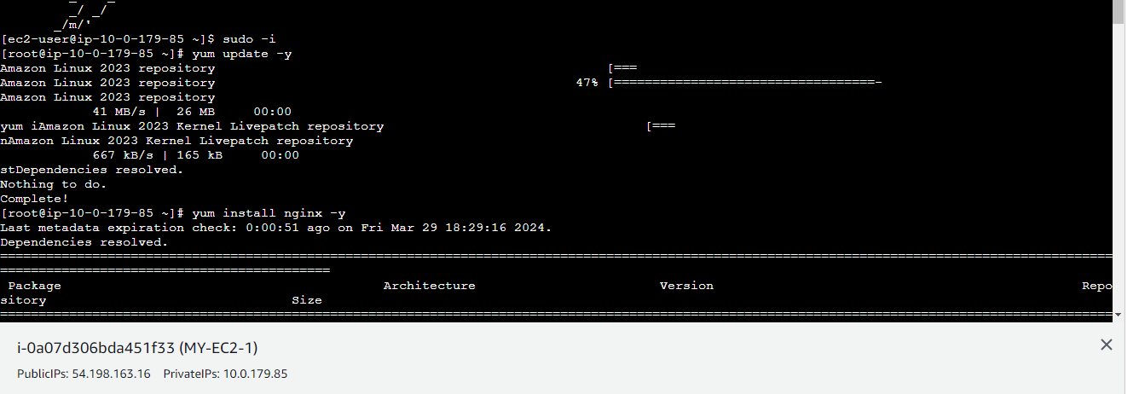

* After successful installation, will get Complete notification like below.

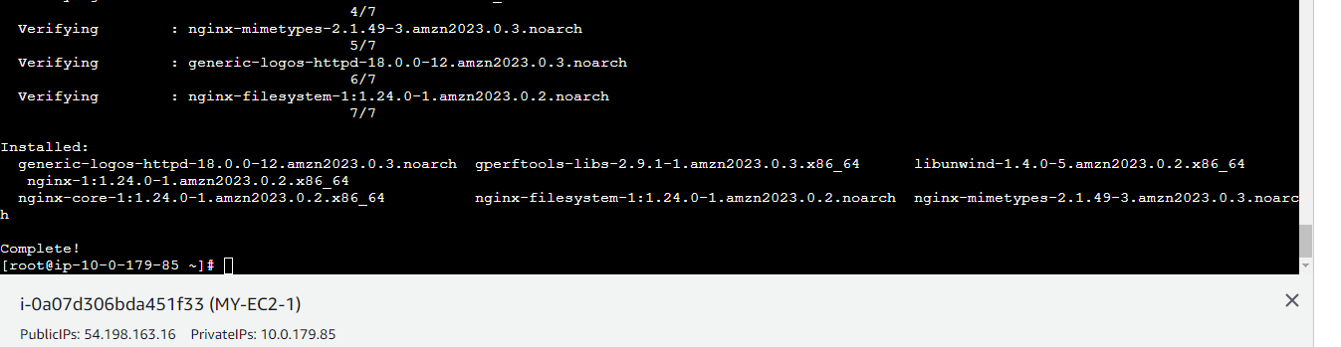

* Now go to cd /usr/share/nginx/html path, there we have an index.html file. Please remove it and create the same file (index.html) with our own content. And save the file.
* 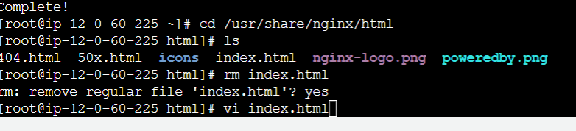
* Now restart nginx with following command

à systemctl restart nginx

* Now copy the public IP of connected server and use below command to see the connect in the index.html file

àcurl 10.0.61.125:80 (see the below pic for clarity)

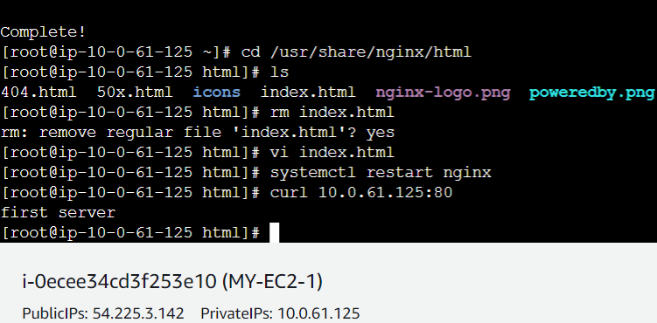

* Now connect to second instance (MY-EC2-2) and follow same process and commands (in index.html, type This is my instance2). Refer below pic

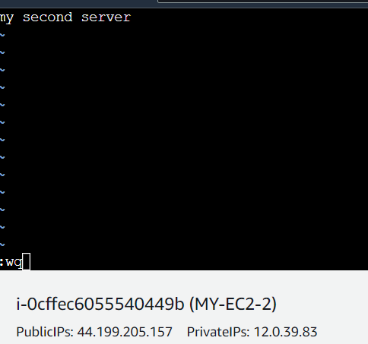

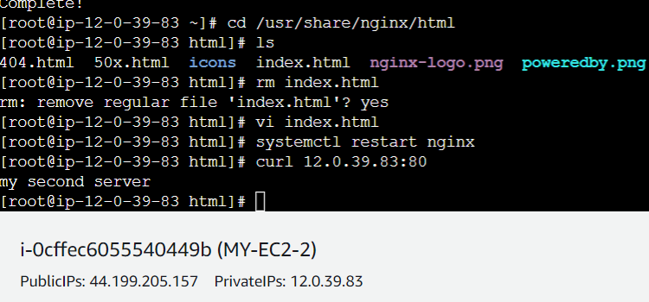

* Now connect to third instance (MY-EC2-3) and follow same process and commands (in index.html, type This is my instance3). Refer below pic

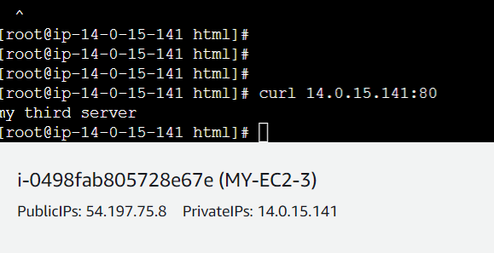

Now copy the private IP of any connected instance and go to another connected instance (for example I have copied the private IP of instance one i.e. our( MY-EC2-1) and paste that IP in third instance i.e. our( MY-EC2-3) and use curl command. Refer below pic

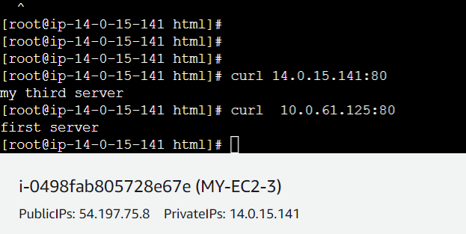

* If we observe above pic, I have copied the private IP of instance1 and pasted on instance3. And after using curl command we got – This is my instance1 content/message in instance3 (MY-EC2-3).
* So our Transit gateway task successfully completed.

.