1. Nanometers (one billionth of a metre) are used in nanotechnology.
2. Nanotubes are more flexible, resistant and durable than regular materials. They will be incorporated into all kinds of products, for example stain-resistant coating for clothes and scratch-resistant paints for cars
3. Doctors will be using expert systems to diagnose illnesses
4. 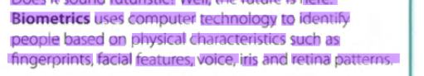
5. Ubiquitous computing is a new approach in which computer functions are integrated into everyday life, often in an invisible way. In the future people will interact naturally with hundreds of these smart devices (objects containing a microchip and memory) every day, each invisibly embedded in our environment and communicating with each other without cables.
6. 
7. 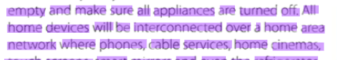
8. Nanobot
9. Android
10. Biometrics
11. Embedded
12. Appliances