**Importing Libraries**

In [2]:



**import** numpy **as** np

**import** pandas **as** pd

**import** matplotlib.pyplot **as** plt

**import** seaborn **as** sns

**from** sklearn.model_selection **import** train_test_split

​

In [3]:



df **=** pd.read_csv('Hours-Data.txt')

**DispLaying The Dataset**

In [9]:



df

Out[9]:

|  | **Hours** | **Scores** |
| --- | --- | --- |
| **0** | 2.5 | 21 |
| **1** | 5.1 | 47 |
| **2** | 3.2 | 27 |
| **3** | 8.5 | 75 |
| **4** | 3.5 | 30 |
| **5** | 1.5 | 20 |
| **6** | 9.2 | 88 |
| **7** | 5.5 | 60 |
| **8** | 8.3 | 81 |
| **9** | 2.7 | 25 |
| **10** | 7.7 | 85 |
| **11** | 5.9 | 62 |
| **12** | 4.5 | 41 |
| **13** | 3.3 | 42 |
| **14** | 1.1 | 17 |
| **15** | 8.9 | 95 |
| **16** | 2.5 | 30 |
| **17** | 1.9 | 24 |
| **18** | 6.1 | 67 |
| **19** | 7.4 | 69 |
| **20** | 2.7 | 30 |
| **21** | 4.8 | 54 |
| **22** | 3.8 | 35 |
| **23** | 6.9 | 76 |
| **24** | 7.8 | 86 |

In [7]:



df.head()

Out[7]:

|  | **Hours** | **Scores** |
| --- | --- | --- |
| **0** | 2.5 | 21 |
| **1** | 5.1 | 47 |
| **2** | 3.2 | 27 |
| **3** | 8.5 | 75 |
| **4** | 3.5 | 30 |

**Exploratory Data Analysis**

In [5]:



df.columns

​

Out[5]:

Index(['Hours', 'Scores'], dtype='object')

In [6]:



df.info()

<class 'pandas.core.frame.DataFrame'>

RangeIndex: 25 entries, 0 to 24

Data columns (total 2 columns):

# Column Non-Null Count Dtype

--- ------ -------------- -----

0 Hours 25 non-null float64

1 Scores 25 non-null int64

dtypes: float64(1), int64(1)

memory usage: 528.0 bytes

In [7]:



df.describe()

Out[7]:

|  | **Hours** | **Scores** |
| --- | --- | --- |
| **count** | 25.000000 | 25.000000 |
| **mean** | 5.012000 | 51.480000 |
| **std** | 2.525094 | 25.286887 |
| **min** | 1.100000 | 17.000000 |
| **25%** | 2.700000 | 30.000000 |
| **50%** | 4.800000 | 47.000000 |
| **75%** | 7.400000 | 75.000000 |
| **max** | 9.200000 | 95.000000 |

In [8]:



df.shape

Out[8]:

(25, 2)

In [9]:



**def** null_detection(df):

num_cols **=** []

count **=** 0

t **=** []

**for** i **in** num_cols:

z **=** np.abs(stats.zscore(df[i]))

**for** j **in** range(len(z)):

**if** z[j]**>**3 **or** z[j]**<-**3:

t.append(j)

count**+=**1

df **=** df.drop(list(set(t)))

df **=** df.reset_index()

df **=** df.drop('index', axis**=**1)

print(count)

**return** df

​

**Outlier Removal**

In [10]:



df **=** null_detection(df)

0

**Visualizing the Dataset**

In [11]:



plt.rcParams["figure.figsize"] **=** [10,5]

df.plot(kind**=**'line', x**=**'Scores', y**=**'Hours',style**=**'.',color**=**'blue',)

plt.xlabel('Scores')

plt.ylabel('Hours')

​

plt.grid()

plt.show()

​

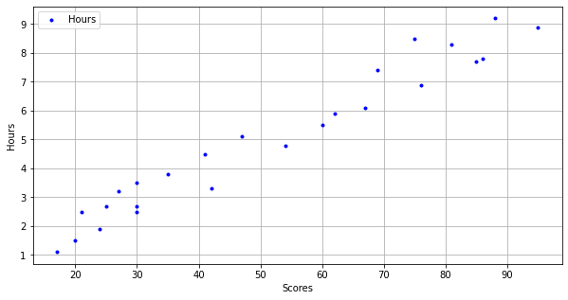

In [12]:



df.corr(method **=** 'pearson')

Out[12]:

|  | **Hours** | **Scores** |
| --- | --- | --- |
| **Hours** | 1.000000 | 0.976191 |
| **Scores** | 0.976191 | 1.000000 |

In [13]:



df.corr(method **=** 'spearman')

Out[13]:

|  | **Hours** | **Scores** |
| --- | --- | --- |
| **Hours** | 1.000000 | 0.971891 |
| **Scores** | 0.971891 | 1.000000 |

In [ ]:



​

**Data Preparation**

In [14]:



X **=** df.iloc[:, :1].values

Y **=** df.iloc[:, 1:].values

​

In [15]:



**from** sklearn.model_selection **import** train_test_split

X_train, X_test, Y_train, Y_test **=** train_test_split(X, Y, test_size**=**0.2 ,random_state**=**0)

**from** sklearn.linear_model **import** LinearRegression

model **=** LinearRegression()

model.fit(X_train , Y_train)

​

Out[15]:

LinearRegression()

**Visualizing the Model**

In [24]:



line **=** model.coef_**\***X **+** model.intercept_

​

plt.rcParams["figure.figsize"] **=** [10,5]

plt.scatter(X_train , Y_train,color**=** 'red')

plt.plot(X, line , color**=** 'yellow');

plt.xlabel('Hours')

plt.ylabel('Scores')

​

plt.grid()

plt.show()

​

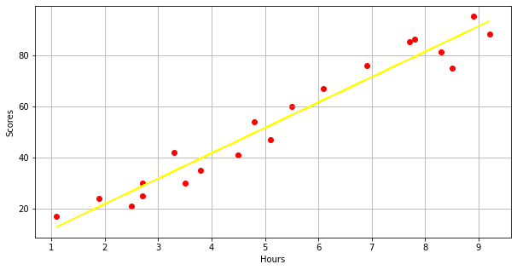

**Making Predictions**

In [17]:



print(X_test)

y_pred **=** model.predict(X_test)

[[1.5]

[3.2]

[7.4]

[2.5]

[5.9]]

In [18]:



Y_test

Out[18]:

array([[20],

[27],

[69],

[30],

[62]], dtype=int64)

In [19]:



y_pred

Out[19]:

array([[16.88414476],

[33.73226078],

[75.357018 ],

[26.79480124],

[60.49103328]])

In [20]:



comp**=** pd.DataFrame({'Actual':[Y_test],'Predictd':[y_pred]})

comp

​

Out[20]:

|  | **Actual** | **Predictd** |
| --- | --- | --- |
| **0** | [[20], [27], [69], [30], [62]] | [[16.884144762398037], [33.73226077948984], [7... |

In [21]:



hours **=** 8.69

my_pred **=** model.predict([[hours]])

print("The predicted score if a person sudies for", hours, "hours is", my_pred[0])

​

The predicted score if a person sudies for 8.69 hours is [88.14176486]

In [22]:



**from** sklearn **import** metrics

​

print('Mean Absolute Error:',metrics.mean_absolute_error(Y_test, y_pred))

​

Mean Absolute Error: 4.183859899002975