Part 1:
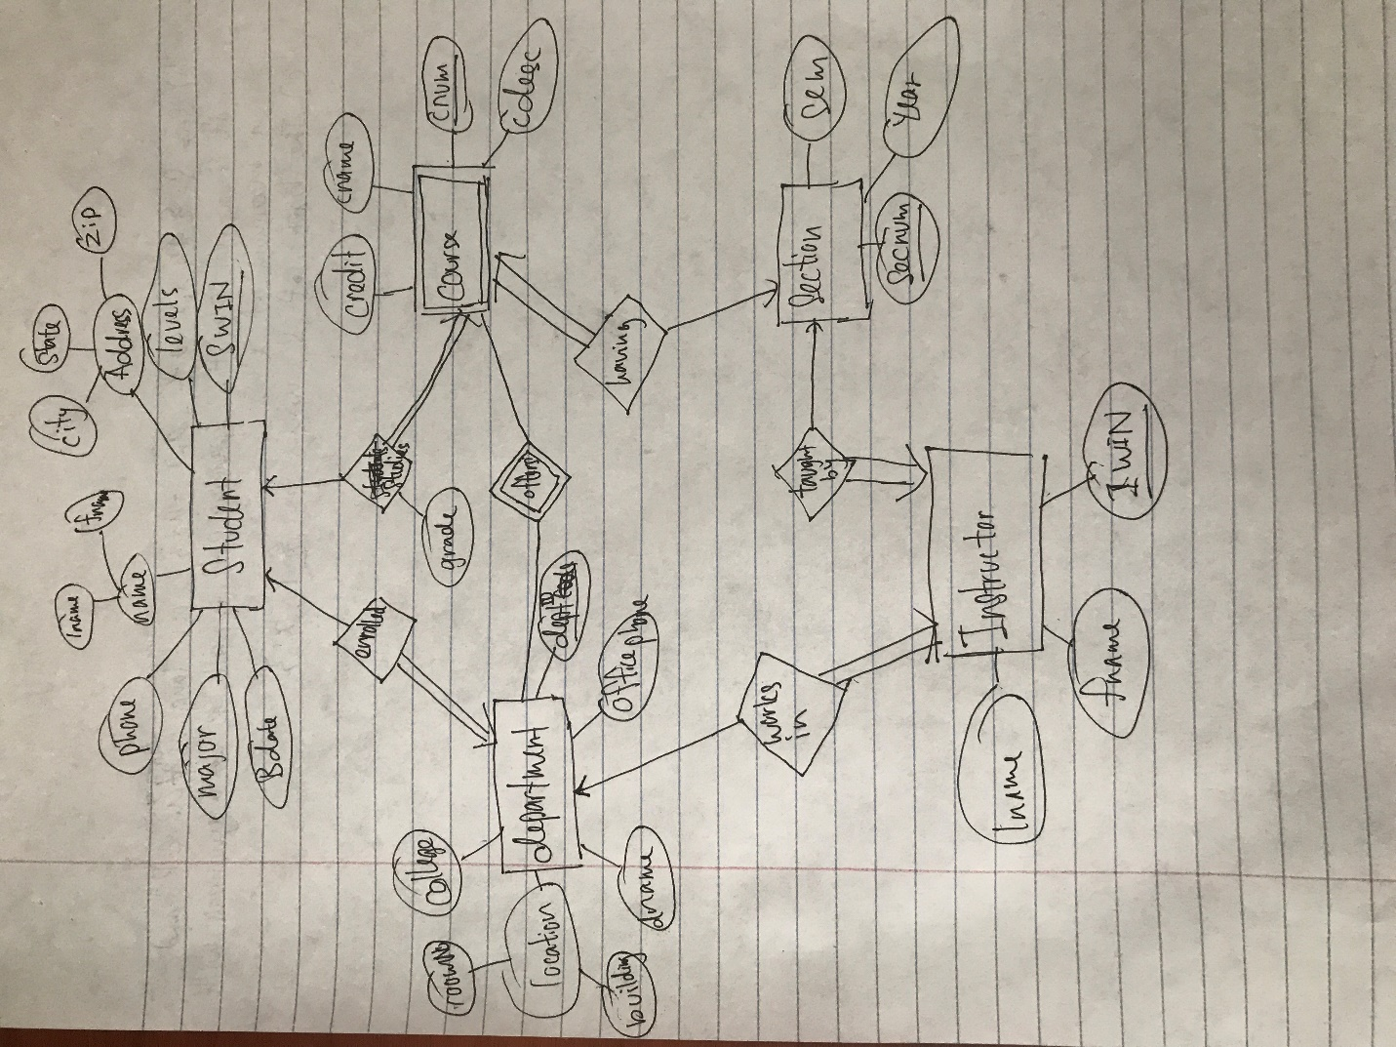
Create table Student(
fname varchar(30),lname varchar (30),SWIN int, major VARCHAR(40), levels varchar(20), sex varchar (10), bdate date, phone varchar(30), city varchar(30), state varchar(2), zip varchar(10), deptID varchar (4) REFERENCES Department(deptID), PRIMARY KEY(SWIN)
);
Create table Department(
deptID int, officephone int, dname varchar(50), building varchar(30), roomNo varchar(4), college varchar(50),
Primary key(deptID)
);
Create table Instructor(
IWIN int, fname varchar(30),lname varchar (30),
deptID varchar(4) references Department(deptID),Primary key(IWIN)
);
Create table Section(
secnum int, IWIN int, sem int, year int, cnum int,
PRIMARY KEY(secnum), foreign key (IWIN) references Instructor(IWIN),
Foreign key (cnum) references Course(cnum)
);
Create table Course(
cnum int, cname varchar(40), cdesc varchar (1000), credit int, deptID varchar(4),
PRIMARY KEY (cnum,deptID), foreign key(deptID) references Department(deptID)
);
Create table Studies(
SWIN int, cnum int, grade varchar(2),
foreign key(SWIN) references Student(SWIN), foreign key(cnum) reference Course(cnum)
);

Part 2
- Keys: B; 2NF; R1(B,C), R2(C,D), R3(A,C)
- Keys: B,D ; 1NF; R1(B,C), R2(B,D), R3(A,D)
- Keys: ABC,BCD ; 3NF; No BCNF
- Keys: A; 2NF; R1(A,B,C), R2(B,C,D)
- Keys: AB,BC,AD,CD; 3NF; No BCNF

