Design principles & Patterns

Exercise 1: Implementing the Singleton Pattern

# Logger.java

public class Logger {

private static Logger instance;

private Logger() {
System.out.println("Logger Started");
}

public static Logger getInstance() {
if (instance == null) {
instance = new Logger();
return instance;
}

public void log(String message) {
System.out.println("Log: " + message);
}
}

# Main.java

public class Main {
public static void main(String[] args) {

Logger logger1 = Logger.getInstance();
Logger logger2 = Logger.getInstance();

logger1.log("First log message");
logger2.log("Second log message");

if (logger1 == logger2) {
System.out.println("Both are same Logger object");
} else {
System.out.println("Different objects (not singleton)");
}
}
}

OUTPUT

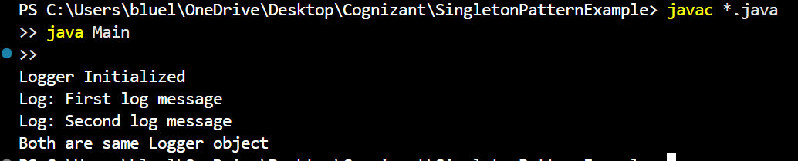

Exercise 2: Implementing the Factory Method Pattern

# Document.java

public interface Document {
void open();
}

# DocumentFactory.java

public abstract class DocumentFactory {
public abstract Document createDocument();
}

#ExcelDocument.java
public class ExcelDocument implements Document {
public void open() {
System.out.println("Opening Excel Document");
}
}

#ExcelFactory.java

public class ExcelFactory extends DocumentFactory {
public Document createDocument() {
return new ExcelDocument();
}
}

# Main.java

public class Main {
public static void main(String[] args) {
DocumentFactory factory;

factory = new WordFactory();
Document doc1 = factory.createDocument();
doc1.open();

factory = new PdfFactory();
Document doc2 = factory.createDocument();
doc2.open();

factory = new ExcelFactory();
Document doc3 = factory.createDocument();
doc3.open();
}
}

# PdfDocument.java

public class PdfDocument implements Document {
public void open() {
System.out.println("Opening PDF Document");
}
}

# PdfFactory.java

public class PdfFactory extends DocumentFactory {

public Document createDocument() {
return new PdfDocument();
}
}

# WordDocument.java

public class WordDocument implements Document {
public void open() {
System.out.println("Opening Word Document");
}
}

# WordFactory.java

public class WordFactory extends DocumentFactory {
public Document createDocument() {
return new WordDocument();
}
}

OUTPUT

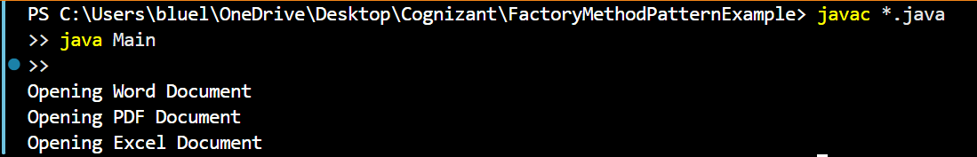

Algorithms_DataStructures

Exercise 2: E-commerce Platform Search Function

# Product.java

public class Product {
int productId;
String productName;
String category;

public Product(int productId, String productName, String category) {
this.productId = productId;
this.productName = productName;
this.category = category;
}
}

# LinearSearch.java

public class LinearSearch {
public static Product search(Product[] products, String name) {
for (Product p : products) {
if (p.productName.equalsIgnoreCase(name)) {
return p;
}
}
return null;
}
}

# BinarySearch.java

import java.util.Arrays;
import java.util.Comparator;

public class BinarySearch {
public static Product search(Product[] products, String name) {
Arrays.sort(products, Comparator.comparing(p -> p.productName.toLowerCase()));

int left = 0;
int right = products.length - 1;

while (left <= right) {
int mid = (left + right) / 2;
int compare = name.compareToIgnoreCase(products[mid].productName);

if (compare == 0) return products[mid];
else if (compare < 0) right = mid - 1;
else left = mid + 1;
}
return null;
}
}

# Main.java

public class Main {
public static void main(String[] args) {
Product[] products = {
new Product(1, "Laptop", "Electronics"),
new Product(2, "Shoes", "Fashion"),
new Product(3, "Watch", "Accessories"),
new Product(4, "Mobile", "Electronics")
};

// Linear Search
Product p1 = LinearSearch.search(products, "Shoes");
System.out.println("Linear Search Result: " + (p1 != null ? p1.productName : "Not Found"));

// Binary Search
Product p2 = BinarySearch.search(products, "Mobile");
System.out.println("Binary Search Result: " + (p2 != null ? p2.productName : "Not Found"));
}
}

#OUTPUT
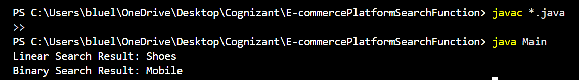

Exercise 7: Financial Forecasting
# FinancialForecasting.java

public class FinancialForecast {

public static double forecast(double presentValue, double rate, int years) {
if (years == 0) return presentValue;
return forecast(presentValue, rate, years - 1) * (1 + rate);
}

public static void main(String[] args) {
double presentValue = 10000.0;
double growthRate = 0.05;
int years = 5;

double futureValue = forecast(presentValue, growthRate, years);
System.out.printf("Forecasted value after %d years: Rs%.2f\n", years, futureValue);
}
}

#Output

