Exercise 4.3 D3 set up

Aim
Use D3 to generate a simple bar chart from a csv file to replace a static chart on your Energy Consumption website.

Purpose
So far you have processed some data and generated some charts using KNIME and/or Excel and displayed them as images in a webpage. However, your ability to customise the chart and allow the user to interact was very limited. In this exercise we will use D3 to build a bar chart of some data from the TV energy consumption data set.
While it is possible to get GenAI to write you code for creating a bar chart with our data set, it is suggested that you work through these exercises so you can see how the data and svgs are attached to the DOM using D3.
Exercises 4.3 to 4.7 will build to create a visualisation to display in your Demonstration 3.
Github Classroom Link
Links to an external site.

Preparation
These exercises are based on Dufour and Meeks (2024). For more detail on any of the steps please review Chapter 2
Links to an external site.
and Chapter 3
Links to an external site.
Make sure you have a server running in VS Code so can load the data! The Live Server extension is easiest way to do this!
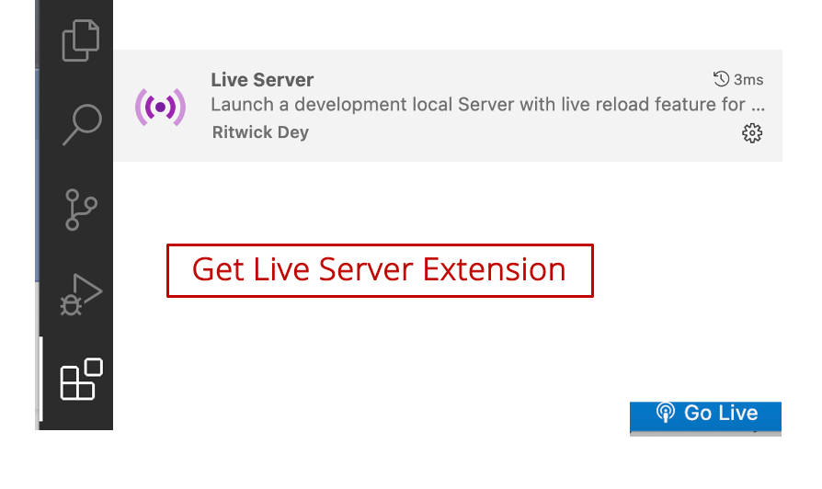

Step 1: Delete code from Exercise 4.2
Delete the D3 code you used for the previous exercise except for those loading the D3 library and your d3 js file.

Step 2: Add a class to help us style the container for our svg elements.
To make sure our D3 generated svgs are responsive to different screen sizes and windows, we will set up a div class to define the style of the canvas the D3 code will sit within.
To do this you will need to add code to your:
    - index.html and
    - style.css.

CSS: Add class to css which will make svg container responsive to changes in window size etc
This CSS code will help make sure or content is centred nicely and changes its size relative to its parent element (e.g., <body></body>).
.responsive-svg-container {
margin-right: auto;
margin-left: auto;
width: 100%;
max-width: 1200px;

Index.html: Apply the new class to a div that will contain our SVG elements
<div class="responsive-svg-container"></div>

Step 2: Create svg object within the new div
Create an svg object in the responsive-svg-container using D3.
To make sure the content of our svg is scaled and positioned properly, we can use the viewBox attribute. We will also add a border around our svg canvas so we can see its boundaries. A border is not necessary for your final visualisation.
const svg = d3.select(".responsive-svg-container")
.append("svg")
.attr("viewBox", "0 0 1200 1600")
.style("border", "1px solid black");
You should now see a box which changes shape when you change the size of the window.

Step 3: Add a test svg rectangle
Add a svg object to the canvas using D3 and define as a rectangle:
svg
.append("rect")
.attr("x", 10)
.attr("y", 10)
.attr("width", 414)
.attr("height", 16)
.attr("fill", "blue");
You should see a long thin rectangle at the top of the svg canvas.
Currently we have 'hard coded' the attributes of the svg. Our next step will be to use the data from an csv file to provide the attributes of a svg.

Exercise 4.4 Load data from CSV

Aim
Learn how to load and format data so it is ready for D3.

Purpose
Previously we have processed our data in KNIME. We have used nodes such as GroupBy to obtain summary tables of our data for attributes such as Screen Technology or Brand which we have plotted in KNIME.
In this activity we will look at loading data from a CSV file into D3 so it is ready to chart.

Preparation
Make sure you have a 'data' folder in your project.
Use the KNIME CSV Writer node to write one of your data summary tables to a csv file and add the new csv to your data folder.
The csv should have at least one category attribute (e.g., brand, screen technology, screensize (as a string)) and one numerical attribute (e.g., count, Star2, Labelled energy consumption etc).
To understand how to complete the programming parts of this activity it is recommended that you review and Chapter 3 of Dufour and Meeks (2024).

Step 1: Use row conversion function, d3.csv(), to give D3 access to data
To read in your data use the following code:
d3.csv("../data/name_of_data_file.csv", d => {
console.log(d);
}
);
Make sure you use the exact name of your csv file and your file is in the data directory.

Step 2: Check browser console tab for java objects created from your data set
When your data is loaded it should look something line this:
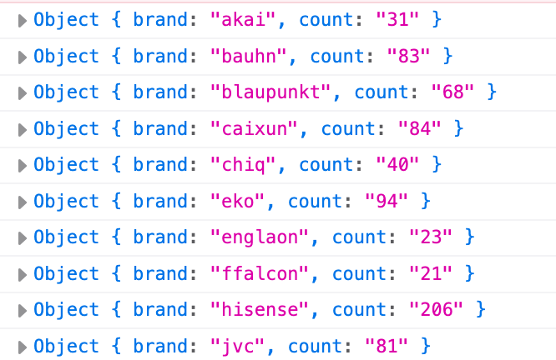
Unfortunately, the import process has interpreted the count data as a string. The next step in the process is making sure our data is typed correctly when it is imported.
We can access the data as it is imported using the d parameter and dot notation. +d.count is used to read the count attribute column in as a number.
d3.csv("../data/tvBrandCount.csv", d => {
return {
brand: d.brand,
count: +d.count
};
For this to work the column names in the file and the code need to match exactly.
To see the data in the console again add:
d3.csv("../data/tvBrandCount.csv", d => {
return {
brand: d.brand,
count: +d.count. //=> converts to number
};

}).then(data => {
console.log(data);
});
If you check the console you can see it has also created an array and the count attribute is not marked as string data:
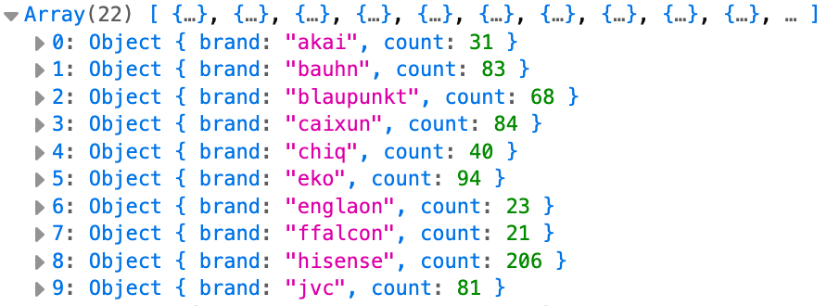

Step 3: Finding information about the data set
For some functions later on it can be handy to know some basic features of our data set. Practice calling these and viewing them in the console.
}).then(data => {
console.log(data);
console.log(data.length);
console.log(d3.max(data, d => d.count));
console.log(d3.min(data, d => d.count));
console.log(d3.extent(data, d => d.count)); //=> array with min and max
You will able to see these values printed to the console:
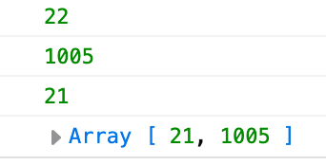
As you may have discovered when exploring data sets in KNIME, unordered data is difficult to interpret. You can use a JavaScript sort() method to sort the data for you. If you are not sure how to do this ask GenAI!
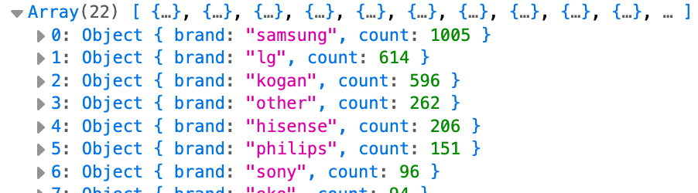
Finally we are ready to start creating the visualisation. To help make our code tidy we are going to pass the data to a new function that will take our data and build the visualisation.
CreateBarChart(data);
Make sure this function is called within the .then promise.
To make our code more modularised we will define our visualisation as a constant and call it with the data:
const createBarChart = (data) => {
We are now ready to start binding our data to DOM elements (e.g., SVGs)!
In the next exercise we will build the createBarChart function.

Exercise 4.5 D3 Binding and drawing with data

Aim
Use the data in the dataset to draw svgs for visualisation.

Purpose
We now have the data ready to go. Now we just have to use the bind the data to a set of rectangles which will become the bars in our bar chart.

Preparation
To understand how to complete the programming parts of this activity it is recommended that you review and Chapter 3 of Dufour and Meeks (2024).

Step 1: Bind the data to DOM elements
First add the function that will build the chart.
const createBarChart = data => {

};
To bind the data, we need to create an svg object that selects the elements we want to add to represent our data (e.g., svg rectangles). We then pass the data into the selection and join it to the selected elements (e.g., the rectangles).
const createBarChart = data => {

svg
.selectAll("rect")
.data(data)
.join("rect")
};
If you check the DOM you can see all the rectangles loaded in.
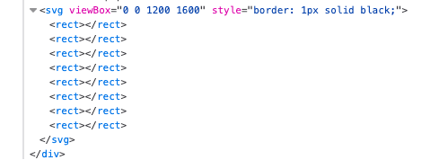
Now we just have to draw them using data from our data set.
To make it easier to update and change styling we can assign a class attribute to our bar rectangles and associate it with the count data:
svg
.selectAll("rect")
.data(data)
.join("rect")
.attr("class", d => {
console.log(d);
return `bar bar-${d.count}`;
})
If you check the DOM you will now see the rects have a class name which is associated with their count value:
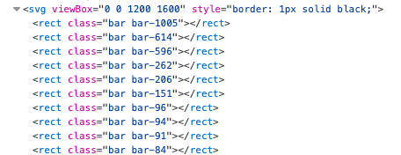
Now we just have to work out the layout for our bars: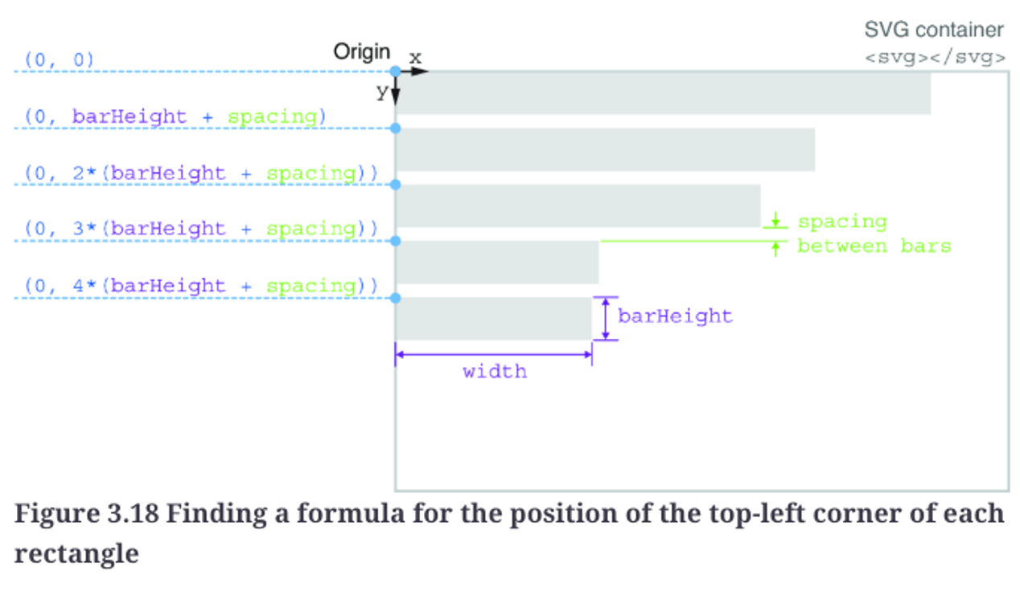

Dufour & Meeks (2024) Ch3

Step 2: Add attributes (.attr) to your bar chart for width and height
The width of the bars should be relative to the count data and bar height should be a constant.
You should have something like this in the DOM when you are done:
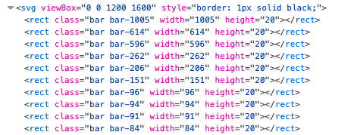
At this point you wont see much as the bars are all drawn on top of each other. You will need to specify the x and y coordinates of rectangles to space them out.

Step 3: Space out the bars
The x is easy, from the diagram you can tell it will aways be the same (i.e., 0) (although you might like to leave some room to add labels later).
For the y you need to take into account its position in the data set and add some spacing between the bars. Check lecture notes or Dufour & Meeks (2024) Ch3 for ideas about how to do this (or use GenAI).
At the end of this exercise you should have something like this:
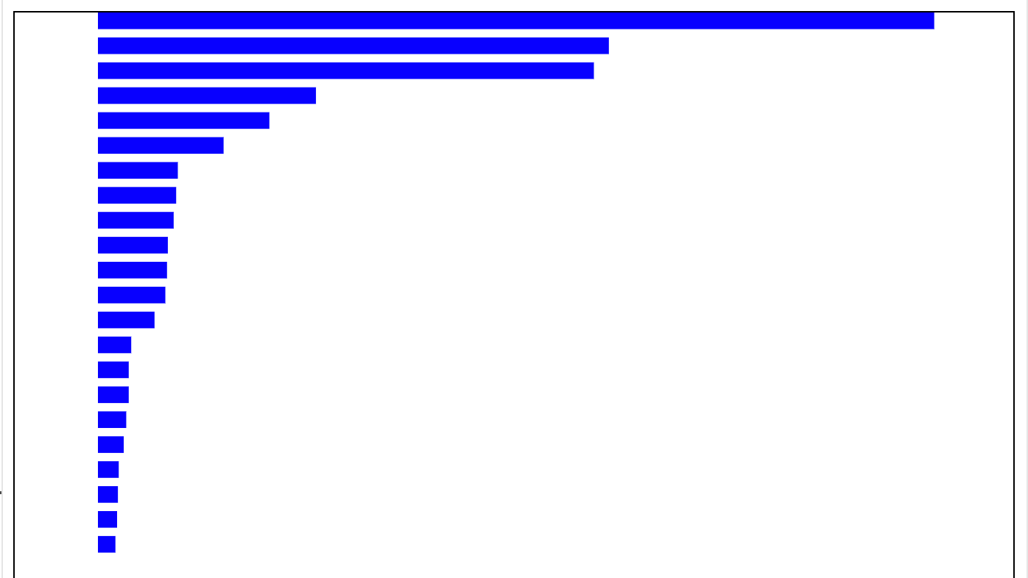
Currently this chart is not very useful. It won't adapt if the data point is larger than the svg size (try changing SVG width to less than your highest count and see what happens) and it doesn't have labels so we don't know what the columns represent.
In the next exercise we will add scaling so chart adapts to different svg sizes.

Exercise 4.6 Scaling charts

Aim
Make chart adaptable to different size svgs.

Purpose
Sometimes you may not be able to take up the whole window for your chart, it may need to fit in a specified size. If your data is one-to-one with pixels, it may not fit. Using scales will make sure your chart always fits into the available space.
D3 has a number of scales to help make your data fit. For this exercise we will be looking at the two most common: d3.scale:linear () (for continuous data) and d3.scaleBand() (for discrete (categorical) data).
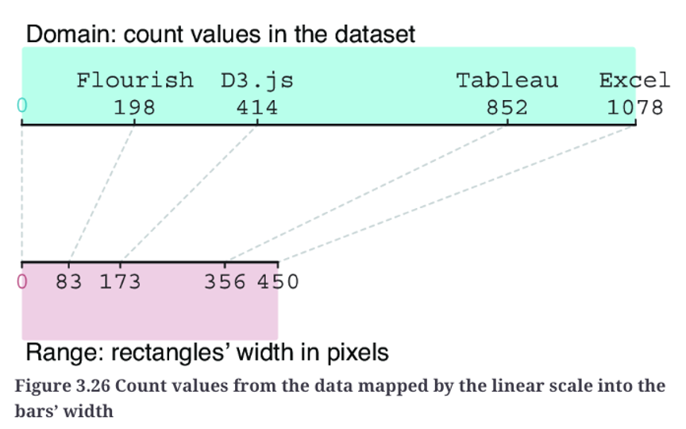
Dufour and Meeks (2024)

Preparation
Complete Exercise 4.6 change your viewBox to a value such that your chart does not fit (e.g.,) so you can see your scales in action (the width value may need to be different due to your particular data set):
const svg = d3.select(".responsive-svg-container")
.append("svg")
.attr("viewBox", "0 0 500 1600")
.style("border", "1px solid black");
To understand how to complete the programming parts of this activity it is recommended that you review and Chapter 3 of Dufour and Meeks (2024).

Step 1: Add Linear scale for count data
To start we will make sure our qualitative data (e.g., TV counts) fits in the svg. This data is being plotted on the x-axis so we will make it an xScale.
The first step in making your scale is to create a constant that specifies the min and max of the domain (your data set) and the range (size of your svg canvas). This constant should appear in the createBarChart function, but before the svg.
const xScale = d3.scaleLinear()
.domain([0, 1310])
.range([0, 500]);
Update the width attribute so the no matter the size of the domain or the svg canvas is the data will always fit nicely.

Step 2: Add a band scale
The band scale will be used to make adjustments based on the number of categories on the y-axis.
const yScale = d3.scaleBand()
.domain(data.map(d => d.brand))
.range([0, 500]);
Update the height and y attributes so that the chart scales according to the number of categories and the size of the range (see Dufour and Meeks or lecture notes if you have trouble with this).
You should end up with something like this:
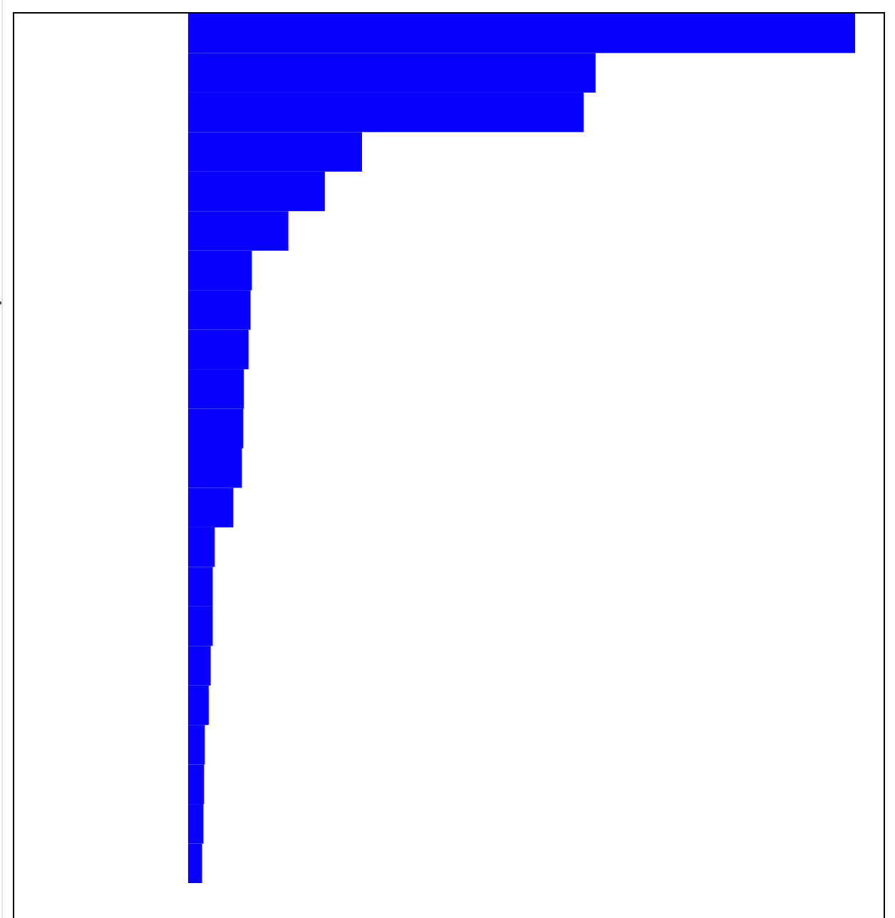
Obviously this in still not quite right so you will need to add some padding to the yScale to make sure there is a gap between the bars.
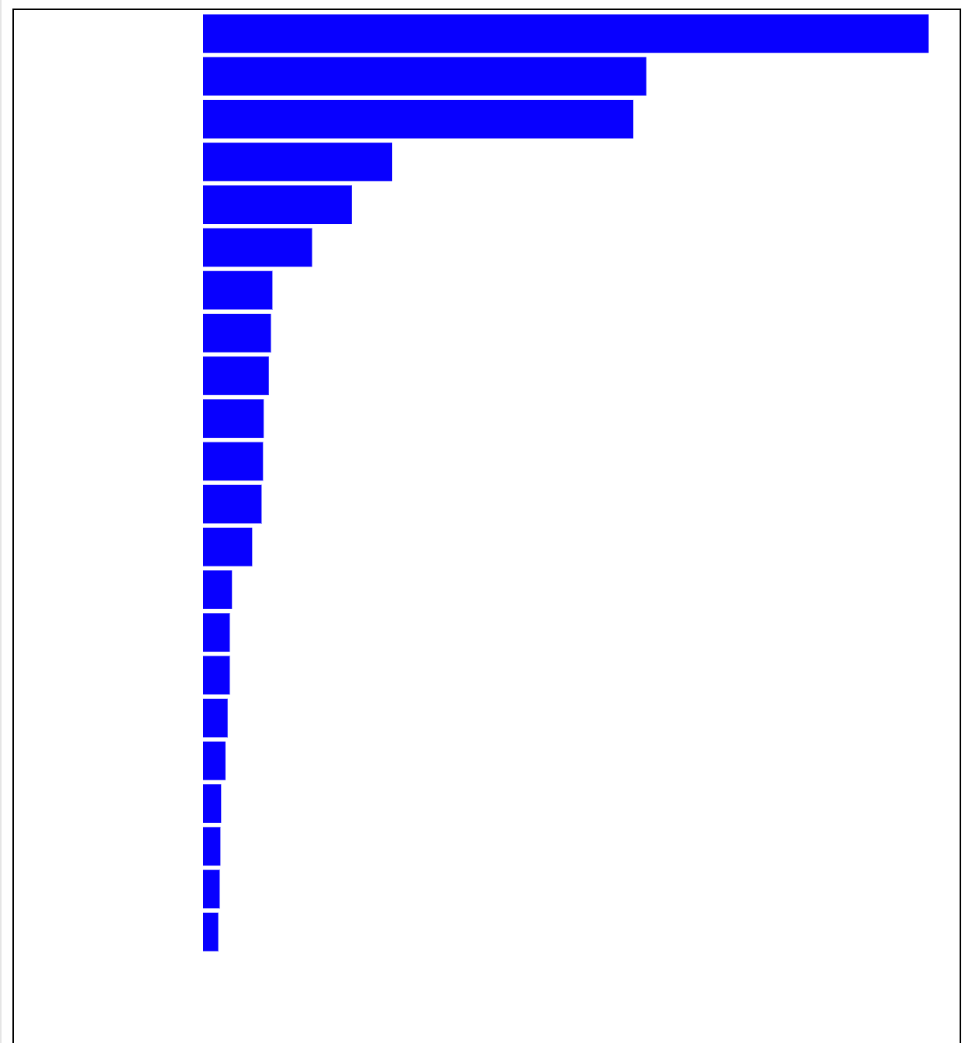
Our chart is looking more like a proper bar chart. However it still needs labels. So in the next exercise we will add labels!

Exercise 4.7 Adding labels

Aim
Add labels to chart.

Purpose
A chart without labels is not very useful. In this exercise you will add labels to the bar chart created in the previous exercise.

Preparation
Completed Exercise 4.7.
To understand how to complete the programming parts of this activity it is recommended that you review and Chapter 3 of Dufour and Meeks (2024).

Step 1: Comment out all rectangle attributes
To add labels we will need to form a group container that attaches the label and it's associated rectangle together. To make this happen we will be replacing the current code for generating the rectangles. We still need the rectangle attributes we currently have, so commented them out or paste them somewhere you can retrieve them.

Step 2: Add an object to hold groups (of text and rectangles)
We want our labels and rectangles to move together. The best way to do this is to create a group that contains both.
Create a new g selection that will keep our bars and labels together.
const barAndLabel = svg
.selectAll("g")
.data(data)
.join("g")
then use transform and translate to make sure these move together relative to the yScale:
.attr("transform", d => `translate(0, ${yScale(d.brand)})`);

Step 3: Add back the rectangles
Create another selection for the barAndLabel group, this time to add the rectangles
barAndLabel
.append("rect")
This code now generates the rectangles. Add the rectangle attr code that you commented out earlier. However, note that the y-coordinate is now being specified at the group so it can be set to 0 in the rect object.

Step 3: Add the category text
Create another selection for the category text.
barAndLabel
.append("text")
.text(d => d.brand)
You will notice that the text may not be well aligned with the bars. You will need to adjust the highlighted values until they properly line up.
...
.attr("x", 100)
.attr("y", 15)
.attr("text-anchor", "end")
.style("font-family", "sans-serif")
.style("font-size", "13px");
Finally, add text displaying the count for each category (which may also require some trial and error to find the right spot):
barAndLabel
.append("text")
.text(d => d.count)
.attr("x", d => 100 + xScale(d.count) + 4)
.attr("y", 12)
.style("font-family", "sans-serif")
.style("font-size", "13px");
After adjusting the x and y, you should end up with something like this:
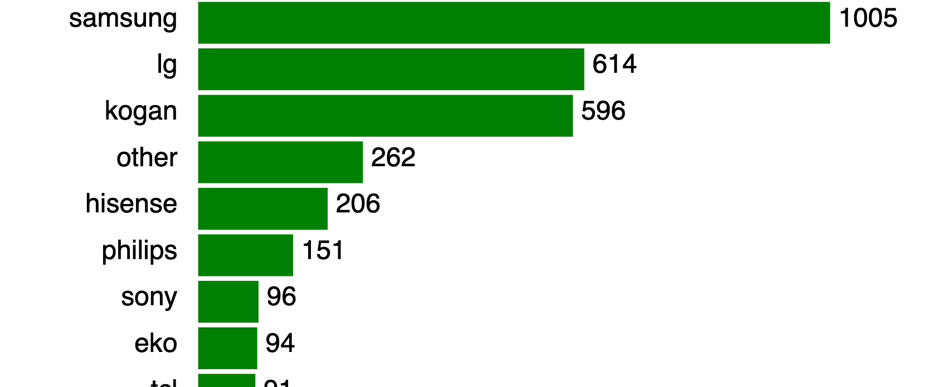
Fantastic! You have now created a bar chart in D3.
Add your chart to your web page.
Try using this code to make more bar charts of other data sets you analysed for the tv data set....

Exercise 5 Multi-chart webpage

Aim
Create a variety of different chart types using D3.

Purpose
So far we have learnt a lot just by making a simple horizontal bar chart. In this activity we take it a few steps further to make a variety of common chart types. A set of csv files have been prepared that will allow you to make the following charts:
TV data energy consumption data
    - Scatter plot (energy consumption vs star rating)
    - Donut-chart (energy consumption for different screen technologies across all TVs combined)
    - Bar chart (energy consumption for different screen technologies for 55inch TVs only)
    - Line chart (spot power prices from 1998 to 2024) (you can plot average only, or have a line for each state)
You can use your own data sets and questions, or the ones provided,
Download ones provided,
but you must have an example of each chart type.

Preparation
It is recommended that you review this week's lecture and review Chapter 4 and 5 of Dufour and Meeks (2024).

Slides
COS30045 W5 Class.pdf
Download COS30045 W5 Class.pdf

GitHub Repository
Start a repository for this code in our GitHub Classroom
Links to an external site.
for this exercise.

Requirements
Your charts should all appear on the one web page. Each chart should have its own js file.
They should change size depending on the size of the user's window.
They should be well placed on the screen and ideally include some introductory text.
The following is an example of the type of thing you should be aiming for:
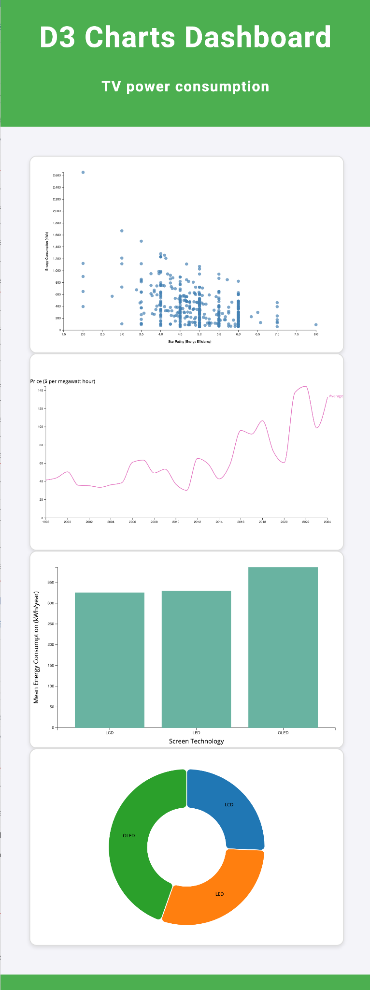
You should try to customise your page to follow good data visualisation guidelines where possible (do not try to replicate this screenshot exactly, it does not follow good design principles).
It is expected that you will need to use GenAI to complete this task efficiently.
When using GenAI take care in phrasing your questions. Don't forget to ask it for different more efficient or best practice ways of doing things and ask it to explain the code it provides.

Exercise 6.1 Interactive Histogram: Filtering

Aim
Build a histogram and add interactive filters.

Purpose
Interaction is one of the key advantages of displaying visualisations on a computer. In this exercise you will build a histogram based on the TV data set and add interactive filters such that users can explore the energy consumption of LCD, LED and OLED TVs in the data set.

Preparation
It is recommended that you review this week's lecture and review Chapter 7 of Dufour and Meeks (2024).

Slides
COS30045 W6 Class.pdf
Download COS30045 W6 Class.pdf

GitHub Repository
Exercise 6
Links to an external site.

Dataset
Ex6_TVdata.csv.zip
Download Ex6_TVdata.csv.zip
Week 6 TV Data.knwf
Download Week 6 TV Data.knwf
(workflow used to create data set for this activity)

Introduction
In this activity you will build a filter for a histogram of the energy consumption of TVs from the Jan 2025 data set similar to the one below:
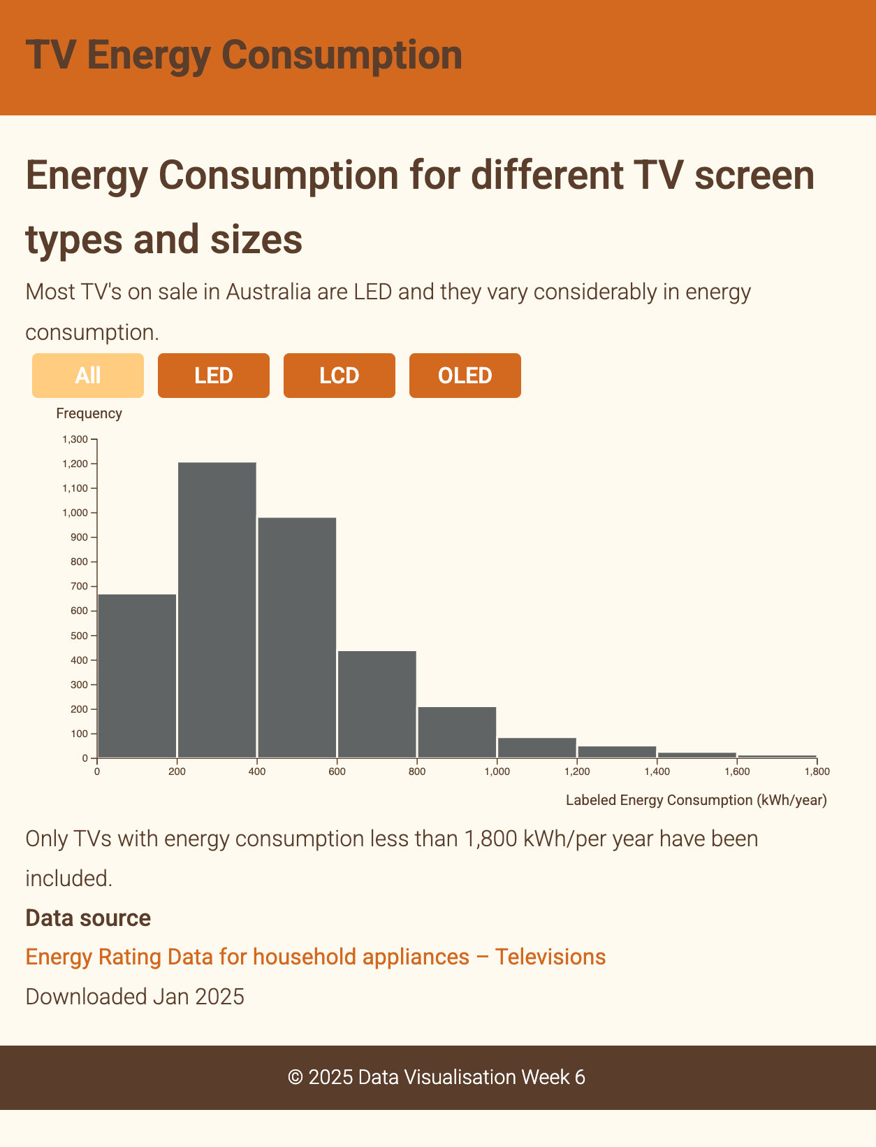
You have probably created a histogram for energy consumption while exploring the data set using KNIME. In this activity D3 will be used to read in nearly four thousand data points to create a histogram. Your task is to add a set of buttons to allow the user to filter the data for screen technology.

Step 1
Set up files. You will need a file structure similar to the following:
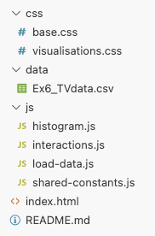

Step 2: Set up index.html
You can use your favourite GenAI to help you code a index.html for this visualisation. Make sure you have:
    - calls to the two css files and the js files (the order in which the js files are called is important).
    - a div for your filters and your chart.
Your index.html should look something like this:
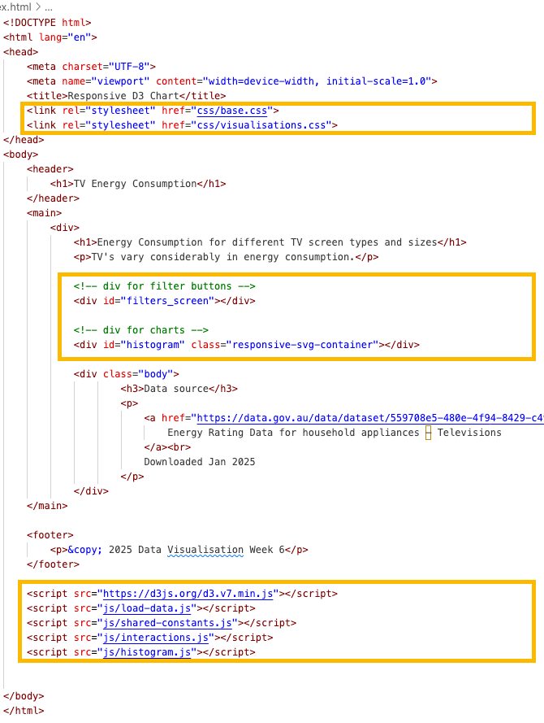

Step 3: Set up the css
Ask your favourite GenAI to suggest a css for your webpage (or reuse css from website developed for Demo1&2). Make sure you css includes styles for filters and buttons as we will be using these.
You can also set up visualisation specific formatting in a separate file:
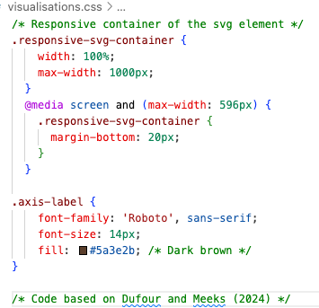

Step 4: Load the data
We will start by loading the data. Firstly become familiar with the dataset. This data set has been cleaned and given programming friendly column headings. Remember if you are using your own data to look for spaces or unusual characters that might prevent the proper parsing of your data into D3. The KNIME workflow used to create this file is provided above.
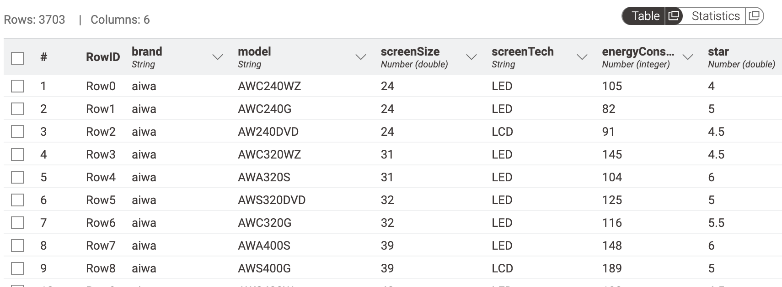
The data has columns for brand, model and star rating (star2 from data set). Although we will not be using them in this chart you may find them useful for other visualisations of the data.
The histogram we are making for this activity will plot the frequency of TV energyConsumption. We will also use the screenTech column to filter the data in the chart.
You can ask your preferred GenAI to assist you build a function to load in the data. You should end up with something like this with calls to the drawHistogram and populateFilters functions that will be built as part of this visualisation.
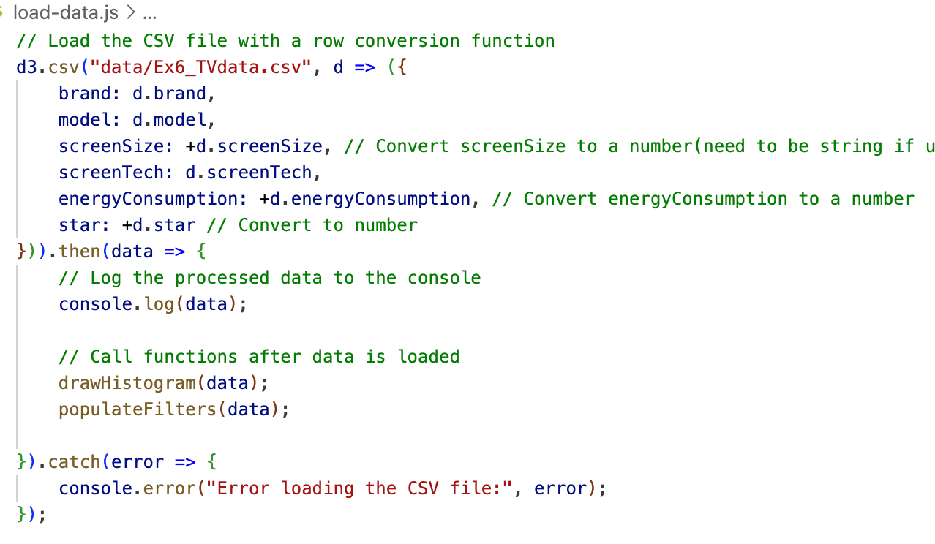
Check your data has loaded correctly in the console.

Step 5: Set up shared constants
In this walkthrough we will be using Dufour and Meeks (2024) strategy of creating Inner chart. To do this you will need the following constants.
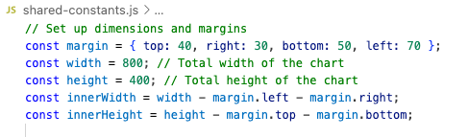
If you are using GenAI it may use a different strategy and your constants may be different.
In this chart we are going to set some colours that will come in handy later:
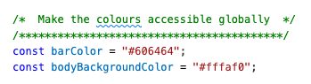
Change the colours to match your colour scheme. We will be using bodyBackgroundColor to make the gap between our bars so it is good if it matches the svg container background.
Our last constant to add at this point will be the scales:
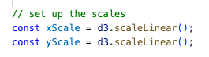
We will use these to set up our histograms scales.

Step 6: Build our histogram
You can ask your favourite GenAI to build a histogram for you, or follow along with these instructions...
All the code for our histogram will be in this function:

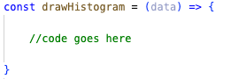

Step 6.1 Set up the chart area
This is a standard (Dufour & Meeks) set up for our chart:
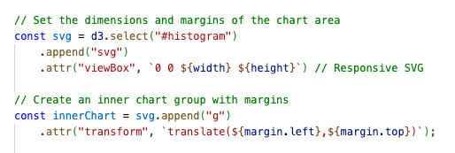

Step 6.2 Set up bins
The main feature of histograms is their bins. Different bin sizes will reveal different patterns in the data:
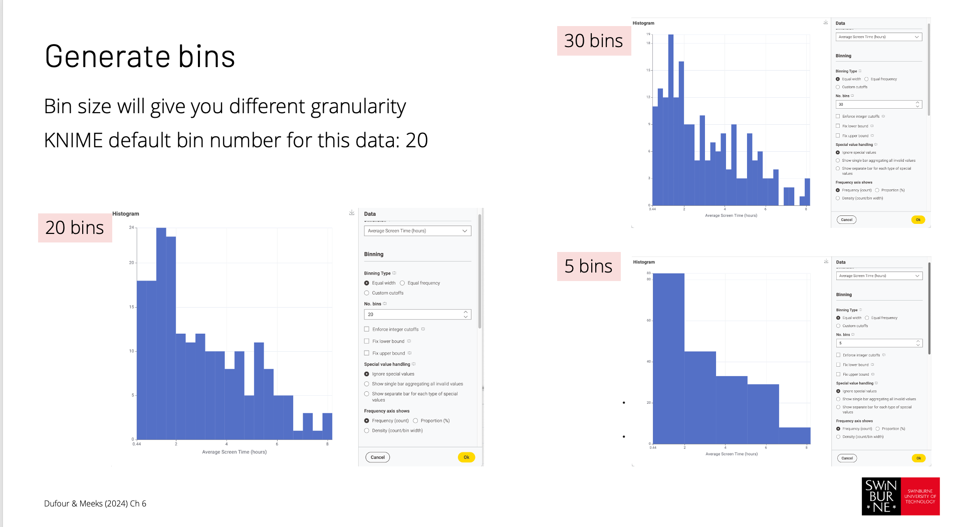
Thus, setting up the bins is a key step in building our histogram.
We will use d3.bin() to generate our bins (your GenAI may suggest d3.histogram(), d3.bin gives a bit more control over how bins created (e.g., bin size (aka threshold)). Put this bin generating code in shared-constants so we can use it later when we update our charts.
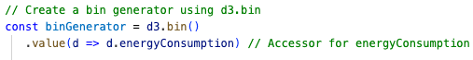
You can change the value being used to plot the histogram here (i.e., d.screenSize).
Going back to our drawHistogram function we need to use our bin generator to create bins form our data:
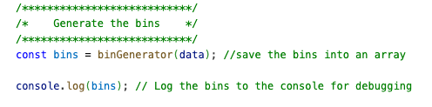
Check the console to see your bins have been created, there will be a lot of data.

Step 6.3: Define the Scales
Next we want to define the scales. To do this we need to know how what the lower and upper bounds of our bins are and how many there are:
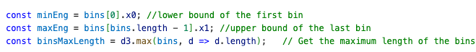
Once we have these values we can use them to let D3 know what our range is so it can calculate the scales:
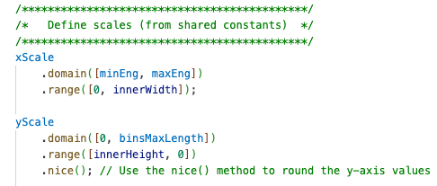

Step 6.4: Draw the bars of the histogram
We are now ready to draw our histogram:
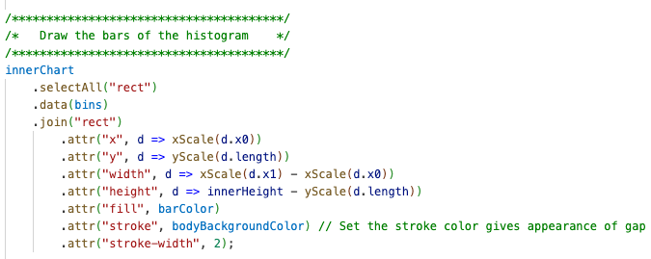
If everything has gone well you should see the bars of your histogram.

Step 6.5: Add bottom axis
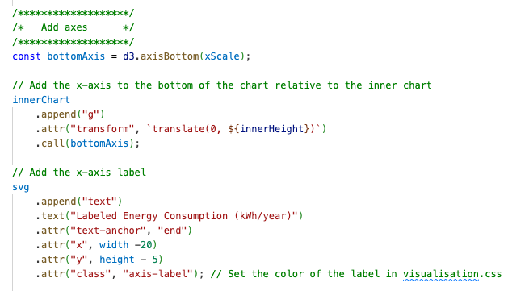

Step 6.6: Add left axis
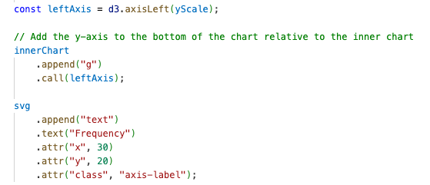

Your histogram should now be complete! The next step is to create the filters that will allow your user to interact with the data set.

Step 7: Building the filters
To build our filters we will need a function to populateFilters. This function will take our filters constant (as per above) and use it to make buttons. The active state of the buttons is toggled on an off with mouse clicks and depending on the state of the button different data is used to update the histogram.
See if your favourite GenAI can help you build the filters or check out code from this weeks Online lecture to work through the logic of the filtering buttons or follow along here.

Step 7.1 Set up filters function in interactions.js
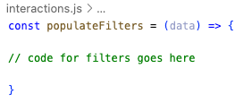

Step 7.2 Set up data required to populate filter labels and state
Our filters will need to know what filters we need, what to put on the label and what state they are in to start with (i.e., if they are active or not active). We can set this up in shared-constants.js
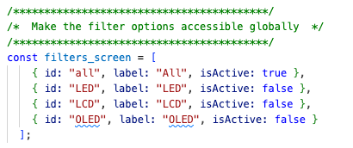
This array will provide information about the label to use on the button and the state of the button.
While we are working on the shared-constants.js file make sure your binGenerator from Step 6.2 is here already. This means it will be able to be used when we want to update the data set displayed when a filter button is selected.
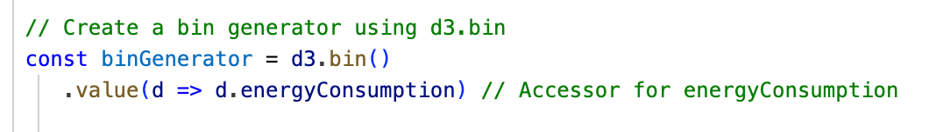

Step 7.3 Set up buttons and event listeners
In the first part of our populateFilter code we are going to:
    - Append the buttons to our filters div in index.html (we prepared earlier). The data used to create the buttons will come from the filters_screen we created in shared-constants.js. The look and feel of our buttons is controlled by styles contained in the base.css. filters_screen will be used to populate it's initial state (i.e., isActive) and the label on the button (e.g. "LED").
    - Append a D3 event listener (.on()) for the JavaScript event click
    - Add the logic to update the status of the button
    - Attach class "active" to button based on isActive state (i.e., true or false)
    - Pass the id of the active button and the data to an update function (which is not built, yet).
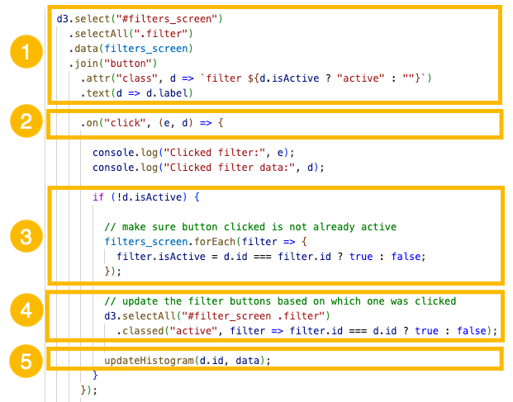

Step 7.4 Update the histogram
Still within our populateFilters function we are going to add an updateHistogram function.
    - Create updatedData and check if the id passed from previous function is "all" if is then don't run the filter. If its not all, then filter the data based on screen tech.
    - Use filtered data to update the bins using binGenerator (which should be already set up in shared-constants.js)
    - Use the updatedBins to draw the histogram rectangles and apply some nice transitions. Ask GenAI or look up the different types of transitions you can apply and test them out!
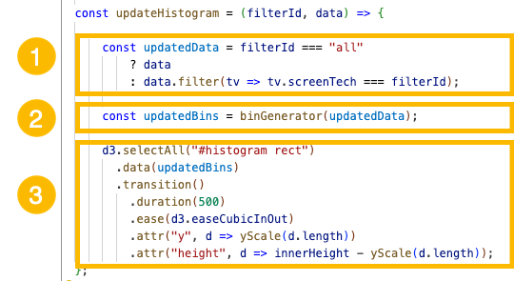
You should now have a set of buttons which can be used to filter the data shown in the histogram.
If you have time you could also make a set of button to filter for screen size. There are a lot of different screen sizes so perhaps just try the most frequent (e.g., 24, 32, 55, 65 and 98). 98 is not particularly frequent, but biggest size with most models.

