BUDT703: Database Management Systems – Team Project

Project Analysis and Design

1. **Band Name**: Moneyball Metrics
2. **Team members:** Solayappan Ganesaan, Devara Sai Sumanth, Bhupathiraju Harish Varma, Gunjan Suriya
3. **Mission Statement**  
   To study the Terrapin Men's Baseball Team's past games and assist team leadership and analysts in gaining insights into the team's competitiveness over the years by analyzing matches played against opponents across different venues and leagues.
4. **Mission Objectives**
   1. Find the ratio of game wins and losses based on home, away, and neutral sites and identify the presence of a possible home-ground advantage.
   2. Calculate the team’s average margin of wins (or losses) to understand the intricate improvements in offense or defense across the years.
   3. Find out the team’s performance in BigTen conference over the years.
   4. Evaluate the team’s performance by opponents to identify historically tough opponents.
   5. Identify the states where our team traditionally performed well versus not to prepare better for tough travels.
5. **Business Processes**

* Each Opponent is identified by a unique Opponent ID and it is affiliated to a university.
* There are multiple tournaments and each tournament has a unique tournament ID and tournament Name.
* Games are played between Maryland and opponents across various months in any given year
* A game is played at a Venue which has a unique Venue ID, Venue Name, the city of the Venue and the state of the venue that together define the location of the Venue.
* Each Game played between Maryland and an opponent has the following attributes: Game Type which helps understand whether the game is played at home, away or at a neutral venue, Maryland Score, Opponent Score, Game Date and Game Time.

1. **ER Schema**

Entities, Attributes and Primary Keys

Opponent(**opponentId**, opponentName, opponentUniversity)

Tournament(**tournamentId**, tournamentName)

Calendar(**calendarMonth, calendarYear**)

Venue(**venueId**, venueName, venueLocation,-venueCity, -venueState)

**Relationships, Attributes, Degrees, Participating Entities and Constraints**

Play(playTime, playDate, playType, playTerpScore, playOpponentScore, =playResult) : Quaternary relationship

1 Opponent, 1 Tournament, 1 Calendar to 1 or Many Venue

1 Opponent, 1 Tournament, 1 Venue to 1 or Many Calendar

1 Opponent, 1 Venue, 1 Calendar to 1 or Many Tournament

1 Venue, 1 Tournament, 1 Calendar to 1 or Many Opponent

1. **ER Diagram**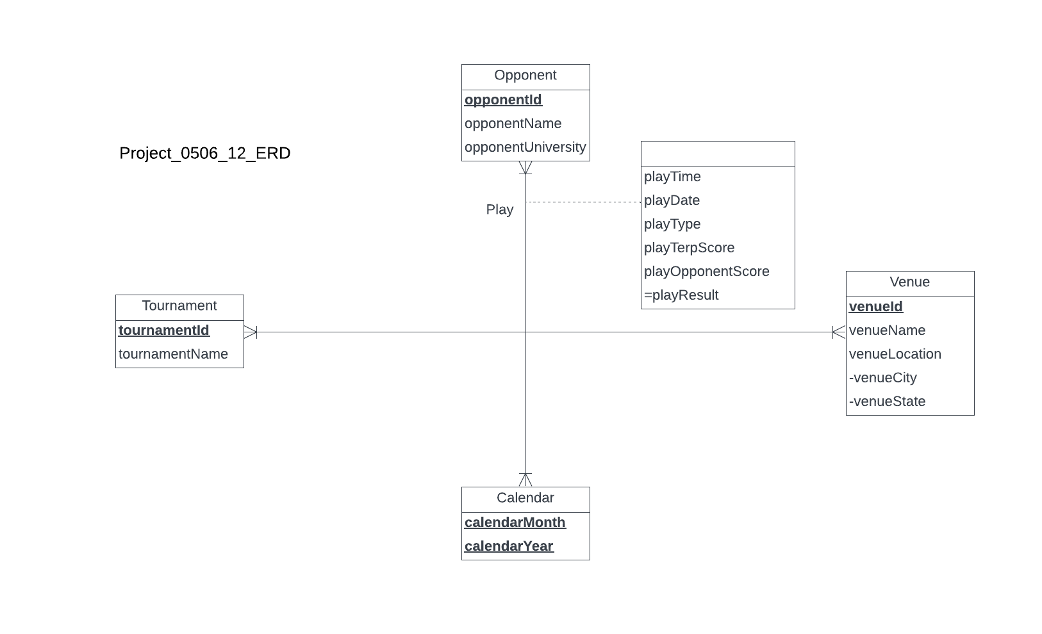

**8) Relations :**

Opponent(**opponentId**, opponentName, opponentUniversity)

Tournament(**tournamentId**, tournamentName)

Calendar(**calendarMonth, calendarYear**)

Venue(**venueId**, venueName,venueCity, venueState)

Play(**playTime, playDate, *calendarMonth, calenderYear*,** *opponentId*, *tournamentId*, *venueId*, playType, playTerpScore, playOpponentScore)

**9) Business Rules:**

[R1]When a play is in action, the corresponding opponent, tournament, venue and calendar details cannot be deleted.

[R2]When the details of the opponent, tournament, venue or calendar change, the corresponding details associated with play should be changed accordingly.

**10) Referential Integrity**

|  |  |  |  |  |  |  |  |
| --- | --- | --- | --- | --- | --- | --- | --- |
| Relation | Foreign Key | Base Relation | Primary Key | Business Rule | Constraint: ON DELETE | Business Rule | Constraint: ON UPDATE |
| Play | opponentId | Opponent | opponentId | R1 | NO ACTION | R2 | CASCADE |
| Play | tournamentId | Tournament | tournamentId | R1 | NO ACTION | R2 | CASCADE |
| Play | venueID | Venue | venueID | R1 | NO ACTION | R2 | CASCADE |
| Play | calendarMonth | Calendar | calendarMonth | R1 | NO ACTION | R2 | CASCADE |
| Play | calendarYear | Calendar | calendarYear | R1 | NO ACTION | R2 | CASCADE |

**11) Sample Data**

Opponent(‘O001’,’Oklahoma’,‘Oklahoma University’)

Tournament(‘T01’,‘Big Ten’)

Calendar(’Mar’,‘2020’)

Venue(‘V001’,‘Bob ‘Turtle` Smith Stadium’,’College Park’, ‘MD’)

Play(‘18:00’, ‘14’, ‘Mar’,’2020’,‘O001’,‘T01’,’V001’ ,’home’,‘21’,‘12’)