1. In the browser new tab login to <https://portal.azure.com/> using the same credential provided in step 1 go to in the search bar type **azure databricks**

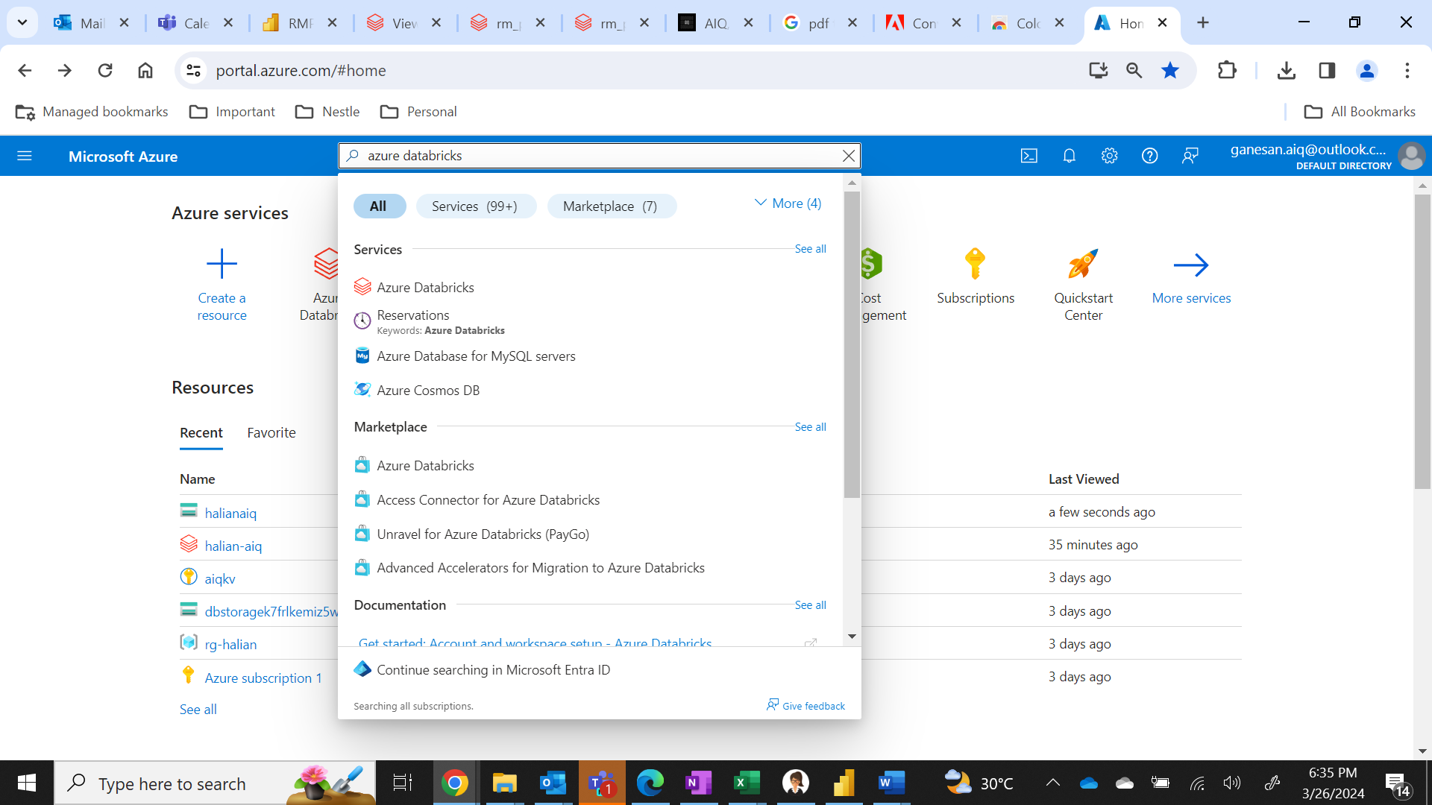

1. Click on the **Azure databricks** option shown in the list.

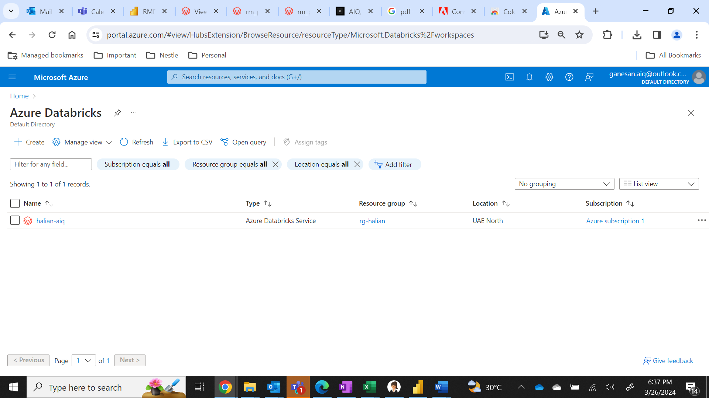

1. Click on the **halian-aiq** service and scroll down to see launch workspace option

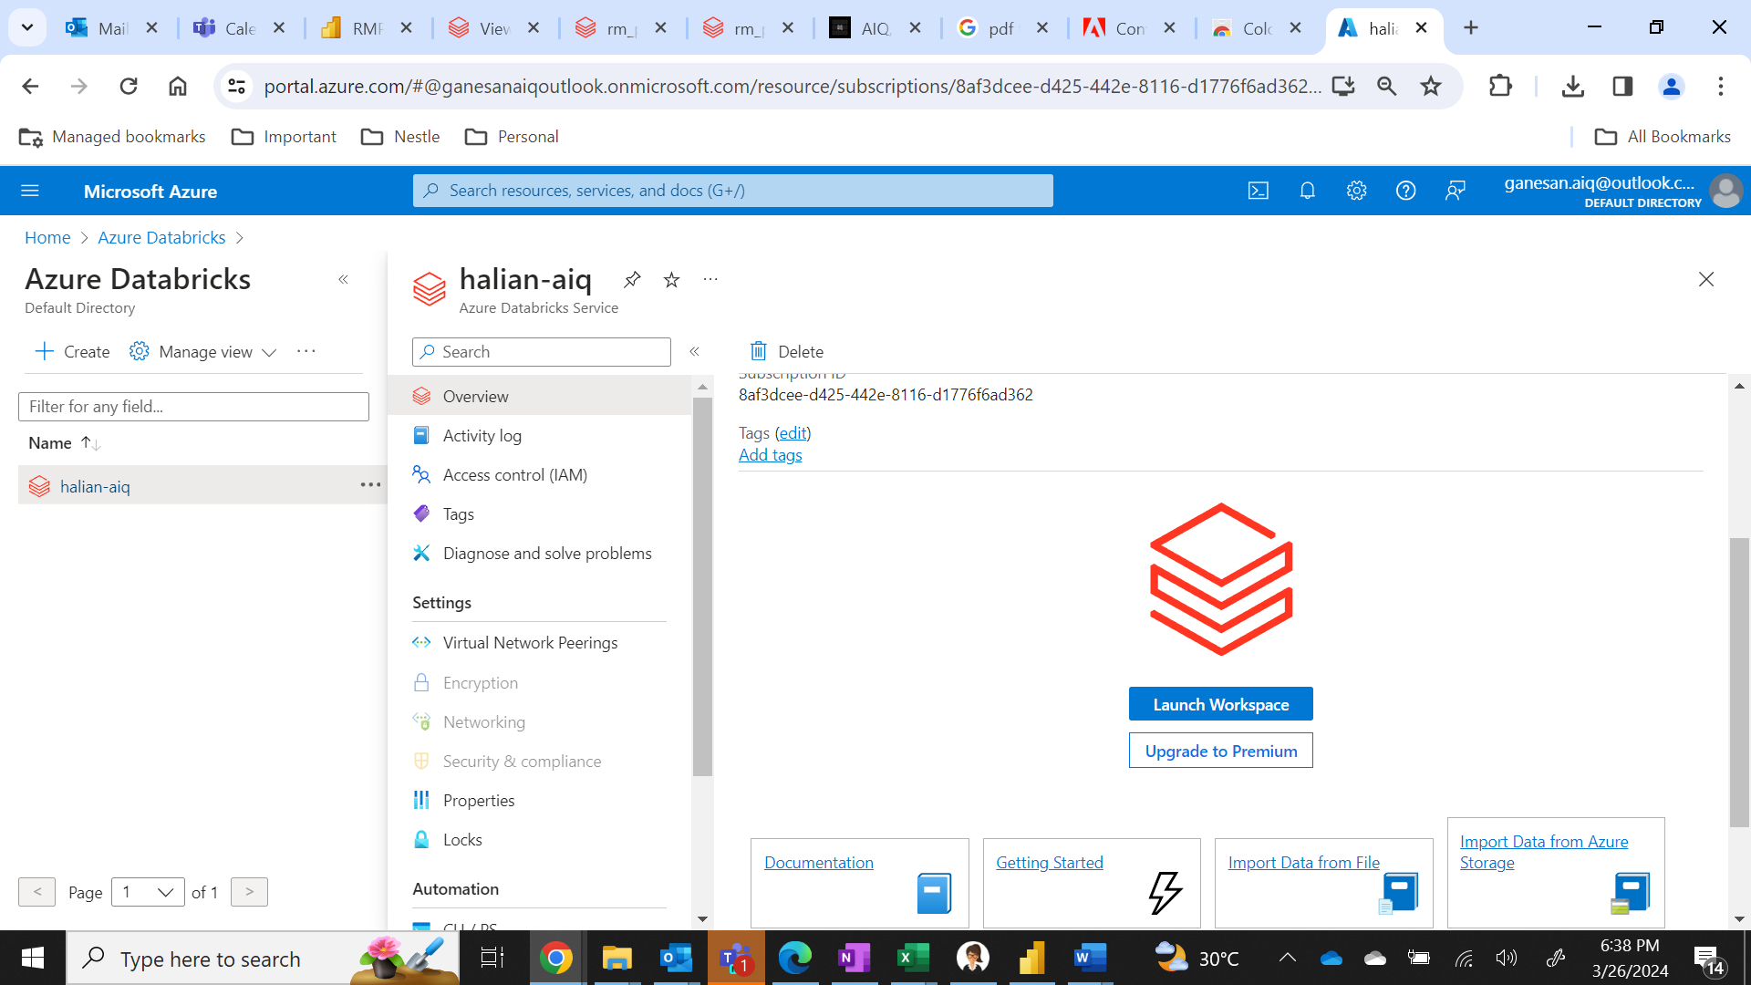

1. Click on **Launch Workspace** as highlighted above then you will see the following page.

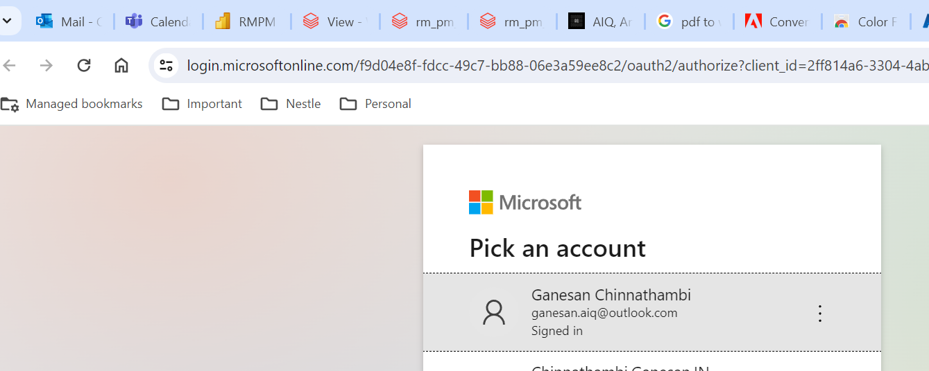

1. Sign in using the same credential provided in step 1, in my case its already signed in as single sign on
2. Once sign in is completed you will be seeing azure databricks home page

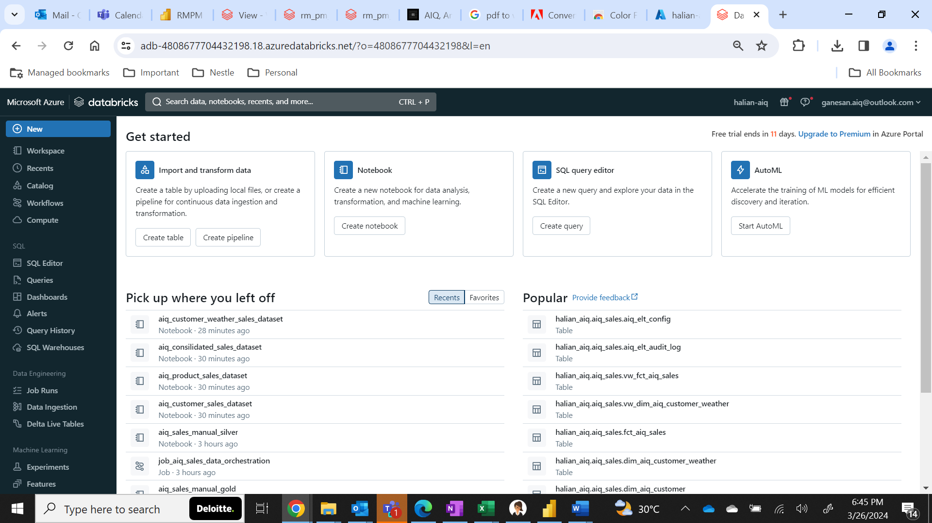

1. In this page navigate to **compute** option

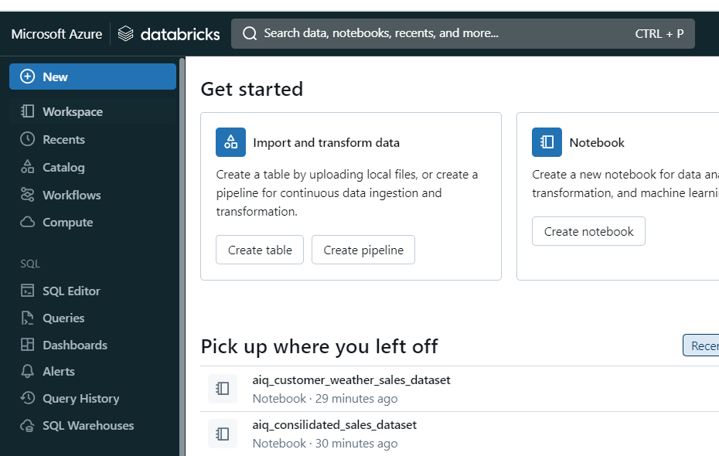

1. You will see the **aiq** cluster created. Click the below **start** icon to start the cluster and wait for the cluster to start (**State 1st column will change as a green tick, see next screenshot for ref**)

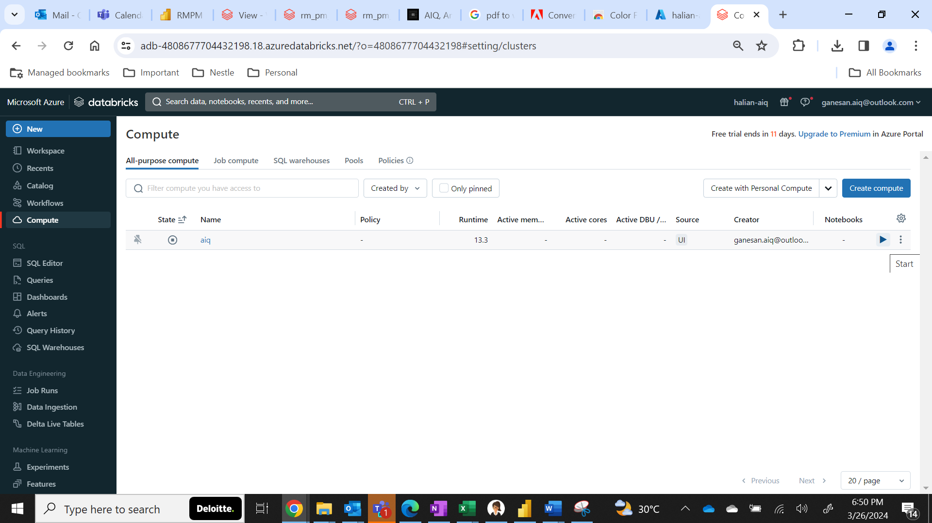

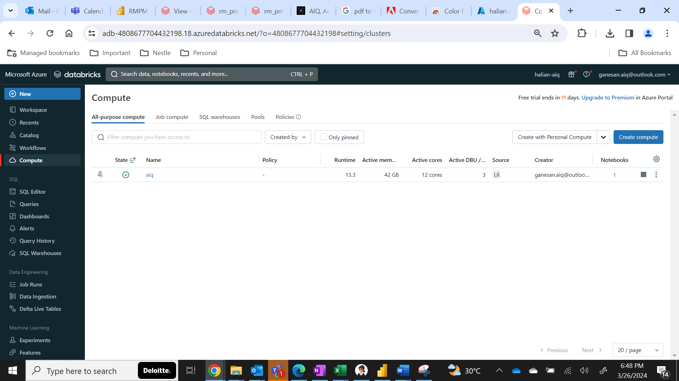

1. Click on **workspace.**

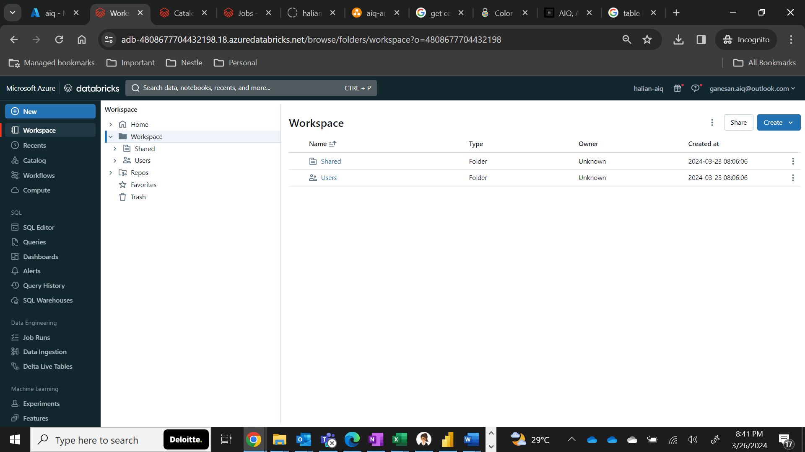

1. Click on **Repos and click aiq-sales-assignment**

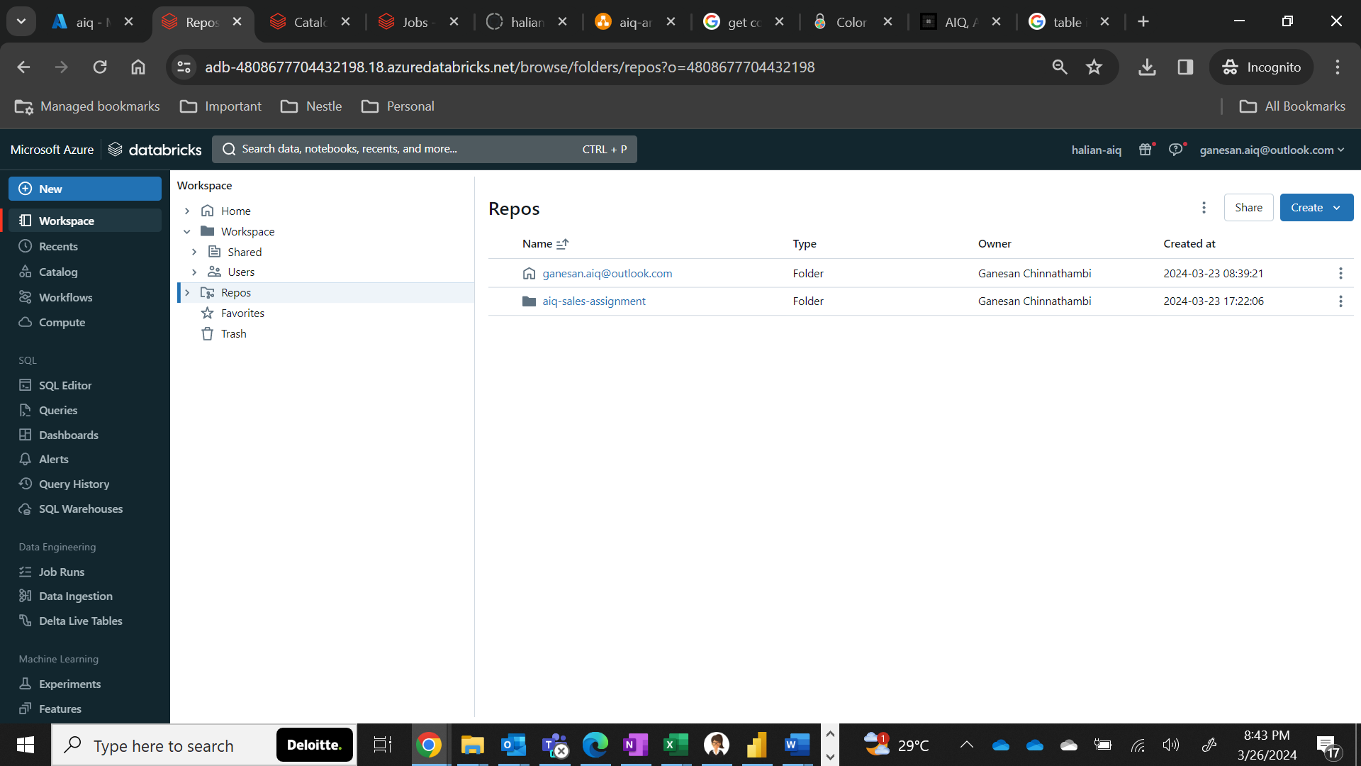

1. Click on the **halian-aiq** repo **(Connected to GitHub)**

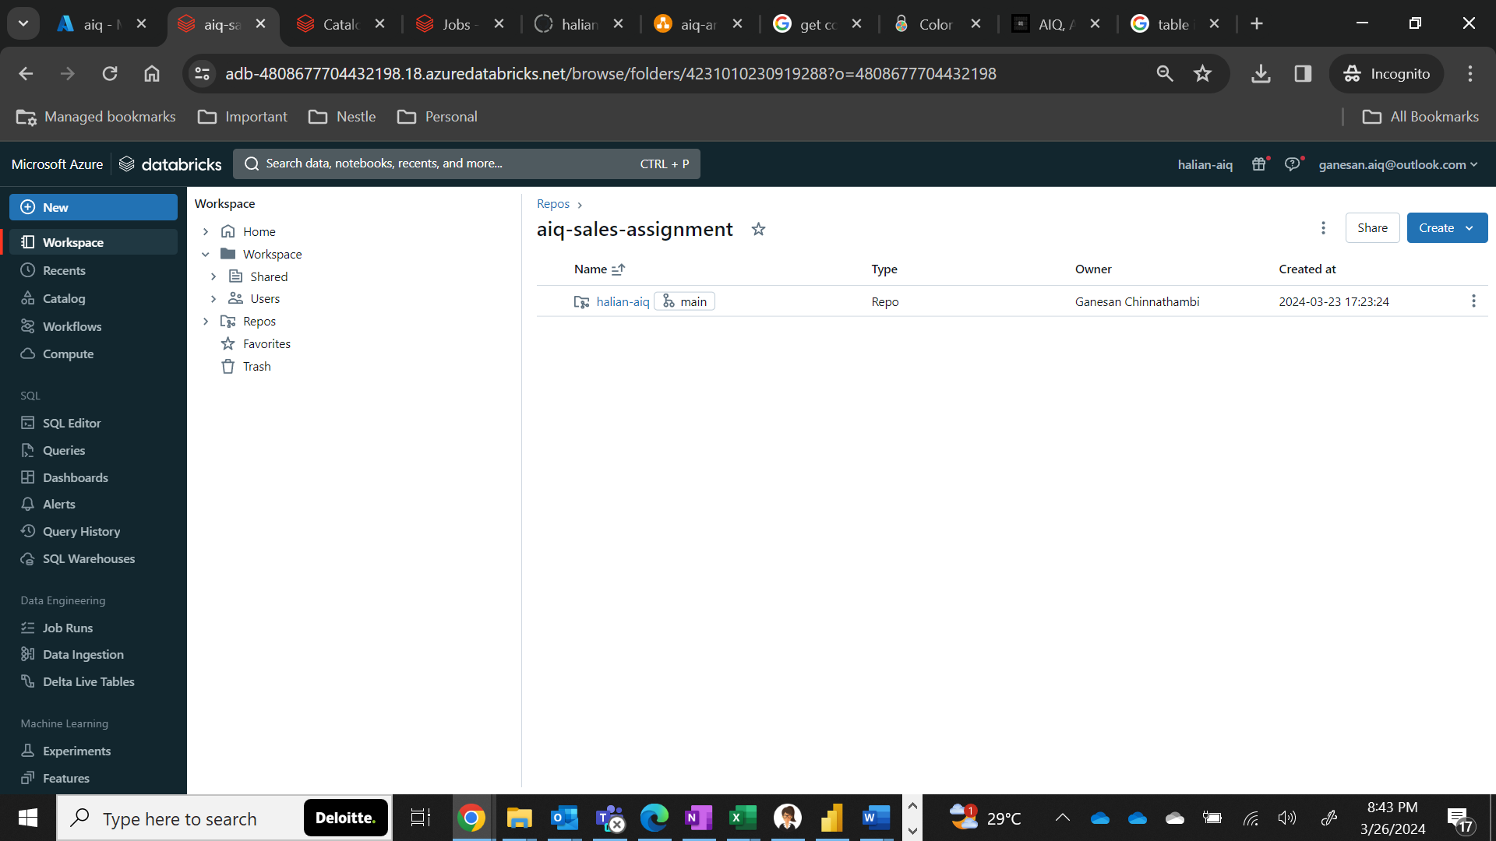

1. Click on **aiq** folder

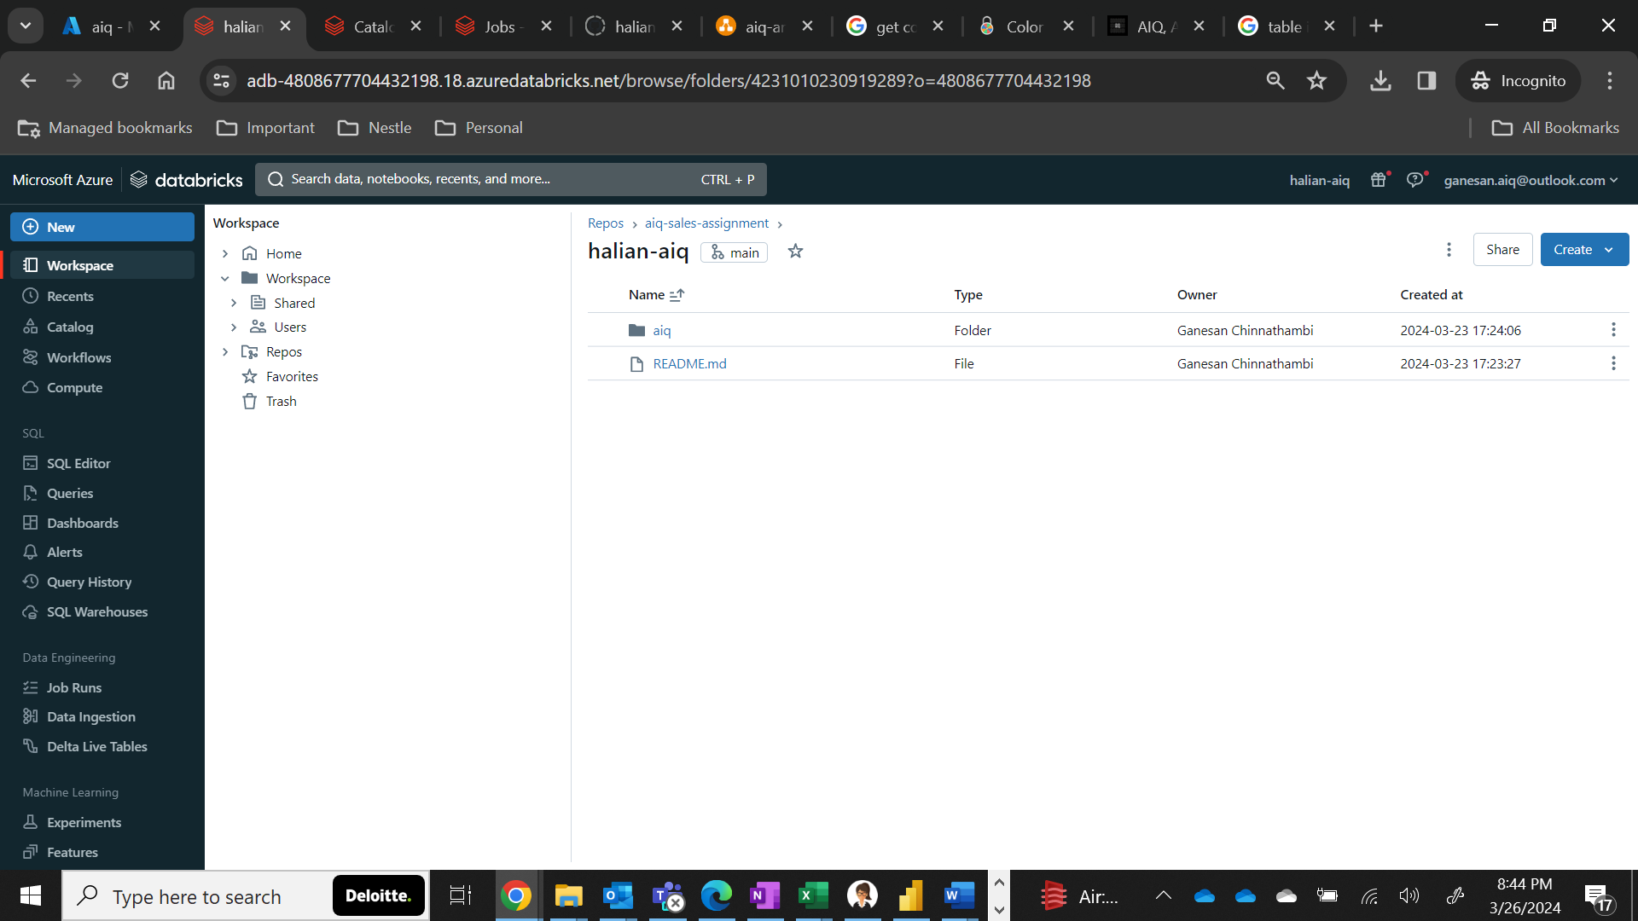

1. You will be able to see all folders used in this entire assignment here, in that click **output** folder.

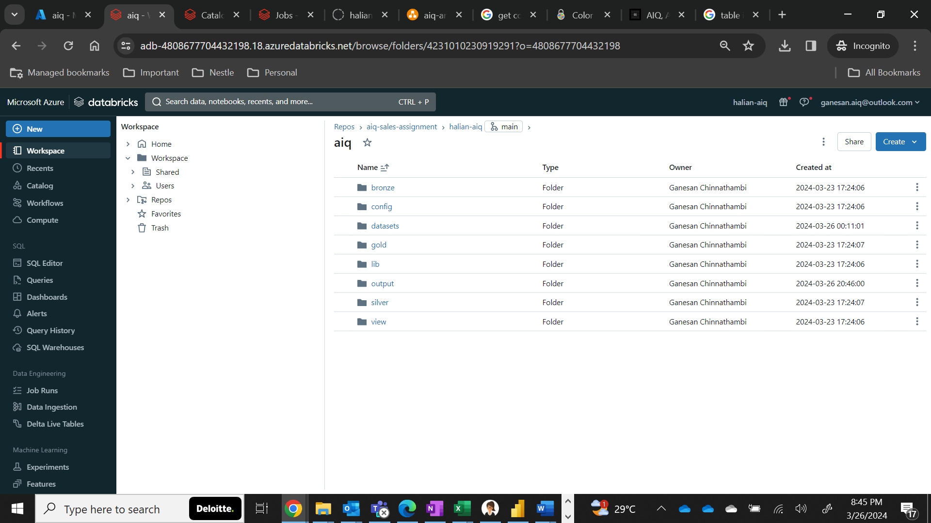

1. Click on the **aiq_otputs** notebook.

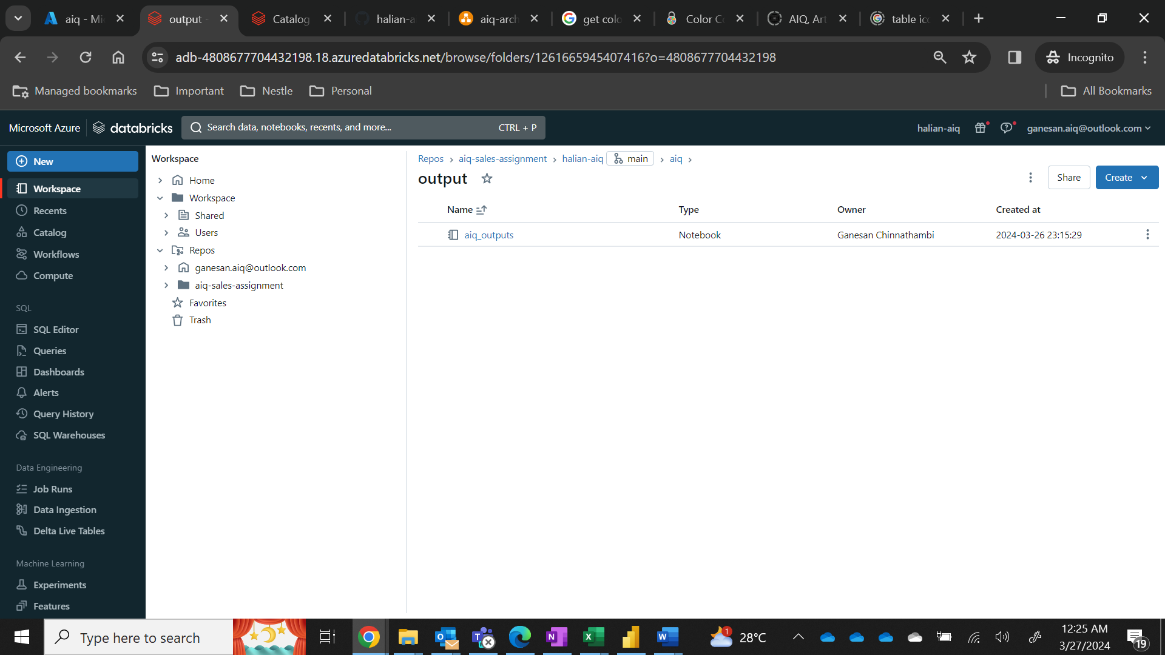

1. Ensure that the cluster is up i.e., a green dot before the cluster name aiq

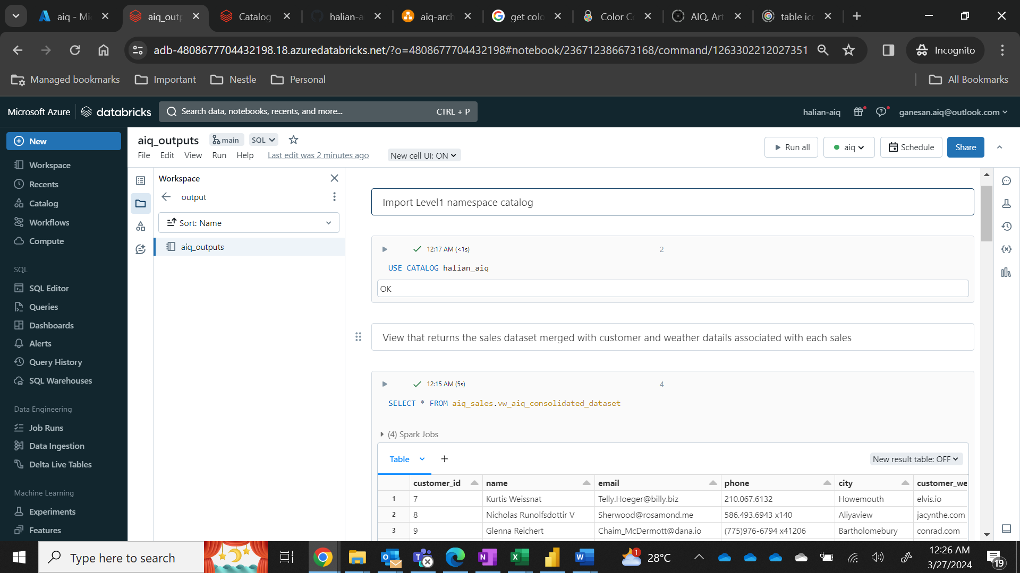

1. Click on the **RunAll** button.

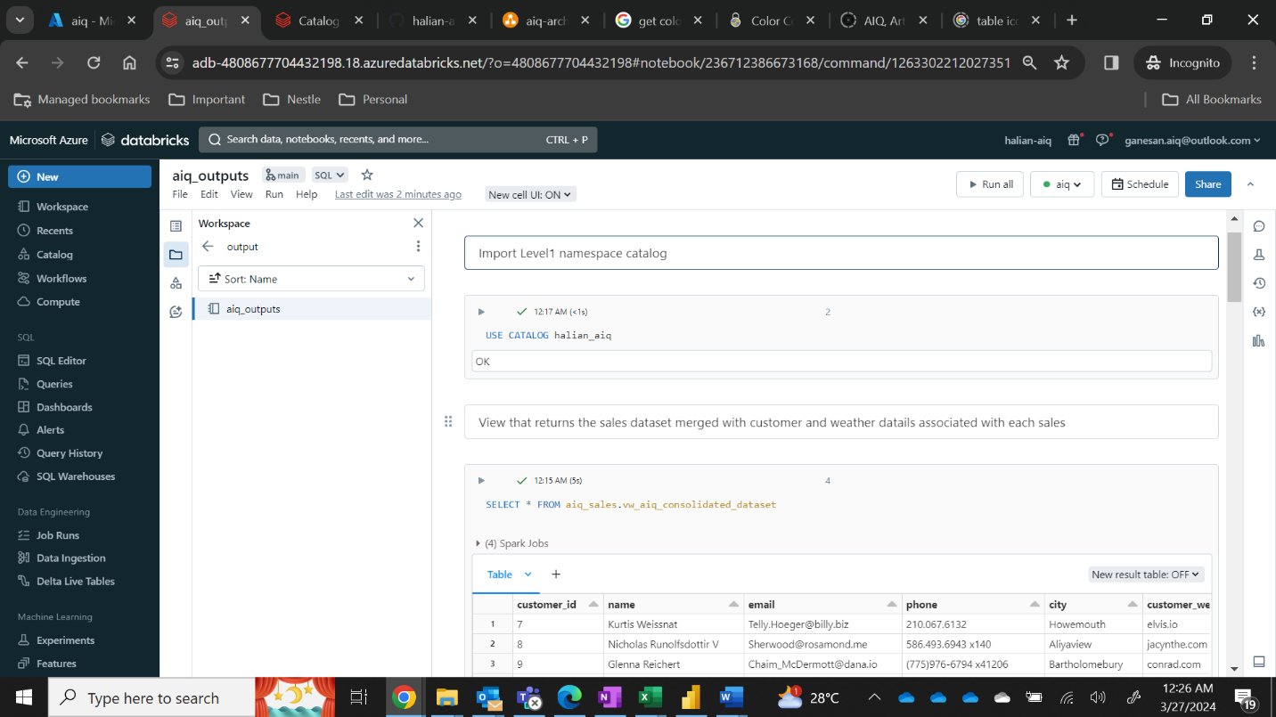

1. Verify all notebook cells with Breen tick with a select query output that is ready for validation.



To view the power BI results

* Open the PBX file shared using power BI desktop

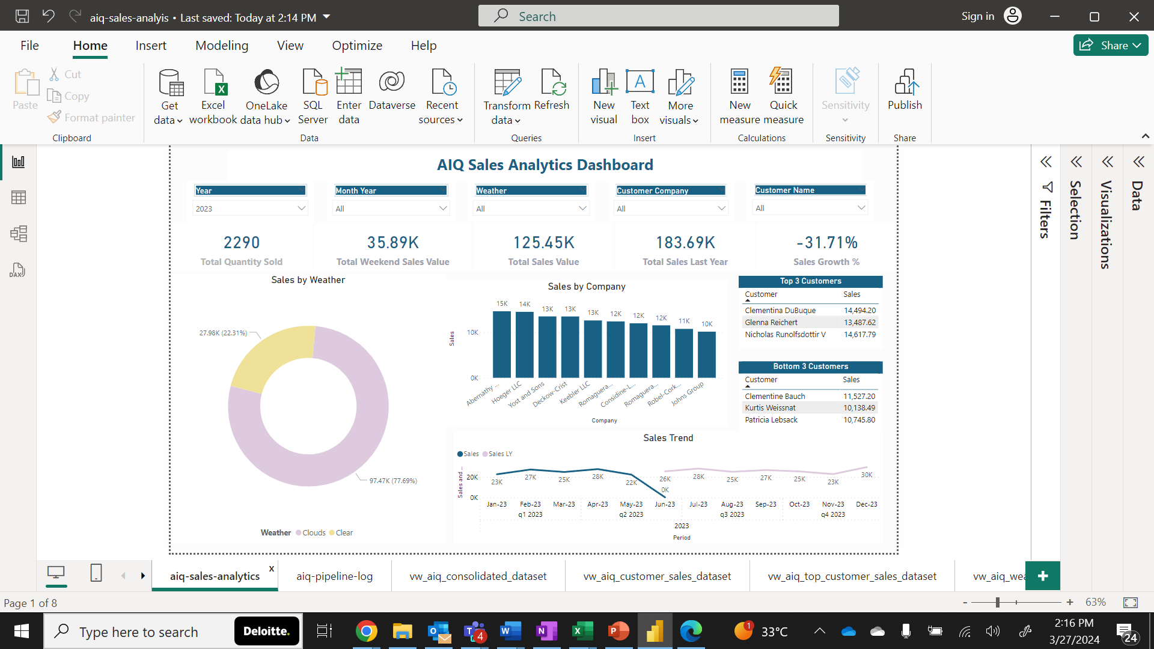

* Click on the refresh button

