**04-06-2017 Understanding DOM**

Browser loads the html and creates an object for the html it is called as “document”.

It handovers the document object to javascript.

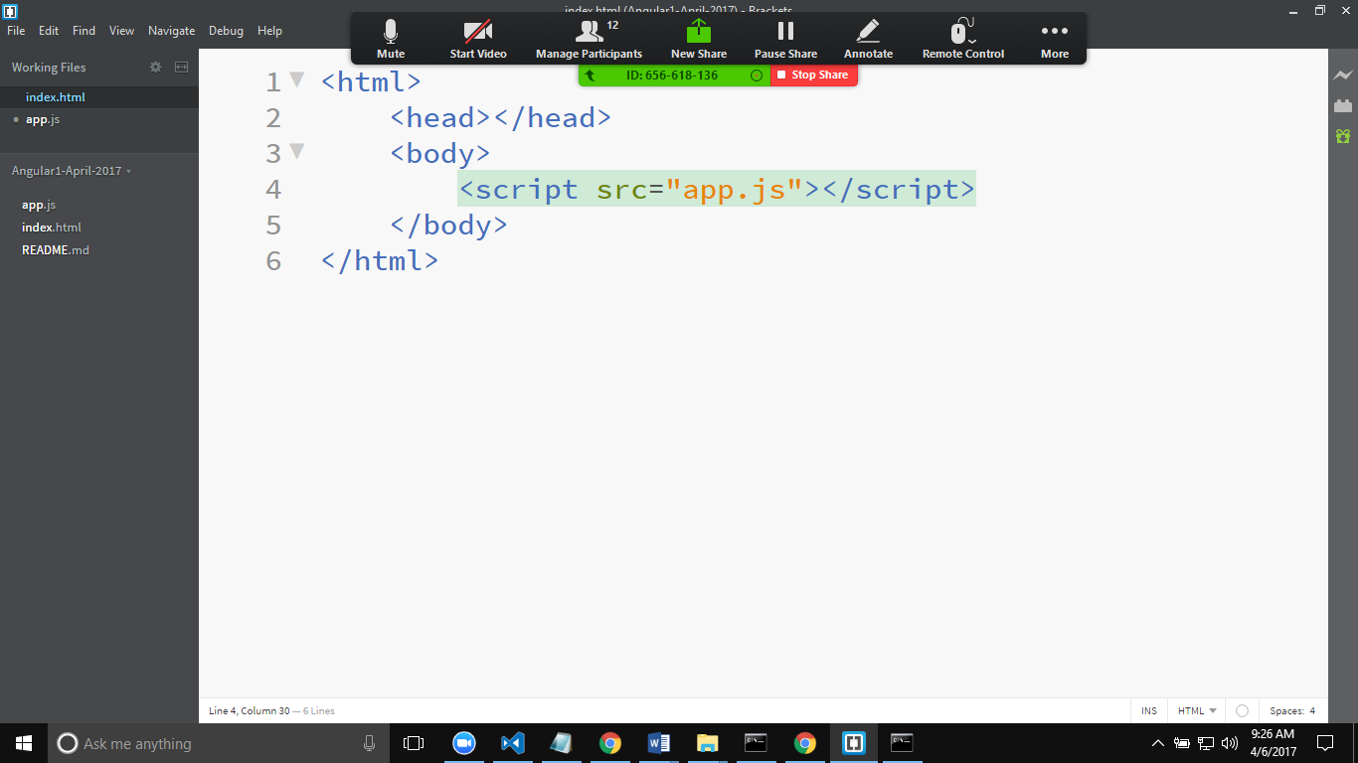

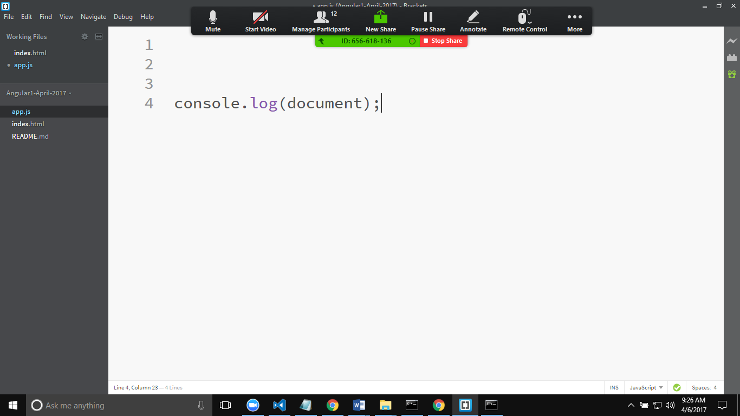

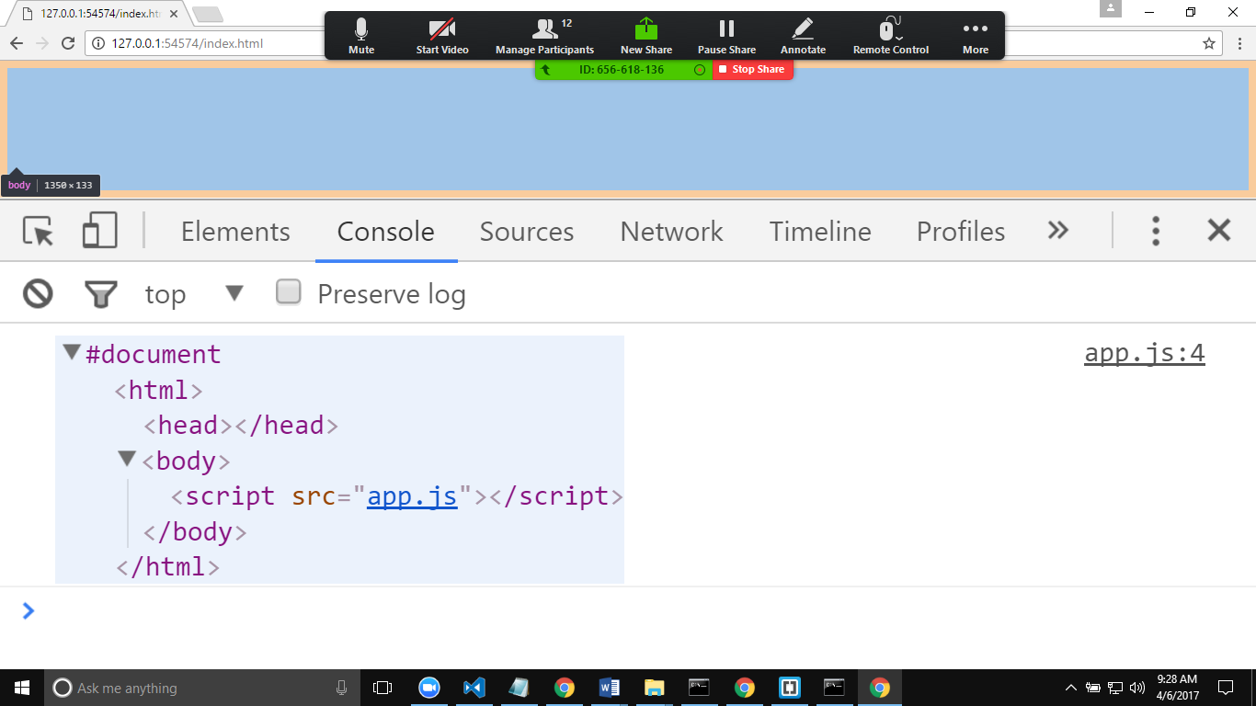

Writing Data to a input field from js

To query html document object will offer few methods.

document.getElementById("txtFirstName");

The above method will give access to the control by its unique identifier i.e. “id”

document.getElementsByClassName("<classname>");

the above method will give the list of elements that are using the cssClass

document.getElementsByTagName("<element name>");

the above method will give the list of elements that are using the tagname.