Javas script will be loaded inside the browser.

Browser will create an environment to store the variables.

Javascript access the browser with the help of window object

If any variable stored inside the browser it will be treated as **global variable.**

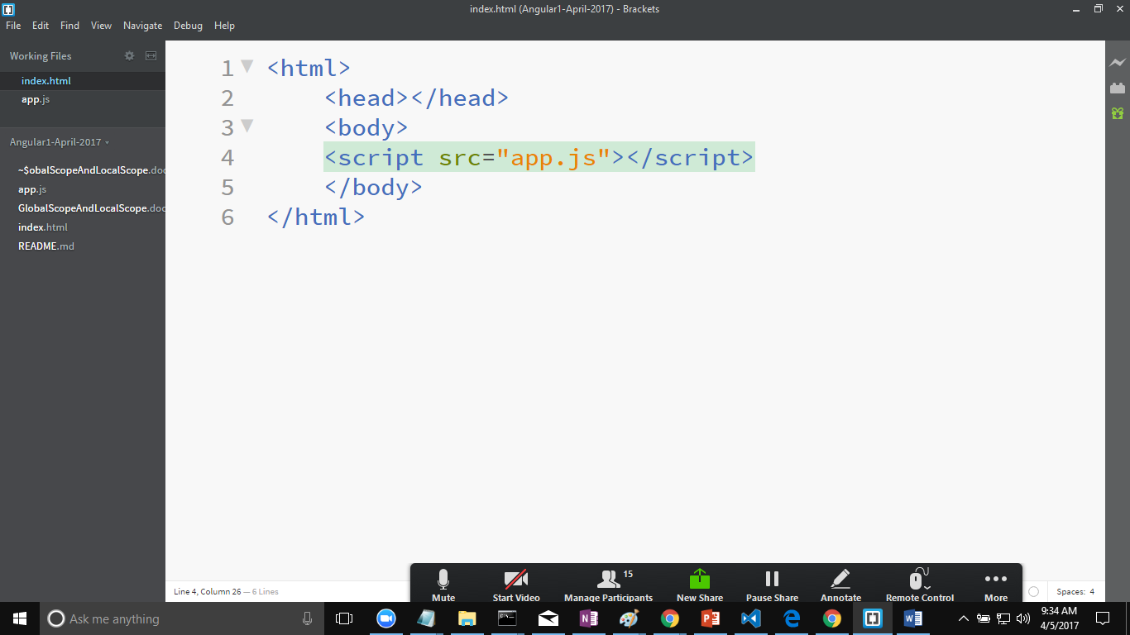

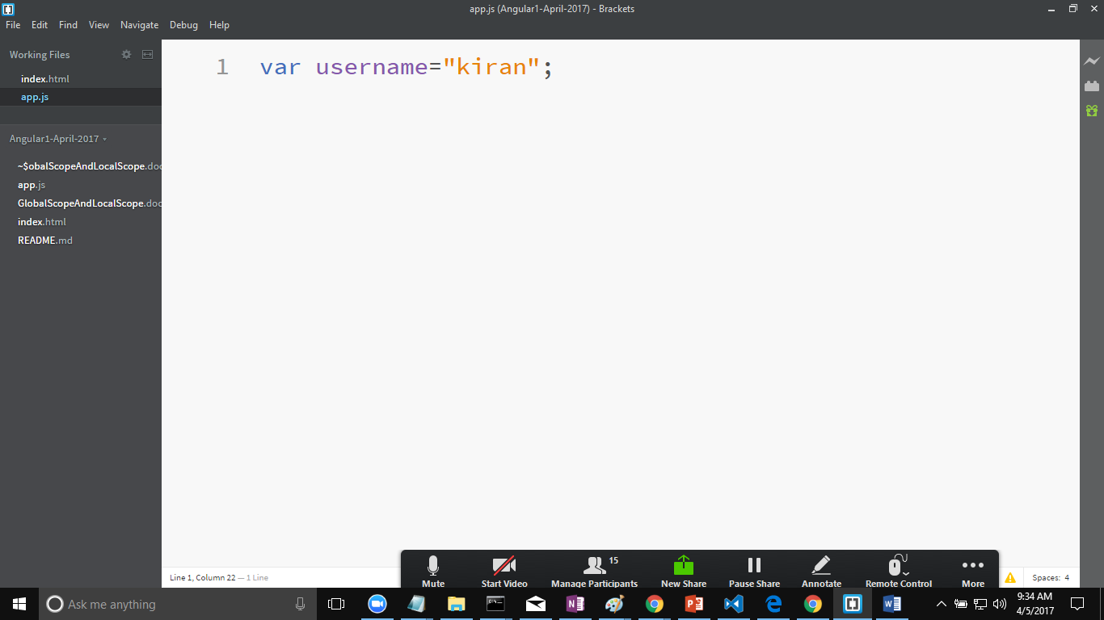

Open the index.html inside brackets and run the code by using live preview.

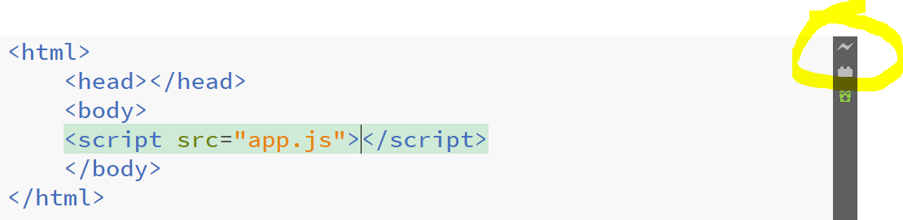

Right click on the browser select inspect.

Or press f12 inside the browser. It will open a debugger for you

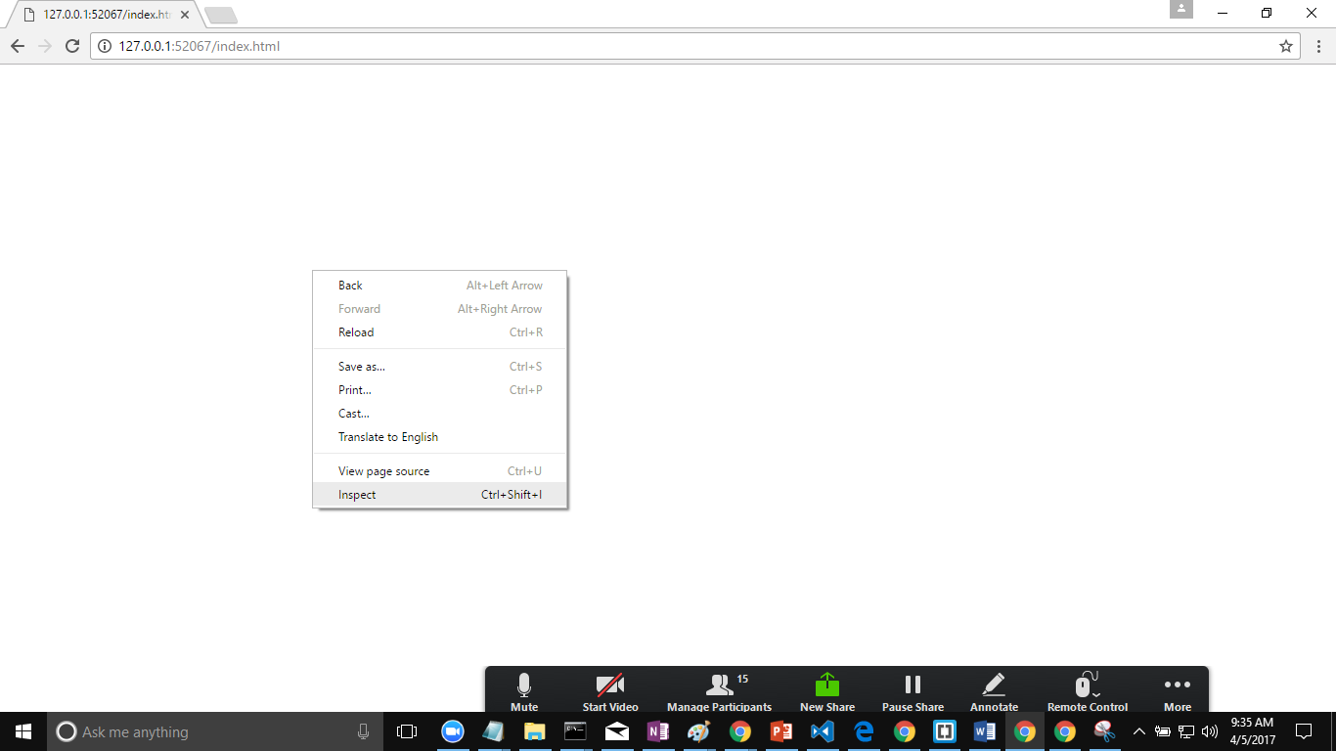

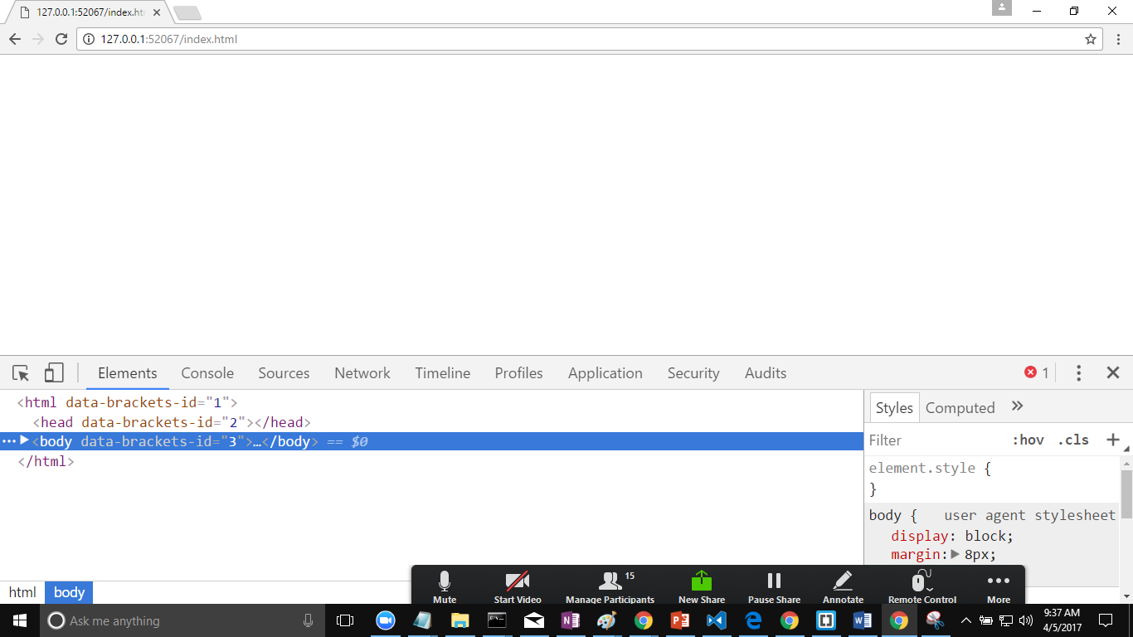

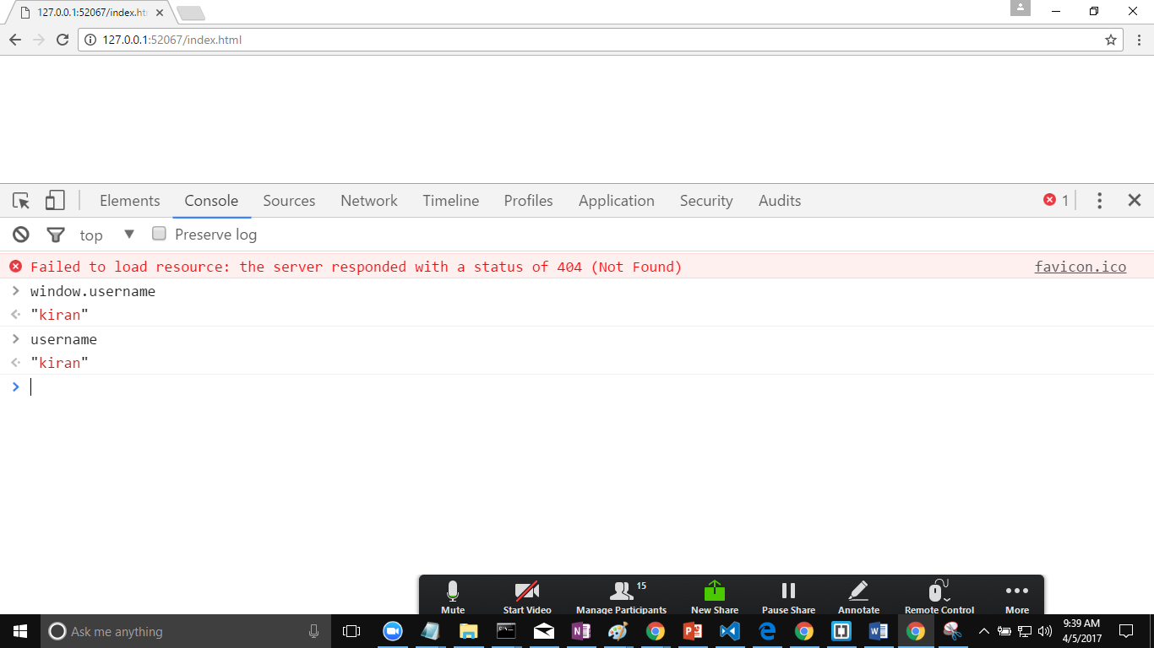

Any variable inside the window object is treated as global variable.

Global variables can be accessed anywhere in the application.

Local Variables

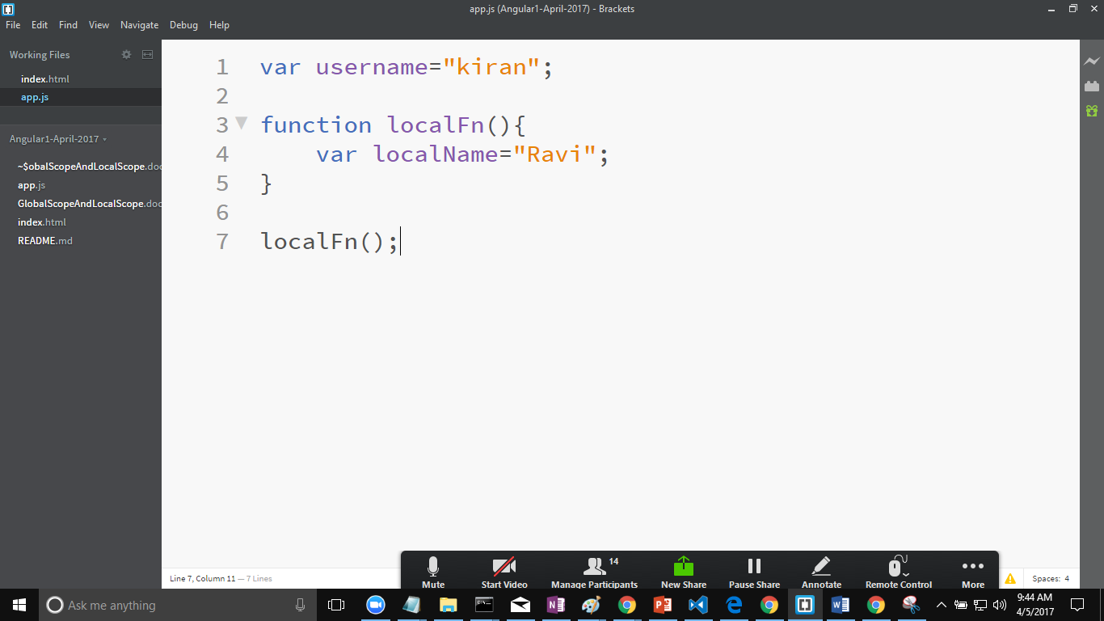

In the above program

Username is global variable.

localName I local variable. Local variables cannot be accessed outside the function.

Take aways:

Global scope

Local scope

Try to reduce the dependency on the global scope.

**GelLocation Api**

Browsers will be having an api to access the user location. That api is termed a geolocation api. It is with the window object.