**CSE 2010 SECURE CODING**

**LAB SLOT –L23+L24**

**NAME-K V P S GANESH M**

**REGISTRATION NUMBER-19BCN7073**

**LAB EXPERIMENT 11**

**Lab experiment – Creating secure and safe executable**

**Download and install visual studio (recent edition)**

**Write a C++ code of your own to build an executable and run the same.**

**Download process explorer and verify the DEP & ASLR status**

**Enable software DEP, ASLR and SEH in the visual studio and rebuild the same executable**

**Again, verify the DEP & ASLR status in the process explorer**

**Report the same with separate screenshot - before and after enabling DEP & ASLR.**

**Happy Learning!!!**

**Experiment analysis:**

1. **Create an executable**

**Executable created: Factorial.exe**

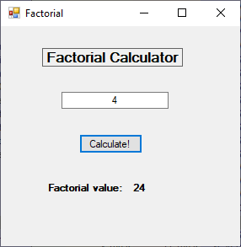

**Select C++ as the language and open an empty CLR project and select Windows Form.**

**Then create the above GUI by adding labels, textbox and button and make the modifications accordingly.**

**MyForm.cpp**

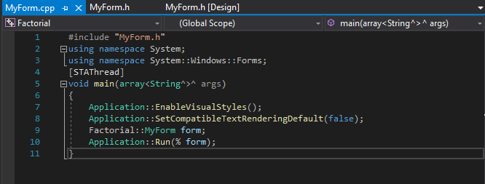

**Cpp code for the Gui**

**Now add the functionality to the label and button values and implement the factorial logic.**

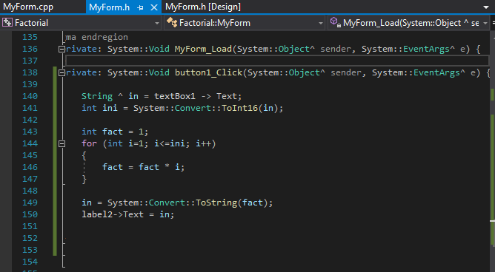

**While making the form the code gets auto generated. Later click on particular control option and add functionality to it.**

**Right click on the Factorial in solution explorer and select “Properties”.**

**Select Linker and then Select System.**

**In Sub System option select Windows**

**Then go to Advanced option and give “main” in the Entry point option.**

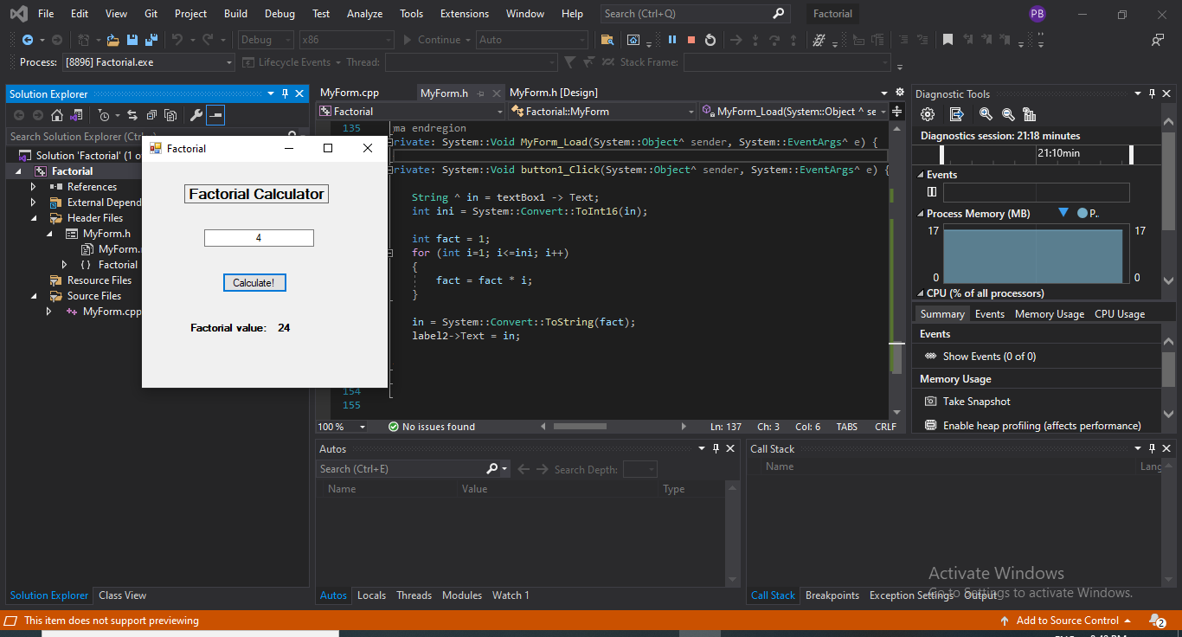

**TURNING ON DEP AND ASLR**

1. **Now open Process Explorer (Sysinternals) and check the DEP and ASLR status for Factorial.exe**

**Firstly let us check the status by turning on ASLR and DEP**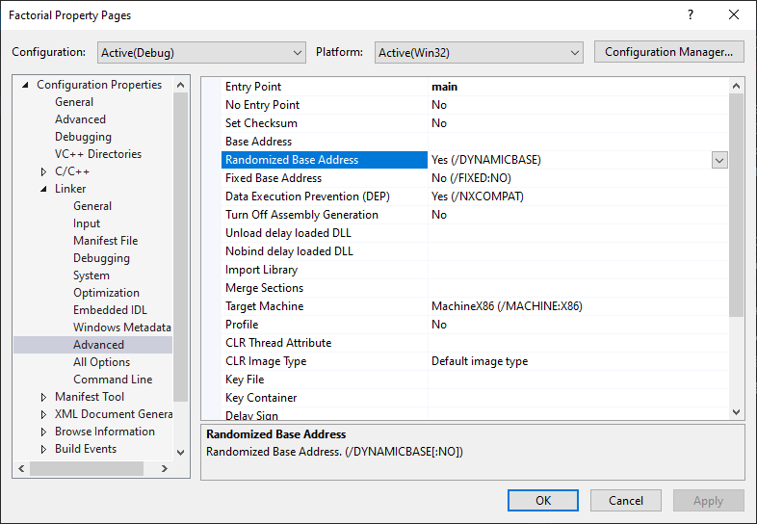

**Check Randomized base address and DEP and make sure it is YES**

**View Status in process Explorer**

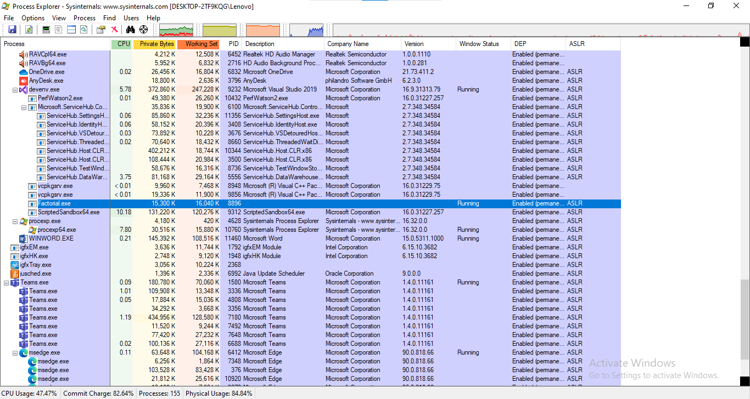

**Factorial.exe status**



**It is enabled**

**TURNING OFF ASLR AND DEP**

**Now let us disable the DEP and ASLR and see if it is reflecting in Process Explorer**

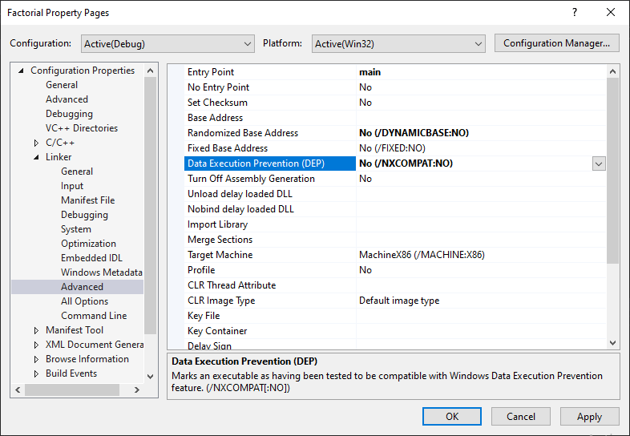

**Run the exe again**

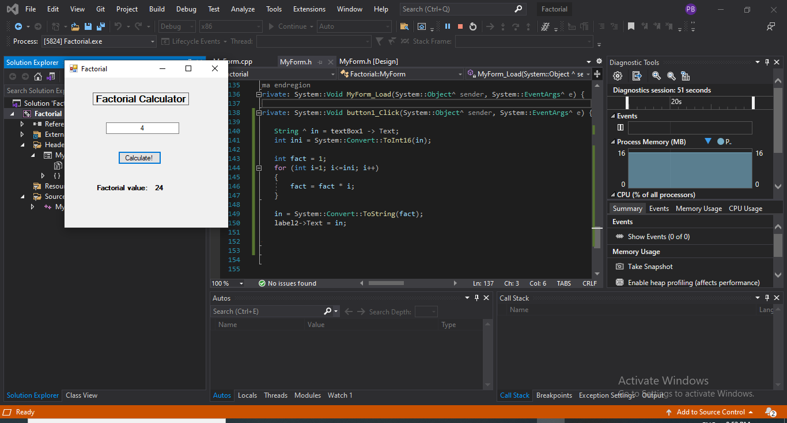

**Check ASLR and DEP status**

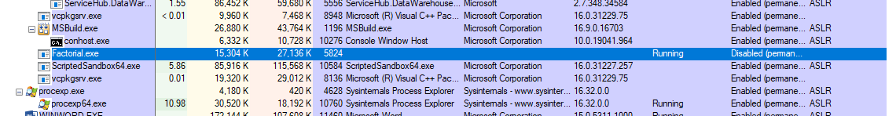

**Here the DEP status is Disabled and ASLR status is off.**