**SECURE CODING(CSE2010)**

**SLOT –L23+L24**

**LAB 1**

**NAME-** KOTI VEERA PRABHU SAI GANESH MAJETI

**REG NO.-**19BCN7073

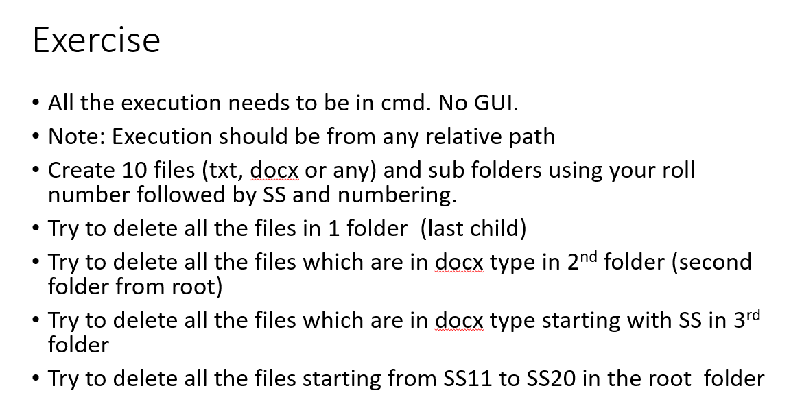

**OPENING DIRECTORY AND CREATING ROOT FOLDER WITH 3 NESTED CHILD FOLDERS**

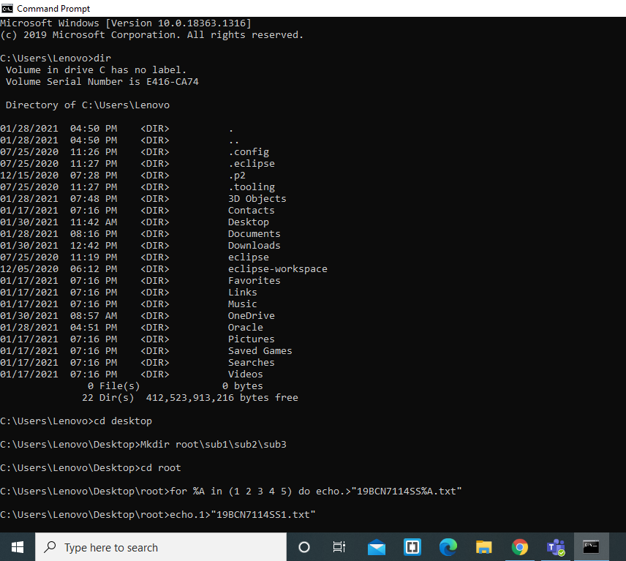

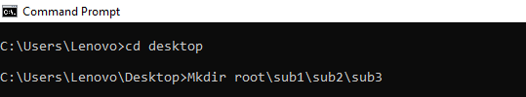

**ADDING FILES TO ROOT FOLDER OF .txt and .docx FORMAT**

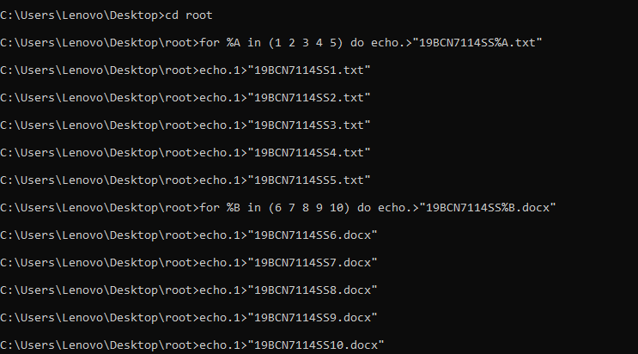

**ADDING FILES TO CHILD FOLDER ‘’SUB1’’ OF ROOT FOLDER AND ALSO ADDING FILES STARTING WITH ‘’SS’’**

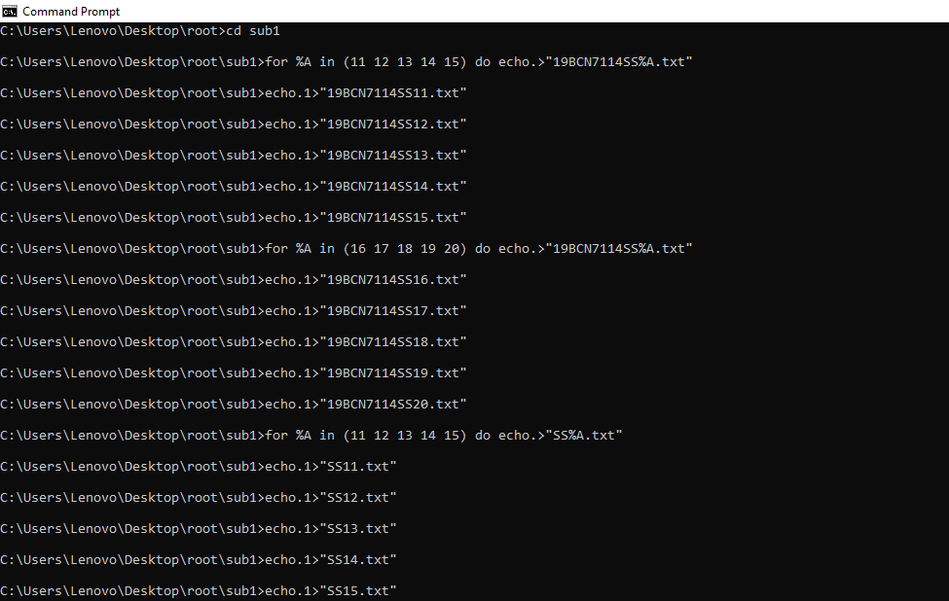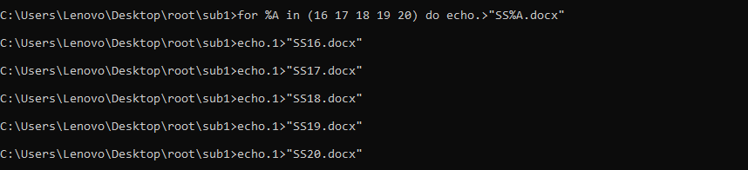

**ADDING FILES TO CHILD FOLDER OF SUB1 WHICH IS ‘’SUB2’’ OF BOTH TXT AND DOCX FORMAT**

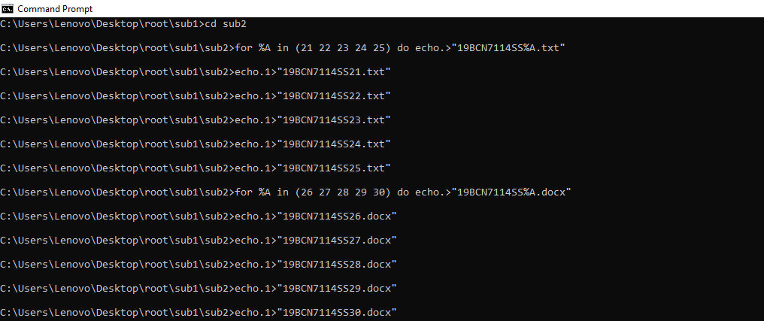

**ADDING FILES TO CHILD FOLDER OF SUB2 WHICH IS ‘’SUB3’’ WHICH HAS BOTH TXT AND DOCX FORMAT FILES**

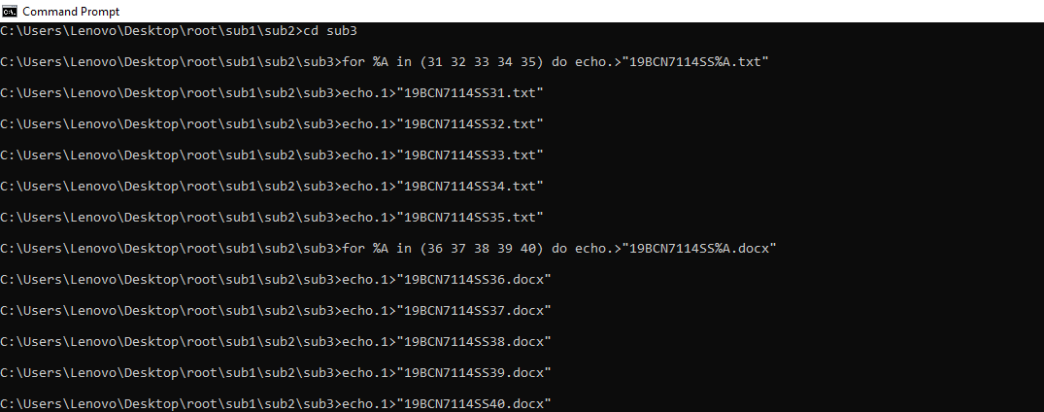

**DELETING ALL FILES OF LAST CHILD FOLDER ‘’SUB3’’ AND DIRECTING TO PARENT DIRECTORY OF SUB3 WHICH IS SUB2**

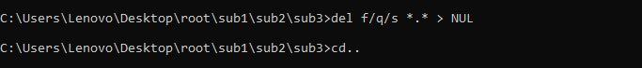

**DELETING ALL FILES OF DOCX FORMAT IN SUB2 AND DIRECTING TO PARENT FOLDER SUB1**

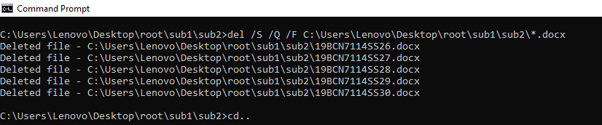

**DELETING ALL FILES HAVING “SS” AS ITS STARTING NAME IN SUB1 FOLDER AND DIRECTING LATER TO ROOT FOLDER**

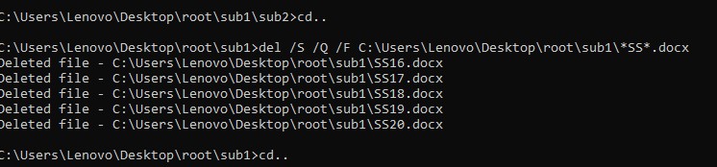

**ADDING FILES SS11 TO SS20 TO ROOT FOLDER**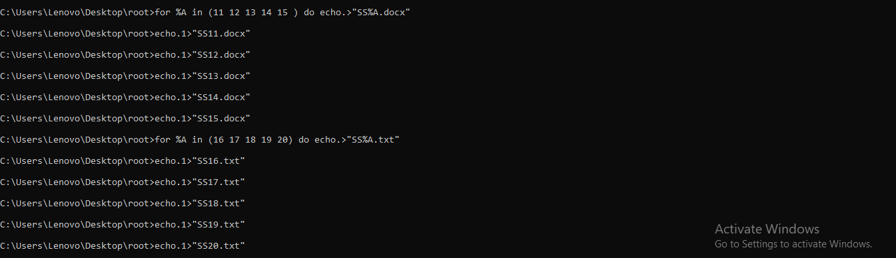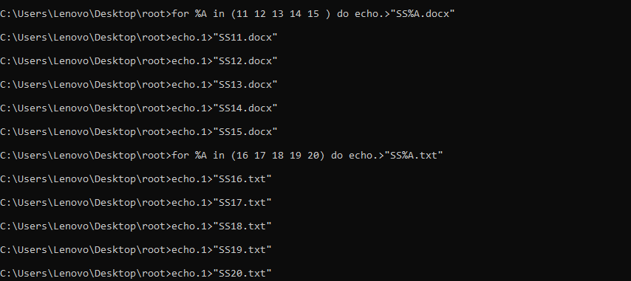

**DELETING ALL FILES STARTING FROM SS11 TO SS20 IN ROOT FOLDER**

