**SECURE CODING(CSE2010)**

**SLOT –L23+L24**

**LAB 2**

**NAME-** KOTI VEERA PRABHU SAI GANESH MAJETI

**REG NO.-**19BCN7073

**Question 1:**

**Silent installation of a software using msiexec command in cmd**

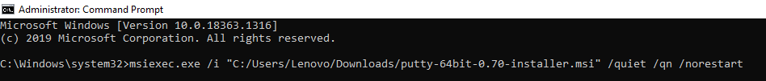

**Question 2:**

**Who has the highest privilege in an OS?**

The **“SYSTEM”** has the highest privilege. There are some tasks where the user cannot end and when the user tries to end the task a dialogue box appears stating that “Access Denied” showing that there is a higher privileged entity.

**Question 3:**

**Find the details of the current user**



**Question 4:**

**In what form is our folders organized and of which type?**

The folders are arranged in the form of **tree** data structure and their type is **hierarchical.**

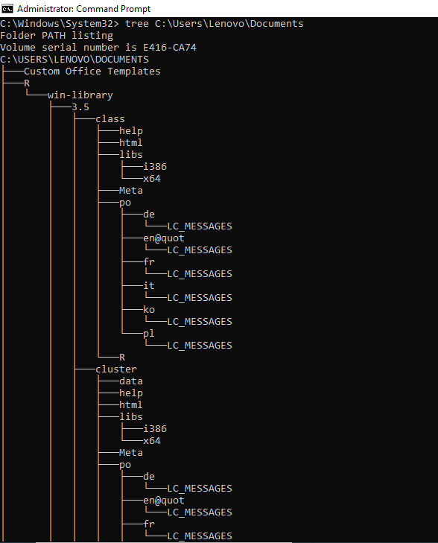

**Question 5:**

**Find the privilege of the user**

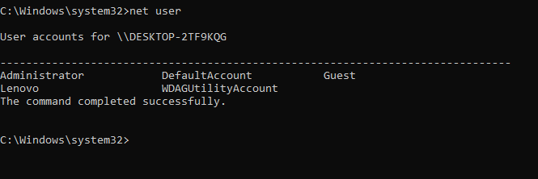

**Question 6:**

**Write down the executable formats in Windows and Linux**

The executable formats are .exe, .deb, .sh, .msi, .jar, .bat, .bin, .dll

**Question 7:**

**Usage of “assoc” command.**

**To find out all file types of a location using assoc command**

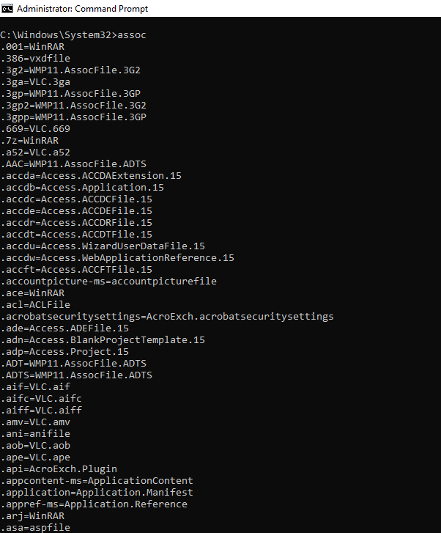

Other commands using >,>>,<

**assoc>types.txt**



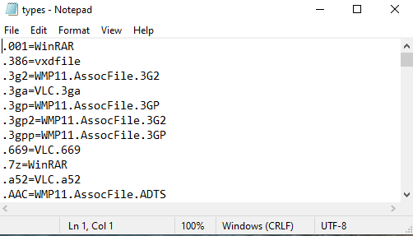

**Ipconfig>>netdata.txt**

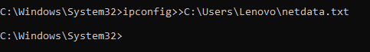

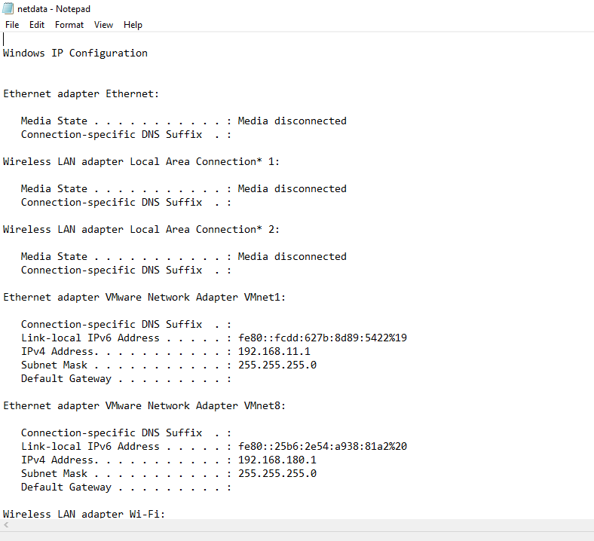

**Sort<textfilename.txt**

Here textfilename-ipconfig.txt

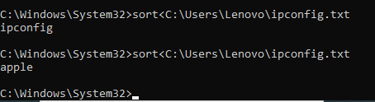

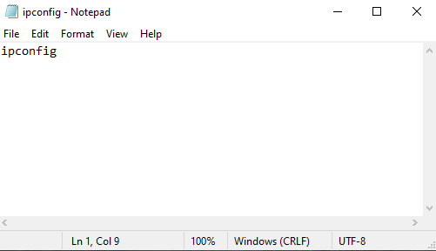

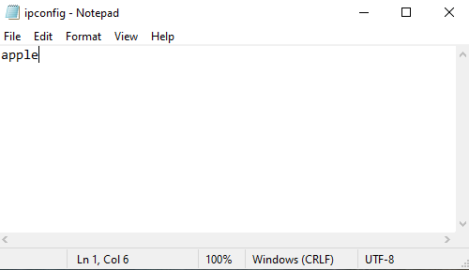

**Reset and enter new time:**

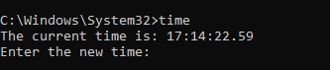

**Pushd and Popd operations:**

These operations are used for file switching by moving forward or backward. The above two operations remove the need of “cd”

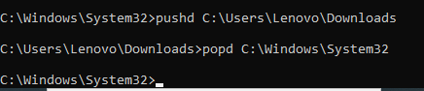

**With cd:**

