**SECURE CODING (CSE 2010)**

**SLOT –L23+L24**

**LAB 3**

**NAME-** KOTI VEERA PRABHU SAI GANESH MAJETI

**REG NO.-**19BCN7073

**QUESTION 1:**

**Command to find browser installation location**

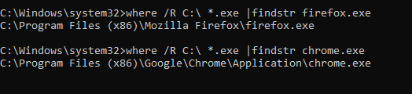

**QUESTION 2:**

**Check Scheduled tasks using schedule tasks**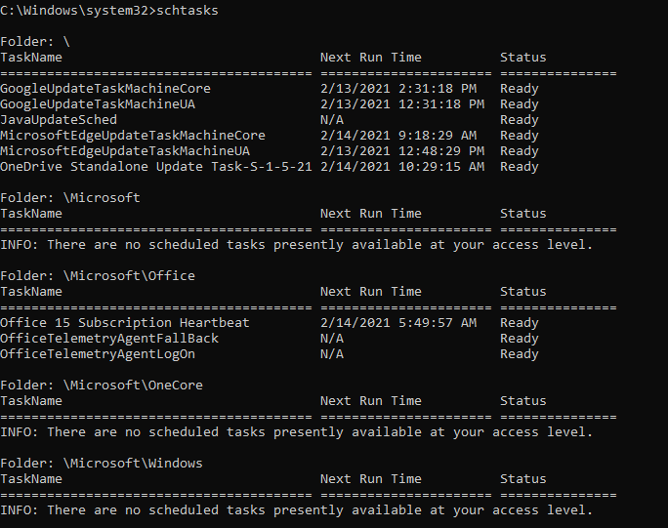 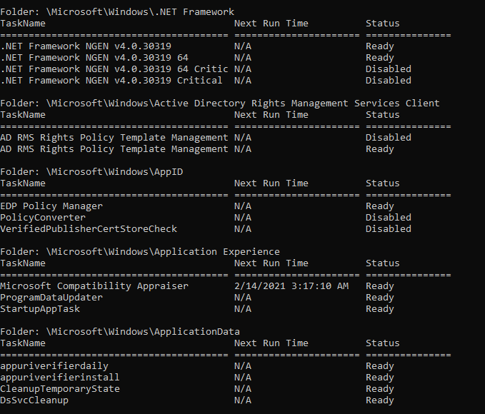 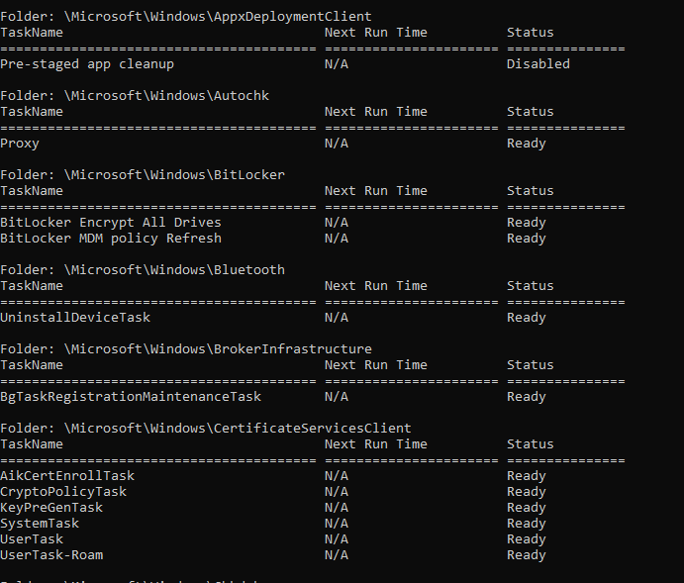 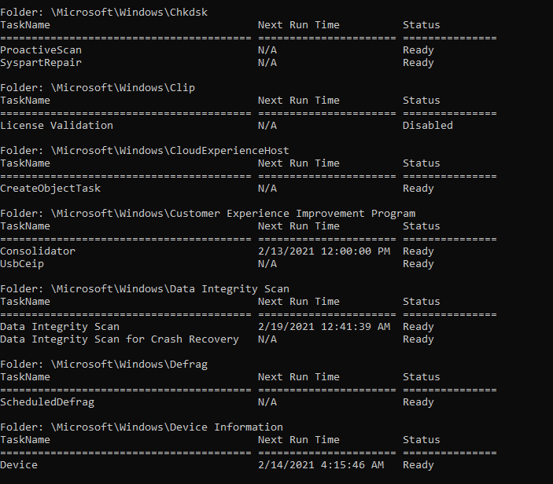 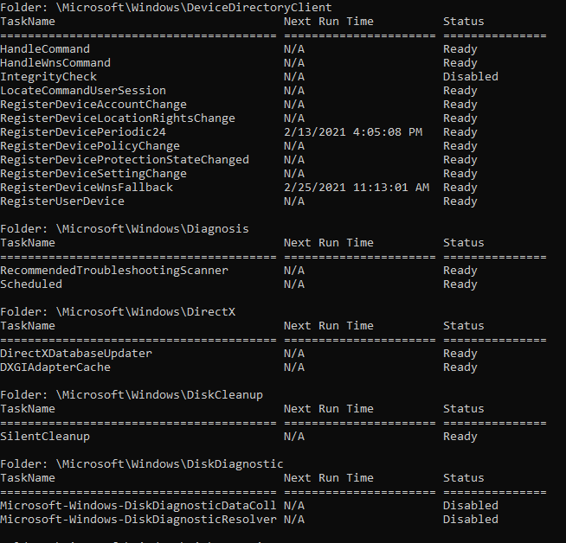

**QUESTION 3:**

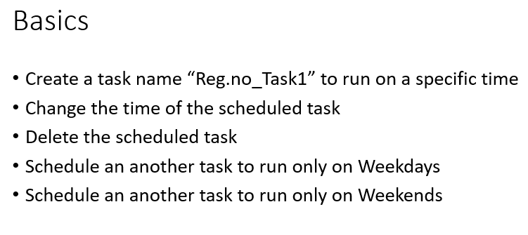

**Creation of task to run on a specific time:**



**Changing the time of scheduled task:**

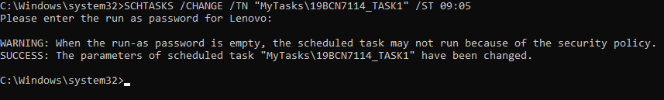

**Deleting the Scheduled task:**

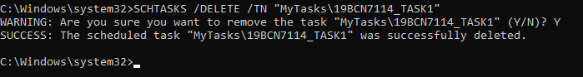

**Scheduling task to run on weekdays:**



**Scheduling tasks to run on weekends:**

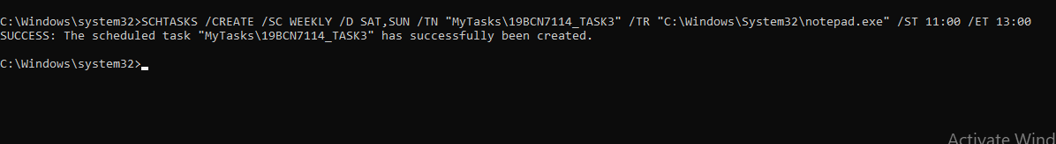

**QUESTION 4:**

**Find a command that searches for text string in a file or files**

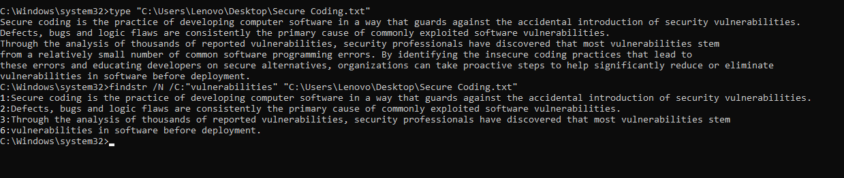

**QUESTION 5:**

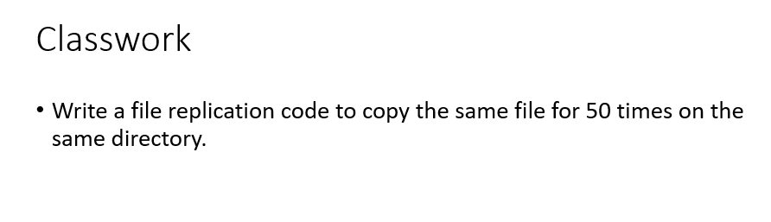

**File before replication: File name- (Secure Coding.txt)**

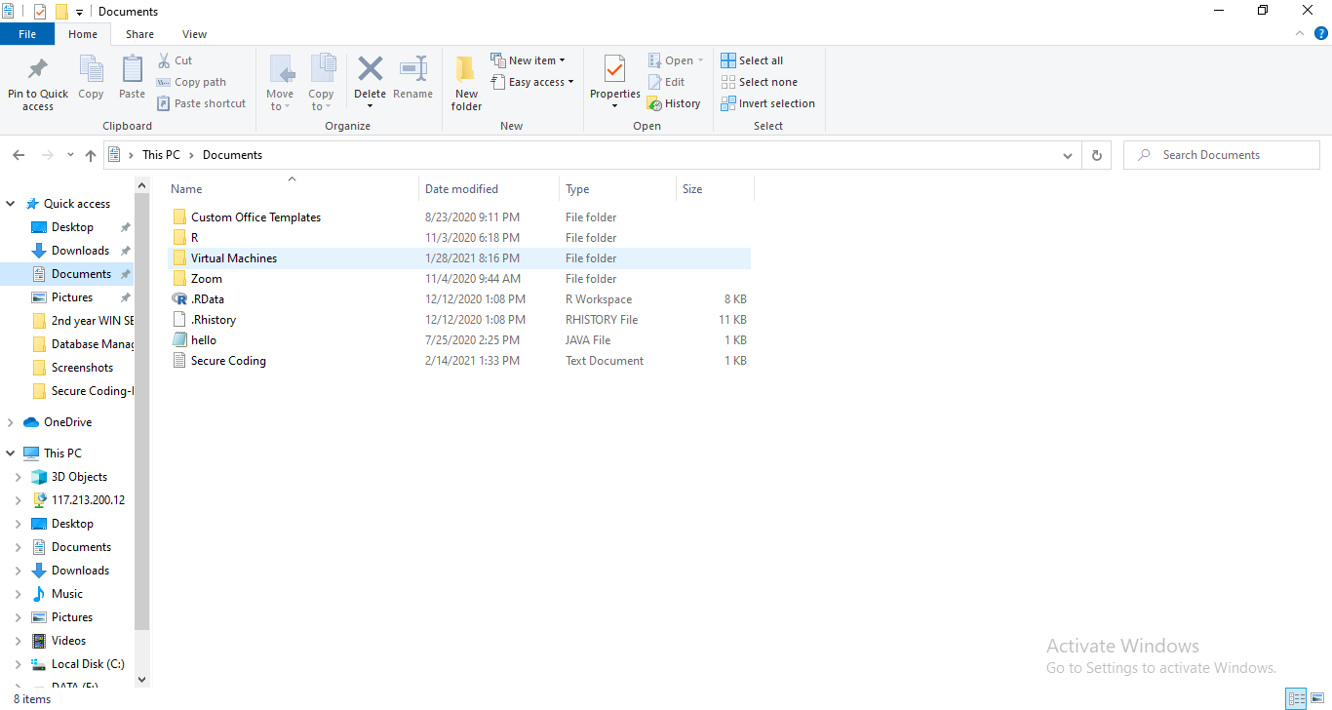

**File Replication:**

**Code-**

for /l %A in (1,1,50) do copy "C:\Users\Lenovo\Documents\Secure Coding.txt" "C:\Users\Lenovo\Documents\Secure Coding-%A.txt"

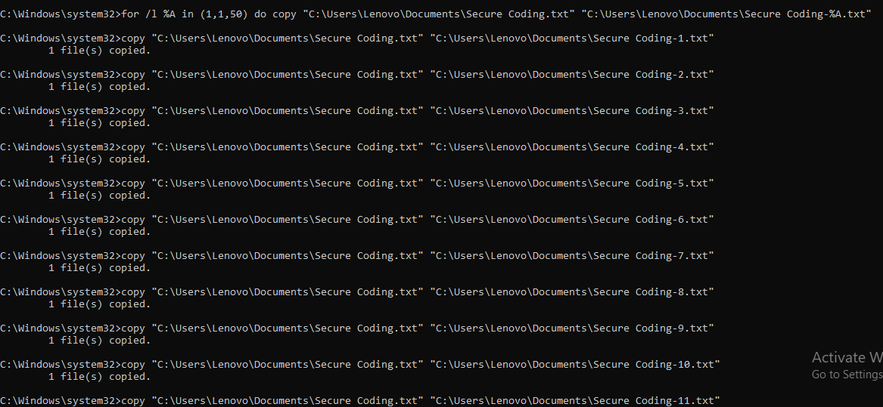

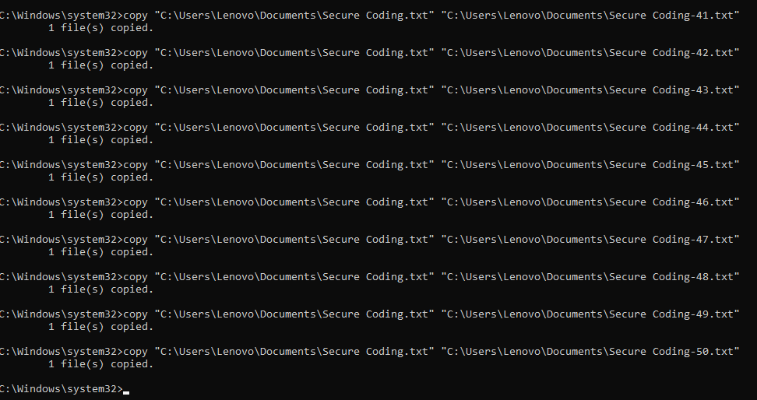

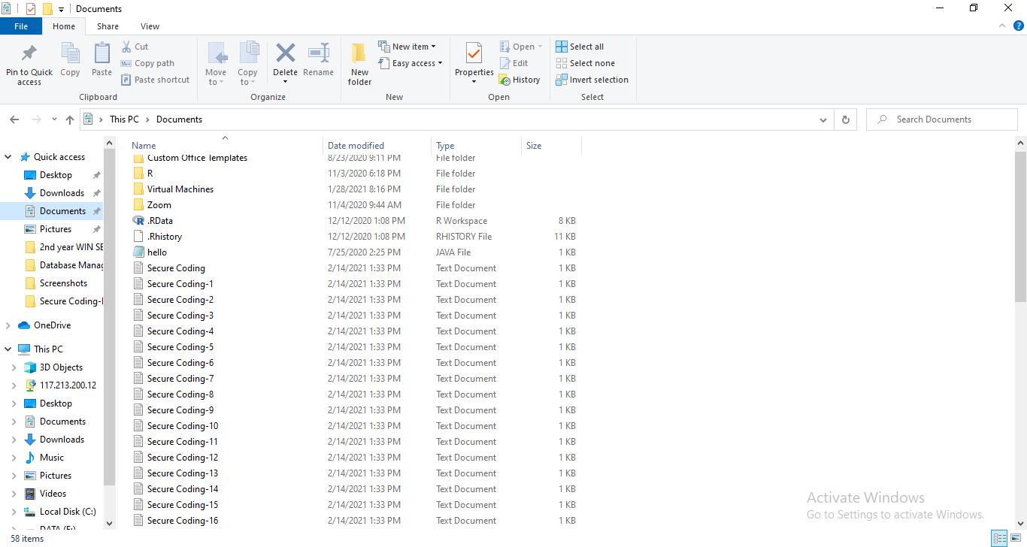**File Replication Output:**

