**SECURE CODING (CSE 2010)**

**SLOT –L23+L24**

**LAB 5**

**NAME-** KOTI VEERA PRABHU SAI GANESH MAJETI

**REG NO.-**19BCN7073

**(Q) How Secure Coding is related to XSS?**

With the help of XSS we are able to find out the vulnerabilities of a website or web application. Here we apply payloads to test the website if it is vulnerable. With the help of XSS the user can write a better code to cover these vulnerabilities. It is just like a reality check for the creator of the website.

**(Q) Rxss on demo website?**

**Payload used:** **<IMG SRC=x onerror="alert(String.fromCharCode(88,83,83))">**

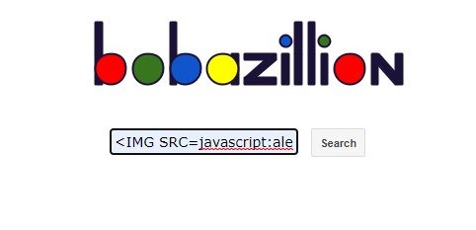

**OUTPUT Generated:**

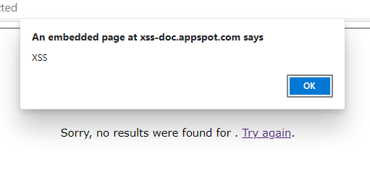

**Q) Storedxss on demo website**

**Attacker console:**

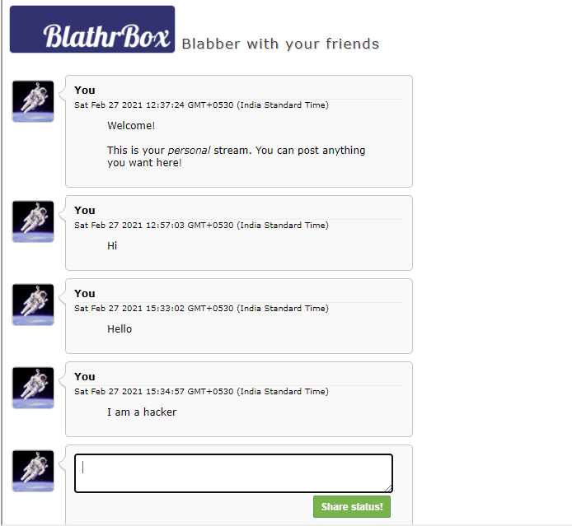

**Victim console:**

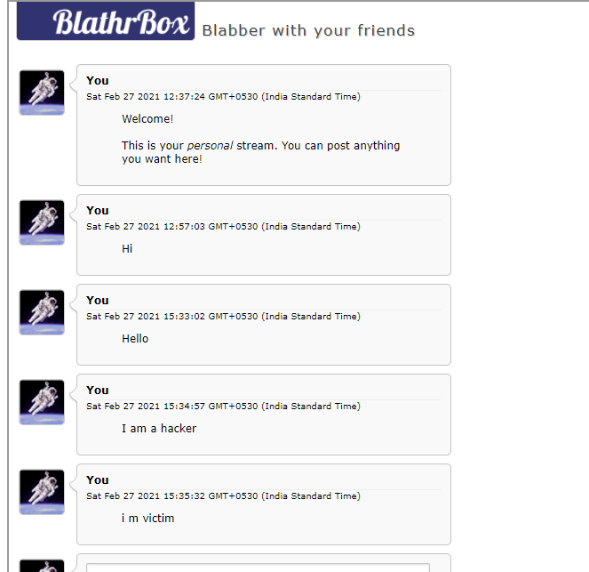

**Injecting payload from attacker console:**

**Payload injected:** **<IMG SRC=x onerror="alert(String.fromCharCode(88,83,83))">**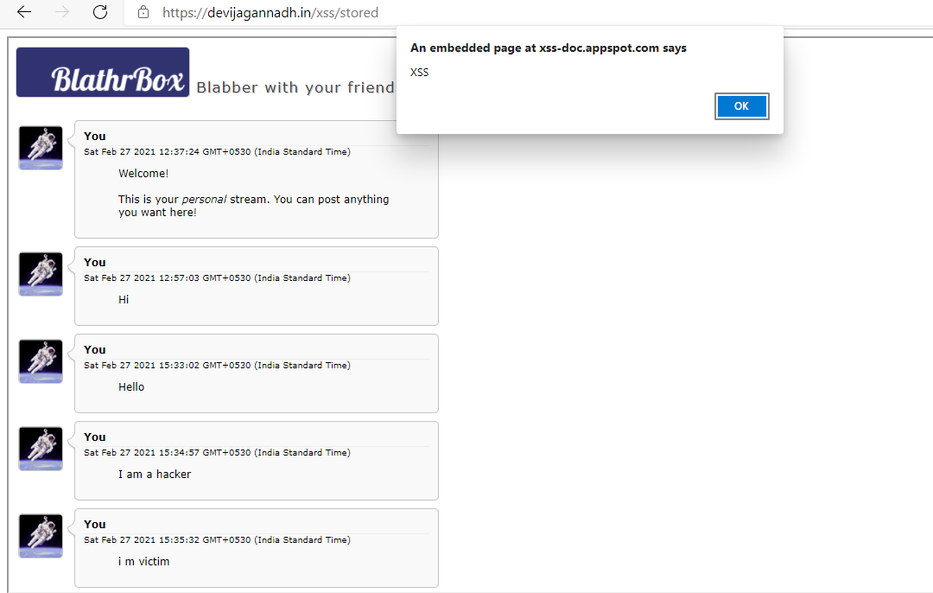

**Payload alert message reflected on victim’s window:**

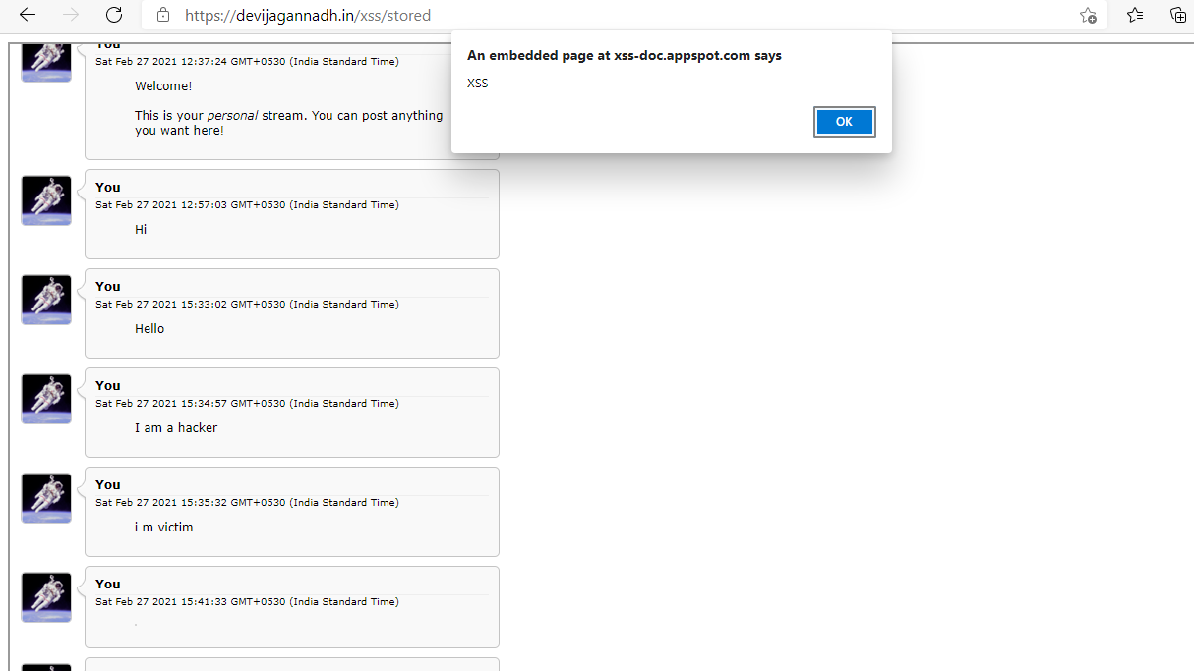

**(Q) DOM xss on demo website**

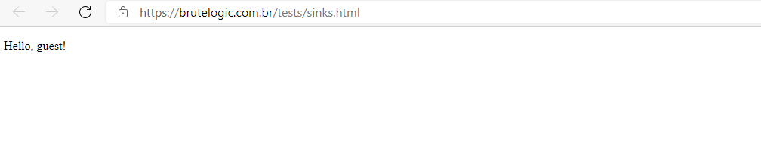

**Checking ways to enter the website:**

**Page source:**

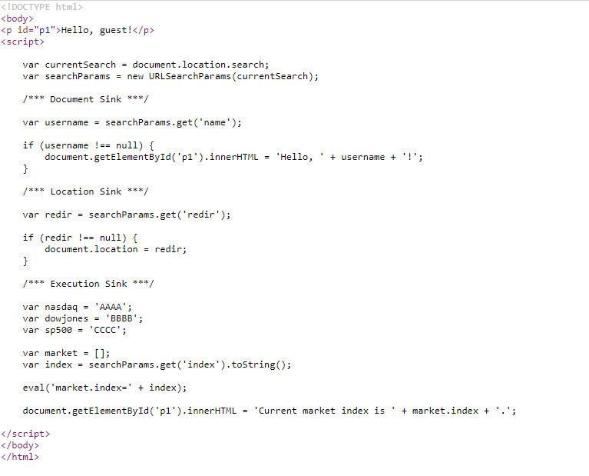

**From this we can alter the name and redir values**

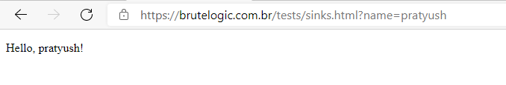

**Previously it was hello guest!**

**Now I gave the name as ‘pratyush’ and it has dynamically changed.**

**Let us add a payload into this and check what happens**

**Payload used:** **<style><img src="</style><img src=x onerror=javascript:alert(1)//">**

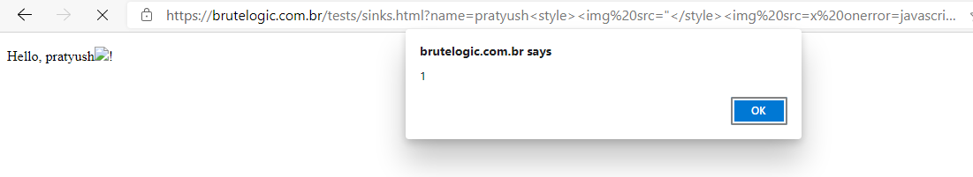

**Here redir in also a sink so let us redirect it by linking to some other website**

**Here I have given vtop link**

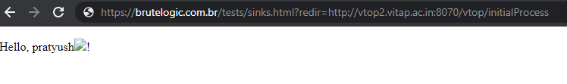

**Output:**

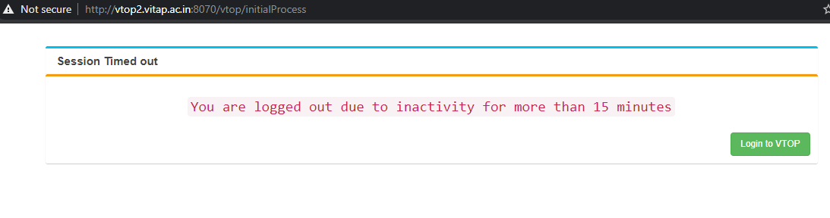

**(Q) Solution of alf.nu/alert1**

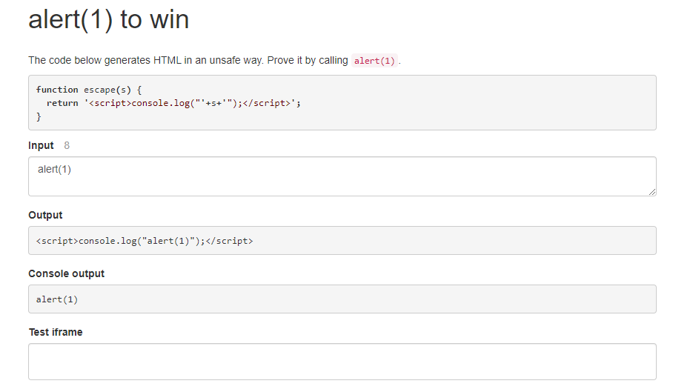

**3-Links :**

**devijagannadh.in/xss/reflected**

**devijagannadh.in/xss/stored**

**devijagannadh.in/xss/dom**

**Challenge : alf.nu/alert1**