**SECURE CODING (CSE 2010)**

**SLOT –L23+L24**

**LAB 6**

**NAME-** KOTI VEERA PRABHU SAI GANESH MAJETI

**REG NO.-**19BCN7073

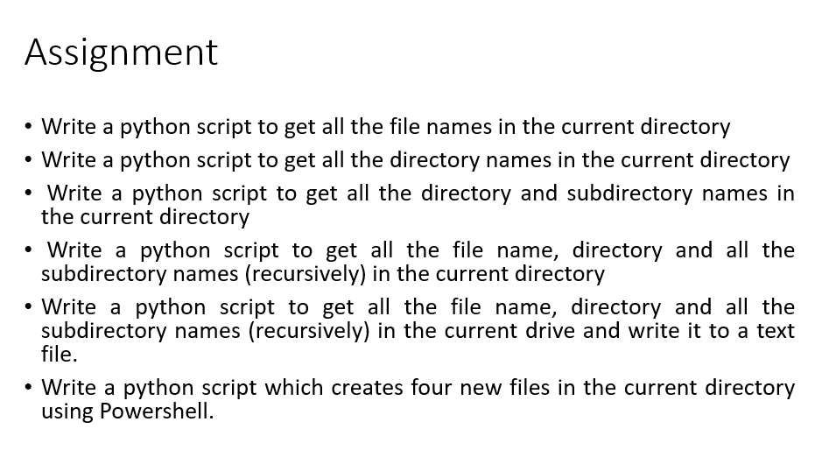

**Question 1 code:**

**import glob**

**path = 'C:\\Users\\Lenovo\\Downloads'**

**files = [f for f in glob.glob(path + "**/*.*", recursive=True)]**

**for f in files:**

**print(f)**

**Output:**

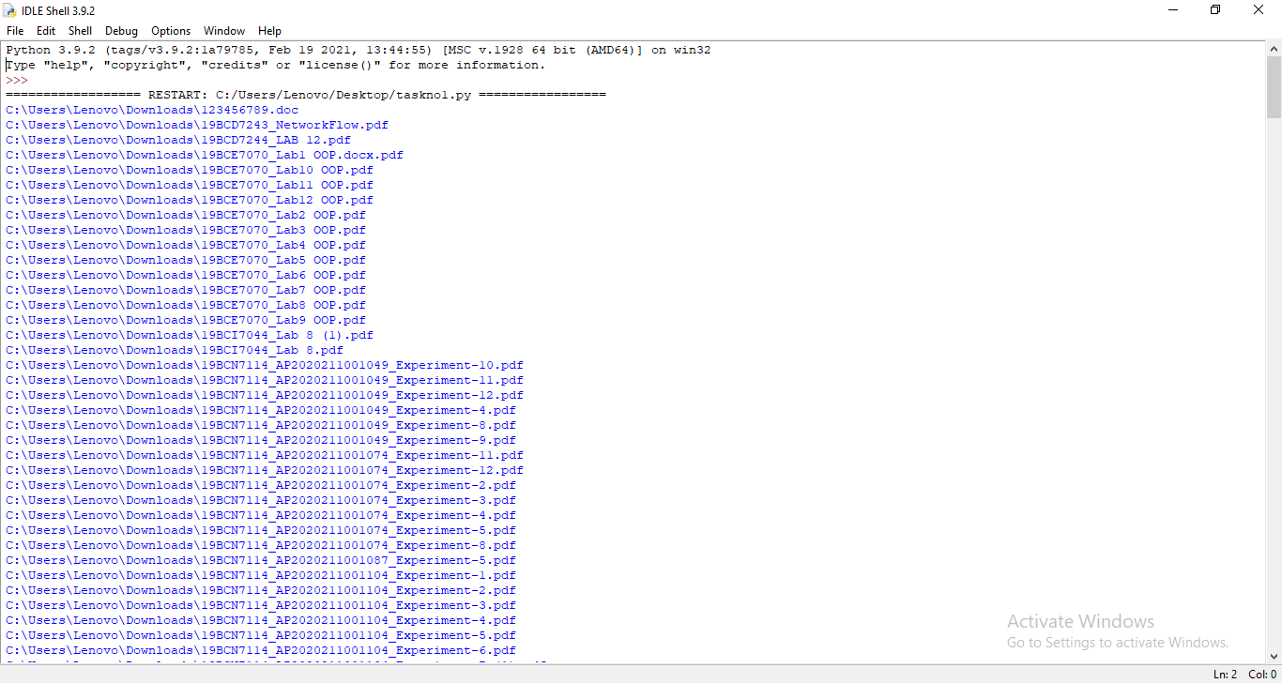

**Question 2 code:**

import os

path = 'C:\\Users\\Lenovo\\Desktop'

folders=[]

os.listdir(path)

for root, dirnames, filenames in os.walk(path):

folders.append(dirnames)

break

for dirnames in folders:

print(dirnames)

**Output:**

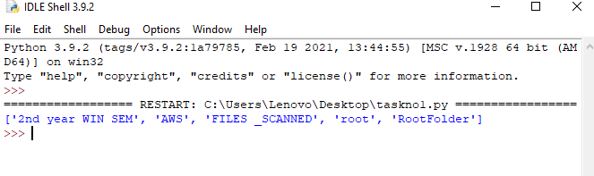

**QUESTION 3 code:**

import os

path = 'C:\\Users\\Lenovo\\Desktop'

folders = []

# r=root, d=directories, f = files

for r, d, f in os.walk(path):

for folder in d:

folders.append(os.path.join(r, folder))

for f in folders:

print(f)

**OUTPUT:**

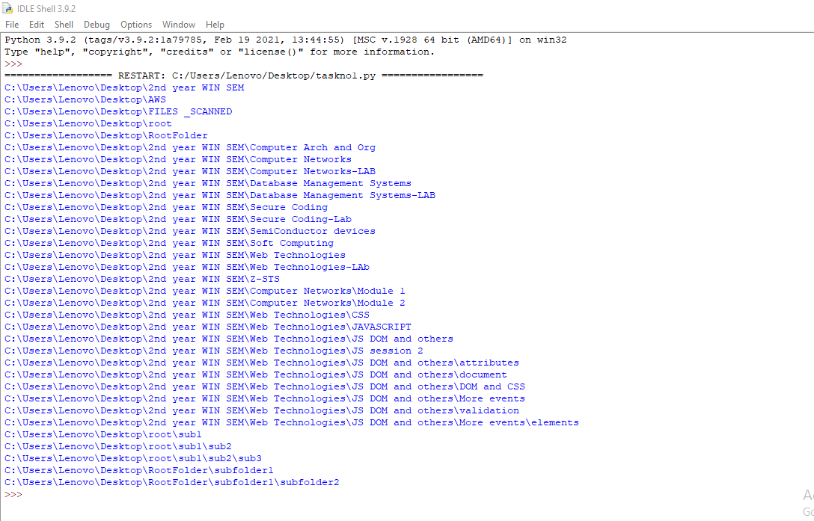

**Question 4 code:**

import os

import glob

path = 'c:\\Users\\Lenovo\\Documents'

print(" Displaying All the files : \n")

files = [f for f in glob.glob(path + "**/*.*", recursive=True)]

for f in files:

print(f)

print("\n Displaying All the directories and sub directories : \n")

folders = []

for root, dirnames, f in os.walk(path):

for folder in dirnames:

folders.append(os.path.join(root,folder))

for f in folders:

print(f)

**OUTPUT:**

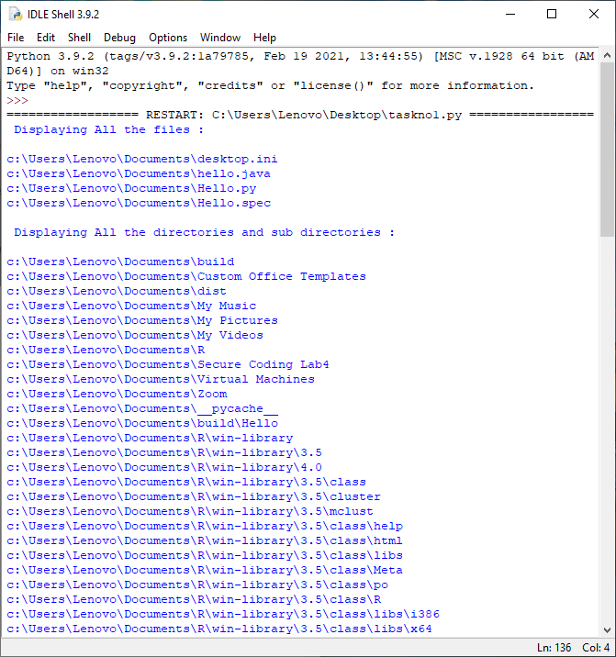

**Question 5 code:**

import os

import glob

path = 'c:'

fw = open("CurrentDrive.txt", "w")

fw.write("All the files : \n")

files = [f for f in glob.glob(path + "**/*.*", recursive=True)]

for f in files:

fw.write(f+"\n")

fw.write("\nAll the directories and sub directories : \n")

folders = []

for root, dirnames, f in os.walk(path):

for folder in dirnames:

folders.append(os.path.join(root,folder))

for f in folders:

fw.write(f+"\n")

fw.close()

**Output:**

**Before Execution:**

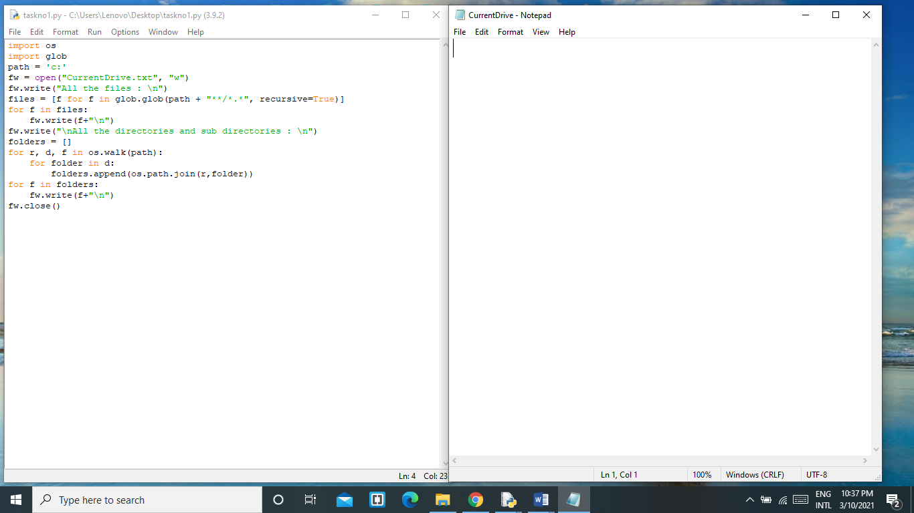

**After execution:**

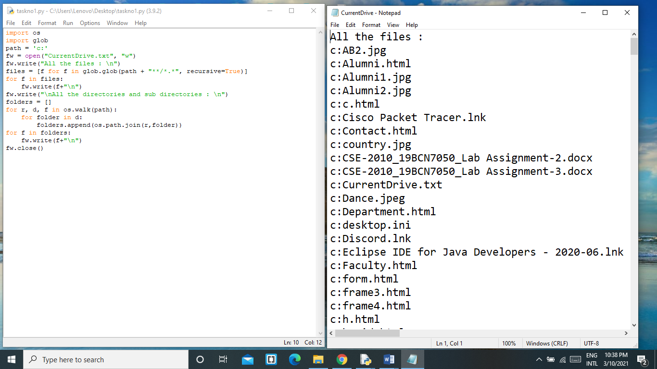

**Question 6:**

**Python code:**

list1 = ['a', 'b', 'c','d']

for i in range(len(list1)):

open('file%s.txt' % i, 'w').write(list1[i])

**Powershell execution:**

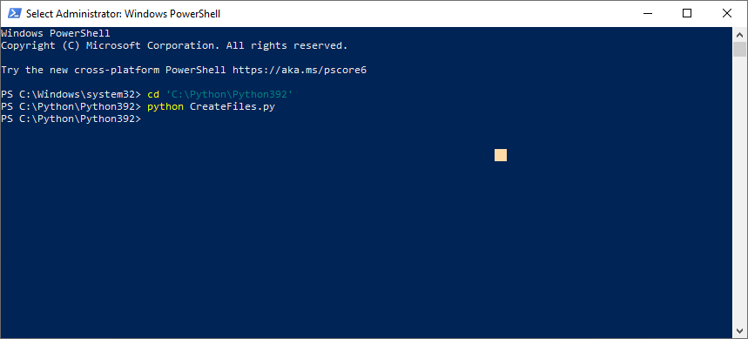

**Output Before Execution:**

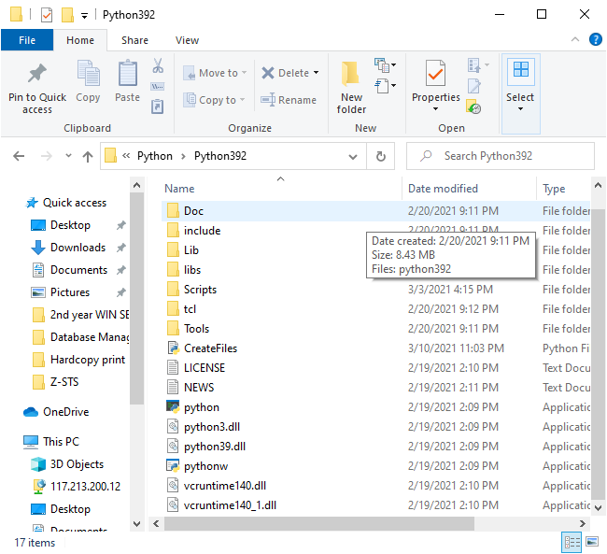

**Output After Execution:**

