SECURE CODING (CSE 2010)
SLOT –L23+L24
LAB 4

NAME- KOTI VEERA PRABHU SAI GANESH MAJETI
REG NO.-19BCN7073

QUESTION:
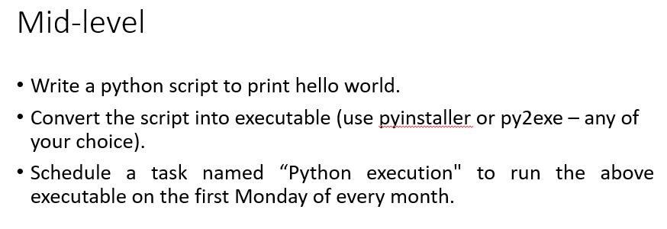

Python script named Hello.py and conversion to exe file:
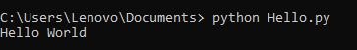
Conversion to exe:

Command used-pyinstaller --onefile Hello.py
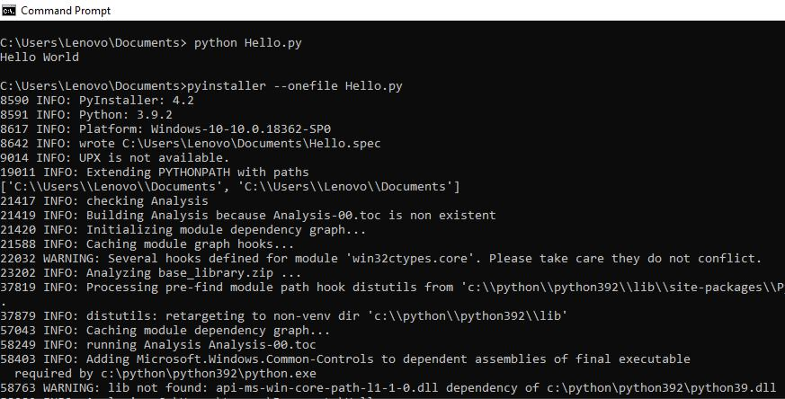

Documents folder with Hello.py file
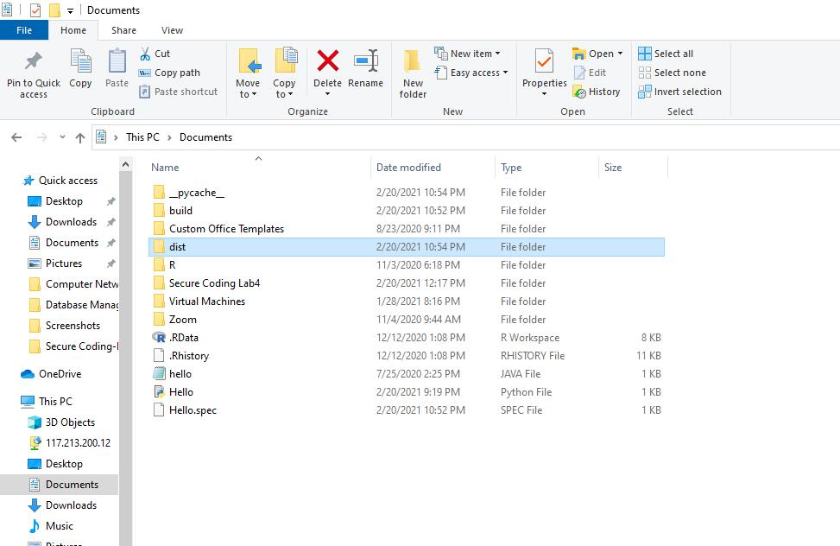
Executable file of Hello.py:

Present in dist folder
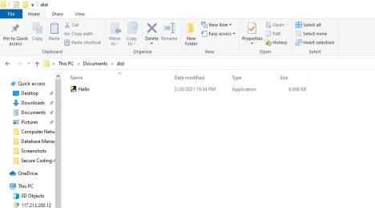

Scheduling task Python_Execution to run on first Monday of every month:
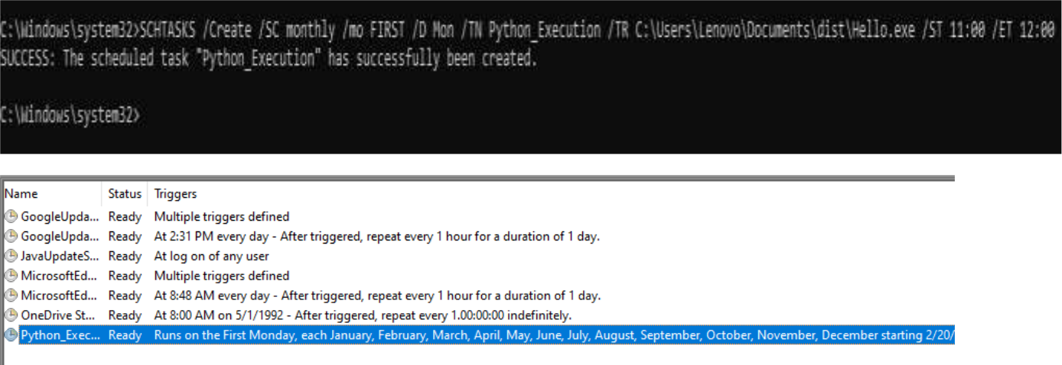
QUESTION:
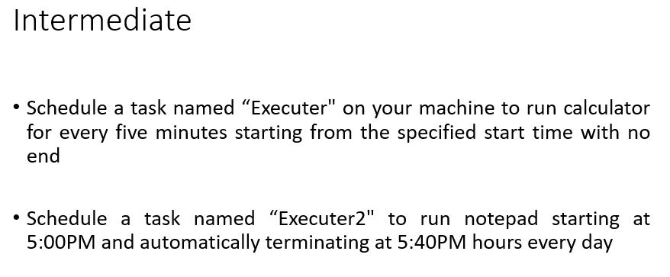

Creation of Executer1 task:
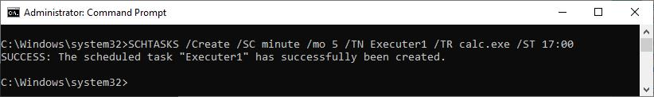

Verification:
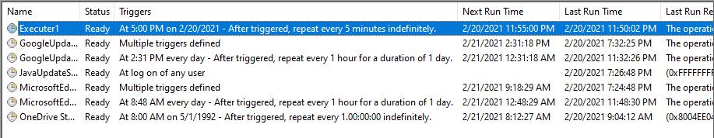

Creation of Executer2 task:
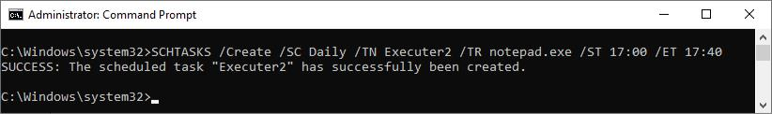
Verification:
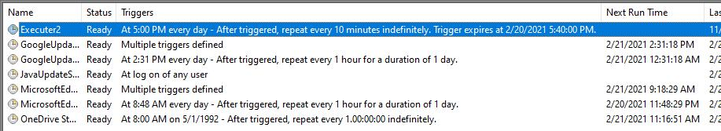

QUESTION:
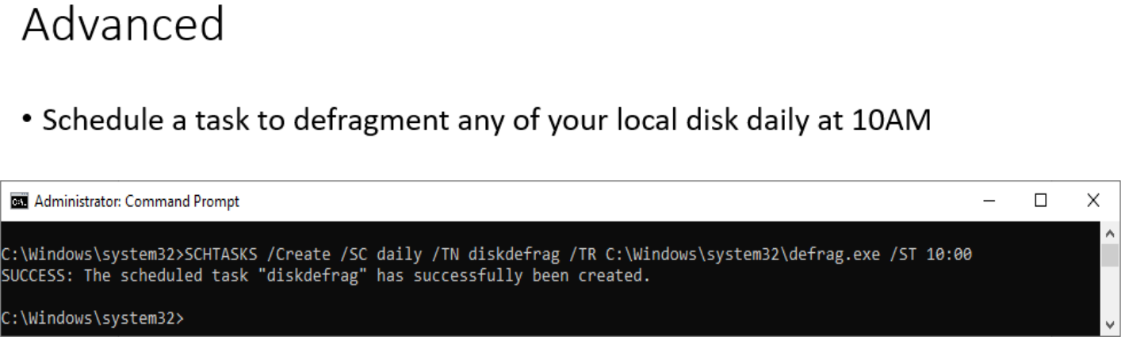

Verification:
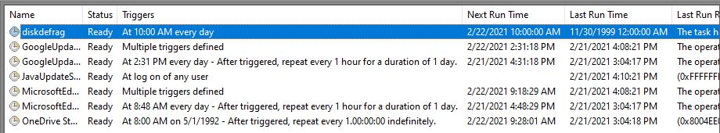

QUESTION:
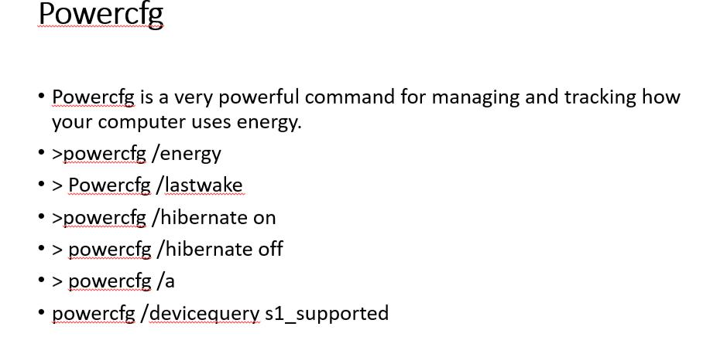

Outputs:

1)powercfg/BATTERYREPORT

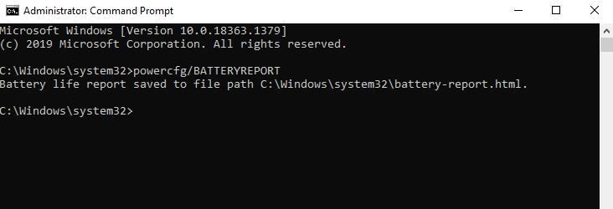

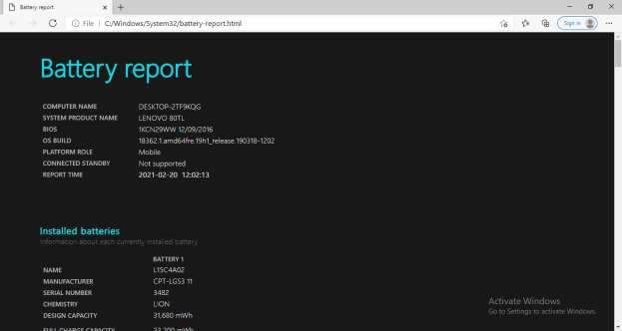

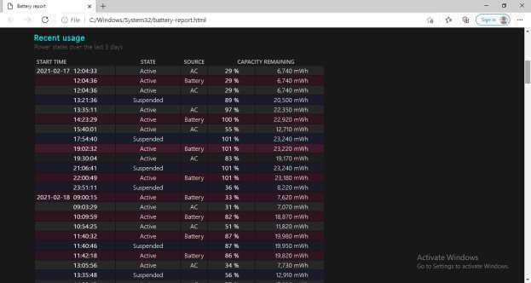
Output:
b) powercfg/lastwake
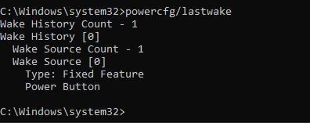

c) powercfg/energy
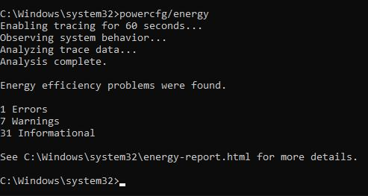
d) powercfg /hibernate on , powercfg/hibernate off , powercfg/a
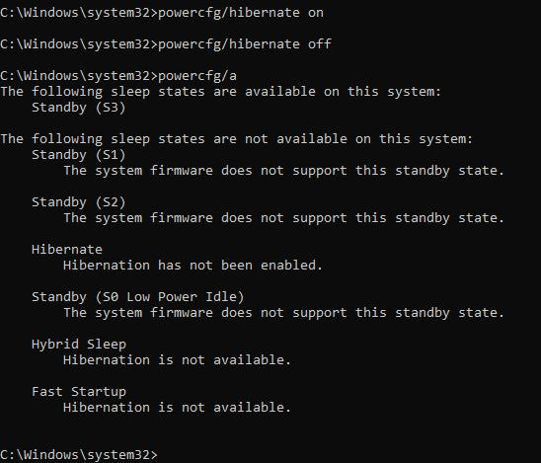

e) powercfg /devicequery s1_supported
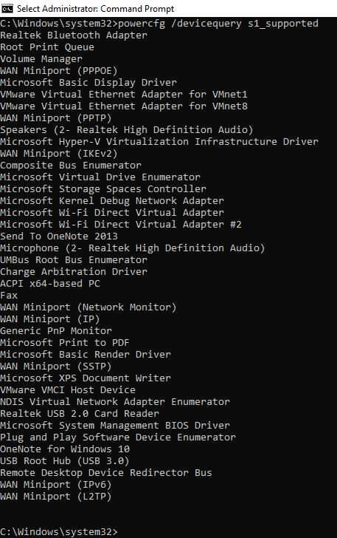
QUESTION:

Attrib command implementation:

Here a folder named Secure Coding Lab4 is created. The folder is being hid using attrib command

Folder before execution of attrib command:
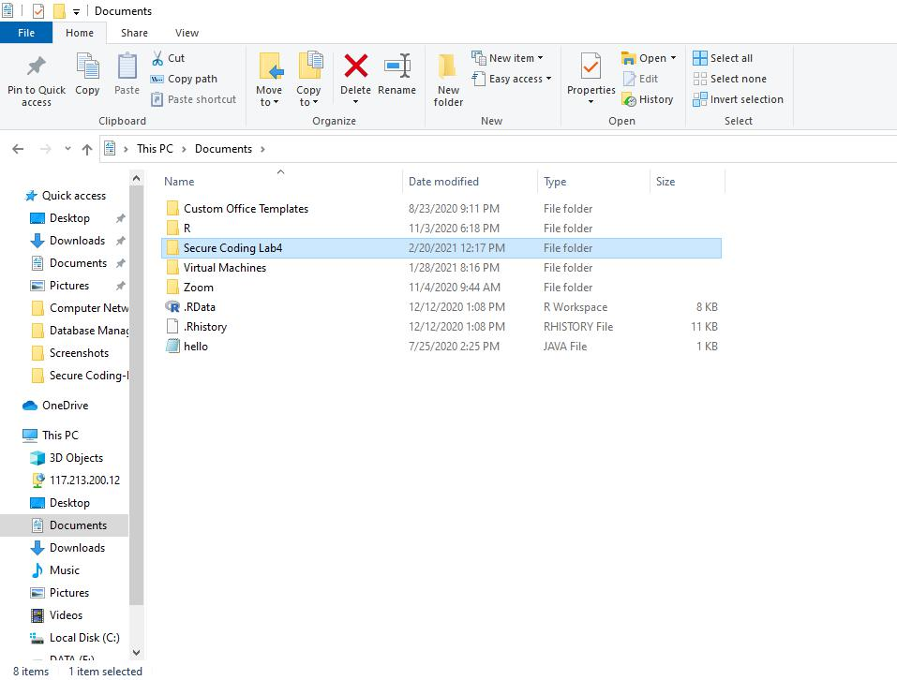

Execution:

Output after executing this command:
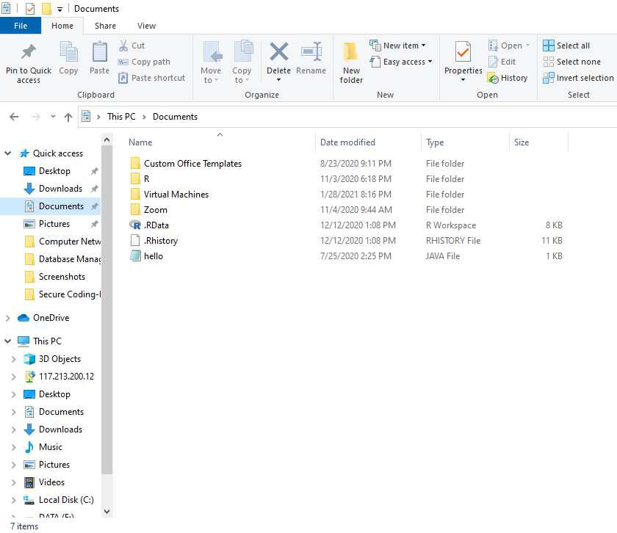

Retrieving back the folder:

Command-

Output:
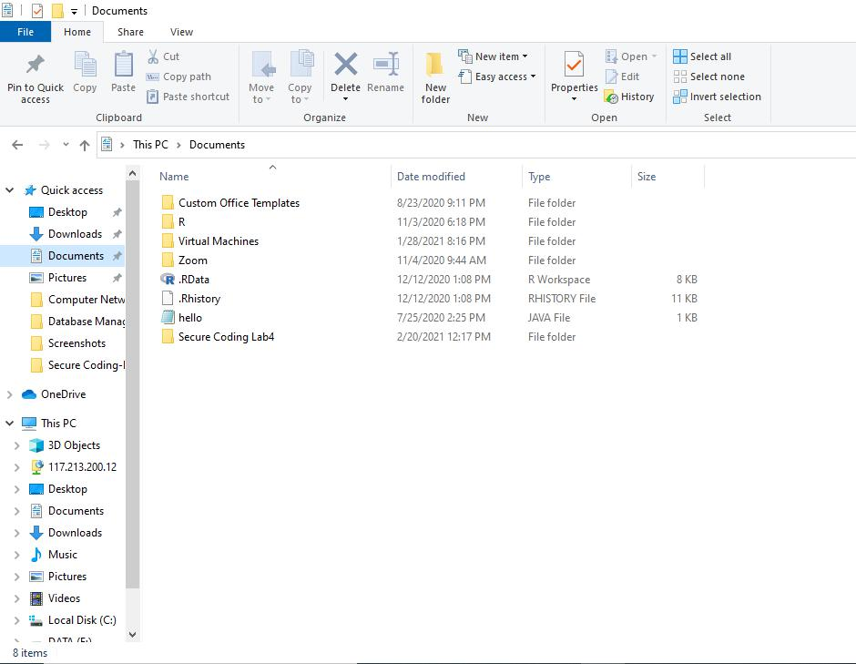

Question:
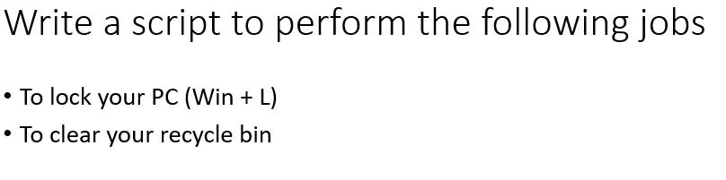

- Script to lock your pc: Lock.java

import java.io.*;

public class Lock

{

public static void main(String args[])throws IOException

{

Runtime run = Runtime.getRuntime();

Process pro = run.exec("C:\\Windows\\System32\\rundll32.exe user32.dll,LockWorkStation");

}

}

Output:
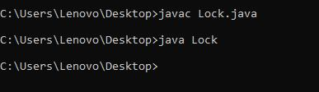

Execute this and we will be able to lock our PC.

b) Script to clear your recycle bin:

$Shell = New-Object -ComObject Shell.Application $RecBin = $Shell.Namespace(0xA)

$RecBin.Items() | %{Remove-Item $_.Path -Recurse -Confirm:$false}

Output:
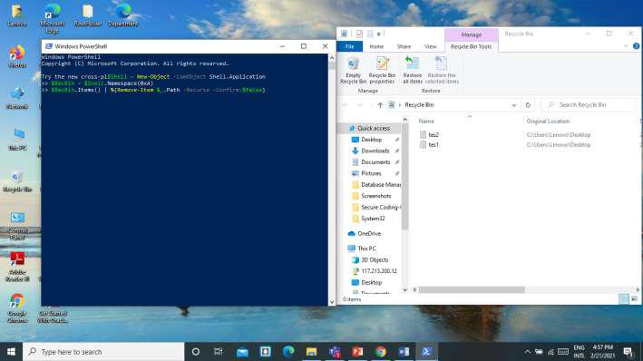

After executing:
