Started Using STM32F103C6 DATE: 29/09/2026
Fixed some software issues:
Working on Proteus 8 Professional and Keil microvision5
Today simulated LED Blinking on Proteus 8 Professional (STM32F103C6)
Circuit and Output:
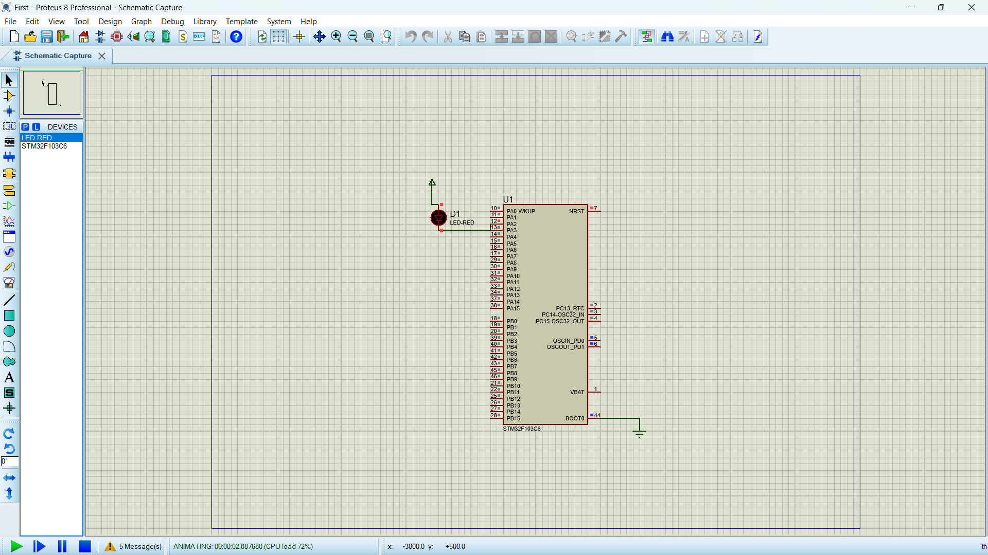

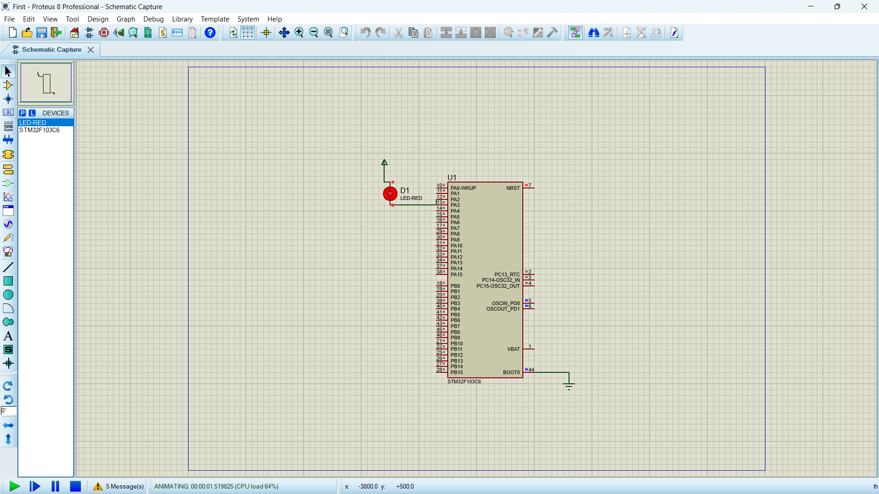

Configurations:
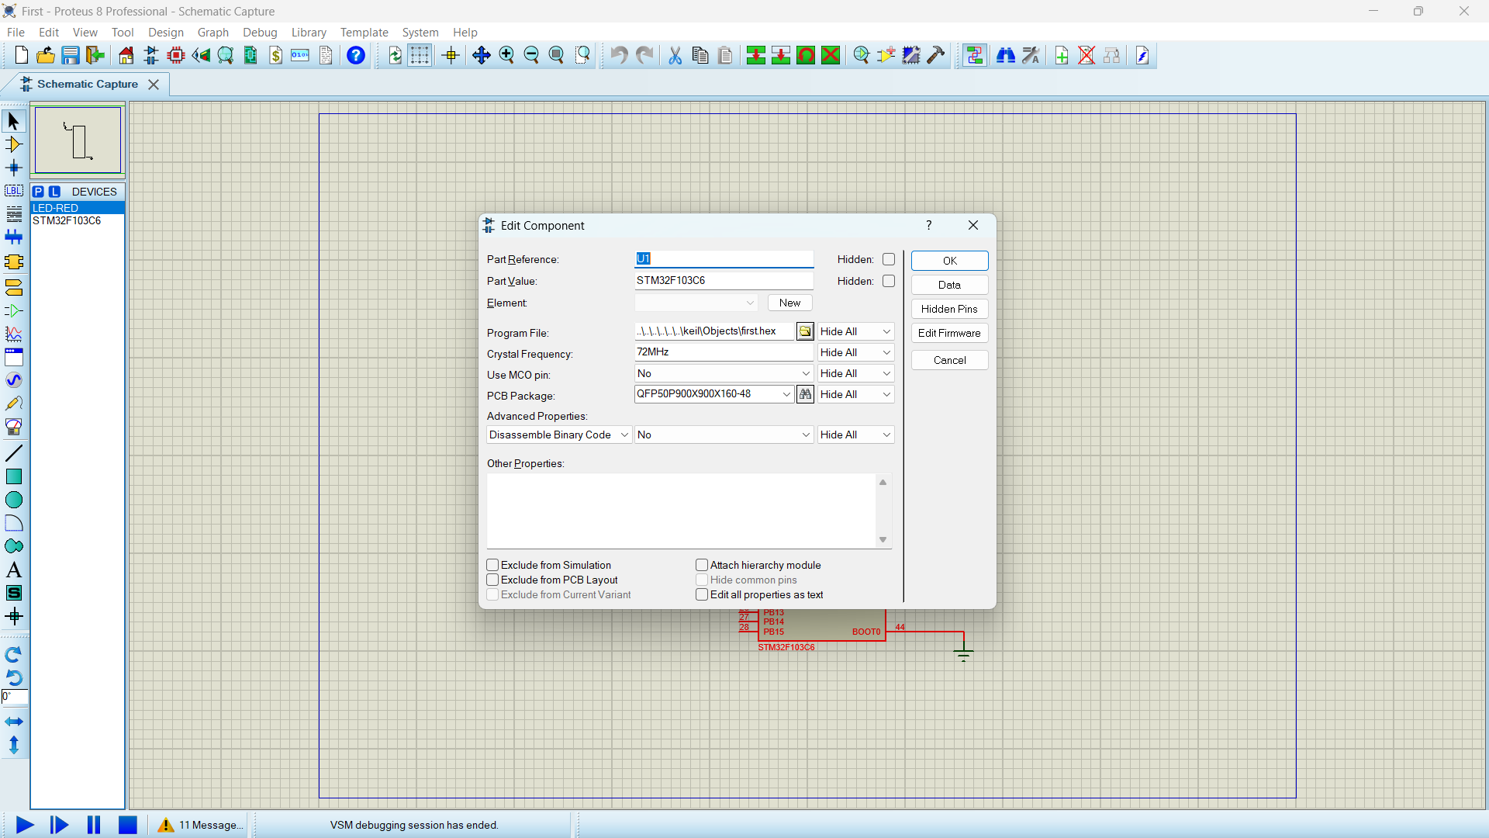

In Design Power rail configuration add VSSA to GND and VDDA to VCC/VDD

Code:
#include <stdint.h>

#define GPIOA_BASE 0x40010800
#define RCC_BASE 0x40021000

/* ================= RCC ================= */

typedef struct
{
volatile uint32_t RCC_CR; // 0x00
volatile uint32_t RCC_CFGR; // 0x04
volatile uint32_t RCC_CIR; // 0x08
volatile uint32_t RCC_APB2RSTR; // 0x0C
volatile uint32_t RCC_APB1RSTR; // 0x10
volatile uint32_t RCC_AHBENR; // 0x14
volatile uint32_t RCC_APB2ENR; // 0x18
volatile uint32_t RCC_APB1ENR; // 0x1C
volatile uint32_t RCC_BDCR; // 0x20
volatile uint32_t RCC_CSR; // 0x24
volatile uint32_t RCC_AHBSTR; // 0x28
volatile uint32_t RCC_CFGR2; // 0x2C
} RCC_Def;

#define RCC ((RCC_Def *)RCC_BASE)

/* ================= GPIOA ================= */

typedef struct
{
volatile uint32_t CRL; // 0x00
volatile uint32_t CRH; // 0x04
volatile uint32_t IDR; // 0x08
volatile uint32_t ODR; // 0x0C
volatile uint32_t BSRR; // 0x10
volatile uint32_t BRR; // 0x14
volatile uint32_t LCKR; // 0x18
} GPIO_Def;

#define GPIOA ((GPIO_Def *)GPIOA_BASE)

/* ================= Delay ================= */

void delay(uint16_t t)
{
volatile uint32_t i;

for(uint16_t j = 0; j < t; j++)
{
for(i = 0; i < 6000; i++)
{
}
}
}

/* ================= Main ================= */

int main(void)
{
/* 1. Enable GPIOA clock */
RCC->RCC_APB2ENR |= (1 << 2);

/* 2. Configure PA2 as output push-pull, 50 MHz */

/*
PA2 uses CRL bits 11:8

CNF2 = 00 -> General purpose push-pull
MODE2 = 11 -> Output, 50 MHz

Therefore:
bits 11:8 = 0011
*/

GPIOA->CRL &= ~(0xF << 8);
GPIOA->CRL |= (0x3 << 8);

/* 3. Continuously toggle PA2 */

while(1)
{
/* PA2 HIGH */
GPIOA->BSRR = (1 << 2);

delay(100);

/* PA2 LOW */
GPIOA->BRR = (1 << 2);

delay(100);
}
}

NOTE: To make everything work you need to install mdk keil and install software packs use chatgpt or any other model for this installations for your convenience, once you finished everything generate hex file and load it in our microcontroller in proteus.
Be patient with software they test your patience most of the time.

