**A Project Report**

**ON**

***“ONLINE BUS TICKET RESERVATION SYSTEM”***

**SUBMITTED BY**

**GANESH BHALEKAR**

**&**

**VAIBHAV GHADAGE**

**Bsc(COMPUTER SCIENCE)**

**Under the Guidance of**

**Prof. Rashmi Gandhi**

**SUBMITTED TO**

**University of Pune**

**SARHAD COLLEGE OF ARTS,COMMERCE& SCIENCE**

**KATRAJ,PUNE-411046**

(AFFILIATED TO SAVITRIBAI PHULE PUNE UNIVERSITY,PUNE)

SEMESTER IV

**\*2018-2019\***

**Ackonwledgement**

We are very glad to represent our project of **“Online Bus Ticket Reservation System”.**

I am grateful to our HOD **Mrs. Sonali Gholve mam** and our voice principle **Sangeeta Shinde**for their guidance and facility provided for the project.

We extent our heart full gratitude to our **Prof. Mrs. Rashmi Gandhi(projectGuide)** for her much needed untiring efforts and cooperation to us. She guided us form time to time and provide us with his valuable suggestion which helped us developing a good system. She always willing to solve our difficulties and saw that the minute details were considered.

We are also indebted to our faculty of Computer Science and entire staff of Computer Science Dept. for their timely guidence, support, encouragement and co-opeation.

Our final thank and greatest appreciation, however, is to our friend friends and companions ,who have helped us in the completion of our project.

**Thank you…**

**Ganesh Bhakekar**

**Vaibhav Ghadage**

**INDEX**

|  |  |  |  |
| --- | --- | --- | --- |
| **SR.No.** | **Contents** | **Page No.** | |
| **1. Introduction** | | | |
| **1.1** | **Need for System** | **5** | |
| **1.2** | **Scope of work** | **5** | |
| **1.3** | **Advantage of existing System** | **6** | |
| **1.4** | **DisadvantageofExistingSystem** | **6** | |
| **2. Proposed System** | | | |
| **2.1** | **Proposed System** | **7** | |
| **2.2** | **Feasibility study** | **8** | |
| **2.3** | **Hardware & Software Requirement** | **9** | |
| **2.4** | **Fact-Finding Techniques** | **9** | |
| **3. Analysis And Design** | | | |
| **3.1** | **ER Diagram** | **11** |
| **3.2** | **DFD** | **12** |
| **3.3** | **Class Diagram** | **13** |
| **3.4** | **Use Case Diagram** | **14** |
| **3.5** | **Activity Diagram** | **15** |
| **3.6** | **Sequence Diagram** | **16** |
| **3.7** | **State Transition Diagram** | **17** |
| **3.8** | **Database Design** | **18** |
| **3.9** | **User Interface(screen shots)** | **20** |

|  |  |  |  |
| --- | --- | --- | --- |
| **4 User Interface** | | | |
| **4.1** | **Drawbacks & Limitations** | **23** | |
| **4.2** | **Future Enhancement** | **23** | |
| **4.3** | **Conclusion** | **23** | |
| **4.4** | **Bibliography** | **24** |

**1: INTRODUCTION**

* 1. **Need For System**
* Provide a simpler method to store and access information related to passenger.
* Provide a simpler interface which will be easily used without much training.
* Provide paperwork and make all related information accessible easily.

* 1. **Scope Of Work**

The online bus ticket reservation System is being developed to provide a tool for the different bus service companies to easily maintain the reservation information. The system will give an effective output for the php and Microsoft excel give as input to the system. The compiled php program given as input to the system, after scanning the program will generate different reports.

At the start of the project setup Microsoft Access an interactive part to store information about passenger.

During the period of finalizing the idea of the system , the primary goal was to design the system i.e. those who don’t know how the handle the software. As designing work began and things started taking shape,the system got developed to a stage where it would be used by entry level.

**Existing System**

In the existing system bus reservation compnaies have to manually maintain information regarding to reservation of tickets of passengers. It is difficult to maintain information manually.

* 1. **Advantage Of Existing System**

1. As the system is manual there is no need of power.
2. As information stored in register books hard copy of record is present.
   1. **Disadvantage Of Existing System**
3. More man power to maintain the system.
4. Searching a record is a tedious task.
5. Possibility of loss of data.

**2: PROPOSED SYSTEM**

**2.1 Proposed System**

The Online Bus Ticket managemet System is a desktop System aimed at bus ticket reservation administration to maintain passenger information. The system takes passenger information as a input source and attempts to maintain ticket record . It allows flexibility during these processes.

The system generates exhaustive tickets related to the passenger. It will maintain information related to passenger who want to reseve booking of tickets.

The system requires comparatively small amount of resources such as memory, input/output, devices and disk space.

The system overall keeps approach highlighting key features of the bus reservation services.

**Objectives Of System**

Develop software such that everybody working in online bus ticket reservation system can handle easily. Trainer can store and retrieve data easily. And hence , keeping these major target segments in focus, the system was developed.

The economic factors were also worked out keeping the target segments into focus. The objective of developing a tool technical as well as non-technical user hence got achieved.

**User Requirement:**

* Need to have basic computer knowledge.
* Needs a little orientation to be able to user the software efficiently.

**2.2 FEASIBILITY STUDY**

Once the scope of the system is defined we have to specified exactly how the system will look like which leads to an estimate of the computer storage requirement that form the basis for the file design that is to be undertaken in the design phase of the project life cycle. Feasibility study is the test of system proposal according to its wokability impact on the organization ability to meet user effective use resources.  
 There are three aspects involved in the feasibility study.

**2.2.1 Technical Feasibility**

The technical feasibility study highlighted various differences in approaches and implementation of the php programming language environment. Total flexibility in student management makes easy to handle the information about passenger.

**2.2.2 Economical Feasibility**

The economical feasibility of the system was given due attention as well considering the emerging market. The system primarily aimed at academic and entry level personnel work out to be a good propective system if positioned properly into the IT market. The system has been kept very compact initially in the college only and depending on the targeted market segment response additional GUI features could be added. The system hence, at present is economical feasible.

Operational feasibility means whether the new system

Performs its work efficiently and asks for the user needs. What are the facilities provided? What is the impact on the user?

We guaranteed that after developing the system it is 100% operationally feasible and very easy to operate. Also on-demand reports will give the users the exact information that itself proves that the system is working perfectly.

**2.3 Hardware And Software Requirement**

* Hardware(minimum requirement):-
* Pentium IV or higher
* 256 MB RAM or higher
* 20.00 GB hard disk
* Software(minimum requirement):-

For Linux platform

* Postgresql as backend
* Php5 as front end

**2.4 Fact-Finding Techniques**

We used four fact-finding technique in this system analysis

1. Questionnaries
2. Interview
3. Record Reviews
4. Observation

* **Questionaries**

We used technique in the initial and final phase of my project. We conducted this session by asking question to the administrator of the manual system, Student and Teacher of different classes in the initial phases we prepared questionnaires to get some basis information about the current system. We could find out the work structure of the organization and it’s functioning. In the final stage we used the questionnaires to get some numerical data that was required or was missing after all the observation. Question asked were both open ended and close ended, which were related to user’s interaction with current system, updating and rules for record maintainance, reports generated by current system complications in the system as per user.

* **Interviews**

We used this technique frequently in the system analysis after questionnaires. These interviews were unstructured. We choose some people in the organization who were either the decision makers or user in the some people the organization who were either the decision makers or user in the some activity related with the project. We interviewed them many times. This helped us understand all the stages involved in activity.

* **Record Review**

This is the most benieficial technique for me while making my database. We studied theexisting file structure, documents used and generated in the organization. For every individual piece of information in these files or registers we tried to identify its significance, need, relation with other features.

* **Observation**

While finding the facts we keenly observed all the activity in the organization. We paid attention to the transaction, usages of files and documents, the record keeping and the handling of the queries in the existing system.

**ANALYSIS DESIGN**

**3.1Entity Relationship Diagram**

1 1

buy

Ticket

passenger

r

M M

check

Travel

1 1

1 1

**bus**

conductor

Have

3.2 DFD

4.book seat and payment

3.Available seat

2.Check seat Availability

Passenger

1.login

Passenger

Passenger

**First Level DFD:**

passenger

3.3 class Diagam-

-

+Passenger_information()

+Bus_information()

+Ticket_information()

+Ticket _dispaly()

+Passenger_information()

+Bus_information()

+Ticket_information()

+Bus_information()

+Ticket_information()

Conductor_information()

Ticket Information()

Conductor

+B_no +B_rout +B_time +B_seat

Bus

Passenger

Ticket

+T_id +T_ammount +T_date

_id +a_name

+p_no +p_address +name +p_mobno +p_age +p_seatno

+cname +c_no +C_age +p_address

3.3 Use Case Diagram –

System

Bus

Traveller

3.4 Component Diagram:

Ticket

Conductor

Bus

Passenger

**3.5 Activity Diagram**:

**3.5 Activity Diagram**:

Yes

NO

Print Not Available

Confirmation Message

Pay Payment

Select Payment Mode

Book Seat

Seat Available

Check Seat Availability

Login

Login Successfully

Passenger

Logout

* **Screenshot:-**

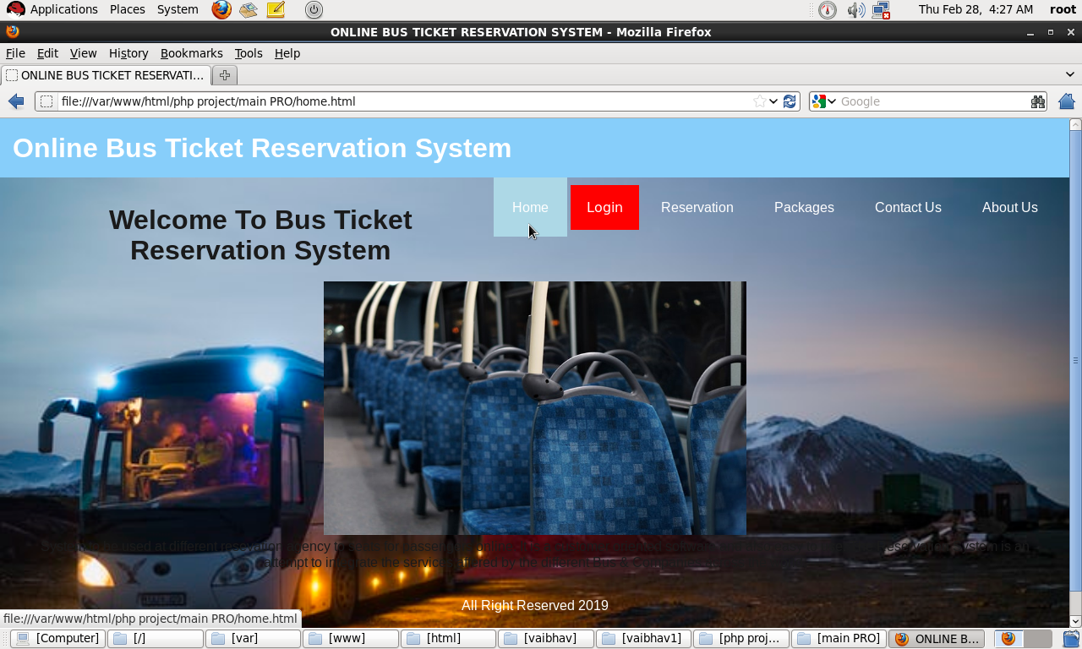

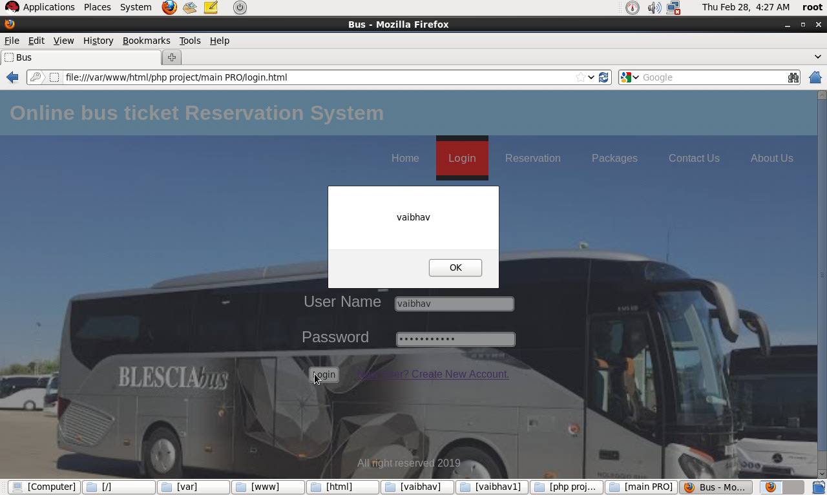

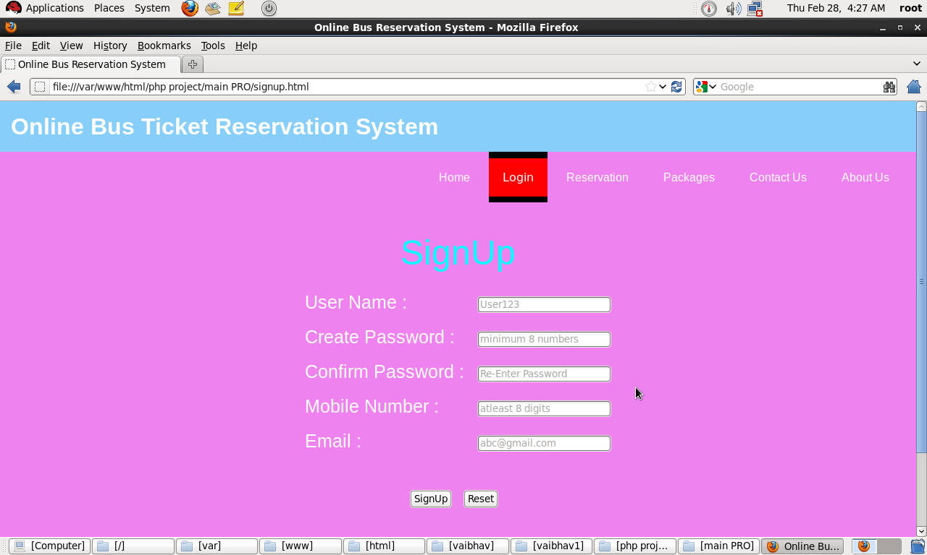

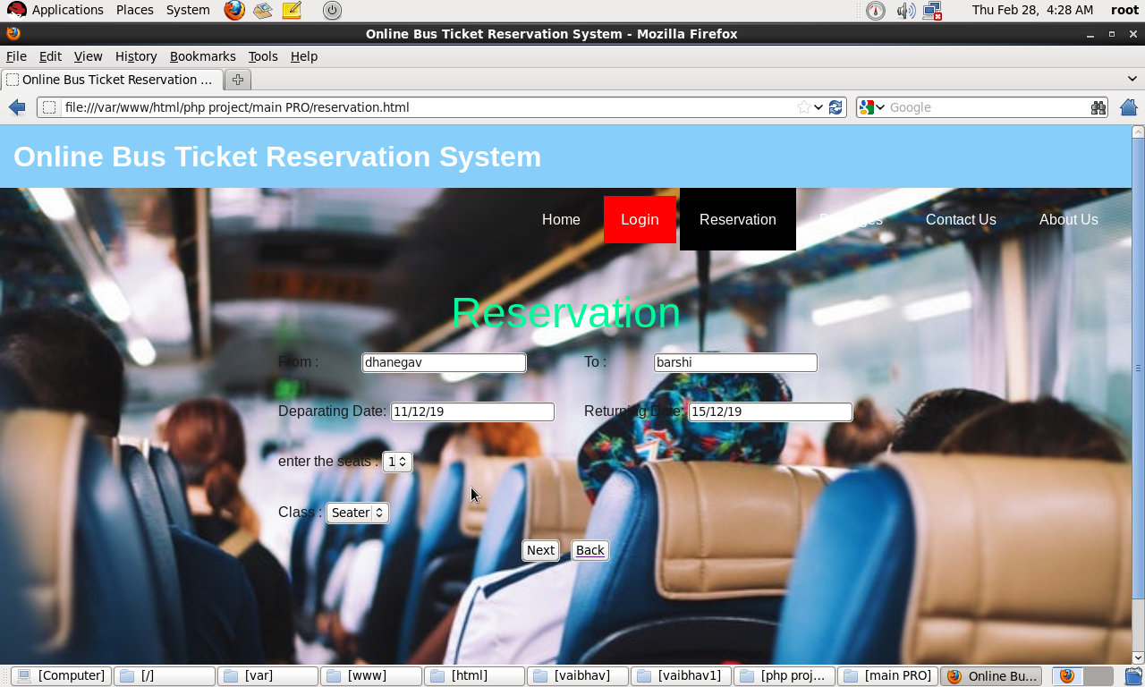

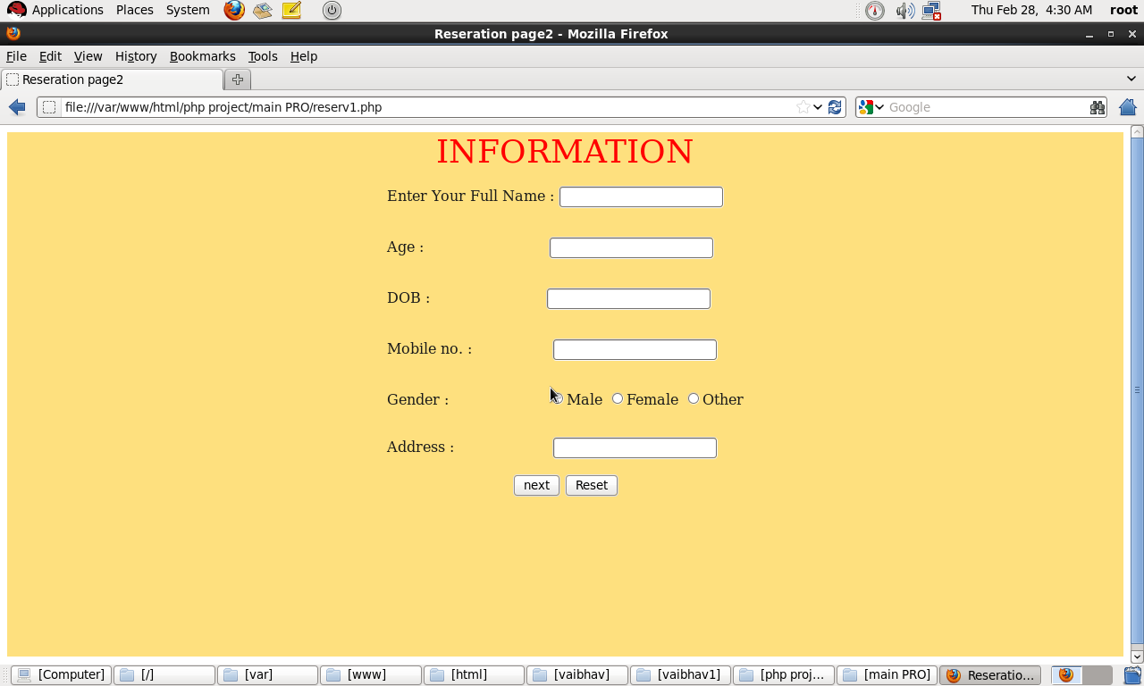

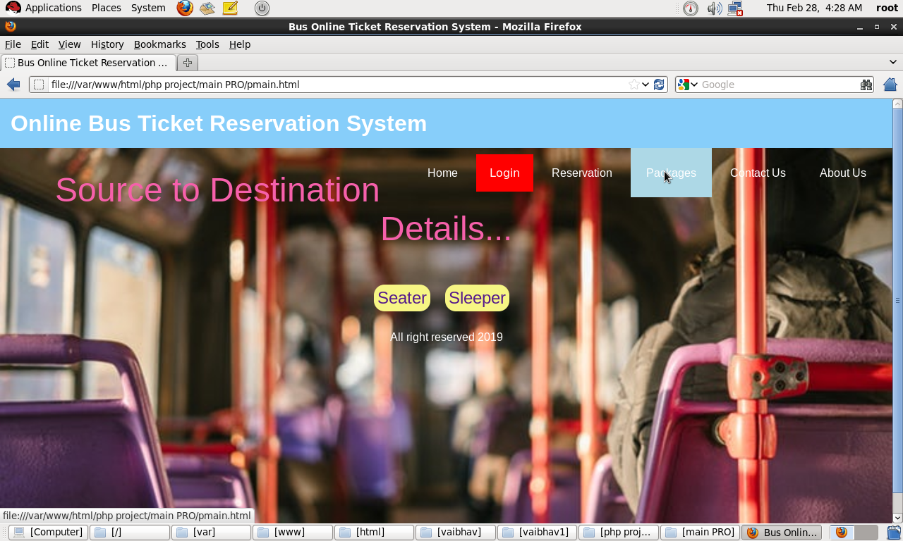

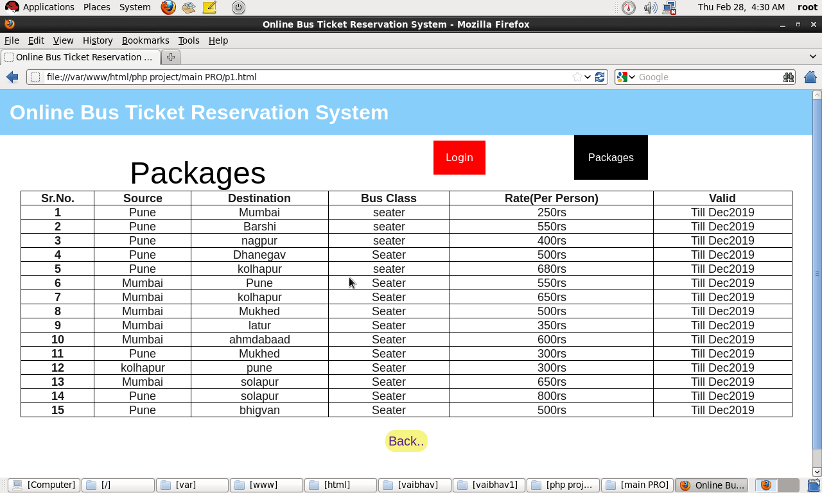

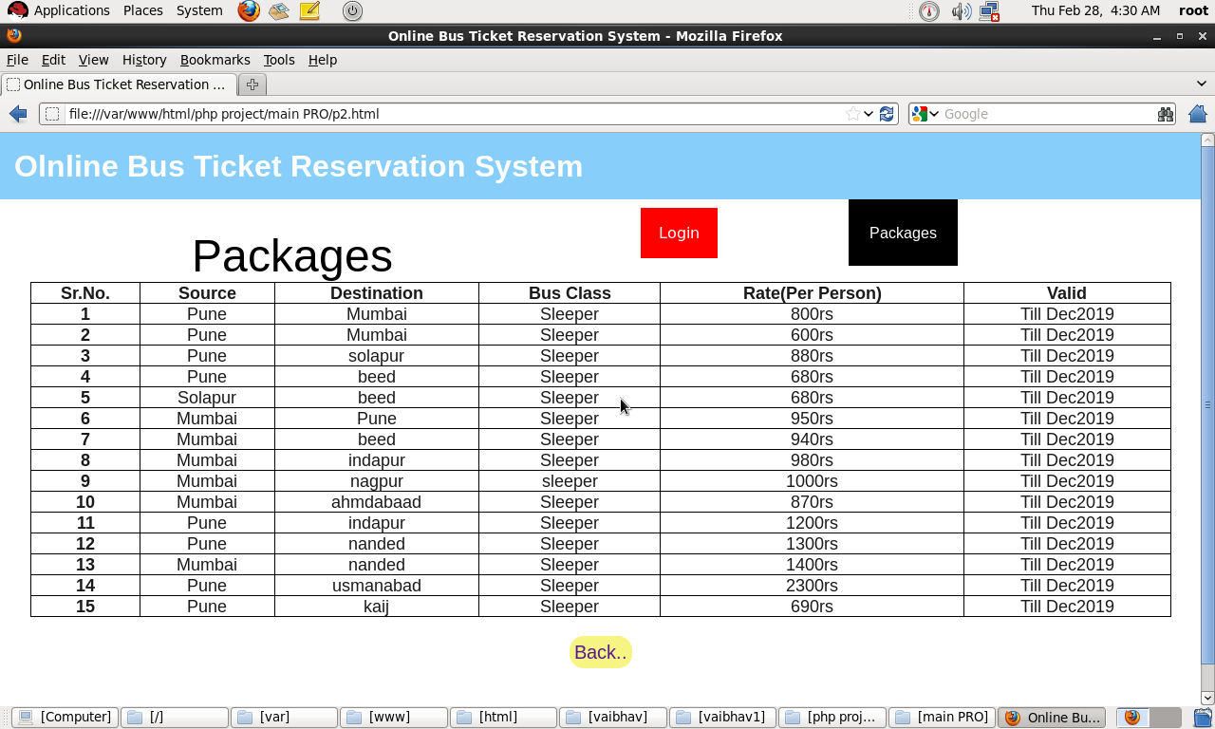

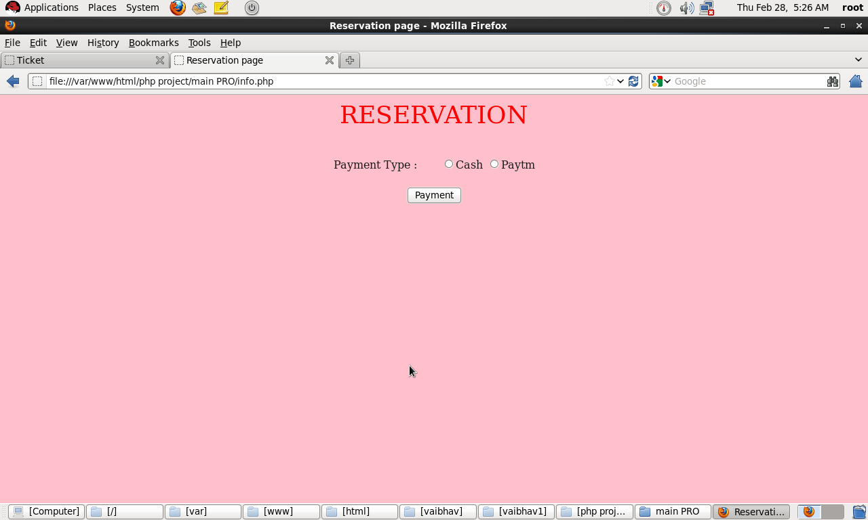

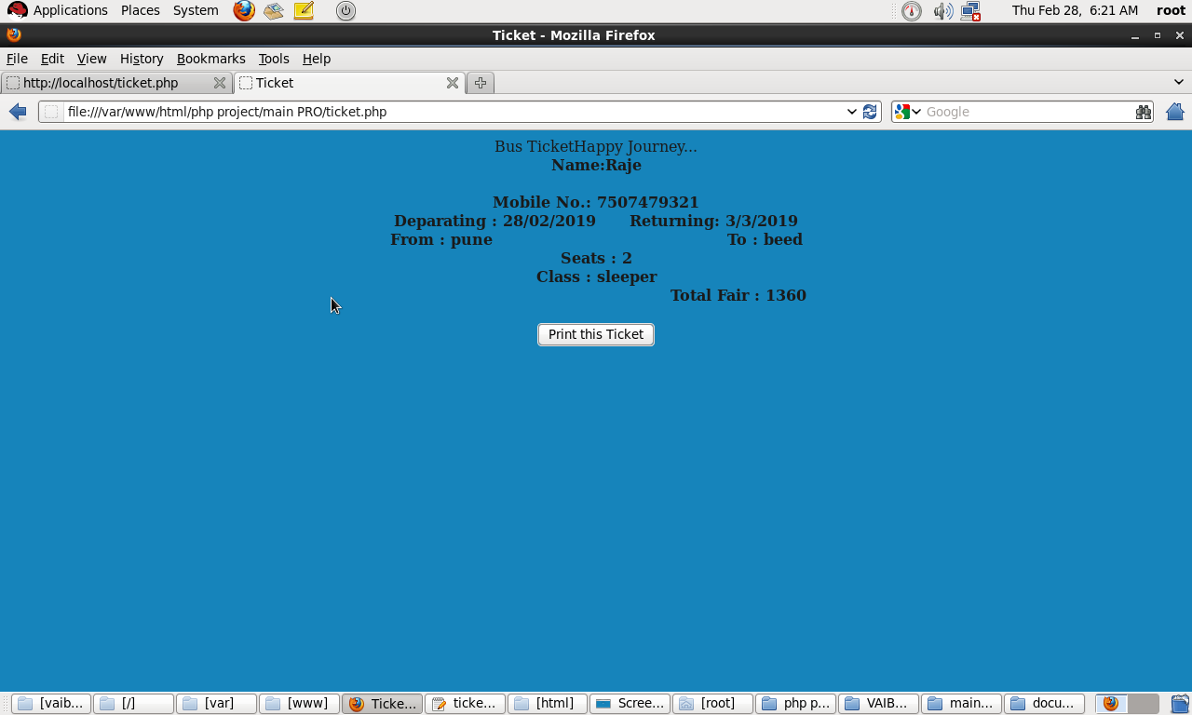

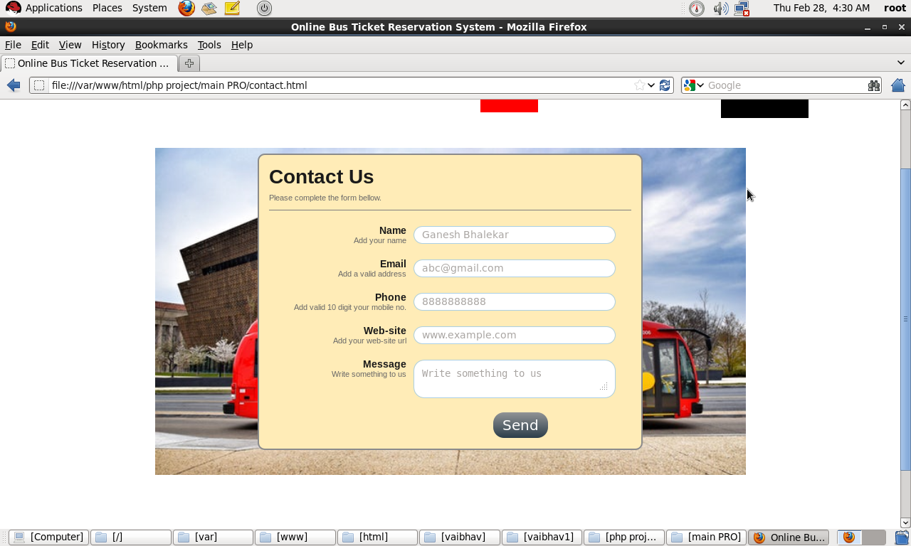

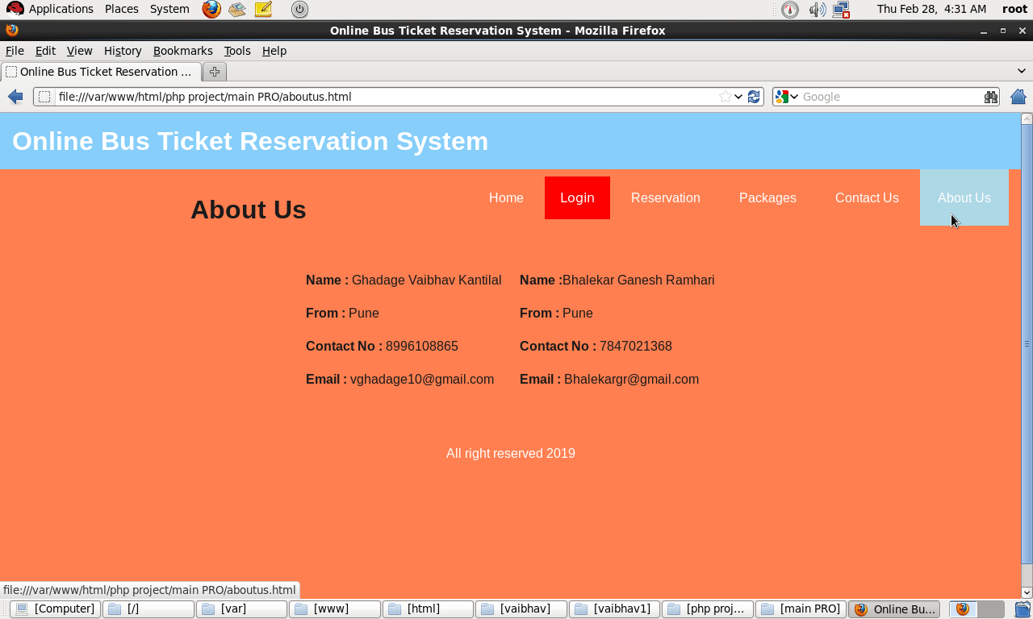

**3.8 DATABASE DESIGN.**

* **RELATIONSHIP TABLE:-**

|  |  |  |
| --- | --- | --- |
| **Table 1** | **Relationship** | **Table 2** |
| **Ticket** | **Many to One** | **Conductor** |
| **Conductor** | **One to One** | **Bus** |
| **Passenger** | **Many to One** | **Bus** |
| **Passenger** | **One to One** | **Ticket** |

* **TICKET TABLE:-**

|  |  |  |  |
| --- | --- | --- | --- |
| **Entity Name** | **Date type** | **Description** | **Constraint** |
| **T_id** | **Int** | **ID of ticket** | **Primary key** |
| **T_date** | **Int** | **Date of ticket** | **Not NULL** |
| **T_ammount** | **Int** | **Ammont of ticket** | **Not NULL** |

**BUS TABLE:-**

|  |  |  |  |
| --- | --- | --- | --- |
| **Bus name** | **Date type** | **Description** | **Constraint** |
| **B_no** | **Int** | **No of bus** | **Primary key** |
| **B_time** | **Int** | **Time of bus** | **Not NULL** |
| **B_seat** | **Int** | **Total no of seat in bus** | **Not NULL** |
| **B_rout** | **Int** | **Rout of bus** | **Not NULL** |

* **PASSENGER TABLE:-**

|  |  |  |  |
| --- | --- | --- | --- |
| **Entity name** | **Data type** | **Description** | **Constraint** |
| **P_name** | **Int** | **ID of passenger** | **Primary key** |
| **P_name** | **varchar** | **Name of passenger** | **NOT NULL** |
| **P_mob no** | **Int** | **Mobile no of passenger** | **NOT NULL** |
| **P_age** | **int** | **Age of passenger** | **NOT NULL** |
| **P_seat no** | **int** | **Seat no of passenger** | **NOT NULL** |
| **P_add** | **int** | **Address of passenger** | **NOT NULL** |

**TABLE CONDUCTOR:-**

|  |  |  |  |
| --- | --- | --- | --- |
| **E_name** | **Data type** | **Description** | **Constraint** |
| **C_no** | **int** | **No of conductor** | **Primary key** |
| **C_name** | **varchar** | **Name of the conductor** | **NOT NULL** |
| **C_add** | **varchar** | **Address of conductor** | **NOT NULL** |
| **C_add** | **int** | **Conductor age** | **NOT NULL** |

**3.10 USER INTERFACE(Screenshots)**

**ER MANUAL**

**4.1 Limitations**

* Testing on platforms like Linux and Mac has not been performed.
* Standalone System with no internet support.
  1. **Future Enhancement**

In Future we try to develop the following:

* The System can be made to allow access from multiple systems with a central system the server for databases.
  1. **Conclusion**

**Proposed System is:-**

* **User Friendly:**

The System has got much simplified screen which makes the system fast enhances quick and accurate data.

* **Validations Check:**

The system has various validationcheck& it also givesappropriateerror message and provides the necessary help.

* **Report Generation:**

The system can generate various report giving student details, teachers details, update student details etc.

* **Easy to Learn**

This system is easy to understand,This mainly due to simply functionally.Even a layman can be trained to use this system.

**4.4 Bibliography**

**References:-**

* Java Complete Reference :-Herbert Schildt
* Software Engineering :-Roger Pressman
* www.google.co.in