PROJECT TASK – 2

To Build Personal Cybersecurity Lab

Lab Build & Validation Report
By
D. Ganesh Ravichandu

SUMERIX GLOBAL
Cybersecurity Internship Program

Deployment Method: Docker-based OWASP Juice Shop on Kali Linux

Tools Used: Docker, Nmap, Burp Suite Community Edition, Wireshark

Report Date: 3 July 2026

Table of Contents

1. Objective 3
2. Lab Architecture Overview 3
3. Prerequisites & Software 4
4. Implementation & Evidence 4
5. Evidence Summary 9
6. Conclusion 10

1. Objective

The objective of this task was to design and build a safe, isolated cybersecurity practice environment on a personal computer. This lab establishes the foundation for all future hands-on work, including vulnerability assessment, web application testing, exploitation practice, and incident response.
The following components were built and validated as part of this task:
- An attacker workstation running Kali Linux, pre-loaded with penetration testing tooling (Nmap, Burp Suite, Wireshark).
- A deliberately vulnerable target application — OWASP Juice Shop — deployed as an isolated Docker container.
- Verified network connectivity and traffic visibility between the attacker tooling and the target application, with evidence captured at the network, application, and packet layers.

2. Lab Architecture overview

The lab uses Kali Linux as the single attacker/host workstation. Docker Engine runs locally on Kali and hosts the OWASP Juice Shop container as the vulnerable target, with its web service port (3000) published to the host. This mirrors Option A of the task specification (“OWASP Juice Shop via Docker”), using Docker's internal bridge network in place of a separate Host-Only VM network.
Architecture summary:
- Host / Attacker: Kali Linux — Nmap, Burp Suite, Wireshark installed and used directly from the host.
- Target: OWASP Juice Shop container (image: bkimminich/juice-shop), published on 0.0.0.0:3000 → 3000/tcp.
- Container network: Docker bridge (docker0), observed addresses 172.17.0.1 (host) and 172.17.0.2 (container).
- Traffic path validated end-to-end: browser → localhost:3000 → Docker bridge → Juice Shop container.

3. Prerequisites & Software

System Requirements
Requirement | Used in this Build
RAM | Kali Linux host — meets minimum 8GB recommendation
Disk Space | Sufficient free space for Docker image + working folders
CPU | Virtualization-capable x86_64
OS | Kali Linux (Debian-based)

Software Installed
Tool | Purpose
Docker Engine (docker.io) | Container runtime used to deploy the OWASP Juice Shop target
OWASP Juice Shop (bkimminich/juice-shop) | Intentionally vulnerable web application — the assessment target
Nmap | Port/service discovery and validation of the target
Burp Suite Community Edition | Intercepting proxy for web traffic analysis
Wireshark | Packet-level capture and validation of client/server traffic

4. Implementation & Evidence

4.1 System Update & Preparation
The Kali Linux host was updated and its package index refreshed prior to installing any lab tooling, using sudo apt update && sudo apt upgrade -y. This ensures all subsequently installed tools are current and reduces the risk of dependency issues.
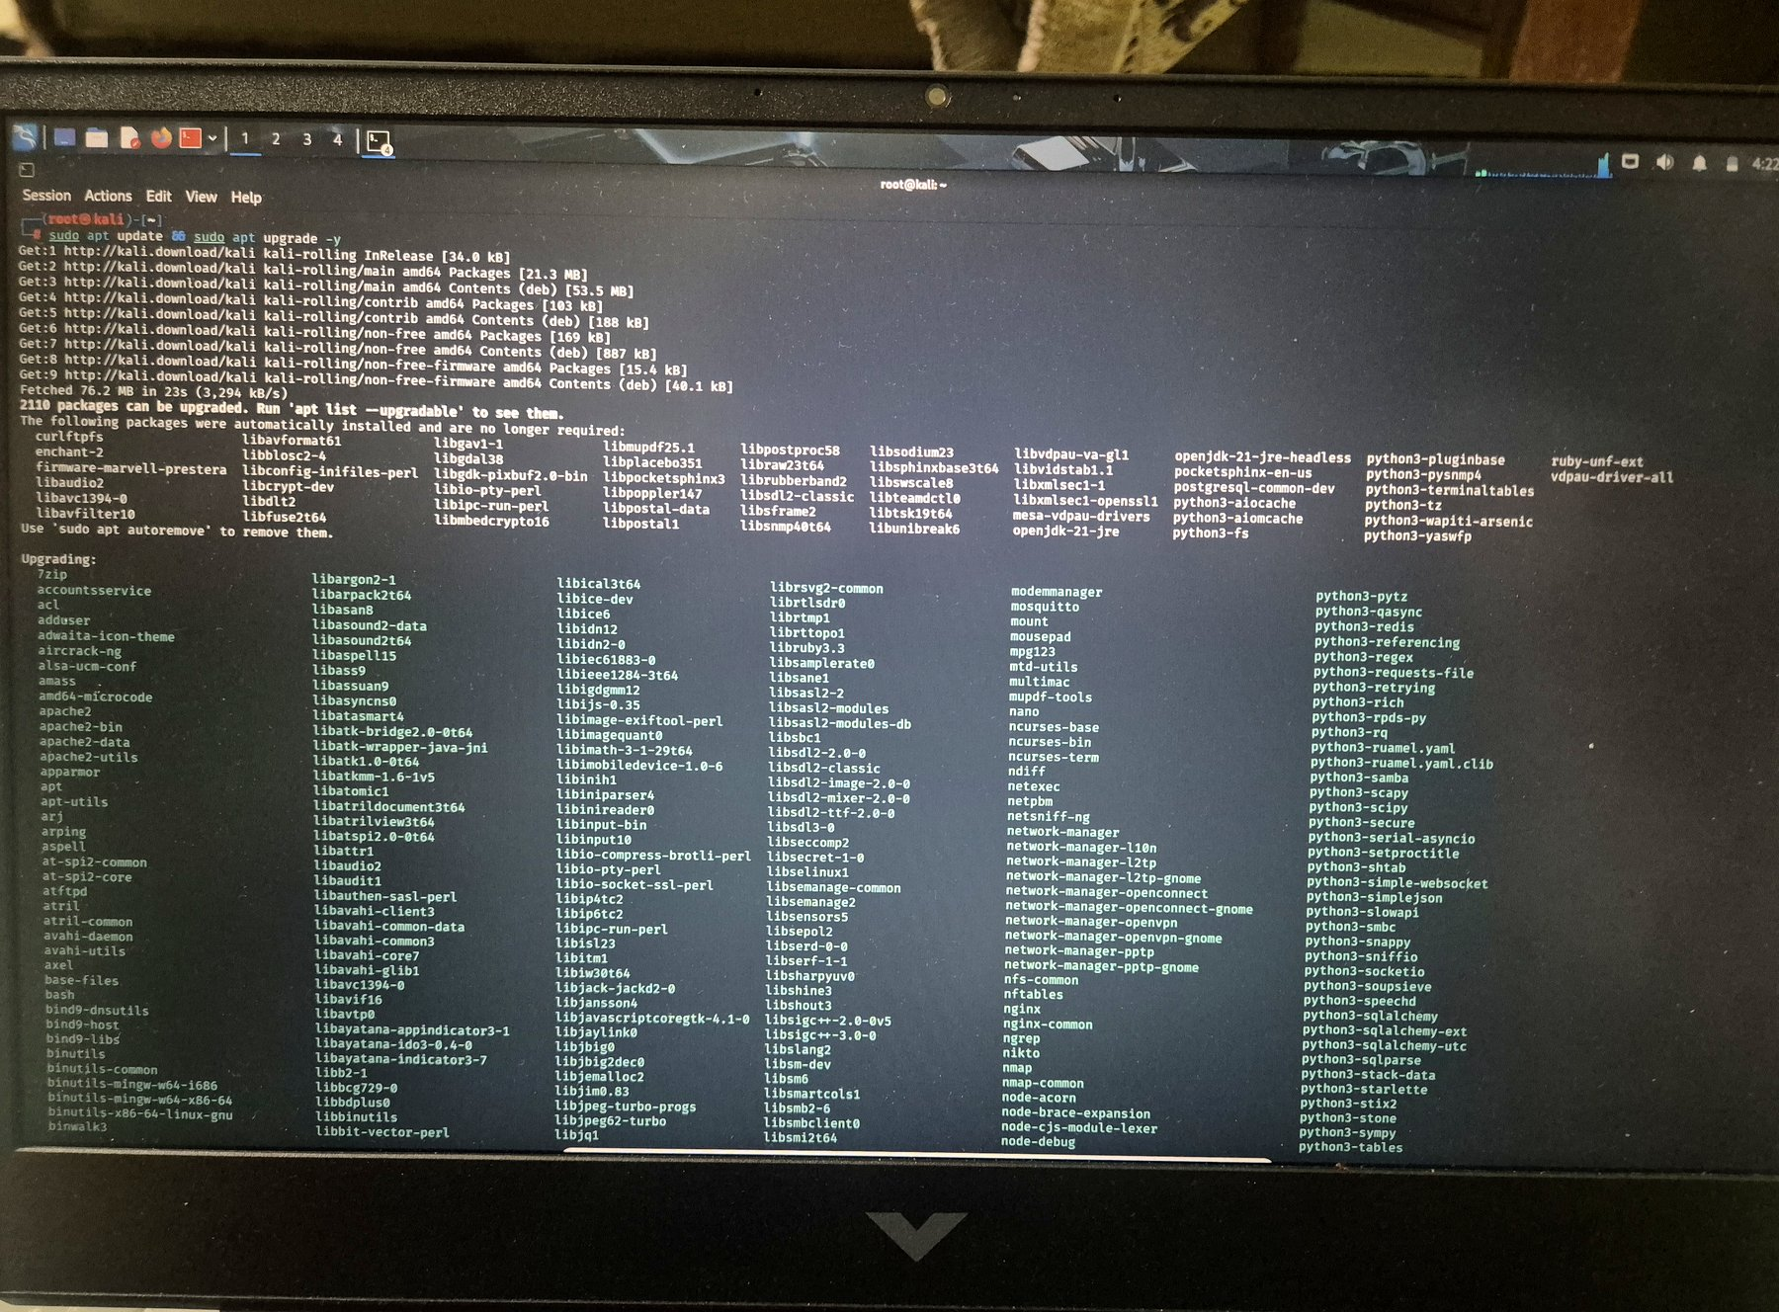
Figure 1 — Kali Linux system update in progress (apt update / apt upgrade).

4.2 Docker Installation
Docker Engine was installed on the Kali host via the native package manager (sudo apt install -y docker.io). This provides the container runtime required to deploy the OWASP Juice Shop target in an isolated environment, without needing a separate virtual machine for the target.
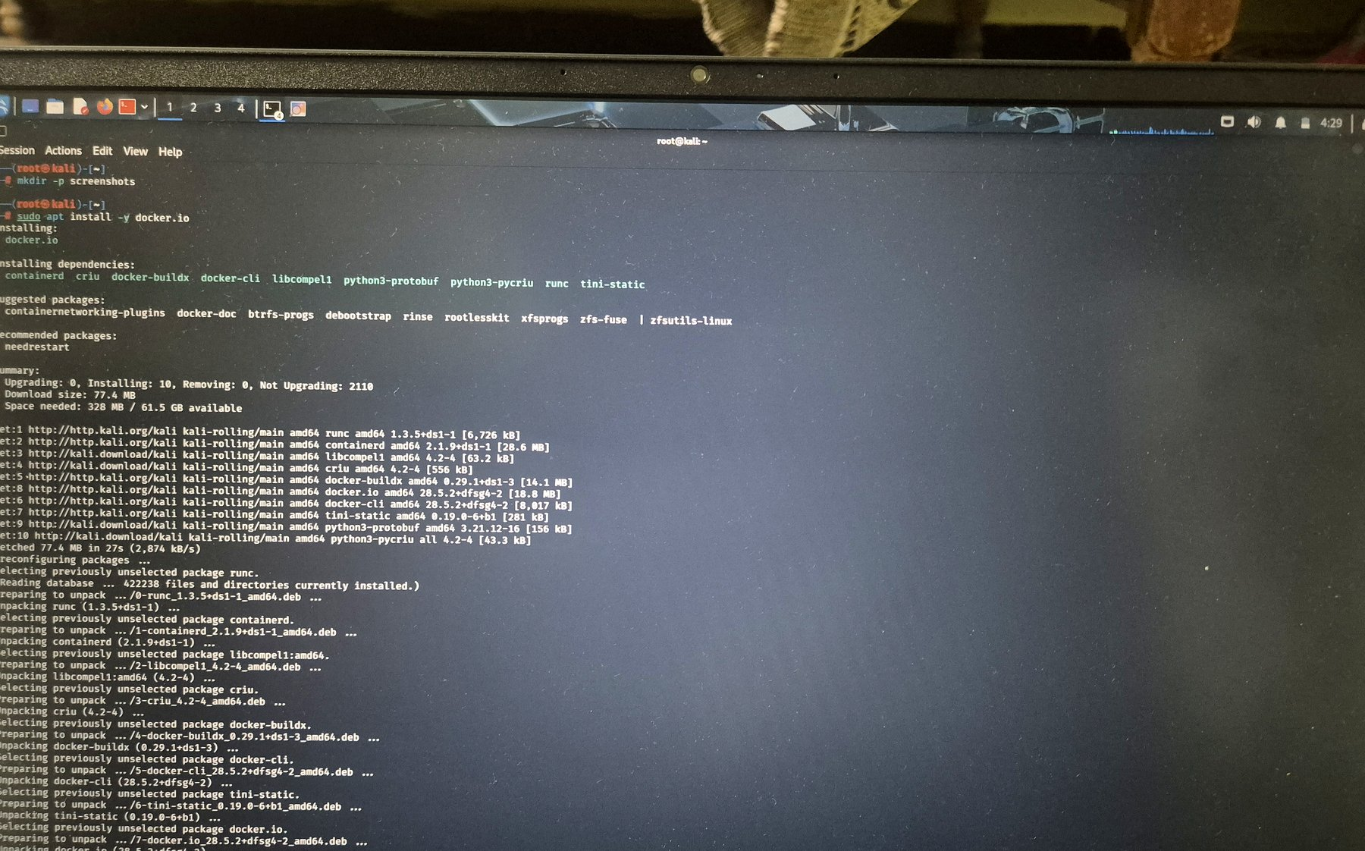
Figure 2 — Docker Engine and dependencies (containerd, runc, docker-cli) being installed.

4.3 Deploying the Target — OWASP Juice Shop
Following Option A of the task specification, the official OWASP Juice Shop image was pulled from Docker Hub and launched as a background container, publishing container port 3000 to host port 3000:
sudo docker pull bkimminich/juice-shop sudo docker run -d -p 3000:3000 --name juice bkimminich/juice-shop
docker ps confirms the container (ID 4c202cadc441) is Up, with port mapping 0.0.0.0:3000→3000/tcp, named juice.
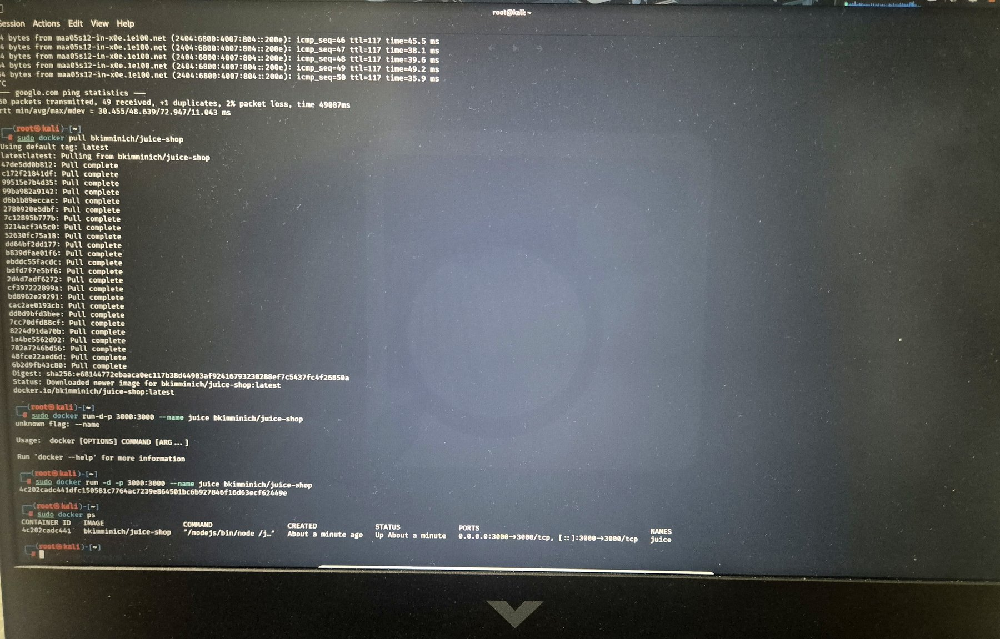
Figure 3 — Juice Shop image pulled and container started; docker ps confirms it is running and port-mapped.

4.4 Verifying the Target Application
With the container running, the Juice Shop web application was accessed from the Kali host browser at http://localhost:3000/, confirming the target is reachable and fully rendered — validating both the container deployment and the port publish.
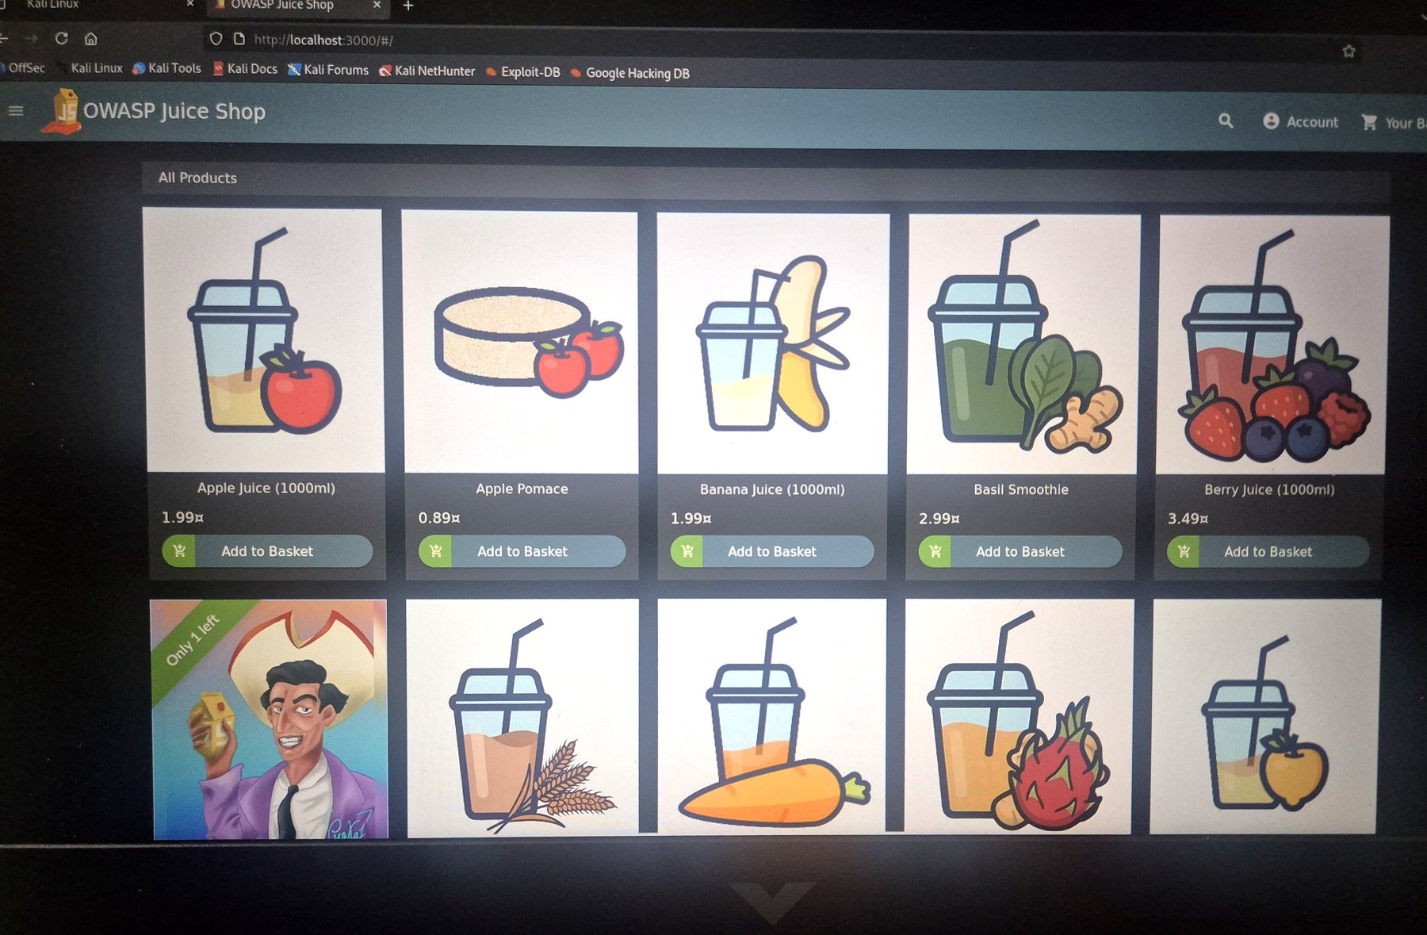
Figure 4 — OWASP Juice Shop storefront loaded successfully in-browser on the attacker host.

4.5 Network & Port Validation (Nmap)
An Nmap service scan (nmap -sV -p 3000 localhost) was run from the Kali host to independently confirm the target port is open and serving an HTTP application, cross-checking the manual browser test:
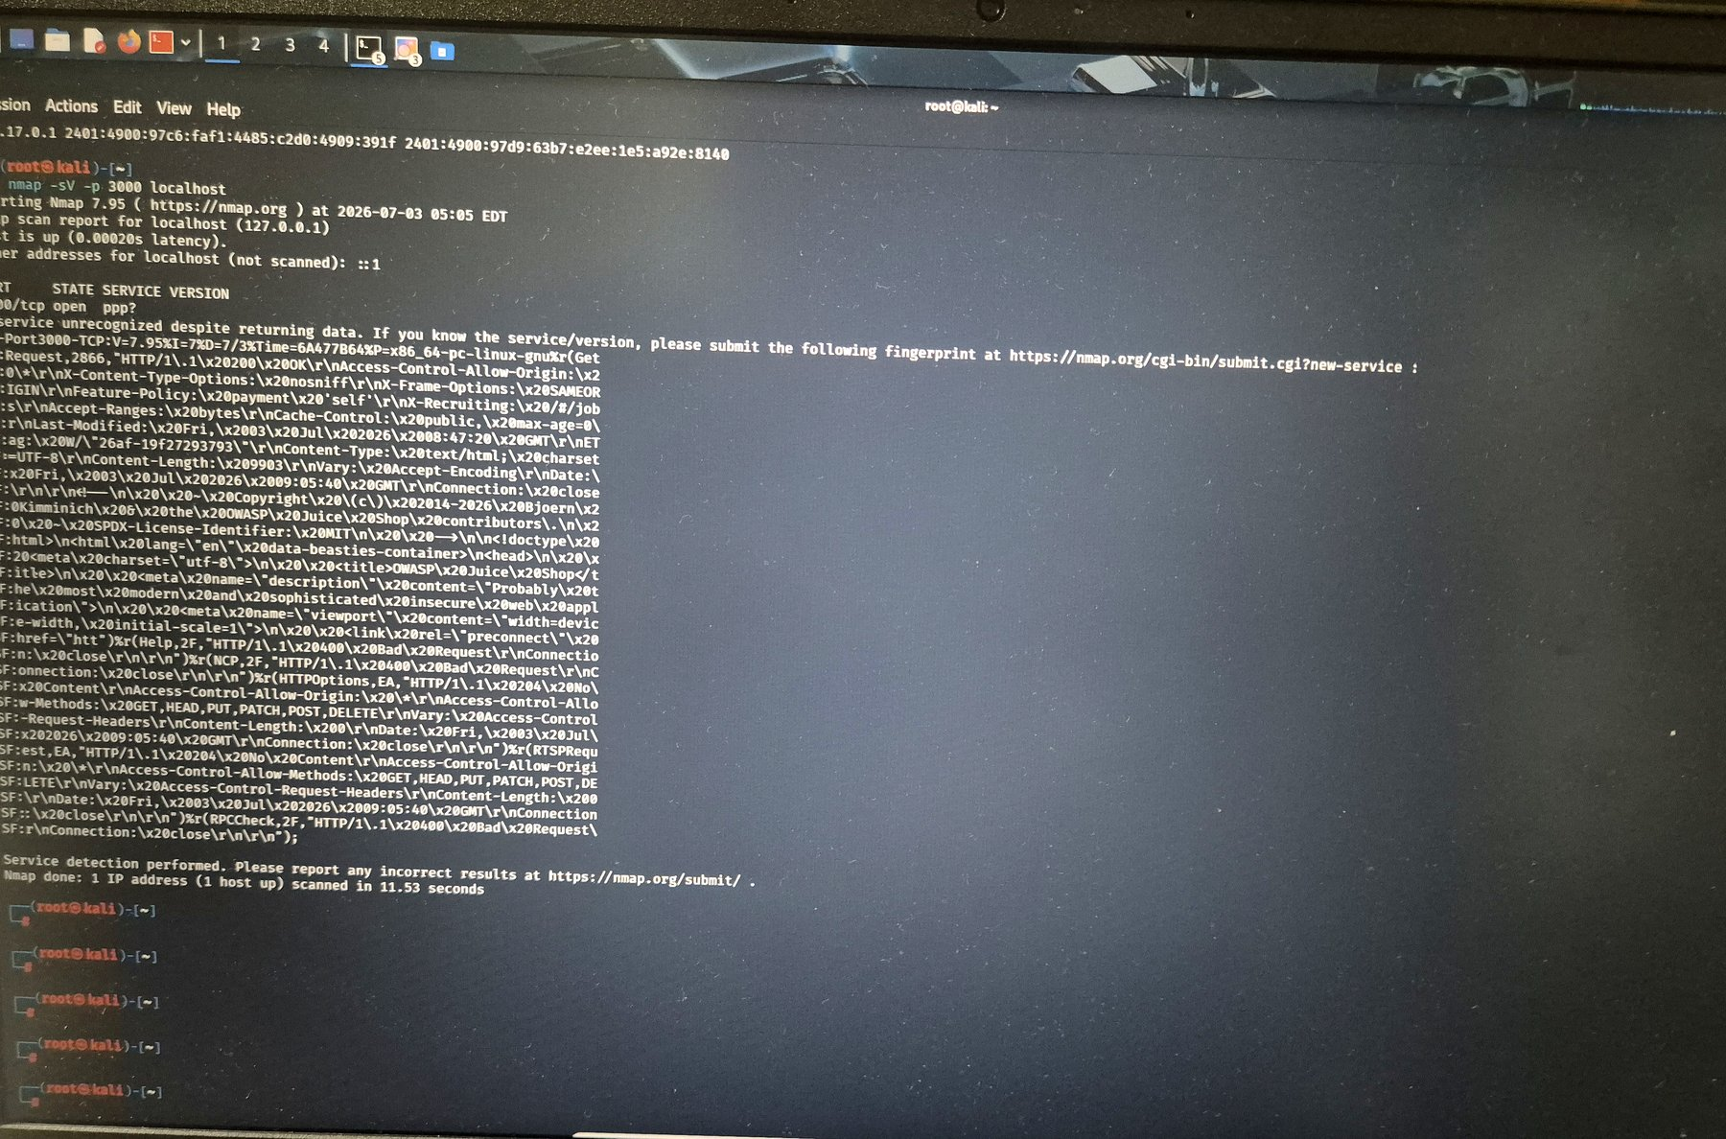
Figure 5 — Nmap service-detection scan against port 3000; the port is open and returns an HTTP fingerprint identifying the Juice Shop banner and headers.

4.6 Traffic Interception (Burp Suite)
Burp Suite Community Edition was configured as an intercepting proxy in front of the browser. A GET request to http://localhost:3000/ was captured in the Proxy → Intercept tab, confirming the toolchain can inspect and manipulate traffic destined for the target — a core capability required for later web application assessment tasks.
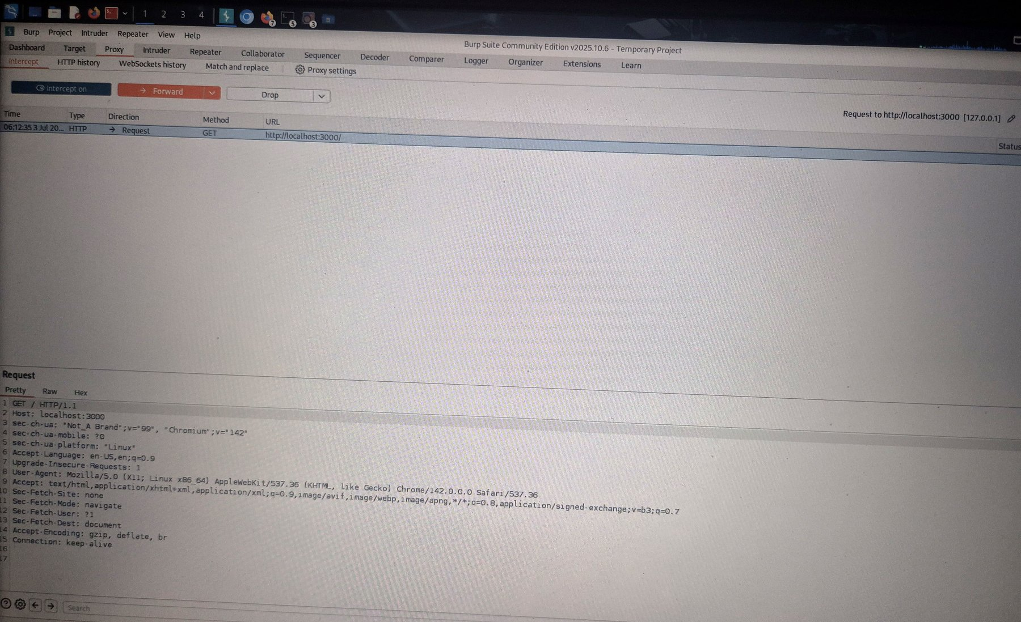
Figure 6 — Burp Suite intercepting a GET request to the Juice Shop target, with full request headers visible.

4.7 Packet Capture (Wireshark)
Wireshark was used to capture traffic on the docker0 interface, filtered on tcp.port==3000. The capture shows the TCP handshake and subsequent PSH/ACK exchanges between the host-side bridge address (172.17.0.1) and the Juice Shop container (172.17.0.2), confirming visibility at the packet level.
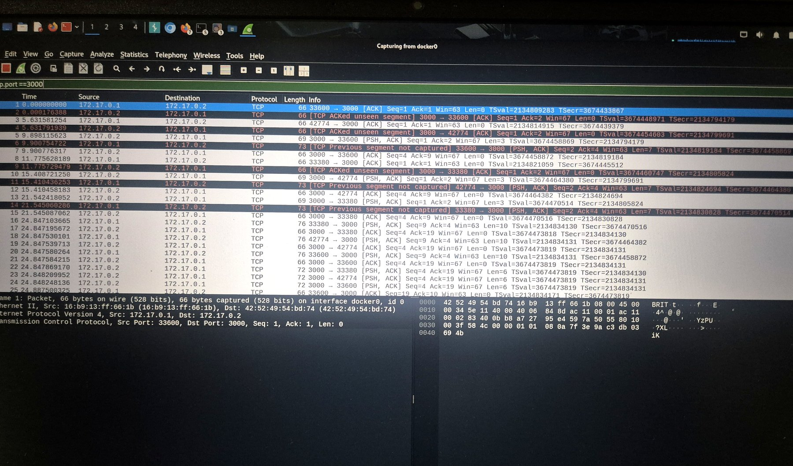
Figure 7 — Wireshark capture on docker0 showing TCP traffic between host (172.17.0.1) and the Juice Shop container (172.17.0.2) on port 3000.

5. Evidence Summary

The table below consolidates the evidence collected against each deliverable required by the task.
Deliverable | Evidence Captured
Container / “VM” list | docker ps output — container 4c202cadc441, image bkimminich/juice-shop, status Up (Figure 3)
IP configuration | Docker bridge addressing observed: host 172.17.0.1, container 172.17.0.2 (Figure 7)
Ping / Nmap validation | nmap -sV -p 3000 localhost — port 3000/tcp open, HTTP service fingerprinted (Figure 5)
Target application access | OWASP Juice Shop storefront rendered at http://localhost:3000/ (Figure 4)
Burp Suite screenshot | GET / request to localhost:3000 intercepted in Proxy tab (Figure 6)
Wireshark screenshot | TCP capture on docker0, filtered tcp.port==3000 (Figure 7)

6. Conclusion

This task successfully established a functioning, isolated cybersecurity lab on a Kali Linux host. A deliberately vulnerable target (OWASP Juice Shop) was deployed via Docker, and connectivity was independently validated through browser access, an Nmap service scan, Burp Suite interception, and a Wireshark packet capture.
The lab satisfies the objective of the task: it provides a safe, self-contained environment isolated from production systems, with the core toolchain (Nmap, Burp Suite, Wireshark) proven operational against the target. This environment is now ready to serve as the foundation for subsequent tasks covering vulnerability assessment, web application testing, exploitation practice, and incident response.
Note on architecture: The task specification offered a VirtualBox dual-VM design (separate Kali attacker VM and target VM on a Host-Only network) as one option, and a single-host Docker deployment (Option A) as an alternative for the target. This build used the Docker option, running the target as a container directly on the Kali host; this was sufficient to meet every stated deliverable and validation step.

