Edge Intelligence
Ganesh G
25MML0043
Image Preprocessing
Import Libraries
import torch
import torchvision.transforms.functional as F
from torchvision import transforms
from PIL import Image
import numpy as np
import matplotlib.pyplot as plt
Resizing Image
def resize_keep_aspect(img, size=224, pad=True):
#resize image using thumbnail(preserves aspect ratio)
img.thumbnail((size, size))

#pad to square
new_img = Image.new("RGB", (size, size))
new_img.paste(img, (size - img.width / 2, size - img.height / 2))
return new_img

image = Image.open("PetImages/0.jpg").convert("RGB")
resized_image = resize_keep_aspect(img=image, size=224, pad=True)
print(f"Before resizing: {image.size}")
plt.imshow(image)
plt.show()
print(f"After resizing: {resized_image.size}")
plt.imshow(resized_image)
plt.show()

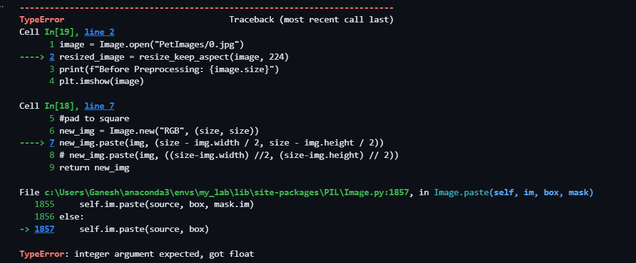
Solution: Integer Division
new_img.paste(img, ((size-img.width) //2, (size-img.height) // 2))
Output:
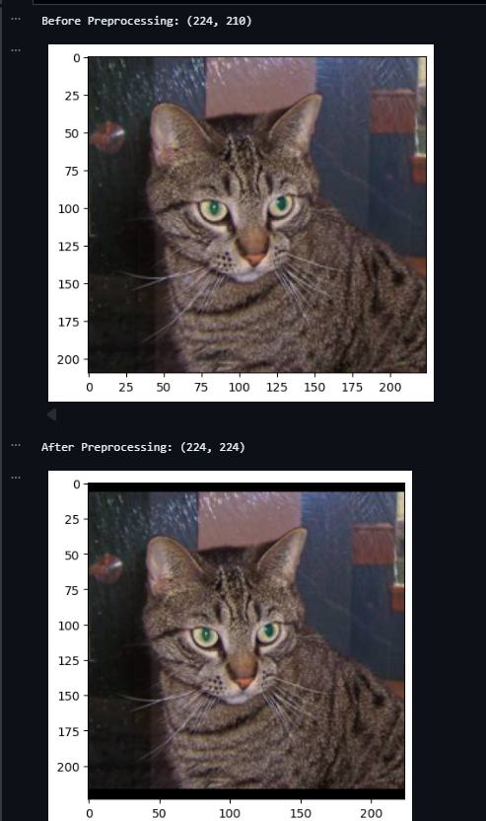
Removing noise in image using gaussian blur
#Removing Noise in image
def gaussian_blur(img_tensor, kernel_size=5, sigma=1.0):
blur = transforms.GaussianBlur(kernel_size=kernel_size, sigma=sigma)
return blur(img_tensor)

noise_reduction = gaussian_blur(resized_image, kernel_size=5, sigma=1.1)
plt.imshow(noise_reduction)
plt.show()

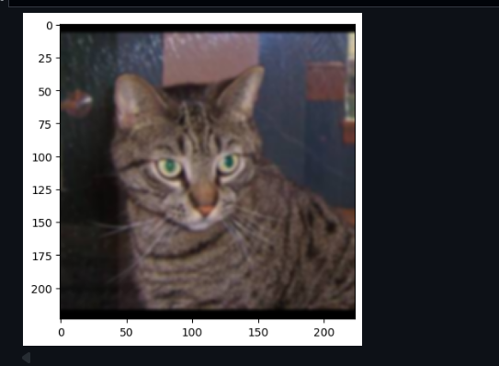
def auto_brightness_contrast(img_tensor, target_mean=0.5):
# img_tensor: [C,H,W] in [0,1]
mean = img_tensor.mean()
img = img_tensor - mean + target_mean # shift mean brightness
# contrast normalization
std = img.std()
if std > 1e-6:
img = (img - img.mean()) / std * 0.25 + target_mean
img = torch.clamp(img, 0, 1)
return img

auto_brightnessed = auto_brightness_contrast(noise_reduction, target_mean=0.5)
plt.imshow(auto_brightnessed)
plt.show()
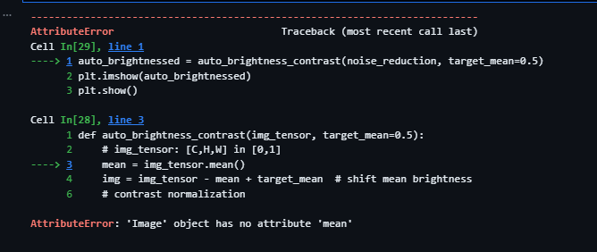
Problem: Requires conversion of normal image to tensors
Why tensors: We need to convert images into tensors because deep learning models can only understand and process numerical data in tensor form.
A tensor is just a multi-dimensional array that allows efficient mathematical operations—such as normalization, convolution, and gradient computation—on both CPU and GPU.
Solution: auto_brightnessed = auto_brightness_contrast(F.to_tensor(noise_reduction))
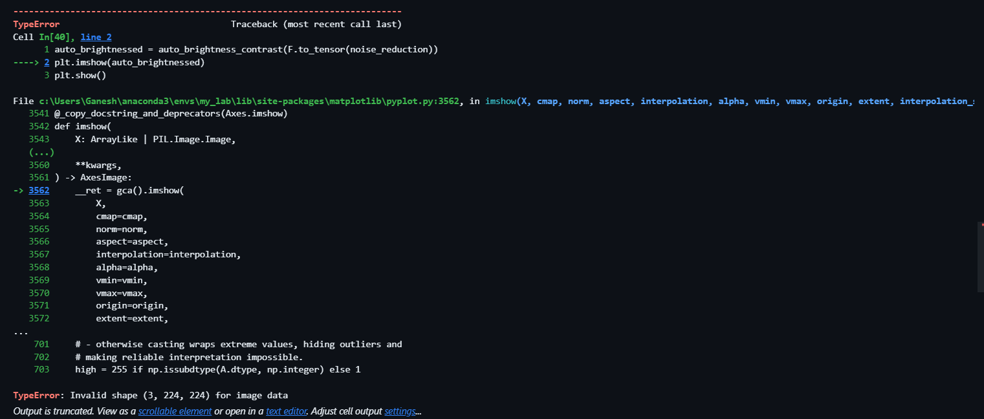
Problem: matplotlib require (Height, Weight, Channel) but it was (Channel, Height, Weight)
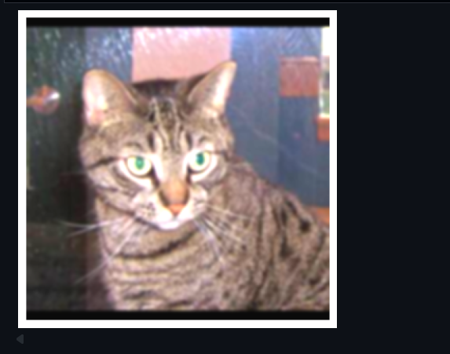
Normalization
#Normalization
normalized = F.normalize(auto_brightnessed, mean=[0.5]*3, std=[0.5]*3)
img_np = normalized.permute(1, 2, 0).numpy()
img_np = np.clip(img_np, 0, 1)

plt.imshow(img_np)
plt.show()

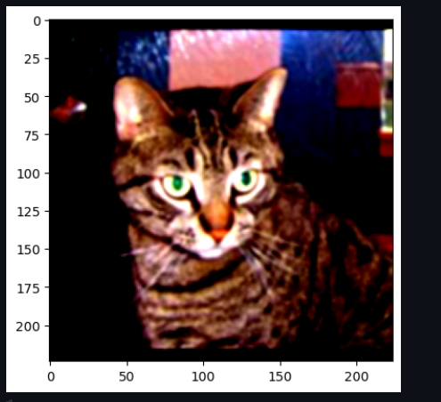
Bulk Image Processing
def preprocess_image(path, size=224):
# load image
img = Image.open(path).convert("RGB")

# resize & pad
img = resize_keep_aspect(img, size=size)

# convert to tensor [0,1]
img = F.to_tensor(img)

# noise reduction
img = gaussian_blur(img, kernel_size=5, sigma=1.1)

# brightness + contrast correction
img = auto_brightness_contrast(img, target_mean=0.5)

# normalize for training
img = F.normalize(img, mean=[0.5]*3, std=[0.5]*3)

return img

def preprocess_folder(folder_path, size=224):
processed = []

for filename in os.listdir(folder_path):
if filename.lower().endswith((".jpg", ".jpeg", ".png")):
full_path = os.path.join(folder_path, filename)
img_tensor = preprocess_image(full_path, size=size)
processed.append(img_tensor)

return processed

petImages = preprocess_folder("PetImages")
print(len(petImages))
print(petImages[0].shape) # -> torch.Size([3, 224, 224])
Final Output
