**High Performance Computing Lab**

**Practical No. 8**

Name: Ganesh Chavhan

PRN No: 22510023

Batch: B

**Problem Statement 1:** Study and implement 2D Convolution using MPI. Use a different number of processes and analyze the performance.

Code:

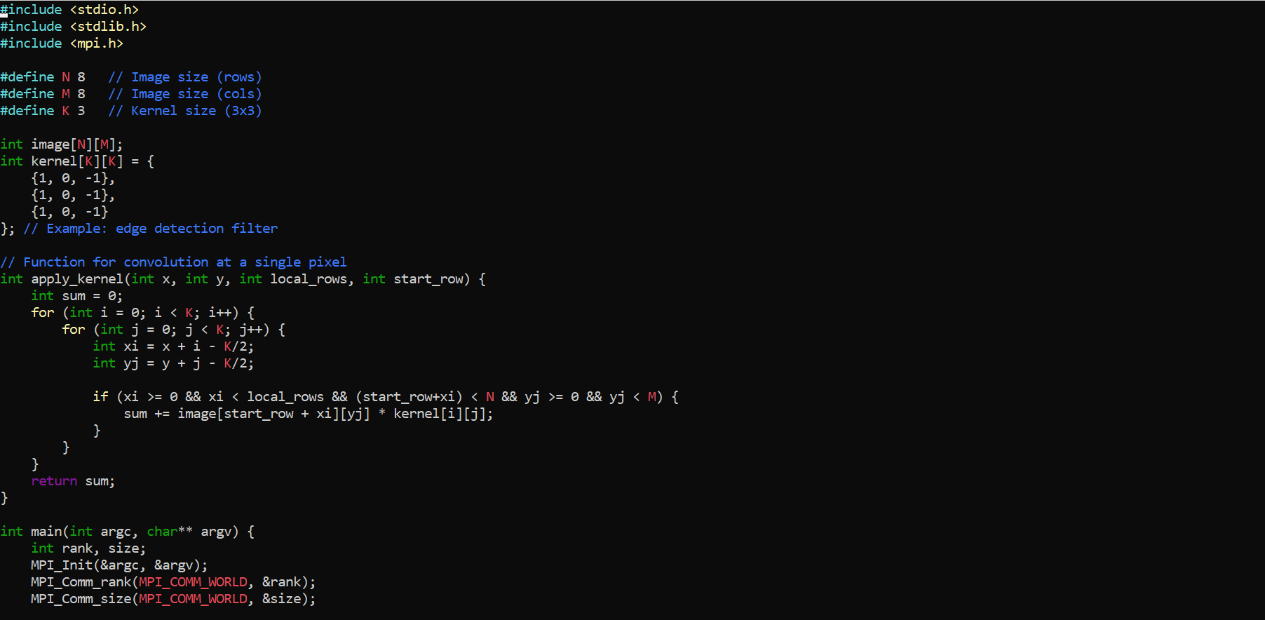 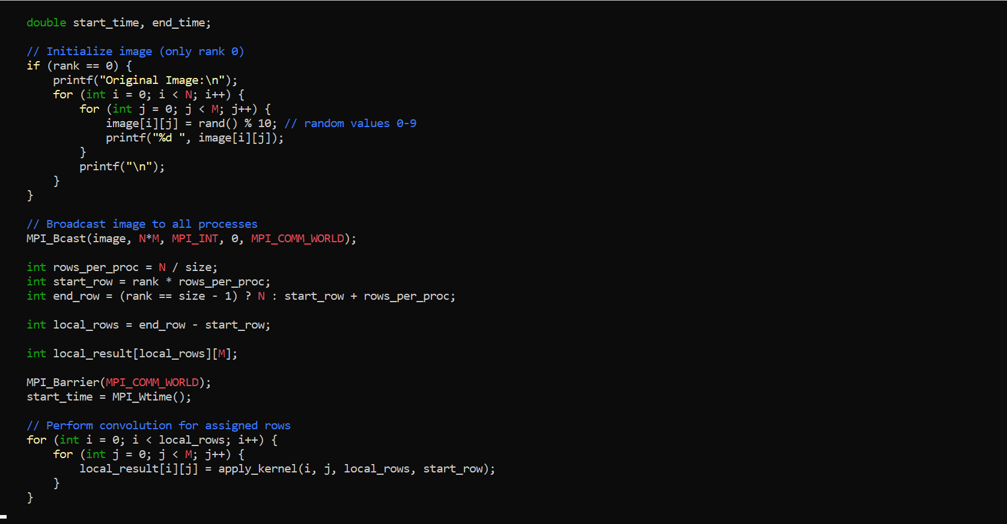 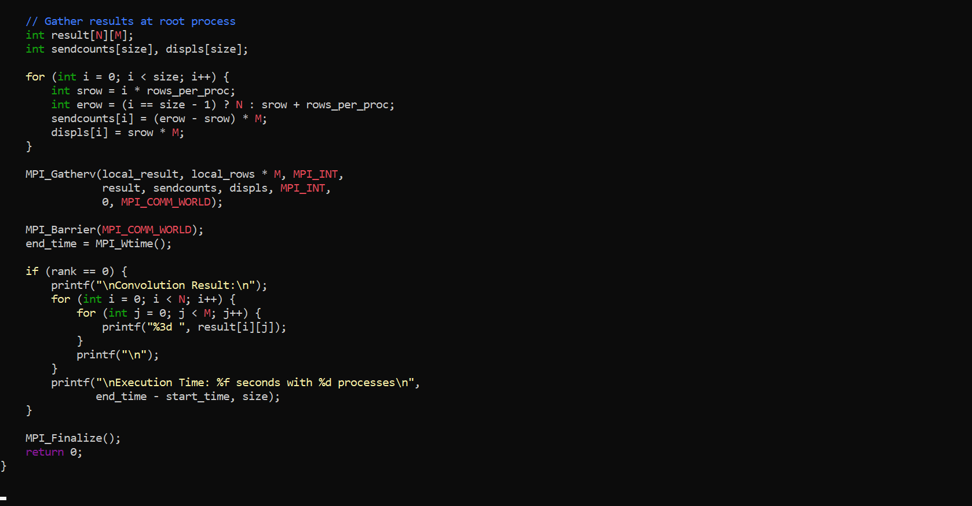

Output:

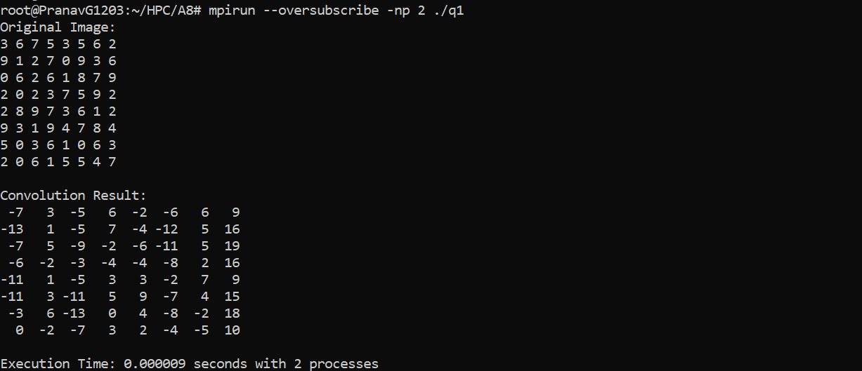

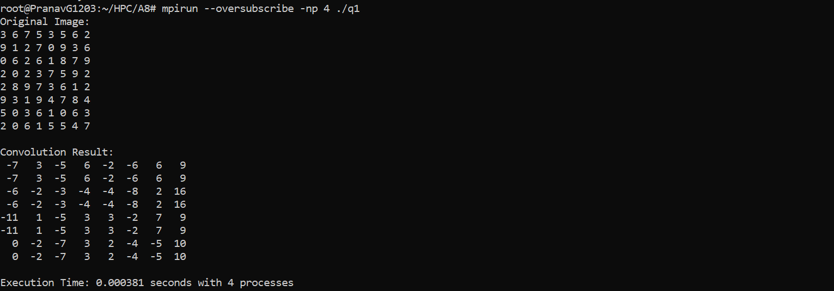

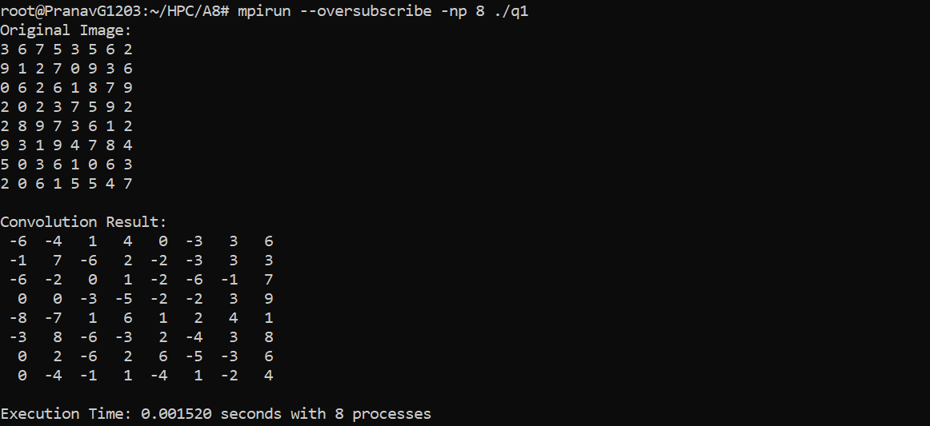

Performance:

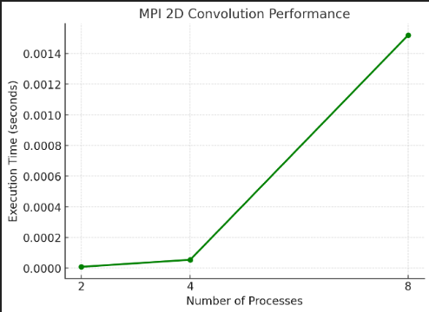

**Problem Statement 2:** Implement dot product using MPI. Use different number of processes and analyze the performance.

Code:

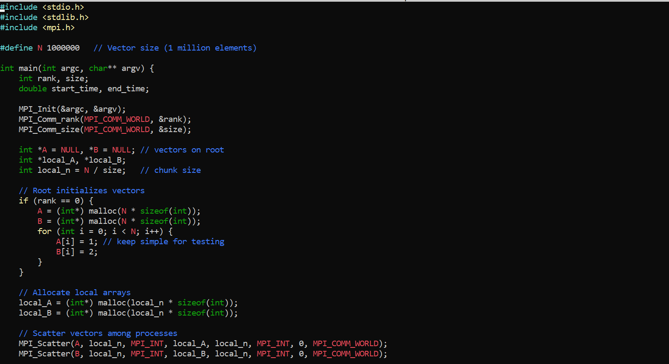

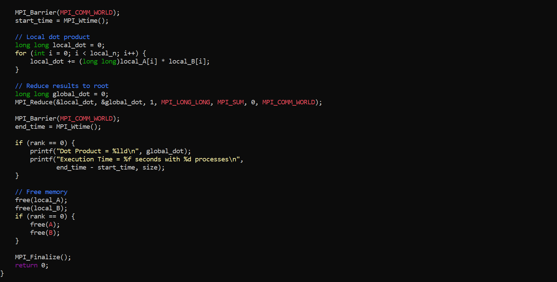

Output:

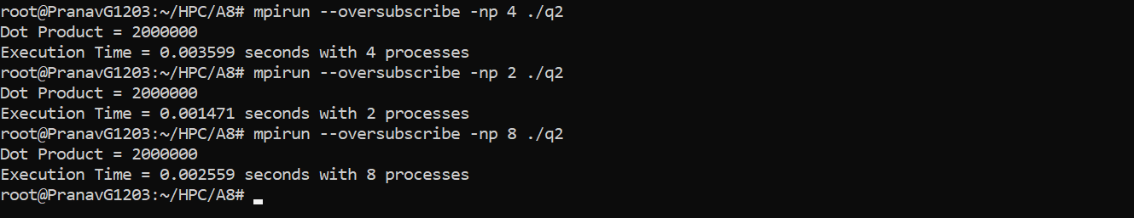

Performance:

