Musculoskeletal System
Study: Orthopedics, Rheumatology
Physician: Orthopedist, Rheumatologist
Functions:
- Providing support and protection for internal organs
- Acting as a lever in producing movements
- Providing surface for the attachment of skeletal muscles
- Blood cells production
- Storage of minerals
Structures:
- Bones: The dense, semi rigid, porous, calcified connective tissue forming the major portion of the Skeleton
- Joints: A union of two bones
- Cartilage: It is a flexible connective tissue found in between joints
- Ligaments: It is a fibrous connective tissue that connects bones to other bones
- Muscles: A band or bundle of fibrous tissue in a body that has the ability to contract, providing movement in or maintaining the position of parts of the body
- Tendons: Tough band of fibrous connective tissue that usually connects muscle to bone
Skeleton: The bony frame work of the body.
Types:
- Axial skeleton: Comprises the bones of head & trunk.
- Skull bones
- Facial Bones
- Ossicles
- Hyoid
- Vertebral column
- Sternum
- Ribs
- Appendicular skeleton: Comprises the bones of limbs and limb girdles.
- Bones of upper limb
- Bones of lower limb
- Shoulder girdle
- Pelvic girdle
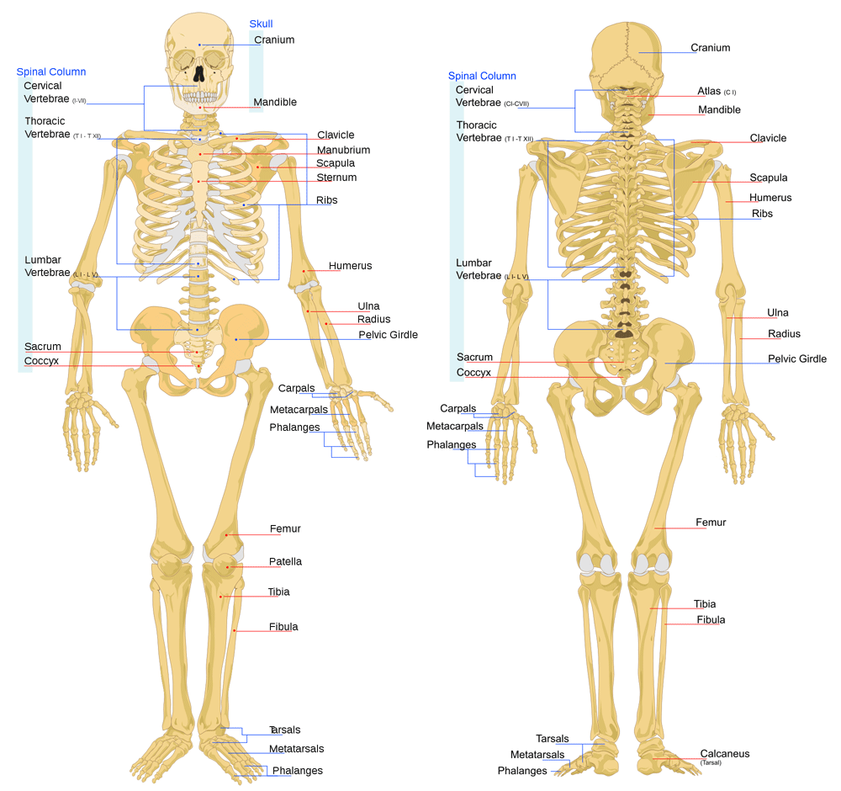

Parts of the bone:
- Epiphysis - Enlarged terminal part of the growing end of the bone.
- Metaphysis - Enlarged part in between epiphysis and diaphysis.
- Diaphysis - Shaft of the bone.
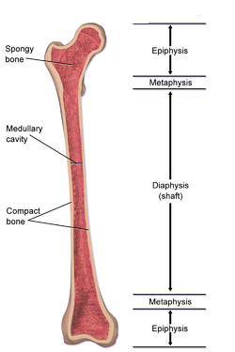
Types of the bone:
- Long bones - Femur, tibia, fibula, Humerus, radius, ulna
- Short bones - Carpal, metacarpal, tarsal, metatarsal, phalanges
- Flat bones - Scapula, ribs, sternum
- Irregular bone - Bones of face, vertebra
- Sesamoid bone – Patella

Hemopoiesis: Process of producing blood cells from bone marrow.
Bones: Total no of bones - 206 (adults), 300 to 350 (new born).

Bones of Human body:
- Upper limb:
- Clavicle
- Scapula
- Humerus
- Radius
- Ulna
- Carpal – 8
- Scaphoid
- Lunate
- Triquetrum
- Pisiform
- Trapezium
- Trapezoid
- Capitate
- Hamate
- Metacarpal
- Phalanges
- Lower limb:
- Hip bone
- Femur
- Tibia
- Fibula
- Patella
- Tarsal – 7
- Calcaneum
- Talus
- Cuboid
- Navicular
- Medial Cuneiform
- Intermediate Cuneiform
- Lateral Cuneiform
- Metatarsal
- Phalanges
- Vertebra:
- Cervical - 7
- Thoracic - 12
- Lumbar - 5
- Sacral - 5
- Coccyx – 4
- Thoracic cage:
- Ribs - 24
- Sternum
- Ossicles:
- Malleus
- Incus (or) anvil
- Stapes (or) Stirrup
- Brain case:
- Paired:
- Temporal
- Parietal
- Unpaired:
- Occipital
- Sphenoid
- Ethmoid
- Facial bone:
- Paired:
- Maxilla
- Zygomatic
- Nasal
- Lacrimal
- Palatine
- Inferior nasal concha
- Unpaired:
- Mandible
- Vomer
Joint: A union of two or more bones. Classified according to their mobility.
- Immovable joint or fibrous joint - Skull bone
- Slightly movable or cartilaginous joint - Intervertebral joints
- Freely movable or synovial joint. It has six types.
- Gliding joint or plane joint - Joints of carpals and tarsals
- Ball & socket joint - Hip, shoulder
- Hinge joint - Elbow, knee
- Condyloid joint – Wrist
- Pivot joint – Joint between C1 & C2 (atlas moves around the axis); radio ulnar joint (pronation & supination)
- Saddle joint - Joint between trapezium & first metacarpal bone. (All movements of thumb mainly opposition of fingers)

Types of muscles:
- Skeletal muscles - Triceps, biceps
- Smooth muscles - Stomach
- Cardiac muscles – Myocardium

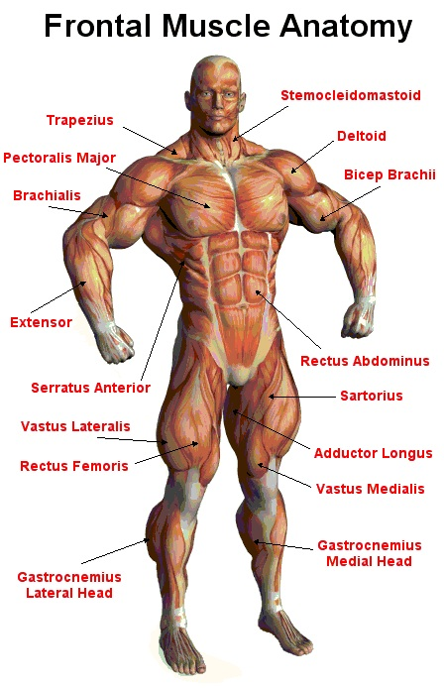
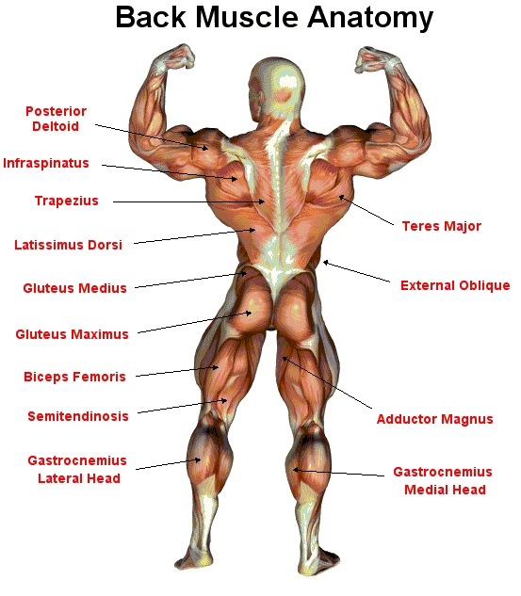
Conditions:
- Arthropathy - Disease of the joint
- Osteoporosis - Lack of bone density
- Osteomalacia - Softening of bone
- Osteomyelities - Inflammation of bone
- Osteoitis - Inflammation of bone cortex
- Osteoma - Bone cancer
- Arthritis - Inflammation of joints
- Rheumatoid arthritis - Auto immune disorder, RA factor in blood affects small and large joints. Pain and swelling is present
- Osteoarthritis - Degeneration of articular cartilage and decreased synovial fluid. Pain, decreased joint movements.
- Kyphosis - Posterior curvature of thoracic spine
- Lordosis - Anterior curvature of thoracic spine
- Scoliosis - Lateral curvature of whole spine
- Arthralgia - Joint pain
- Myalgia - Muscle pain
- Metatarsalgia - Pain in metatarsal bone
- Tendonitis - Inflammation of tendon
- Achilles tendonitis - Inflammation of Achilles tendon
- Spinal stenosis - Narrowing of spinal / vertebral column
- Spondylitis - Degeneration of vertebra
- Tennis elbow / lateral epicondylitis - Inflammation of lateral epicondyle. Pain, numbness, swelling.
Diagnosis:
- X-ray
- Arthroscopy
- Arthrocentesis
- EMG
- CT
- MRI
Treatment:
- ORIF for fractures
- Splints
- Physiotherapy
- Joint replacement surgery

