Urinary System
Study: Urology
Physician: Urologist
Nephrologist: Specializing in kidney diseases

The urinary system consists of the following structures
- Kidneys
- Ureters
- Bladder
- Urethra
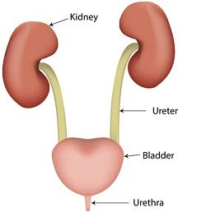
Kidney:
Shape: Bean shaped organs
Position: Lie on the posterior abdominal wall, mainly in the lumbar region T12-L3 region. Right kidney is slightly lower than the left because liver occupies considerable space on the right side. Each kidney measures 10-13 cm in length 6 cm in breadth and 2.5 - 4cm in thickness.

Weight: Adult kidney weighs about 140grams.

ureter: The ureters are two ducts or tubes, one attached to each kidney, passing from it to the bladder. Each ureter is about 35 - 40cm long.

Bladder: Acts as a reservoir for urine. It is a pear shaped organ. Triangular area between the openings of ureters and the urethra is the trigone of the bladder.
Urethra: It is a canal passing from the neck of the bladder to the external opening. The female urethra is 2.5 - 3.5cm long, the male 17-23cm long.
Nephron: The functional unit of kidney. Approximately 10,00,000 nephrons in each kidney.
Structure:
- Afferent & efferent arterioles
- Bowman's capsule
- Glomerulus - tuft of capillaries
- Proximal convoluted tubule
- Henle's loop - descending limb
- ascending limb
- Distal convoluted tubule
- Collecting duct
Nephron
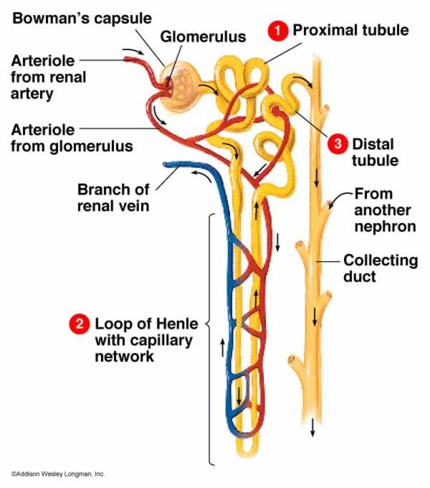

Functions of kidney:

- Regulation of water balance
- Regulation of concentration of salt in blood ( acid-base balance)
- Excretion of waste products & excess of salts through urine.
Micturition: The act of passing urine, The quantity of urine averages from 1-2 litres daily . It may varies with amount of fluid taken.
Colour - Clear pale amber
Odour - Aromatic
Reaction - Acidic pH of 6
Specific gravity - 1010 to 1025
Composition of urine:
- Water 96%
- Solid 4% (urea 2% and other metabolic products 2%)
- Urea
- Uric acid
- Creatinine
- Electrolytes or salts
Conditions:
- Polyuria - Increased urine volume
- Oliguria - Decreased urine volume
- Anuria - Absence of urine
- Nocturia - Passing urine frequently during night
- Enuresis - Bed wetting
- Hematuria - Blood in urine
- Chyluria - Lymph in urine
- Pneumaturia - Passage of gas in urine
- Uremia - Urea in blood
- ARF - Acute renal failure, may be produced by acute nephritits, by renal toxins, are very commonly by a period of low blood pressure which deprives the kidneys of their blood supply.
- CRF - Chronic renal failure usually due to chronic nephritis, pyelonephritis,diabetes and hypertension.
- Ketonuria - Ketone bodies in urine
- Proteinuria - Protein in urine
- Nephrosis - Degenarative kidney disease , where protein is present in urine
- Nephroptosis - Floating kidney .The kidney drops down into the pelvis when the patient stands up.
- Glomerulonephritis - Inflammation of kidney ,where blood and protein present in urine.
- Pyelonephritis - Inflammation of kidney due to bacterial infection
- ESRD - End stage renal disease. complete loss of kidney function due to progressive chronic kidney disease.
- Hydroureter - Accumulation of water in ureter
- Nephrolithasis - Kidney stone, renal calculi
- Urinary Incontinence - Inability to control urine
- Dysuria - Difficulty / pain while passing urine
- UTI - Urinary tract infection
- Cystits - Inflammation of bladder
- Hydronephrosis - Accumulation of water in kidney
- Edema - Swelling, It is defined as an abnormal accumulation of fluid in the interstitium, located beneath the skin and the cavities of the body which cause severe pain
Diagnosis:
- BUN - Blood urea nitrogen
- Creatinine clearance test
- Urine analysis – PH, colour, odour, pus cells, ketone, glucose, protein
- Bacterial culture
- KUB -Kidney, Ureter, Bladder scan
- Biopsy
- Renal pyelogram
- Cystoscopy
Procedure:
- Dialysis,Lithotripsy
- Nephrectomy
- Kidney transplantation

