Reproductive system
Male Reproductive system
Study: Urology
Physician: Urologist.
Function:
- Production of germ cell spermatozoa from the testis during coitus
- Production of male sex hormone testosterone from the testis
Primary male sex organs: Testis, scrotum, penis
Secondary male sex organs: Epididymis, vas deferens, prostate gland
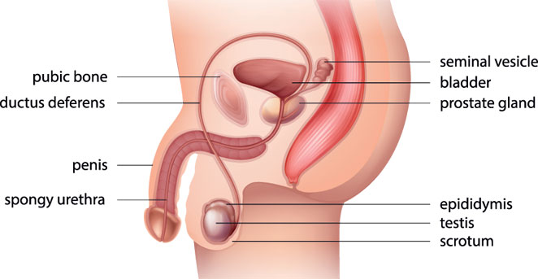
Conditions:
- Orchitis: Inflammation of testis
- Hydrocele: Pathological accumulation of serous fluid around the testis which causes the swelling of the scrotum
- Erectile dysfunction: Inability to achieve erection during coitus
- Balanitis: Inflammation of glans penis
- Impotence: Inability to perform sexual act.
- Spermatocele: Accumulation of excessive sperm in testis
- Testicular torsion: Twisting of spermatic cord
- Epispadia: Congenital opening of urethra on upper surface of penis.
- Hypospadia: Congenital opening of urethra on lower surface of penis
- Paraspadia: Congenital opening of urethra on sides of penis
- Phimosis: Congenital narrowing of the opening of the foreskin
- Infertility: Inability to reproduce after continuous coitus for one year
- Varicocele: Enlarged, twisted, dilated, swollen veins near the testis
- Circumcision: Removal of entire or part of the prepuce or foreskin of the penis
Procedures:
- Vasectomy
- Orchiectomy
- Vasovasostomy

Female Reproductive system
Study: Gynaecology,
Physician: Gynaecologist
Obstetrics: Study concerned with pregnancy, childbirth and the postpartum period
Physician: Obstetrician
Functions:
- Production of germ cell ovum or egg from the ovary
- Production of female sex hormones - oestrogen and progesterone
Primary sex organs: Uterus, ovary, vagina
Secondary sex organs: Breast
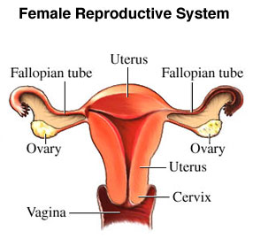
Menstrual cycle: The rhythmical series of changes that occurs in a cycle of about 28days throughout the reproductive life of women from puberty to menopause except during the times of pregnancy. Menstrual cycle consists of four phases.
- Menstrual phase - 1 to 5 days
Uterus sheds its lining through vagina
- Follicular phase - 6 to 12 days
Oestrogen level increases and endometrium gets thicker, maturation of ovarian follicles.
- Ovulation phase - 13 to 16 days
Maturation and release of ovum (ovulation) from the ovary.
- Luteal phase or premenstrual phase - 17 to 28 days
Progesterone & oestrogen level decreases, destruction of corpus luteum and endometrium lining sheds out.
Pregnancy period:
- 1st trimester - 1 to 13 weeks
- 2nd trimester - 14 to 27 weeks
- 3rd trimester - 28 to 40 weeks ( till birth)

Pregnancy is otherwise known as Gestation or Gravida.

Total number of gestational days - 280 days (40 weeks). It varies from 38 to 42 weeks.

Baby born before 37 weeks is known as preterm delivery.

Terminologies:

- Nulligravida: No pregnancy ( women who has never been pregnant)
- Primigravida: First time pregnancy
- Secondogravida: Second time pregnancy
- Multigravida: More than two pregnancy
- Nullipara: No visible offsprings ( women who has never given birth to a viable child)
- Elderly primi gravida: First time pregnant after 35 years
Delivery:
- Caesarean section
- Abdominal incision
- Uterine Incision
- Normal
- Uterine contraction
- Cervix dilatation and fetus expelled out from the vagina ( birth canal)
- Placenta expelled out
Postpartum period: It is the period beginning immediately after the birth of a child and extending for about six weeks. It is also called puerperium or puerperal or postnatal period.
Conditions:

- Amennorrhea: Absence of menstrual cycle
- Vaginitis - Inflammation of vagina
- Cystitis - Inflammation of cyst ( bladder)
- Salphingitis - Inflammation of fallopian tube
- Oophoritis - Inflammation of ovary
- Menopause - Absence of menses due to deficiency of oestrogen after 40yrs
- Ectopic pregnancy - Zygote formation other than uterus
- Hyperemesis gravida - Nausea / vomiting during 1st trimester of pregnancy
- Gestational diabetes - Increased blood sugar level during pregnancy
- Eclampsia – Seizure or convulsion in a pregnant woman results from hypertension during pregnancy
Diagnosis:

- Urine test ( HCG)
- Blood test
- Ultra sound
- Aminocentesis

Procedures:

- Tubectomy
- Oopherectomy
- Salphingoopherectomy
- Hysterectomy.
- MTP - medical termination of pregnancy (induced abortion)
- Other contraceptive methods - Condoms, IUD - copper T, etc.

