circulatory system
The circulatory system consists of heart, blood vessels and the lymphatic vessels.
Study: Cardiology
Physician: Cardiologist
Function: Pumping of blood and carries blood throughout the body.
Heart: Heart is a cone - shaped, hollow, muscular organ having the base above and apex below. The apex inclines towards the left side. The heart weights about 300 grams.
Position: The heart is located in the mediastinum, the space between the lungs.

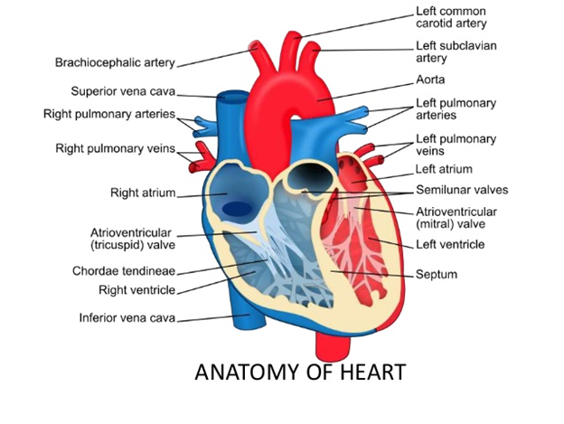
Structure: The heart consists of four chambers - Right atrium, right ventricle, left atrium and left ventricle.
- Interatrial septum - Between right and left atrium
- Interventricular septum - Between right and left ventricles
- Atrioventricular septum - Between the auricles and ventricles
Valves:
- Tricuspid valve - Between right atrium and right ventricle
- Bicuspid valve or mitral valve - Between the left atrium and left ventricle
Blood vessels:
- Pulmonary artery
- Pulmonary veins
- Aorta
Arteries: It carries oxygenated blood from the heart
Veins: It carries deoxygenated blood to the heart
Capillaries: It unites arterioles and venules
Layers of the heart:
- Pericardium: Outer layer of the heart
- Myocardium: The middle muscular layer of the heart
- Endocardium: The inner layer of the heart
The cardiac cycle:
The events which occur in the heart during the circulation of blood is known as cardiac cycle
- Contraction of heart - Systole
- Relaxation of heart – Diastole
Conduction of heart:
The hearts action originates from the SA node (sino-atrial node), then the atria contract, the electrical impulse moves along the bundle of his and the ventricles contract.
- Contraction of atria - Atrial systole
- Relaxation of atria - Atrial diastole
- Contraction of ventricle - Ventricular systole - 0.3 seconds
- Relaxation of ventricle - Ventricular diastole - 0.5 seconds
In this way the heart beats continuously.
Heart sounds:
- First sound - Lubb - Closure of Tricuspid & bicuspid valves (long & dull)
- Second sound - Dup - Closure of aortic & pulmonary valves (short & sharp)

Normal heart rate:
- Adult - 60 to 80 beats per min
- New born - 140 per min
- Adult - 150 per min, during exercise
Cardiac output: In resting person the heart beats about 70 times a minute & pumps 70 ml of blood each time. The stroke volume is 70ml. The amount of blood pumped each minute is therefore 70 x 70ml or about 5 litres.
The circulation of blood:
- Superior and inferior vena cava carries the deoxygenated blood from the whole body to the right atrium.
- Blood enters into the right ventricle through tricuspid valve.
- From there blood is pumped into the pulmonary artery which carries the deoxygenated blood to the lungs.
- Blood is oxygenated in the lungs and return back to the left atrium through four pulmonary veins.
- From left atrium blood enters into left ventricle through mitral valve.
- From left ventricle the blood is pumped into the aorta.
- Aorta supplies the oxygenated blood throughout the body.
- Arterial system carries the blood throughout the body where it eventually reaches the capillary beds.
- In capillary beds, O₂ is transferred from the blood to the surrounding tissues and CO₂ is transferred from tissue to the blood.
- Venous system transports deoxygenated blood to superior and inferior vena cava.
Pulmonary circulation:
- The course of blood from right ventricle
- Lungs
- Left atrium
Systemic circulation:
- Left ventricle
- Aorta
- Arteries, arterioles, capillaries
- Return back to right atrium by veins (SVC and IVC)
Coronary circulation:
Coronary circulation supplies the heart. The right and left coronary arteries which encircle the heart and supply blood to the all parts of the heart. The return blood from the heart is collected by the coronary sinus and returned directly into the right atrium.

Conditions:
- Tachycardia: Increase in heart rate.
- Bradycardia: Decrease in heart rate.
- Palpitation: Abnormality of heart beat that causes a conscious awareness of its beatings.
- Cardiomegaly: Enlargement of heart.
- Cardiomyopathy: Disease of heart muscle.
- Cor pulmonale: Abnormal enlargement of the right side of the heart due to disease of lungs or pulmonary blood vessels.
- Arrhythmmias: Abnormal rhythm of heart.
- Fibrillation: Irregular, fast heart rate.
- Flutter: Abnormal heart rhythm that occurs in the atria of the heart, usually associated with tachycardia.
- Heart block: Blockage at any level of electrical conduction system of heart.
- Murmurs: Abnormal heart sounds.
- Rheumatic heart disease (RHD): Inflammatory disease of the heart following rheumatic fever
- Cardiac arrest: Sudden cessation of heart function.
- CPR: Mouth to mouth respiration, external cardiac massage.
- Pericarditis: Inflammation of pericardium, it is one of the cause of heart failure.
- Endocarditis: Inflammation of endocardium usually associated with rheumatic fever.
- Coronary artery disease (CAD): Plague builds up inside the coronary arteries or narrowing by atheroscelerosis or thrombus formation inside the coronary artery.
- Myocardium deprived of blood supply (myocardial ischemia)
- Pain results (Angina pectoris)
- If artery totally occluded
- Heart muscle dies (myocardial infarction or heart attack)
- Atheroscelerosis: Hardening and narrowing of blood vessel
- Aneurysm: Dilatation of blood vessel.
- Congestive heart failure (CHF): Pumping mechanism of heart fails. Mitral, aortic, pulmonary & tricuspid valve lesions are common cause of CHF.
- Symptoms: dyspnea, oedema in soft tissues, pheripheral oedema, pulmonary oedema occurs.
- Congenital (birth) heart diseases (CHD):
- Atrial septal disease (ASD): Hole in the wall between the upper chamber of heart.
- Ventricular septal disease (VSD): Hole in the wall between lower chamber of heart.
- Tetrology of fallot (TOF): It involves four heart defect.
- A large VSD
- Pulmonary artery stenosis
- Right ventricular hypertrophy
- Overriding of aorta
- Mitral valve prolapse (MVP): Two way blood flow, blood pumps in both sides when ventricles contract.
- Patent ductus arteriosus (PDA): In fetal life connection between aorta and pulmonary artery will be seen. After birth the hole in the aorta remains patent (unclosed).
Diagnosis:
- X-ray
- CT
- CTA
- MRI
- MRA
- ECG
- Angiography
Treatment:
- Angioplasty
- CABG - Coronary artery bypass grafting
- Heart transplantation

