Endocrine system
Study: Endocrinology
Physician: Endocrinologist
The endocrine system is a network of ductless glands that produce & release hormones that help control many important body functions.
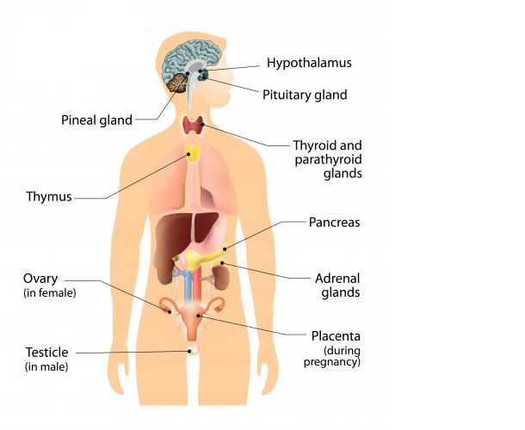
Pituitary gland: A gland found at the base of brain behind the sinuses. It is often called the “master gland” because it influences many other glands.
Anterior lobe:
- Growth hormone or somatotrophic hormone
- Thyrotrophic hormone
- Adrenocorticotropic hormone
- Follicle stimulating hormone
- Luteinizing hormone
- Prolactin
Posterior lobe:
- Antidiuretic hormone
- Oxytocin
Thyroid: A butterfly shaped gland in front of the neck
- Thyroxine or tetraiodothyronine – T4
- Triiodothyronine – T3
- Calcitonin
Parathyroid: Four tiny glands placed two on each side of the thyroid gland in the neck
- Parathormone
Adrenal gland: Two glands that sit on top of the kidneys
- Cortex:
- Cortisol or hydrocortisone
- Medulla:
  - Adrenaline or Epinephrine
  - Noradrenaline or norepinephrine
  - Aldosterone
  - Corticosterone
Islets of Langerhans: Cells in the pancreas
- Insulin
Ovary: Female reproductive organ that produce ovum and sex hormones
- Oestrogen
- progestrone
Testes: Male reproductive organ that produce sperm and sex hormones
- Testosterone or Androgen
Functions:
- Growth hormone: Controls the growth of the body.
- Thyrotropic hormone: Controls thyroid gland in the production of thyroxine.
- Adrenocorticotropic hormone: Controls adrenal gland in the production of cortisol.
- Follicle stimulating hormone: Development of graffian follicles in ovary, formation of spermatozoa in testis.
- Leutenizing hormone: Controls secretion of estrogen and progesterone in ovary, testosterone in testis.
- Prolactin: Controls secretion of milk, existence of corpus luteum during pregnancy.
- Antidiuretic hormone: Regulates the amount of water passed by the kidney.
- Oxytocin: Contraction of uterus during child birth, release of milk during breast feeding.
- Thyroxin (T4) and T3: Metabolic activities of the body.
- Calcitonin: Inhibits calcium release from bone, thereby reducing blood calcium level.
- Parathormone: Regulates calcium metabolism.
- Cortisol: Stimulates fat breakdown in adipose tissue, inhibits protein synthesis, inhibits inflammatory response.
- Adrenaline: Aids carbohydrate metabolism by increasing the output of glucose from liver, vasodilatation.
- Noradrenaline: Increasing blood pressure by stimulating muscle fibers in the blood vessels, vasoconstriction.
- Aldosterone and Corticosterone: Controls metabolism, growth, renal function, muscle tone.
- Insulin: Controls the blood glucose level.
- Oestrogen: Development of female sex organs, secondary sexual characters at puberty, maintenance of physical and mental qualities which distinguish from men.
- Progesterone: Prepares the endometrium for the reception of fertilized ovum, inhibits menstruation.
- Testosterone: Development of male sex organs, secondary sexual characters like growth of beard, deepening of voice, muscle mass, increased bone density, bone growth and strength.
Conditions:
Growth hormone
- Hyposecretion of growth hormone:
- Dwarfism: Poor physical growth thereby very short in appearance.
- Hypersecretion of growth hormone:
- Gigantism: It occurs before puberty. Increased physical growth thereby very tall and gigantic in appearance.
- Acromegaly: It occurs after puberty. Bones and soft tissues of organs thickens and coarsen. It particularly affects hand, skull and jaw bone.
Anti-diuretic Hormone
- Hyposecretion of ADH:
- Diabetes insipidus: Increased secretion of urine with increased thirst.
Thyroid Gland
- Hypothyroidism:
- Cretinism: Deficiency of thyroid hormones secretion at birth produces a condition known as cretinism in which physical and mental growth are retarded in children.
- Myxoedema (Adults ): General metabolic process slow down , tendency to gain weight, movements are lethargic, slowness of mind and speech, skin thickness and dry, hair fall & thin, body temperature subnormal ,pulse slow.
- Hyperthyroidism: (Symptoms opposite to myxoedema) Increased metabolic rate, increased pulse, weight loss, temperature higher than normal, cardiac output, atrial fibrillation & heart failure.
- Grave’s disease or exophthalmic goiter: Increased secretion of thyroid hormones results in goiter. Eyeballs protusion seen.
Parathyroid Gland
- Hypoparathyroidism:
- Osteomalacia: In adults
- Rickets: In children
- Tetany: It is known as hypocalcemia. It is characterised by muscular twitching, convulsions, carpopedal spasm. Symptoms relieved by administration of calcium.
- Hyperparathyroidism:
- Osteitis fibrosa cystica: Calcium is attracted out of the bone and enters into the blood stream. Calcium may be deposited in kidney causing kidney stone & kidney failure.
Adrenal Gland
- Hyposecretion of adrenal:
- Addison’s disease:Kidney fails to conserve sodium so too much of sodium is excreted in urine. Patient becomes weak, weight loss, darkening of skin, low back pain, decreased blood pressure, vomitting.
- Hypersecretion of Adrenal:
- Cushing syndrome: Obesity, sparing of limbs, moon face, hypertension, defective carbohydrate and protein metabolism.
Islets of langerhans
- Hypersecretion of insulin :
- Hypoglycemia: Decreased blood sugar level.
- Hyposecretion of insulin:
- Hyperglycemia (or) Diabetes mellitus: Insulin secretion decreases so blood sugar level increases. Loss of weight, fatigue, polyuria, thirst, dry skin, dry mouth & tongue.
- Diabetic coma: Severe diabetes mellitus can lead to coma.

Diagnosis:
- Blood test
- X-ray
- CT
- MRI
- Biopsy – thyroid nodule
- Computed axial tomography (CAT)
- Nuclear Magnetic resonance (NMR)
Treatment:
- Chemotherapy
- Diet management
- Surgery

