Respiratory system
Study: Pulmonology
Physician: Pulmonologist
Function: Exchange of gases
The act of respiration consists of two types of movements.
- Inspiration - Intake of oxygen
- Expiration- Giving out of carbondioxide
Types of respiration:
- External or pulmonary respiration: The act of breathing which replaces the air in the alveoli with outside air.
- Internal or tissue respiration : Respiration takes place between cells.
The respiratory passages :
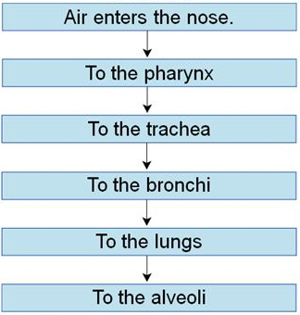
Paranasal sinuses:
- Frontal
- Ethmoid
- Maxillary
- Sphenoid
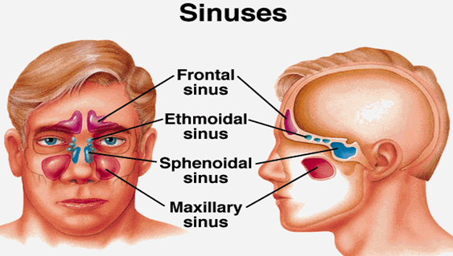

Structure of lungs:
The lungs are the principal organs of respiration located in the chest cavity. The lungs are cone- shaped, with an apex above and base below. It weighs about 1.3kg approximately (both lungs).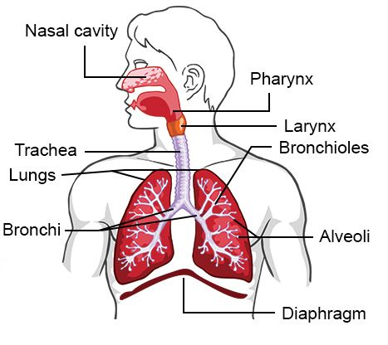
- Right lung - 3 lobes
- Upper lobe
- Middle lobe
- Lower lobe

- Left lung - 2 lobes
- Upper lobe
- Lower lobe
Lungs are covered by a membrane called Pleura. It has 2 layers.
- Outer- Parietal pleura
- Inner - Visceral pleura
Pulmonary examination techniques :
- Auscultation - Listening to sounds
- Percussion – Tapping
- Palpation- By using fingers
Abnormal breathing sounds :
- Wheezing - Musical sounds
- Rales - Crackling sounds during inspiration due to water, blood, pus in the alveoli
- Ronchi - Rumbling sound in bronchi during expiration
Vital capacity of lungs :
The volume of air that can be made to pass into and out of the lungs by the most forcible inspiration and expiration is termed as the vital capacity of the lungs
It is measured by using Spirometer.
Man :- 4 to 5 litres
Woman - 3 to 4 litres
It is reduced by disease of lungs, heart and by weakness of the muscles of respiration.
Normal respiratory rate :
- New born - 40 breath per minute
- Adult - 10 to 20 breath per minute
Pulmonary respiration :
- Air in alveolus
- Enters into capillary
- O₂ from alveolus is passed into blood stream
- O₂ is carried by the Hemoglobin of RBC
- CO₂ is transferred form blood into alveoli
- From Alveoli – Bronchioles – Bronchi – Trachea - Nose - Expired out
Tissue respiration:
- CO₂ from tissue enters into the capillary
- O₂ from capillaries enters into the tissue
Symptoms :
- Apnea - Absence of breathing
- Dyspnea - Difficulty in breathing
- Orthopnea - Difficulty in breathing in lying position
- Nocturnal dyspnea - Difficulty in breathing during night time
Conditions :
- Asthma: A condition characterized by paroxysmal attacks of bronchospasm, causing difficulty in breathing (expiration)
- Pneumonia: Inflammation of the lungs with congestion
- Lobar Pneumonia: An acute disease of lung characterized by fever, cough, blood, tinged phlegm, difficulty in breathing caused by bacteria Streptococcus pneumonia
- Atelectasis: Collapse of lungs Incomplete expansion of the lungs at birth, as from lack of breathing force
- Pulmonary edema: Swelling and fluid in the air sac
- Empyema: Pus formation in the lungs
- Pneumoconiosis: Dust in lungs; Asbestosis, Silicosis, Anthracosis
- Pulmonary abscess: Collection of pus in lungs
- Cystic fibrosis: Thick secretion of mucus
- Tuberculosis: Infectious disease of lung due to Mycobacterium tuberculosis, nodules formation inside the lung
- Pleural effusion: Collection of water in pleural cavity
- Pulmonary effusion: Collection of water in lungs
- Pulmonary emboli: Blood clot in the pulmonary vessels
- Pleurisy/ Pleuritis: Inflammation of pleura
- Hemothorax: Blood in pleural cavity
- Pneumothorax: Presence of air /gas in pleural cavity
- Bronchogenic carcinoma: Malignant neoplasm of the lung due to smoking
- Emphysema: A chronic irreversible disease characterized by abnormal enlargement of air spaces and destruction of the alveolar tissues
- Bronchiectasis: Permanent dilatation of the bronchi. Severe cough with expectoration of sputum
Daignosis:
- Chest X-ray
- PFT
- Bronchoscopy
- Thoracocentesis
- Lung scan
- Pulmonary angiography
Procedures:
- Lobectomy
- Pneumonectomy
- Tracheostomy
- Physiotherapy

