Integumentary System

Skin
Study : Dermatology
Physician : Dermatologist

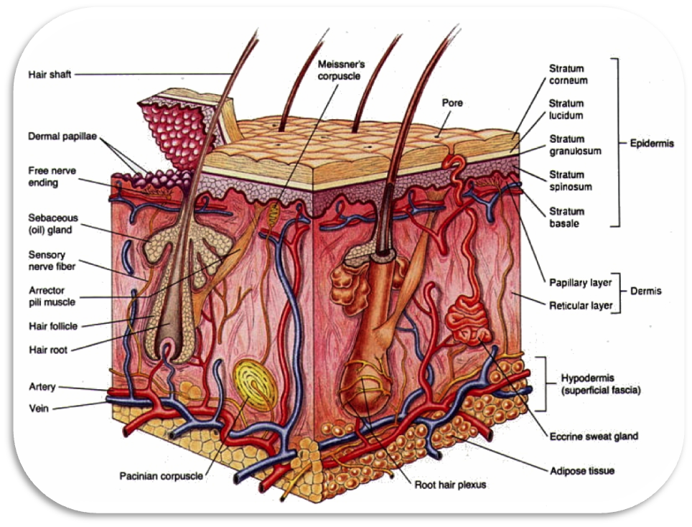
Structure of Skin
The skin is divided into two layers.
- Epidermis or cuticle
- Dermis or corium
Epidermis
The outer layer of skin. It does not contain any blood vessels and nerve endings. It consists of hair follicles. The surface of epidermis consists of lines and ridges. These lines at the tips of fingers and thumbs they form a distinct patterns which differ in each individual. The study of fingerprints in criminology is based on this fact. The epidermis has 5 layers known as Horny zone and germinal zone.

- Stratum corneum
- Stratum lucidum
- Stratum granulosum
- Stratum spinosum
- Stratum germinativum
Horny zone:
Stratum corneum, stratum lucidum and stratum granulosum

Germinal zone:
Stratum spinosum consists of prickle cells and stratum germinativum or basalae consists of basal cells.

Dermis

The inner layer of skin. It consists of sensory nerve endings and capillary blood vessels. It consists of
- Sweat glands – Sweat
- Sebaceous glands – Sebum (fatty secretion)
- Eccrine glands – All over the body producing watery sweat
- Apocrine glands – Armpit/Inguinal region, producing thick milky white sweat. Bacteria which react with it and producing odour
- Ceruminous glands in the ear – altered sweat gland produces ear wax/cerumen
Functions:

- Protecting the internal organs against infection, injuries and harmful chemicals.
- Maintaining body temperature.
- Synthesizing vitamin-D while exposed to sunlight.
- Little excretory, secretary and absorptive properties.
Appendages of the skin:

Hairs, Nails and sebaceous glands

Hair made up of protein called keratin. The hair grown from the hair follicles.

Nail made up of protein called keratin. Arch shaped growing point of nail is called lunula.

Melanin – A pigment present in skin, hair and eyes which gives their colour.

Skin lesions:
- Bulla – Large blisters with clear fluid > 10mm
- Vesicles – Small blisters with clear fluid < 10mm
- Cyst – A sac like filled with fluid or semisolid material
- Fissure – A crack like open or slit
- Erythema – Redness of skin
- Nodule – Large elevation in the skin, movable lumps
- Papule – Small elevation in the skin, movable lumps
- Polyps – Mushroom like growth on a slender stalk which protrude outwards
- Macule – A flat discoloration of skin
- Wheals – A swollen discoloration of skin
- Pustule – Elevation containing pus
- Ulcer – Lesions in the mucous membrane which leads to bleeding/inflammation

Conditions
- Dermatitis or eczema – Inflammation of skin due to an allergy to some food, drug and chemicals.
- Urticaria (Raised wheals)- Severe itching caused by local contact with irritant substances or allergic substances such as washing powder, cosmetics, eating some food.
- Alopecia – Loss of hair
- Petechia – Small pinpoint hemorrhage
- Wart – Thickening of epidermis due to viral infection
- Varicella – Viral infection, Chicken pox
- Cyanosis – Bluish or purple decolouration of skin due to lack of oxygen
- Abrasion – Removal of superficial layer of skin
- Vitilligo – Irregular shaped milky white skin surrounded by normal pigmented skin
- Xeroderma – Excessive dryness of skin
- Tinea – Ringworm infection (group of disease caused by fungus)
- Tinea pedis – Athelete’s foot – Toes itching, scaling, redness
- Tinea barbae – Beard infection (face & neck)
- Tinea onychomycosis – Infection of nail
- Albinism – Inability to produce melanin
- Hematoma – Collection of blood under the skin
- Pruritis – Itching
- Lipoma – Cancerous fat cells
- Herpes simplex – Viral infection due to Herpes simplex virus
- Hyperhidrosis – Excessive sweat
- Impetigo – Bacterial skin infection causes red sores, break and ooze fluid
- Psoriasis – Chronic auto immune disease affects scalp, face, elbow, genitalorgans,knees, buttocks
Symptoms: Itching, redness, scaly patches

Diagnosis
- Biopsy
- Blood test
Skin grafting Procedure
- Autograft- Transplanting graft within the same individual.
- Allograft- Transplanting graft within the same species.
- Xenograft – Transplanting graft between different species
Procedures
- Radiotherapy
- Immunotherapy
- Chemotherapy
- Laser surgery
- Plastic surgery
- Moh’s Surgery – Surgically removing the cancer affected superficial layer(epidermis)

