Our Approach:

In the task of image classification, feature extraction plays a very important role. For weather images we need to have good features in order for our model to classify them with high accuracy. Starting from low-level feature extraction methods like SURF (Speeded Up Robust Features) and ORB (Oriented FAST and Rotated BRIEF) would be a good start as they are relatively fast methods to compute but have shown poor accuracies for the classification task at hand. An improvement would be using a feature extraction method called HOG (Histogram of oriented gradients) which computes the gradient of each pixel of the image after reshaping. These gradients are used to obtain a histogram of oriented gradients which after flattening give a feature vector. A feature extraction method called Scale invariant feature transform (SIFT) which works on similar principle is also considered for our task. However, extraction methods like SURF/SIFT/ORB are used mainly in image search, object mapping tasks because they are used to describe specific points in an image whereas HOG is used to describe the image as a whole which is very useful in image recognition/classification tasks such as our own.

The features obtained through HOG were put into the classification pipeline consisting of data pre-processing, dimensionality reduction and finally into the classification algorithms. For our experiments, we used classifiers like Support Vector Machine (SVM), Decision Trees, K-Nearest Neighbors and Naïve Bayes Classifier. In addition, ensemble learning methods like Bagging, Random Forests, AdaBoost and Voting Classifier were also applied. The accuracies obtained from the classifiers were not satisfactory enough for the purpose of our experiment. And we sought for a feature extraction method which would improve upon HOG.

We ventured into Deep Learning feature extraction methods to improve our accuracy. For this we used the ResNet-18 Convolution Neural Network to extract our features. Resnet-18 is a CNN that is 18 layers deep and pretrained on the ImageNet dataset. The input image shape for ResNet-18 is 224*224 and we use average pooling which averages the feature values obtained in the feature map. The average pool layer is extracted as our feature vector for a particular image. All such feature vectors are combined to obtain our features. Following the similar process as HOG, we created a classification pipeline and fit our model to different classifiers. There was definitely an improvement over our previous methods but we strived to improve it further.

Deeper CNNs could have been used to obtain the features but we were performing these experiments on the basis of constraints in computation ability that would be allotted to our model. Hence, we need something that would be relatively faster to compute and also improve upon our previously obtained our results. For this our approach was to use the features obtained using both HOG and ResNet-18 to train our model. This would give us richer features that would help our model to fit the data well. But there was a major problem to this approach which incidentally is the problem for so many of Machine Learning models dealing with lots of features and that is the curse of dimensionality.

The features obtained using HOG for a single image were 3780 and features obtained using ResNet-18 were 512. Using them both would give our feature count over 4000 and is not desirable. Our solution to that was to apply dimensionality reduction (Principal Component Analysis) to each of these features separately and then concatenate them together. This gave us 750 odd features which had the advantages of both HOG and ResNet features and also were in reasonable amount which ensured our classification models would not be underfit. This worked extremely well compared to previously taking each of those features individually to fit our classifiers. All the results were up to the highest of standards compared to other models on the same dataset.

Dataset used:

For the purpose of our experiment, we used the Multi Class Weather Recognition Dataset (MCWRD) which consists of 1125 images of classes Cloudy, Shine, Sunrise and Rain. We also tested our model on the Multi Weather Image (MWI) dataset to compare with other prominent classification models in the field of weather image classification.

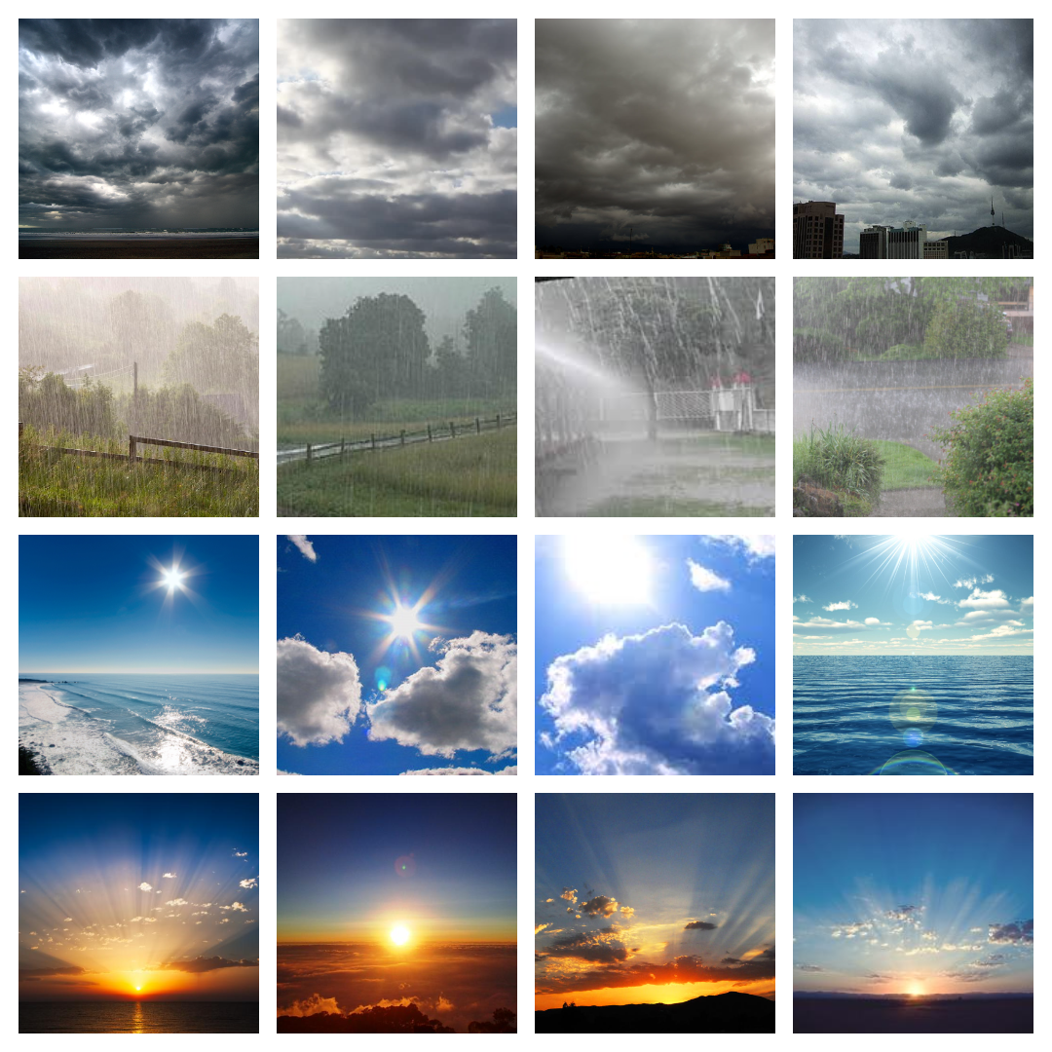

|  |  |
| --- | --- |
| **Class** | **Number of images in the class** |
| Cloudy | 300 |
| Shine | 253 |
| Sunrise | 357 |
| Rain | 215 |
| Total number of images = 1125 | |

For MCWRD

For MWI

|  |  |
| --- | --- |
| **Class** | **Number of images in the class** |
| Haze | 500 |
| Rainy | 500 |
| Sunny | 500 |
| Snowy | 500 |
| Total number of images = 2000 | |