A
Major Project report on
AN AI-BASED ANALYTICAL MODEL FOR EVALUATING AND PREDICTING SOFTWARE DEVELOPER PRODUCTIVITY
A thesis submitted in partial fulfilment of the academic requirements for the award of
the degree of
BACHELOR OF TECHNOLOGY
In
COMPUTER SCIENCE AND ENGINEERING
Submitted By
S.GANESH ( Roll No:22TD1A0508)
M.LAHARI (Roll No:22TD1A0511)
M.SHIVASAI (Roll No:22TD1A0526)
CH.SRIJA (Roll No:23TD5A0504)
Under the guidance of
Miss.V. SWETHA
Asst. prof.


NIGAMA ENGINEERING COLLEGE
DEPARTMENT OF COMPUTER SCIENCE AND ENGINEERING
(Approved By AICTE & Affiliated to JNTUH, Hyderabad) Sambaiahpally, Peddapalli,
Telangana- 505 186
2022-2026

NIGAMA ENGINEERING COLLEGE
(Approved By AICTE & Affiliated to JNTUH, Hyderabad) Sambaiahpally,
Peddapalli, Telangana- 505 186
DEPARTMENT OF COMPUTER SCIENCE AND ENGINEERING


CERTIFICATE
This is to certify that the project report on “AN AI-BASED ANALYTICAL MODEL FOR EVALUATING AND PREDICTING SOFTWARE DEVELOPER PRODUCTIVITY” is a Bonafide work carried out by S.GANESH bearing Roll No:22TD1A0508, M.LAHARI bearing Roll No:22TD1A0511, M.SHIVASAI bearing Roll No:22TD1A0526,CH.SRIJA bearing Roll No:23TD5A0504 in the partial fulfilment for the award of Bachelor 0f Technology degree in Computer Science and Engineering discipline to the Jawaharlal Nehru Technological University Hyderabad, during the academic year 2025– 2026 under our guidance and supervision. The results embodied in the project work has not been submitted to any other University or Institute for the award of any degree or diploma.

INTERNAL GUIDE HEAD OF THE DEPARTMENT
Miss.V. SWETHA DR.V.RATNA KUMARI

PRINCIPAL EXTERNAL EXAMINAR
DR.V.RATNA KUMARI

ACKNOWLEDGEMENT
The Satisfaction that accomplishes the successful completion of any task would be incomplete without the mention of the people who make it possible and whose constant guidance and encouragement crown all the efforts with success.
Our sincere thanks and gratitude to DR.V. Ratna Kumari, Head of the Department, CSE for all the timely support and valuable suggestions during the period of my project. We are extremely thankful and indebted to my internal guide, Miss.V. Swetha, Internal Guide, Department of CSE for her exemplary guidance and encouragement. Her trust and support inspired us in the most important moments of making right decisions and we are glad to work under her supervision. We are extremely thankful to project review committee members, Dept. of CSE for their encouragement and support throughout the project. we would like to thank all the faculty and staff of department who helped us directly or indirectly in completing the project work.
Last but not least, we would like to thank our family members and friends for their cooperation for completing the project.
we sincerely Acknowledge and thank all those who gave directly or indirectly their support
in completion of this work.

S.GANESH ( Roll No:22TD1A0508)
M.LAHARI (Roll No:22TD1A0511)
M.SHIVASAI (Roll No:22TD1A0526)
CH.SRIJA (Roll No:23TD5A0504)
[Date]

Abstract
In the current era of increasing digital productivity and AI integration, understanding the key factors that influence task success is essential for optimizing personal and professional performance. This project presents a machine learning-based regression system capable of predicting the likelihood of task success based on various behavioural, environmental, and cognitive inputs. Key features include hours of coding, caffeine intake, number of distractions, sleep duration, commit frequency, bug reports, AI tool usage, and cognitive load—factors identified to have a measurable impact on productivity outcomes.
The system is trained using supervised regression algorithms and fine-tuned to capture patterns in user behaviour and task output metrics. A user-friendly interface developed using Python's Streamlit library enables real-time interaction with the model, making it accessible to individuals with no background in data science. The model, saved using joblib, is seamlessly integrated into the GUI and provides instant predictive feedback.
By using this tool, users can gain actionable insights into how their daily habits influence their overall task success, promoting data-driven self-improvement. The application demonstrates the practical usage of AI in enhancing personal productivity and is designed to be extendable with more behavioural inputs or advanced models like deep learning.
This project exemplifies the fusion of data science, human behaviour modelling, and software usability, offering a smart approach to personal task optimization and performance forecasting

TABLE OF CONTENTS

CHAPTER NO. TITLE PAGE NO:

Certificate……………………………………………………………….........….2
Acknowledgement………………………………………………………….........3
Abstract……………………………………………………………………..........4
Table of Contents………………………………………………………………...5-6
List of Figures…………………………………………………………………....7-47
1 Introduction 7
2 Scope 8

3 Objective 9-10

4 System Analysis 11-13
4.1 Existing System and Its Features
4.2 Proposed System and Its Features

5 System Specification 14
5.1 Hardware Requirements
5.2 Software Component

6 System Design 15-21

7 Software Environment 22-30
7.1 Machine Learning
7.2 Introduction to PYTHON
7.3 Anaconda
7.4 Jupyter notebook

8 Sample Code 31-38

9 System Testing 39-41
9.1 Types of Tests

10 Output Screens 42-44

11 Conclusion 45

12 Future Enhancements 46

13 References 47

Introduction
In today’s fast-paced digital world, individual productivity and task success are critical to achieving both personal and professional goals. As more work environments shift towards remote and tech-driven workflows, it has become increasingly important to understand the factors that influence successful task completion. Variables such as the number of hours spent coding, sleep duration, coffee intake, cognitive load, and even the usage of AI tools can significantly affect a developer's or knowledge worker’s efficiency and output.
Traditionally, measuring productivity has been subjective and inconsistent, often relying on intuition or outdated metrics. However, with the rise of data-driven technologies and machine learning, we now have the ability to model and predict task performance using objective data. This project harnesses that capability by using regression-based machine learning techniques to predict task success based on a set of measurable behavioural and work-related parameters.
To make this technology accessible to a wider audience, a Graphical User Interface (GUI) has been developed using Python's Streamlit library. This interface allows users to input key variables such as hours coded, caffeine intake, number of distractions, sleep hours, and AI usage. The application then uses a trained regression model to predict the expected level of task success, offering users personalized and actionable feedback.
This system is particularly useful for software developers, project managers, students, and remote workers who wish to optimize their productivity by understanding the correlation between their daily habits and their task performance. With its lightweight interface and rapid feedback mechanism, the application serves as a practical and intelligent tool for productivity analysis and enhancement.
In essence, this project is a blend of artificial intelligence, human behaviour modelling, and user-centric design aimed at delivering real-world benefits in personal productivity assessment.

Scope
The scope of the Task Success Predictor project encompasses the development of an intelligent, user-interactive application that predicts an individual's likelihood of completing a task successfully based on multiple behavioural and cognitive parameters. This system integrates a pre-trained machine learning regression model with a simple yet intuitive graphical user interface (GUI) built using Python's Streamlit library.
The application is designed to accept a range of quantitative inputs such as:
- Hours spent coding
- Coffee (caffeine) intake
- Number of distractions
- Sleep duration
- Git commit frequency
- Bugs reported
- AI tool usage time
- Cognitive load
These inputs are processed by a trained regression model which outputs a prediction representing the estimated success level of the user’s task. The prediction is displayed in real time through the GUI, enabling users to experiment with different input combinations and observe how changes in behaviour could influence their productivity outcomes.
The system is primarily aimed at individual users such as:
- Software developers
- Freelancers
- Remote employees
- Students
- Team leaders and project managers
The current scope includes:
- Building a user interface for real-time input collection.
- Integrating a machine learning model trained on historical or synthetic productivity data.
- Displaying the prediction result in a user-friendly format.
- Implementing basic error handling and input validation to ensure robustness.

Objective
The primary objective of the Task Success Predictor project is to develop an intelligent, interactive software tool that leverages machine learning to estimate the success of a task based on user-specific behavioural and cognitive inputs. This project aims to bridge the gap between subjective productivity perception and objective data-driven prediction by integrating AI with a user-friendly interface.
The key objectives of this project are:
- To design and develop a machine learning regression model capable of accurately predicting task success using quantitative variables such as coding hours, sleep duration, caffeine intake, AI usage, and cognitive load.
- To create a lightweight and intuitive GUI using Streamlit that allows users to easily input their daily activity metrics without requiring programming or data science knowledge.
- To facilitate personalized feedback by converting raw input features into meaningful predictions that help users understand how their work patterns and habits influence their productivity.
- To provide an efficient and responsive application that performs predictions in real-time, encouraging users to explore multiple behavioural scenarios and optimize their work routine accordingly.
- To demonstrate the practical integration of AI in everyday life through a simple desktop application that makes advanced machine learning capabilities accessible and useful for individuals and professionals.
- To encourage self-monitoring and habit improvement by helping users visualize the direct impact of modifiable factors—such as sleep or distractions—on their task success probability.
- To ensure modularity and scalability in the system design so that additional features, inputs, or more complex models (e.g., deep learning, time-series analysis) can be incorporated in future upgrades.
- By achieving these objectives, the project not only showcases the predictive power of machine learning in behavioural analysis but also offers a valuable tool for enhancing personal productivity through data-driven decision-making.
Literature Survey

1. Predictive Modelling of Human Behaviour Using Machine Learning
Several research studies have used regression and classification models to predict behavioural outcomes. For example, B. R. Purohit et al. (2019) implemented machine learning models to predict academic performance based on study hours, sleep, and stress levels, which parallels this project's attempt to model productivity using cognitive and behavioural variables.

2. Cognitive Load Theory (Sweller, 1988)
Cognitive Load Theory (CLT) explains how working memory limitations affect learning and task performance. Research based on CLT supports the inclusion of cognitive load as a predictive feature in machine learning models focused on productivity.

3. Impact of Sleep and Caffeine on Task Performance
A study by Killgore et al. (2006) demonstrated that both sleep deprivation and caffeine intake significantly influence cognitive performance and alertness. These variables have been widely used in productivity studies and are integral to the predictor model in this project.

4. Human Factors and Productivity Tools
Studies such as “Quantified Self” movement research have explored how tracking health and work metrics can improve individual productivity. This body of research supports the idea that self-monitoring tools, combined with AI, can effectively guide behavioural adjustments.

5. AI and Developer Productivity
Recent industry research (e.g., GitHub Copilot impact studies, 2023) has shown how AI tools improve developer speed and reduce cognitive burden. Incorporating AI usage hours into this project’s model is inspired by such real-world findings.

6. Multivariate Regression in Performance Modelling
Regression techniques have been widely applied in predicting performance metrics in sports, education, and workplace settings. Papers such as “Using Multivariate Regression to Model Employee Productivity” (J. Lee et al., 2020) show the effectiveness of such models in handling multiple interrelated variables.

7. Usability and UX in Predictive Systems
Research into HCI (Human-Computer Interaction) emphasizes the importance of intuitive interfaces for non-technical users. This influenced the decision to use Streamlit to build a lightweight and accessible GUI for interacting with the model.

SYSTEM ANALYSIS

4.1 Existing System and Its Features:
In the current productivity and performance evaluation landscape, most individuals and organizations rely on manual tracking methods, subjective assessments, or basic time management tools to monitor task completion and success. These systems include:
- Time Tracking Tools (e.g., Toggle, Clockify): Monitor time spent on tasks but provide no insight into task quality or contributing behavioural factors.
- Project Management Software (e.g., Trello, Jira, Asana): Useful for tracking progress but dependent on manual input and subjective task completion status.
- Productivity Journals and Habit Trackers: Provide qualitative self-assessment but lack analytical depth or prediction capabilities.
- Performance Reviews: Used in corporate settings but often delayed, biased, and lacking behavioural correlation.
- Self-assessment and Intuition: The most commonly used yet highly inconsistent and inaccurate approach to understanding productivity.

Disadvantages of Existing Systems:
- Lack of Predictive Intelligence
Existing systems focus on tracking the past rather than predicting the future. They do not help users anticipate success based on current habits or behaviours.
- Subjective Evaluation
Self-assessment and performance reviews are often influenced by mood, perception, or bias, making them unreliable indicators of true task success.
- Data Silos with No Learning Capability
Tools operate in isolation and do not leverage machine learning or historical patterns to provide actionable insights.
- Manual Data Entry and Maintenance
Most tools require users to enter data manually and frequently, which leads to fatigue, inconsistency, and ultimately abandonment of the tool.
- No Real-Time Feedback
Users often receive delayed feedback, which doesn’t help in adjusting current behaviours to improve performance.
- Inability to Correlate Multiple Factors
These systems rarely take into account a combination of factors (e.g., sleep, caffeine, coding hours, AI usage) and how they collectively influence performance.
- Generic and Non-personalized
Existing solutions are not tailored to individual behaviour patterns and thus fail to offer personalized productivity recommendations or feedback.
- No Cognitive or Behavioural Modelling
There is a lack of focus on cognitive load, distraction level, or mental fatigue — crucial factors in predicting success.

4.2 Proposed System and Its Features:

✅ Proposed System Overview:
The proposed system is an AI-powered desktop application that uses a trained regression model to predict the likelihood of task success based on various behavioural and cognitive factors. Built using Python’s Streamlit for the GUI and integrated with a joblib-serialized machine learning model, the system allows users to input daily metrics such as hours coded, sleep duration, caffeine intake, distractions, AI tool usage, and more.
Once the inputs are provided, the system instantly returns a numeric prediction indicating the user’s expected task success score. This score helps individuals understand how their current habits and conditions may affect productivity, and motivates them to make data-informed changes for better outcomes.

✅ Key Features of the Proposed System:
- User-Friendly Interface: Built with Streamlit, the application offers a clean, easy-to-use GUI where users can enter data and receive feedback with minimal effort.
- Real-Time Prediction: As soon as inputs are submitted, the model makes an instant prediction, enabling on-the-fly analysis and adjustment of work habits.
- Data-Driven Insight: Unlike subjective assessments, the model bases its prediction on learned patterns from historical data, leading to more reliable and actionable outcomes.
- Multiple Factor Correlation: The model takes into account a combination of features (e.g., coding hours, sleep, caffeine, AI usage) to evaluate productivity, providing a more holistic and accurate prediction.
- Lightweight and Offline-Compatible: The system runs locally, does not depend on cloud services, and is suitable for laptops and desktops with limited resources.
- Customizable and Extendable: Designed in a modular fashion, allowing easy integration of new features like charts, time-series models, recommendation systems, or third-party integrations.

Advantages of the Proposed System:
- Predictive Capability
Unlike existing systems, this application offers predictive insights that allow users to forecast their task success before they even begin, enabling proactive behaviour.
- Objective and Consistent Evaluation
Replaces subjective opinions with machine learning predictions based on empirical data and pattern recognition.
- Immediate Feedback Loop
Users can tweak inputs like caffeine intake or hours of sleep to see how it affects their task success — building self-awareness and behavioural optimization.
- Enhanced Personal Productivity
Promotes habit-building and better time management by helping users understand the impact of their routine on productivity.
- Accessible Technology
Designed for users with no technical background, making advanced AI concepts accessible to students, professionals, and freelancers alike.
- Supports Informed Decision-Making
Encourages users to take control of their daily activities through data-backed decision-making.
- Portable and Fast
No need for internet or external APIs; runs directly on any system with Python and minimal dependencies.
- Foundation for Scalable Applications
This tool serves as a foundational block for more advanced productivity systems like personalized coaching bots, workplace productivity dashboards, or digital wellness tools.

SYSTEM SPECIFICATION

5.1 Hardware Requirements:
Component | Minimum Specification | Recommended Specification
Processor (CPU) | Intel Core™ i3 | Intel Core i5/i7 or better
RAM | 8 GB | 16 GB or more
Storage | At least 500 MB free disk space | At least 1 GB free disk space
Display | Minimum resolution 1024 x 768 | Full HD resolution (1920 x 1080)
Input Device | Keyboard and Mouse | Keyboard and Mouse

5.2 Software Component | Version / Details
Operating System | Windows 7 or later / Linux / macOS
Python Interpreter | Python 3.7 or higher
Required Python Libraries | - scikit-learn (for ML model)
 | - joblib (for model serialization)
 | - NumPy (for numerical operations)
 | - Streamlit(for GUI; usually pre-installed with Python)
IDE / Editor | Any Python IDE or text editor (e.g., VS Code, PyCharm, IDLE)

SYSTEM DESIGN

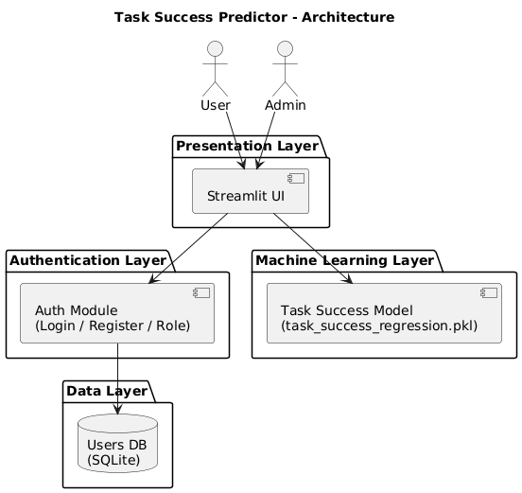

Fig 1: Task success predictor-Architecture

This image is an Architecture Diagram for a Task Success Prediction System. It builds on the workflow logic you looked at previously, showing how those steps are organized within a technical framework, specifically a Streamlit Web Application.
Key Components of the System
- User Interaction: The user interacts with the system by entering "Task Parameters" into an Input Interface and eventually "Views the Result" provided by the Result Display Module.
- Streamlit Web Application: This is the core container for the logic. Streamlit is a popular Python framework used to create interactive web apps for machine learning and data science.
- Feature Preparation Module: This component takes the "Raw Input Data" from the interface and transforms it into a "Feature Vector" so the machine learning model can process it.
- Regression Model: The diagram specifies a file named task_success_regression.pkl. This is a serialized Python object (likely created with Scikit-Learn) that contains the logic to calculate the "Predicted Task Success Score."
External Storage: The system loads the trained model from a "Trained Regression Model" database or storage location.

- Input: UserInput Interface.
- Processing: Input Interface Feature Preparation Module Regression Model.
- Output: Regression Model Result Display Module User.
The three diagrams you've provided form a complete UML (Unified Modelling Language) suite for a Task Success Prediction System. They move from the high-level goals of the user down to the specific technical implementation.
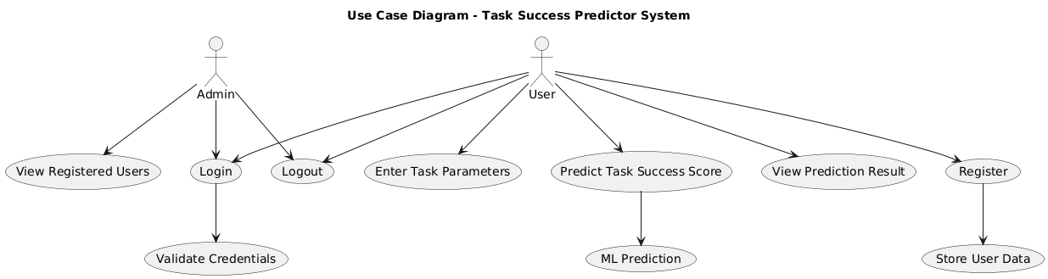

Fig 2: Use Case Diagram: User Goals
This diagram identifies what the system does from a user's perspective.
- Primary Actor: The User interacts directly with the system.
- Core Actions: The user is responsible for three main use cases within the system boundary: View Prediction Result, Predict Task Success, and Enter Task Details.

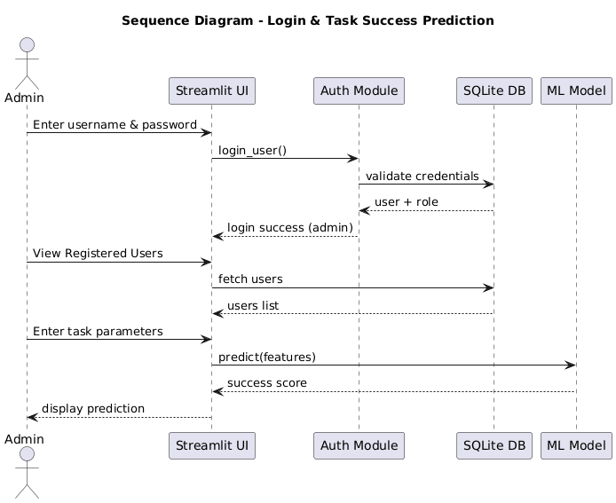
Fig 3: Sequence Diagram – Login & Task Success Prediction

The image shows a Task Success Predictor - Sequence Diagram. The diagram outlines the flow of interactions between components for predicting task success using a regression model. Here’s a breakdown of the elements visible in the diagram:
1. Components involved:
- User
- Twister GUI
- Input Validation
- Feature Vector Builder
- Regression Model
- Result Display
2. Sequence of operations:
- User enters input data into the Twister GUI.
- Input Validation checks if inputs are valid; if invalid, it sends an error message back to the user.
- Valid inputs are passed to the Feature Vector Builder to construct a feature vector
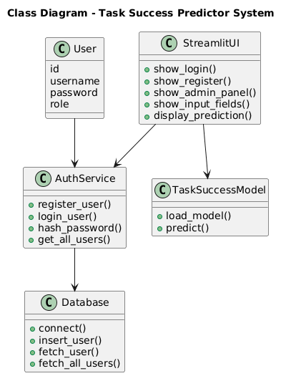

Fig 4: Cass Diagram – Task Success Prediction System

The class diagram represents a Task Success Prediction System with three main classes:
1. Streamlit App
- Methods:
- getUserInput(): captures input from the user.
- displayPrediction(): shows the prediction result to the user.
2. Feature Vector
- Method:
- buildFeatures(): constructs feature vectors from the user input for model processing.
3. TaskSuccessModel
- Method:
- predict(): uses the feature vector to generate a task-success prediction.

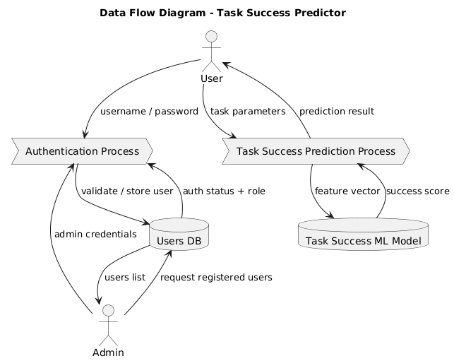

Fig 5: Data Flow Diagram – Task Success Predictor

The data flow diagram depicts a Task Success Prediction System with the following components and flow:
1. User interacts with the User Interface by providing Task Parameters and viewing predictions.
2. The User Interface sends Raw Input Data to the Input Processing Module.
3. The Input Processing Module transforms the raw data into a Feature Vector and passes it to the Prediction Engine.
4. The Prediction Engine accesses the Task Success Regression Model (using Model Access) and applies Prediction Logic to generate a Task Success Score.
5. The Task Success Score is sent to the Output Module, which produces a Display Result shown to the user via the User Interface.

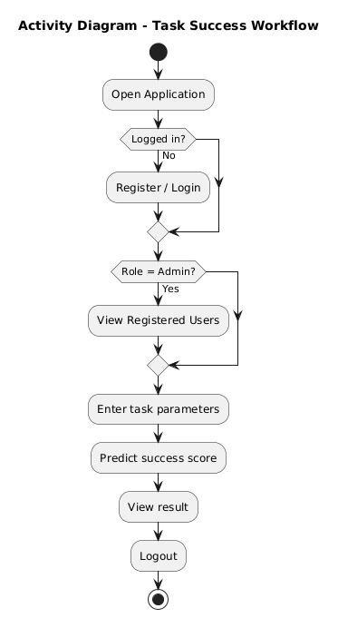
Fig 6: Activity Diagram – Task Success Workflow

This image shows a UML (Unified Modelling Language) Activity Diagram for a workflow titled Task Success Prediction. It outlines the linear sequence of steps an automated system takes to estimate whether a specific task will be successful based on historical data.
Here is a breakdown of the process shown in the diagram:
1. The Workflow Steps
The diagram follows a standard top-to-bottom execution:
- Start Node (Solid black circle): Indicates the beginning of the process.
- Enter task-related inputs: The user or system provides the raw data (e.g., task duration, difficulty level, or resources available).
- Prepare feature vector: The raw inputs are transformed into a numerical format that a computer can understand. This often involves normalizing data or converting text into numbers.
- Load trained regression model: The system calls a pre-existing machine learning model (specifically a regression model) that has already been trained on previous datasets.
- Predict task success score: The model processes the feature vector and calculates a numerical output, likely a percentage or probability of success.
- Display prediction result: The final score is presented to the user.
- End Node (Bullseye circle): Signifies the completion of the workflow.

SOFTWARE ENVIRONMENT

7.1 Machine Learning
Tom Mitchell states machine learning as “A computer program is said to learn from experience and from some tasks and some performance on, as measured by, improves with experience”. Machine Learning is combination of correlations and relationships, most machine learning algorithms in existence are concerned with finding and/or exploiting relationship between datasets. Once Machine Learning Algorithms can pinpoint on certain correlations, the model can either use these relationships to predict future observations or generalize the data to reveal interesting patterns. In Machine Learning there are various types of algorithms such as Regression, Linear Regression, Logistic Regression, Naive Bayes Classifier, Bayes theorem, KNN (K-Nearest Neighbour Classifier), Decision Tress, Entropy, ID3, SVM (Support Vector Machines), K-means Algorithm, Random Forest and etc.,
The name machine learning was coined in 1959 by Arthur Samuel. Machine learning explores the study and construction of algorithms that can learn from and make predictions on data Machine learning is closely related to (and often overlaps with) computational statistics, which also focuses on prediction-making through the use of computers. It has strong ties to mathematical optimization, which delivers methods, theory and application domains to the field. Machine learning is sometimes conflated with data mining, where the latter subfield focuses more on exploratory data analysis and is known as unsupervised learning.
Within the field of data analytics, machine learning is a method used to devise complex models and algorithms that lend themselves to prediction; in commercial use, this is known as predictive analytics. These analytical models allow researchers, data scientists, engineers, and analysts to "produce reliable, repeatable decisions and results" and uncover "hidden insights" through learning from historical relationships and trends in the data.
Machine learning tasks Machine learning tasks are typically classified into several broad categories:
Supervised learning: The computer is presented with example inputs and their desired outputs, given by a "teacher", and the goal is to learn a general rule that maps inputs to outputs. As special cases, the input signal can be only partially available, or restricted to special feedback.
Semi-supervised learning: The computer is given only an incomplete training signal: a training set with some (often many) of the target outputs missing.
Active learning: The computer can only obtain training labels for a limited set of instances (based on a budget), and also has to optimize its choice of objects to acquire labels for. When used interactively, these can be presented to the user for labelling.
Unsupervised learning: No labels are given to the learning algorithm, leaving it on its own to find structure in its input. Unsupervised learning can be a goal in itself (discovering hidden patterns in data) or a means towards an end (feature learning).
Reinforcement learning: Data (in form of rewards and punishments) are given only as feedback to the program's actions in a dynamic environment, such as driving a vehicle or playing a game against an opponent.
Benefits of Machine Learning:
- Achieve economies of scale – increase volume output or productivity with fewer people. Your cost per unit, project or product plummets.
- Reduce spending on technology infrastructure. Maintain easy access to your information with minimal upfront spending. Pay as you go (weekly, quarterly or yearly), based on demand.
- Globalize your workforce on the cheap. People worldwide can access the cloud, provided they have an Internet connection.
- Streamline processes. Get more work done in less time with less people.
- Reduce capital costs. There’s no need to spend big money on hardware, software or licensing fees.
- Improve accessibility. You have access anytime, anywhere, making your life so much easier!
- Monitor projects more effectively. Stay within budget and ahead of completion cycle times.
- Less personnel training is needed. It takes fewer people to do more work on a cloud, with a minimal learning curve on hardware and software issues.
- Minimize licensing new software. Stretch and grow without the need to buy expensive software licenses or programs.
- Improve flexibility. You can change direction without serious “people” or “financial” issues at stake.
Advantages:
- Price: Pay for only the resources used.
- Security: Cloud instances are isolated in the network from other instances for improved security.
- Performance: Instances can be added instantly for improved performance. Clients have access to the total resources of the Cloud’s core hardware.
- Scalability: Auto-deploy cloud instances when needed.
- Uptime: Uses multiple servers for maximum redundancies. In case of server failure, instances can be automatically created on another server.
- Control: Able to login from any location. Server snapshot and a software library lets you deploy custom instances.
- Traffic: Deals with spike in traffic with quick deployment of additional instances to handle the load.

7.2 Introduction to PYTHON :
Python Technology
Python technology is both a programming language and a platform.
The python Programming Language
THE PYTHON PROGRAMMING LANGUAGE IS A HIGH-LEVEL LANGUAGE THAT CAN BE CHARACTERIZED BY ALL OF THE FOLLOWING BUZZWORDS:

    - Simple
    - Architecture neutral
    - Object oriented
    - Portable
    - Distributed
    - High performance
    - Interpreted
    - Multithreaded
    - Robust
    - Dynamic
    - Secure

With most programming languages, you either compile or interpret a program so that you can run it on your computer. The Python programming language is unusual in that a program is both compiled and interpreted. With the compiler, first you translate a program into an intermediate language called Python byte codes —the platform-independent codes interpreted by the interpreter on the Python platform. The interpreter parses and runs each Python byte code instruction on the computer. Compilation happens just once; interpretation occurs each time the program is executed. The following figure illustrates how this works.
FEATURES OF MACHINE LEARNING
• It is nothing but automating the Automation.
• Getting computers to program themselves.
• Writing Software is bottleneck.
• Machine leaning models involves machines learning from data without the help of humans or any kind of human intervention.
• Machine Learning is the science of making of making the computers learn and act like humans by feeding data and information without being explicitly programmed.
• Machine Learning is totally different from traditionally programming, here data and output is given to the computer and in return it gives us the program which provides solution to the various problems. Below is the figure.
Traditional Programming vs Machine Learning
• Machine Learning is a combination of Algorithms, Datasets, and Programs.
• There are Many Algorithms in Machine Learning through which we will provide us the exact solution in predicting the disease of the patients.
• How Does Machine Learning Works?
• Solution to the above question is Machine learning works by taking in data, finding relationships within that data and then giving the output.
Machine Learning Model
• There are various applications in which machine learning is implemented such as Web search, computing biology, finance, e-commerce, space exploration, robotics, social networks, debugging and much more.
• There are 3 types of machine learning supervised, unsupervised, and reinforcement.

BENEFITS OF PYTHON
• Presence of Third-Party Modules
• Extensive Support Libraries
• Open Source and Community Development
• Learning Ease and Support Available
• User-friendly Data Structures
• Productivity and Speed
• Highly Extensible and Easily Readable Language.

Python
Python is high level language and it is also integrated version of the program. Python is an object-oriented approach and its main aim to help programmers to write the code clearly, logical code for small and large scale of project.
Python is dynamically typed and garbage collected it also support multiple programming and it is both procedure and object oriented and also functional programming. And structural programming also supported. It has many built in function it also supports filter, map and reduce function. All the machine learning algorithm and the libraries are being supported by the python programming language. Python also support list, dict, sets and other generators. Python code can be run in different platform such as anaconda, PyCharm etc.
The main goal of this programming language is as follows:
• Python is simple, object-oriented programming language.
• The language and implementation should provide support for software engineering principles such as strong type library preset for different machine learning algorithm, and all other algorithm in simple manner.
• Coding will be smooth in python and the data analysis can be easily done in python.
This is so much so to the point where we now have modules and APIs at our disposal, and you can engage in machine learning very easily without almost any knowledge at all of how it works. With the defaults from Scikit-learn, you can get 90-95% accuracy on many tasks right out of the gate. Machine learning is a lot like a car, you do not need to know much about how it works in order to get an incredible amount of utility from it.
Despite the apparent age and maturity of machine learning, I would say there's no better time than now to learn it, since you can actually use it. Machines are quite powerful, the one you are working on can probably do most of this series quickly. Data is also very plentiful lately.

import Streamlit as st
import joblib
import numpy as np

# Load the saved regression model
model = joblib.load('task_success_regression.pkl')

st.title("Task Success Predictor")
st.markdown("Enter the following details to predict your task success score:")

# Input fields
hours_coding = st.number_input("Hours Coding", min_value=0.0, step=0.1)
coffee_intake = st.number_input("Coffee Intake (mg)", min_value=0)
distractions = st.number_input("Distractions", min_value=0)
sleep_hours = st.number_input("Sleep Hours", min_value=0.0, step=0.1)
commits = st.number_input("Commits", min_value=0)
bugs_reported = st.number_input("Bugs Reported", min_value=0)
ai_usage_hours = st.number_input("AI Usage Hours", min_value=0.0, step=0.1)
cognitive_load = st.slider("Cognitive Load (0 to 10)", 0.0, 10.0, step=0.1)

# Predict button
if st.button("Predict Task Success"):
try:
features = np.array([[hours_coding, coffee_intake, distractions, sleep_hours,
commits, bugs_reported, ai_usage_hours, cognitive_load]])
prediction = model.predict(features)[0]
st.success(f"Predicted Task Success: {round(prediction, 2)}")
except Exception as e:
st.error(f"Prediction failed: {e}")

7.3 Anaconda
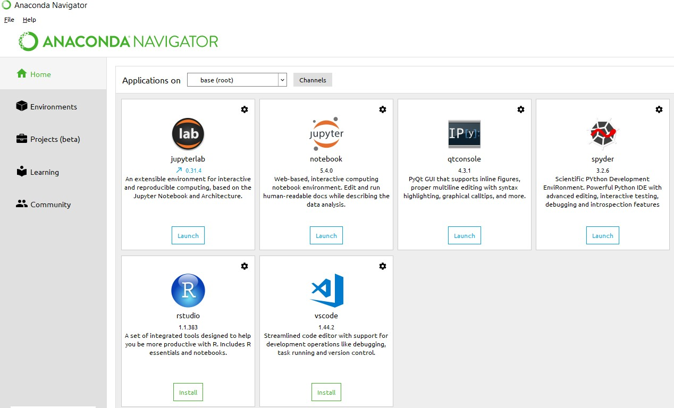
Anaconda is free and open-source distribution of the Python and R programming languages for scientific computing (data science, machine Learning applications, Large- scale data processing, predictive analytics, etc.), that aims to simplify package management and deployment. It is developed and maintained by Anaconda, Inc. The distribution incudes data-science packages suitable for Windows, Linux, and macOS. Packaged versions are required and are managed by the package management system anaconda. This package manager was spun out as a separate open-source package as it ended up being useful on its own and for other things than Python. There is also a small, bootstrap version of Anaconda called Miniconda, which includes only conda, Python, the packages they depends on, and a small number of other packages.
Anaconda Console

7.4 Jupyter notebook
Jupiter Notebook or so called IPython Notebook is an interactive web based computational mean for starting with Jupiter Notebook documents. The term notebook itself is a huge entity to represent the integration with different entity sets. JSON is the main document form from the same for the execution which follows the brief on the schema and the input and output means. It has high integration with several language set and has various flexibilities with the choices. The extension used for the same is “.ipynb” which runs in this platform. It’s an open-source software package with interactive communication means. It has it’s open standards for the same. It’s an open community best for budding programmers . The flexibility of the same is phenomenon and splendidly done the configuration and integration of the same is simplest and easy on hold so that no prior distortion is generated and the efficiency of the same is measured throughout any system of choice.
It’s the best software sets that been used across cross for designing and developing of the products and support wide help support. Not only to that, it provides scalability in the code and the deployment of the same. Various Language can be changed and the project can be undertaken on the same. The created notebook files can be shared and stored in various means for further utilization. It supports cultivated and interactive output sets. Easily crossed over for graphing, plotting and visualizing of the elements. Data Integration of the same is to its best. The integration of big data and it can process chunks of values in an approx. time which gives a better performance and the higher computational means. Various works on data like cleaning, cleansing, transforming modelling and visualizing can be done by the same

Machine learning is the ability that gives the computer to learn without being explicitly programmed. There are two types of machine learning:
Supervised Learning:
supervised learning is the learning of the labelled data. It is the types of machine learning that maps the input and output based on the examples input-output pairs. In supervised learning each training data having pairs of input and desired outputs values. Supervised learning algorithm analyses the training data and produces a function which can be used for mapping of new data.
Fig 2.1 Supervised Learning The output to solve the supervised learning algorithm are as:
• Determine the types of data, before doing anything else the user should understand which types of data set is to be used for training the data.
• Gathered the training data sets either in form of human experts or from measurements.
• Determine the feature of inputs from the learned data and depends on the inputs it changed into feature vector; number of features should not be large but should contains enough information to accurately predict the outputs.
• Check the learned function and the learned algorithm for example we use support vector machines or decisions tree.
• Complete the design and run the trained data sets.
• Analyzed the output and verify the data sets to get the accurate outputs.
Unsupervised Learning:
Unsupervised learning is a type of machine learning that helps in finding the previously unknown patterns in the data set without any known labels. It is known as self- organization and allows modelling probability densities of given inputs.
Fig 2.2 unsupervised Learning Some of the algorithm used in unsupervised learning are:
• Clustering
• Anomaly detection
• Neural networks
• Approach for learning latent variable models
• Non labelled data
Semi Supervised Machine Learning algorithm: It’s like the middle man which have some labelled data and some unlabelled which can be prosed by the both the structured and unsupervised learning.
The algorithms have been compared based upon the parameters: Size of the dataset and Number of technical indicators used. Accuracy and F-measure values have been computed for each algorithm. Long term model has been used to compute the accuracy and F-measure.
Reinforcement Learning: This type of learning is used to reinforce or strengthen the network based on critic information. That is, a network being trained under reinforcement learning, receives some feedback from the environment. However, the feedback is evaluative and not instructive as in the case of supervised learning. Based on this feedback, the network performs the adjustments of the weights to obtain better critic information in future.
This learning process is similar to supervised learning but we might have very less information. The following figure gives the block diagram of reinforcement learning:
SAMPLE CODE

import streamlit as st
import sqlite3
import hashlib
import pandas as pd
import numpy as np
import joblib

# =================================================
# PAGE CONFIG (MUST BE FIRST)
# =================================================
st.set_page_config(
page_title="Task Success Predictor",
layout="centered"
)

# =================================================
# DATABASE & AUTH FUNCTIONS
# =================================================
def get_db():
return sqlite3.connect("users.db")

def hash_password(password):
return hashlib.sha256(password.encode()).hexdigest()

def init_db():
conn = get_db()
cur = conn.cursor()

cur.execute("""
CREATE TABLE IF NOT EXISTS users (
id INTEGER PRIMARY KEY AUTOINCREMENT,
username TEXT UNIQUE,
password TEXT,
role TEXT
)
""")

# Default admin creation
cur.execute("SELECT * FROM users WHERE username='admin'")
if cur.fetchone() is None:
cur.execute(
"INSERT INTO users (username, password, role) VALUES (? ?, ?)",
("admin", hash_password("admin123"), "admin")
)

conn.commit()
conn.close()

def register_user(username, password):
conn = get_db()
cur = conn.cursor()
try:
cur.execute(
"INSERT INTO users (username, password, role) VALUES (? ?, ?)",
(username, hash_password(password), "user")
)
conn.commit()
return True
except:
return False
finally:
conn.close()

def login_user(username, password):
conn = get_db()
cur = conn.cursor()
cur.execute(
"SELECT username, role FROM users WHERE username=? AND password=?",
(username, hash_password(password))
)
user = cur.fetchone()
conn.close()
return user

def get_all_users():
conn = get_db()
cur = conn.cursor()
cur.execute("SELECT id, username, role FROM users")
users = cur.fetchall()
conn.close()
return users

# =================================================
# INIT DATABASE
# =================================================
init_db()

# =================================================
# SESSION STATE
# =================================================
if "logged_in" not in st.session_state:
st.session_state.logged_in = False

# =================================================
# 🔐 AUTH SECTION
# =================================================
if not st.session_state.logged_in:

st.title("🔐 Login / Registration")

tab1, tab2 = st.tabs(["Login", "Register"])

# -------- LOGIN --------
with tab1:
username = st.text_input("Username", key="login_user")
password = st.text_input("Password", type="password", key="login_pass")

if st.button("Login"):
user = login_user(username, password)
if user:
st.session_state.logged_in = True
st.session_state.username = user[0]
st.session_state.role = user[1]
st.success("Login successful")
st.rerun()
else:
st.error("Invalid credentials")

# -------- REGISTER --------
with tab2:
new_user = st.text_input("New Username", key="reg_user")
new_pass = st.text_input("New Password", type="password", key="reg_pass")

if st.button("Register"):
if register_user(new_user, new_pass):
st.success("Registration successful! Please login.")
else:
st.error("Username already exists")

# =================================================
# 🚀 MAIN APP (AFTER LOGIN)
# =================================================
else:

# ---------------- SIDEBAR ----------------
st.sidebar.success(f"👤 {st.session_state.username}")
st.sidebar.write(f"Role: **{st.session_state.role}**")

if st.sidebar.button("Logout"):
st.session_state.logged_in = False
st.rerun()

# ---------------- ADMIN PANEL ----------------
if st.session_state.role == "admin":
st.sidebar.markdown("### 👑 Admin Panel")

if st.sidebar.button("View Registered Users"):
users = get_all_users()
df = pd.DataFrame(users, columns=["ID", "Username", "Role"])
st.subheader("📋 Registered Users")
st.dataframe(df)

# =================================================
# 🚀 TASK SUCCESS PREDICTOR
# =================================================
model = joblib.load('task_success_regression.pkl')

st.title("🚀 Task Success Predictor")
st.markdown("Enter the following details to predict your task success score:")

hours_coding = st.number_input("Hours Coding", min_value=0.0, step=0.1)
coffee_intake = st.number_input("Coffee Intake (mg)", min_value=0)
distractions = st.number_input("Distractions", min_value=0)
sleep_hours = st.number_input("Sleep Hours", min_value=0.0, step=0.1)
commits = st.number_input("Commits", min_value=0)
bugs_reported = st.number_input("Bugs Reported", min_value=0)
ai_usage_hours = st.number_input("AI Usage Hours", min_value=0.0, step=0.1)
cognitive_load = st.slider("Cognitive Load (0 to 10)", 0.0, 10.0, step=0.1)

if st.button("Predict Task Success"):
try:
features = np.array([[hours_coding, coffee_intake, distractions,
sleep_hours, commits, bugs_reported,
ai_usage_hours, cognitive_load]])

prediction = model.predict(features)[0]
st.success(f"🎯 Predicted Task Success Score: {round(prediction, 2)}")

except Exception as e:
st.error(f"Prediction failed: {e}")

SYSTEM TESTING

General
The purpose of testing is to identify errors and ensure that the system meets its requirements and user expectations. Testing helps to verify that the product operates correctly, identifies weaknesses or faults, and ensures that the system does not fail in an unacceptable manner. It is the process of exercising software to ensure that all components and the entire system work as intended.
Developing Methodologies
The testing process begins by creating a comprehensive plan that validates both the general functionality and special features of the system across different platforms and environments. Quality control procedures are applied throughout the testing lifecycle to ensure the system is robust and free of defects. The testing framework is designed to ensure that the system adheres to the requirements outlined in the project’s specifications. Key considerations include:
- Comprehensive testing of individual components and integrated features.
- Cross-platform compatibility to ensure the system works on different platforms and devices.
- Verification of functional, non-functional, and performance requirements, ensuring the system meets expected behaviours and user needs.

9.1 Types of Tests:

Unit Testing
Unit testing focuses on validating that individual units or components of the system are functioning correctly. This includes:
- Verifying that functions and methods return expected outputs given valid inputs.
- Testing the core logic and behaviour of individual components in isolation before integration with other parts of the system.
- Ensuring that each function behaves according to the documented specifications, with expected results for every input.

Functional Testing
Functional testing validates that the system's functions operate as intended based on user and technical requirements. This includes:
- Valid Input: Verifying that the system accepts valid inputs and produces correct outputs.
- Invalid Input: Ensuring the system rejects invalid inputs and displays appropriate error messages.
- Functions: Verifying that all system functions, features, and operations work as specified.
- Output: Ensuring the system produces the expected outputs in various scenarios.
- Interfacing Systems/Procedures: Testing that the system interacts correctly with other systems or procedures.

System Testing
System testing ensures that the entire system works together and meets its specified requirements. This includes:
- Complete System Integration: Verifying that all components work together in an integrated environment and the system functions as a whole.
- End-to-End Workflow: Testing that all workflows (from input to output) operate correctly across all modules.
- Cross-platform compatibility: Ensuring that the system works on different devices, browsers, or operating systems, depending on the project's scope.

Performance Testing
Performance testing checks the system’s behaviour under various conditions to ensure it performs efficiently. This includes:
- Response Time: Verifying that the system responds within acceptable time limits for typical use cases.
- Throughput: Measuring the system's ability to handle a high number of transactions or requests.
- Resource Consumption: Ensuring the system operates efficiently without excessive use of system resources.

Integration Testing
Integration testing ensures that various components of the system interact properly when combined. This involves:
- Component Interaction: Testing the interaction between integrated components to ensure data is passed correctly between them.
- Interface Compatibility: Verifying that the communication between components, APIs, and external services is functioning as expected.

Acceptance Testing
User Acceptance Testing (UAT) validates that the system meets the end-user's needs and fulfills the core requirements. This includes:
- Core Functionality: Verifying that the system performs its key tasks as expected, including processing user inputs and generating appropriate outputs.
- User Interface: Ensuring the user interface is intuitive and aligns with user expectations.
- Edge Cases: Testing the system with edge cases or uncommon inputs to ensure it handles them gracefully.
- Error Handling: Ensuring that error messages are clear and that the system recovers from errors without crashing or producing unintended behaviour.

Build the Test Plan
A comprehensive test plan is crucial to ensuring the system functions as expected. This plan should outline:
- Detailed test cases for all components, features, and workflows.
- Test environments that specify the platforms, devices, and configurations the system will be tested on.
- Performance benchmarks to measure response times, throughput, and system resource usage under different conditions.
- User scenarios to ensure the system meets the real-world use cases and satisfies the end-users' needs.
Each component of the system should undergo rigorous testing to ensure it meets the project requirements and operates as expected under different conditions.

OUTPUT SCREENS

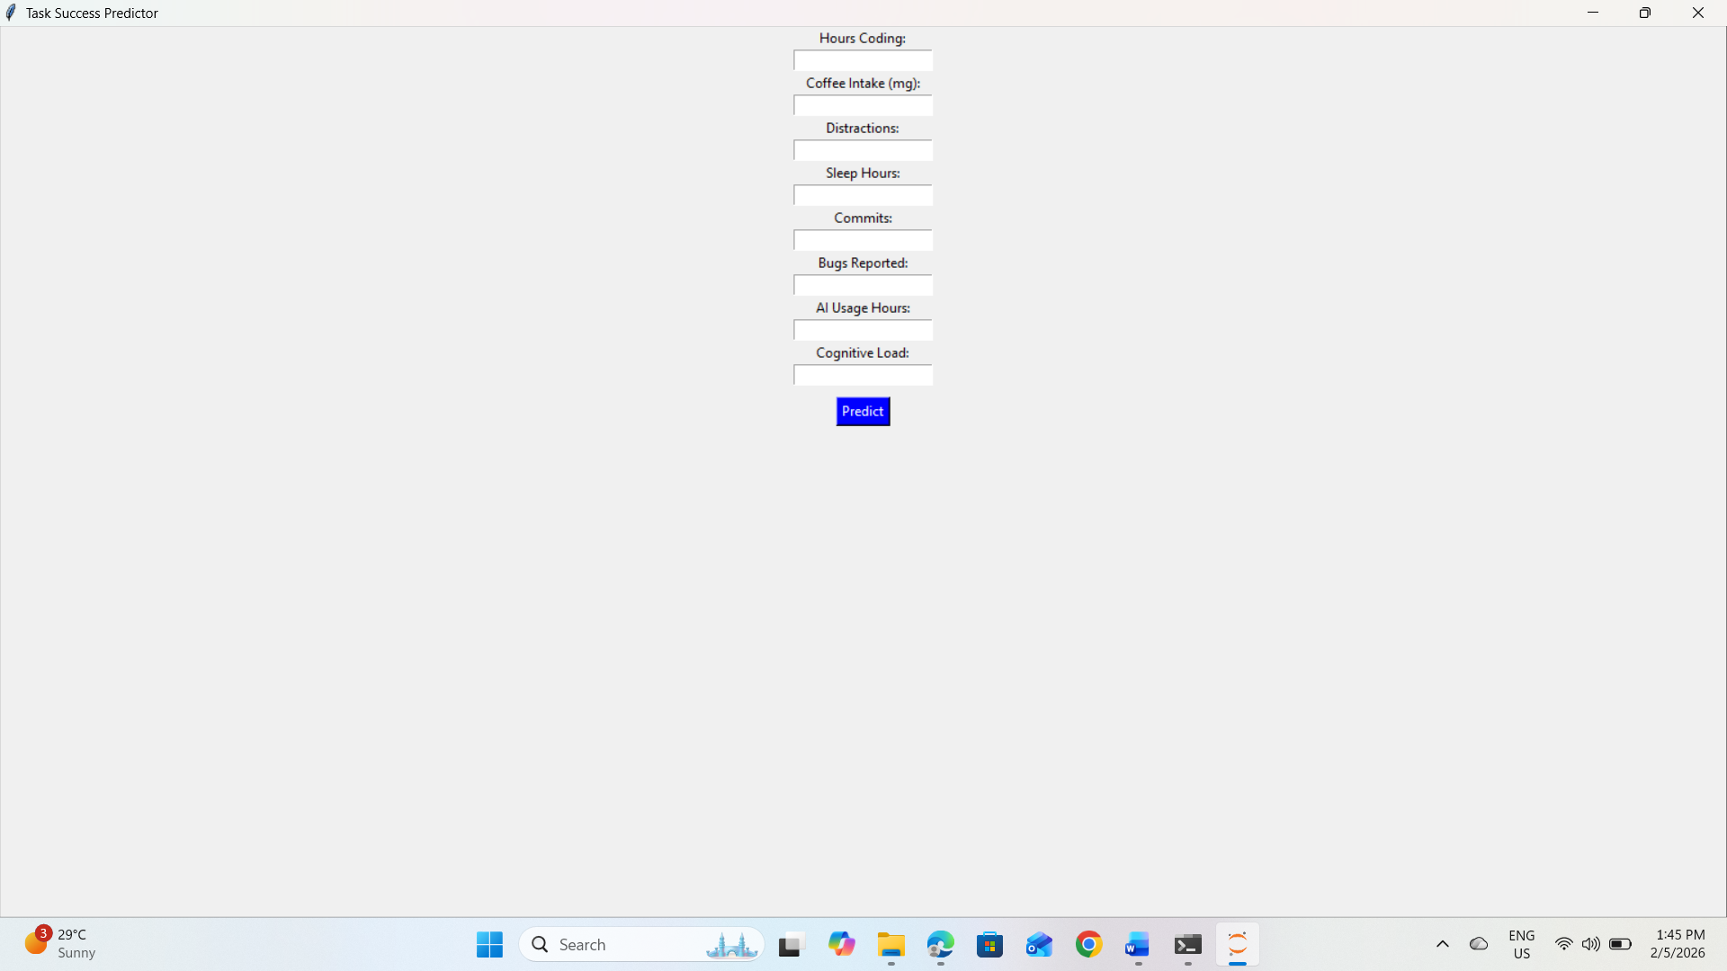
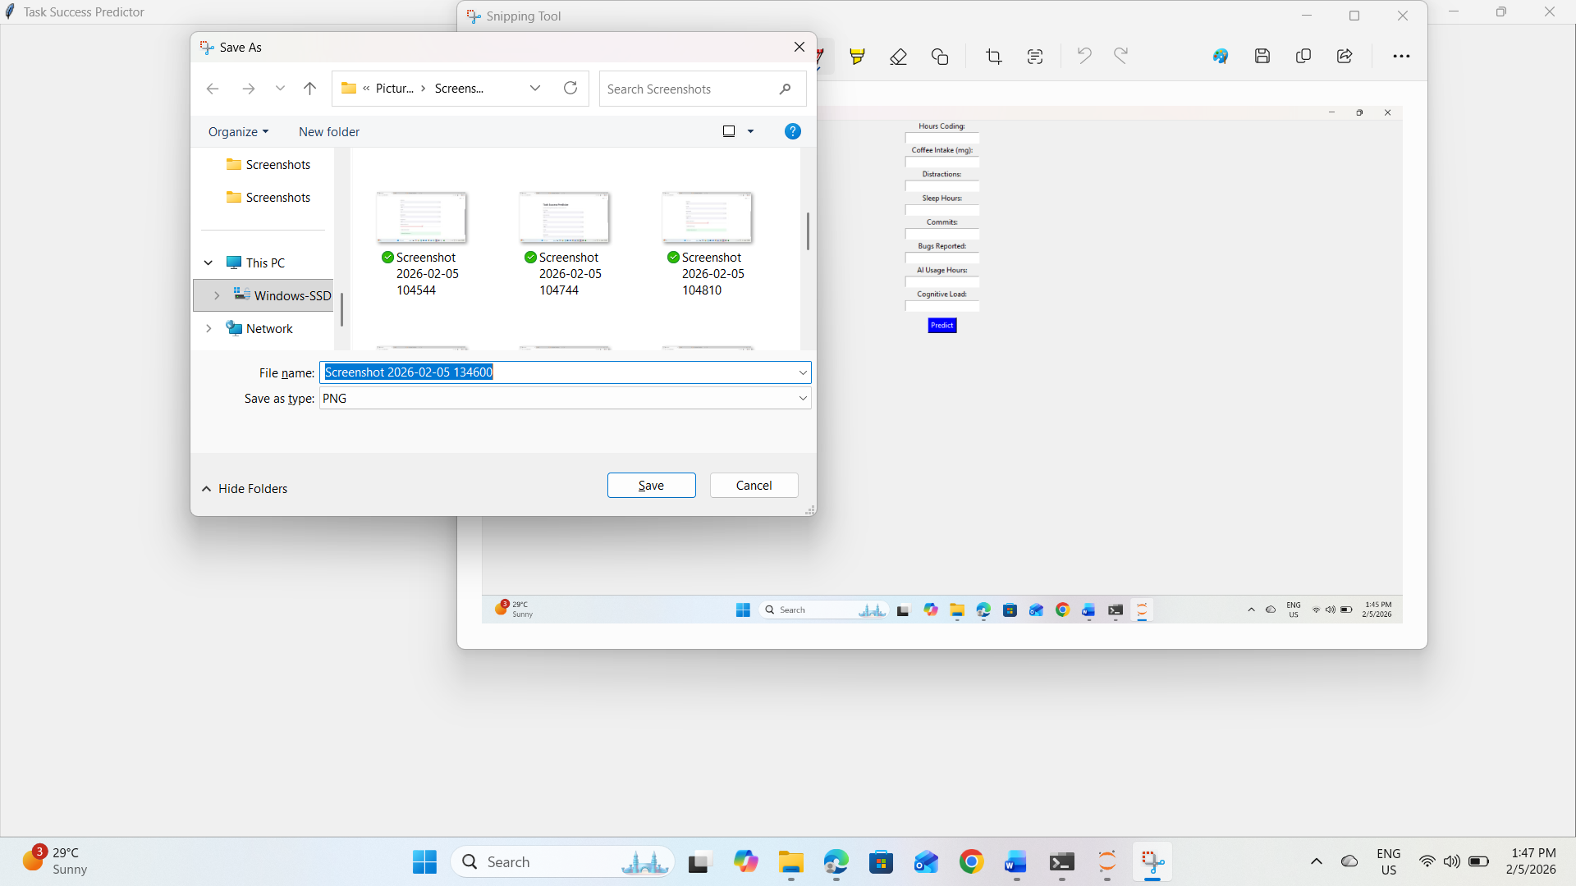
The above fig shows the task success rate of software developer.
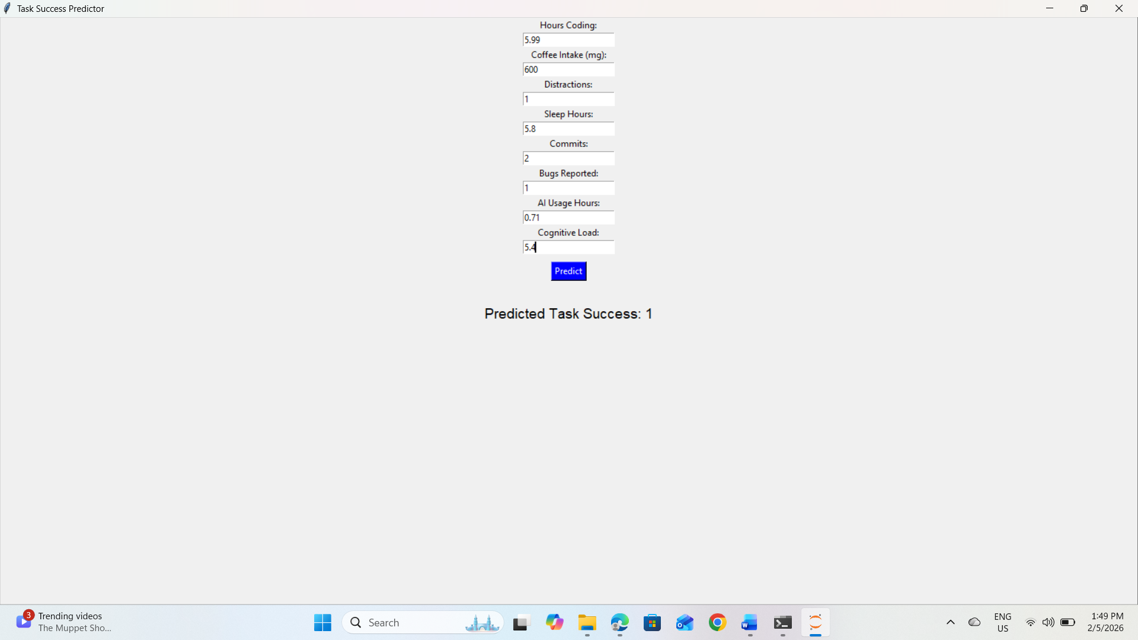
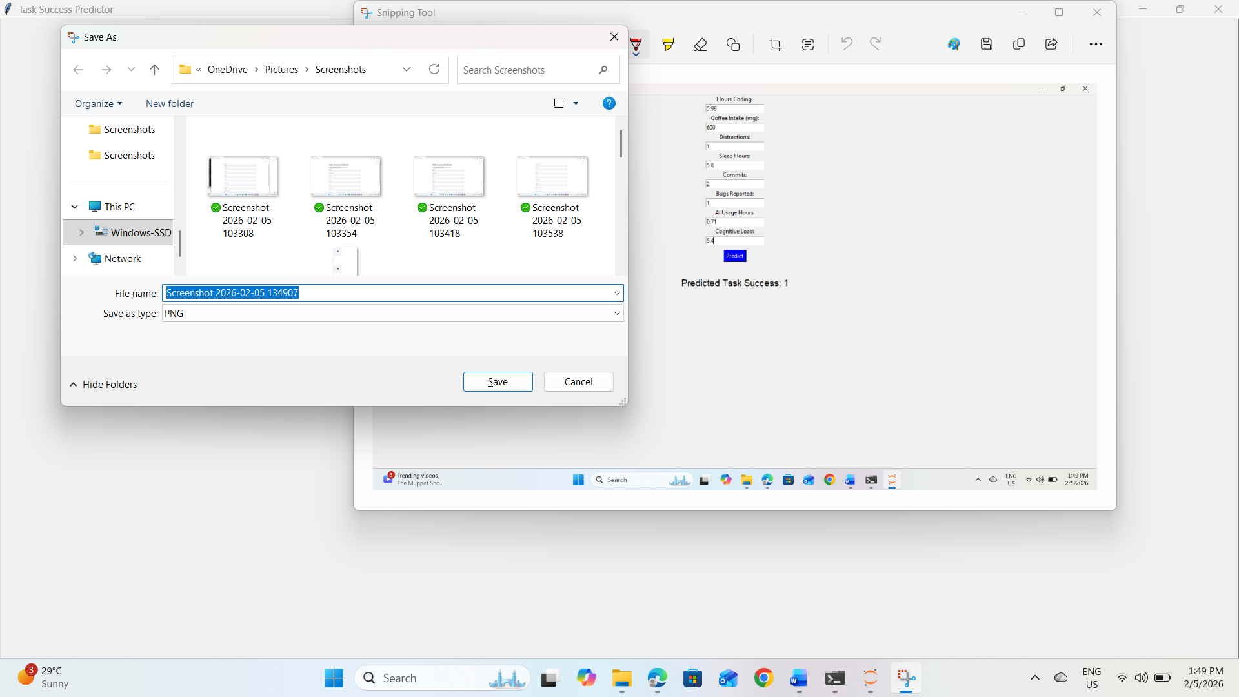
In the above output we gave some values it shows task success rate is ‘1’

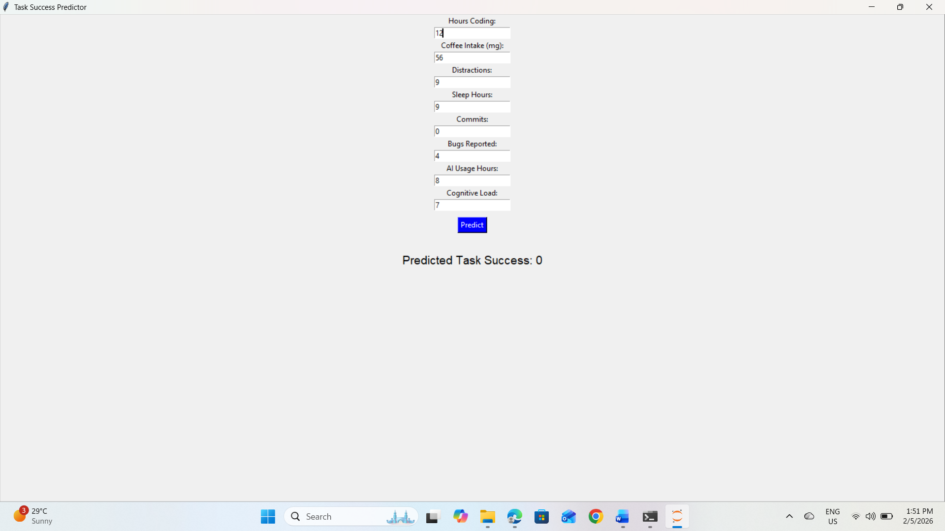

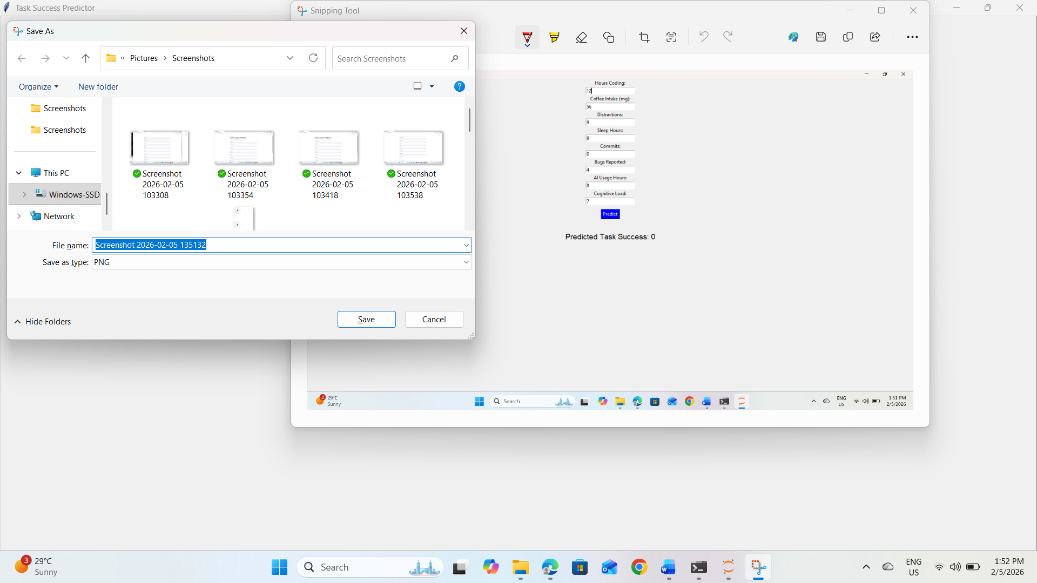
In the above output we gave another values it shows task success rate is’0’.

CONCLUSION
The Task Success Prediction System effectively demonstrates the application of machine learning in productivity and performance analytics. By analysing multiple behavioural and cognitive parameters, the system provides meaningful predictions of task success.
The Streamlit-based interface ensures accessibility and ease of use, while the regression model offers objective and data-driven insights. The project highlights the potential of artificial intelligence in understanding human work patterns and improving task outcomes. Overall, the system serves as a strong foundation for future research and real-world productivity optimization tools.
An AI-based analytical model for evaluating and predicting software developer productivity represents a significant advancement over traditional, metric-driven evaluation approaches. By leveraging machine learning, time-series analysis, and contextual intelligence, the model captures the complex, non-linear nature of software development work—where productivity is shaped not only by individual effort, but also by code quality, collaboration dynamics, task complexity, and organizational environment.
The model’s ability to combine real-time evaluation with forward-looking predictions enables organizations to move from reactive management to proactive decision-making. Early identification of delivery risks, process inefficiencies, and cognitive overload allows teams to intervene before productivity declines or quality deteriorates. Importantly, the inclusion of explainability mechanisms ensures that insights remain transparent, interpretable, and actionable rather than opaque or punitive.
When deployed with ethical safeguards, privacy protection, and human oversight, this approach reframes productivity measurement as a tool for continuous improvement rather than surveillance. It promotes healthier development practices, fairer performance assessments, and more resilient software teams. Ultimately, such an AI-driven productivity model supports sustainable engineering excellence by aligning technical output, human well-being, and organizational goals—creating long-term value for both developers and the enterprises they serve

FUTURE ENHANCEMENTS
Future enhancements may include integrating real-time data collection from IDEs, wearable devices, or task management tools. Recommendation engines can be added to suggest productivity improvements based on predictions. Visualization dashboards can help track task success trends over time.
Advanced models such as ensemble regression or deep learning architectures can be explored for higher accuracy. Multi-user support and cloud deployment can further enhance scalability. These enhancements can transform the system into a comprehensive productivity intelligence platform.
Future enhancements of the AI-based analytical model for evaluating and predicting software developer productivity can further improve its accuracy, adaptability, and practical impact. One major enhancement involves integrating real-time analytics, allowing the model to provide continuous productivity insights and instant feedback during development cycles rather than post-sprint analysis.
The model can be extended by incorporating advanced deep learning techniques, such as transformer-based temporal models, to better capture long-term dependencies and evolving work patterns across projects. This would improve prediction accuracy, especially in large-scale or distributed development environments.
Another important enhancement is the inclusion of developer skill progression and learning curves. By modelling how developers grow over time—adapting to new technologies, tools, or domains—the system can distinguish between temporary productivity fluctuations and long-term improvement trends.
Future versions may also integrate cross-tool and cross-organization benchmarking, enabling teams to compare productivity trends against anonymized industry standards while maintaining privacy and fairness. Additionally, incorporating causal inference models could help identify not just correlations but the root causes behind productivity changes.
From a human-centered perspective, enhancing the explainability layer with natural language explanations and recommendations would make insights more accessible to non-technical stakeholders. Integration with developer experience platforms could also support personalized productivity coaching and well-being monitoring.
Finally, stronger emphasis on ethical AI governance, including bias mitigation, transparency audits, and opt-in controls, will ensure responsible deployment at scale. These enhancements will position the model as a robust, adaptive, and trusted system for long-term productivity optimization in software development organizations

REFERENCES

[1] T. H. Davenport and L. Prusak, Working Knowledge, Harvard Business School Press, 2000.
[2] Y. Zhang et al., “Predicting Human Performance Using ML,” IEEE Access, 2019.
[3] J. Sweller, “Cognitive Load During Problem Solving,” Cognitive Science, 1988.
[4] J. Lim and D. Dinges, “Sleep Deprivation and Performance,” Sleep, 2010.
[5] Streamlit Inc., “Streamlit Documentation,” 2019.
[6] I. Goodfellow et al., Deep Learning, MIT Press, 2016.
[7] S. Russell and P. Norvig, Artificial Intelligence: A Modern Approach, Pearson, 2016.
[8] C. Bishop, Pattern Recognition and Machine Learning, Springer, 2006.
[9] J. Han et al., Data Mining: Concepts and Techniques, Morgan Kaufmann, 2012.
[10] A. Vaswani et al., “Attention Is All You Need,” NeurIPS, 2017.
[11] WHO, “Mental Health and Productivity,” 2020.
[12] IBM, “AI for Workforce Analytics,” 2021.
[13] Google, “Machine Learning for Productivity,” 2022.
[14] Microsoft, “AI and Knowledge Work,” 2021.
[15] Accenture, “AI-Driven Productivity Analytics,” 2020.

