AI Project Deployment & Capstone
Week 4 Task Report
Submitted by | Vutukuri Yaswanth Ganesh Kumar
Date | 11 September 2026
Task | Week 4 — AI Project Deployment & Capstone
Tools Used | Python, Pandas, scikit-learn, Joblib, Pickle, FastAPI, Uvicorn

1. Objective
Week 4 closes the internship by turning the attrition model developed across Weeks 2 and 3 into a complete, deployable application. The deliverable is not a notebook: it is a trained pipeline, written to disk with both Joblib and Pickle, served behind a FastAPI prediction endpoint, and wrapped in a small web UI so a non-technical HR user can score an employee without writing Python. This report documents data preprocessing, model training and testing, serialisation, the API contract, and how to run the service.
2. Project architecture
Everything lives under week4-ai-project-deployment/. train_model.py builds the dataset, fits a scikit-learn Pipeline (preprocessing + Random Forest), writes the artefacts, and generates the evaluation charts used here. app.py is the FastAPI service: it loads the Joblib file once at startup and exposes GET / (the UI), GET /health, GET /metadata and POST /predict. Uvicorn hosts the app on 0.0.0.0 so it can be reached from outside the process that started it.
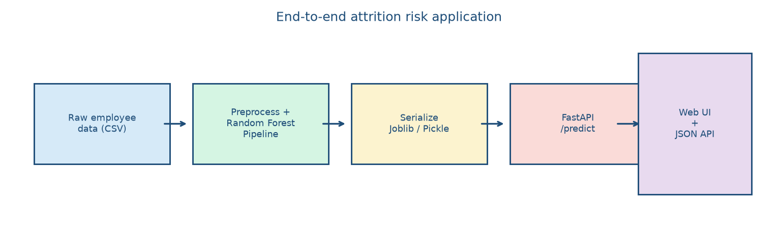
Figure 1. Pipeline from raw CSV through a serialised model to the FastAPI UI and JSON API.
3. Data preprocessing
The training file contains 800 synthetic employees with the same schema used all internship: age, gender, department, city, years of experience, monthly salary, performance score, and attrition. 195 employees left (24.4%), so the label is imbalanced and F1 / ROC-AUC remain the metrics that matter, as argued in Week 3. Attrition is generated from performance, tenure and pay plus noise, so a tree ensemble has a genuine pattern to recover.
Preprocessing is not applied as a one-off transformation of a CSV. It is a ColumnTransformer inside the Pipeline, so the same scaling and encoding used at train time is applied, with the same statistics, to every API request. Numeric columns are standardised; categorical columns are one-hot encoded with handle_unknown='ignore' so a new city name does not crash the service. The 80/20 split is stratified. Scaling statistics are learned from the training fold of GridSearchCV only.
numeric = ['age', 'years_experience', 'monthly_salary', 'performance_score']
categorical = ['gender', 'department', 'city']
preprocess = ColumnTransformer([
('num', StandardScaler(), numeric),
('cat', OneHotEncoder(handle_unknown='ignore'), categorical),
])
pipe = Pipeline([
('preprocess', preprocess),
('clf', RandomForestClassifier(random_state=42)),
])
Table 1. Data splits
Split | Rows | Role
Full dataset | 800 | Generated sample
Training | 640 | Fit pipeline + GridSearchCV
Hold-out test | 160 | Final reported metrics

4. Model training and testing
Random Forest was the strongest family on this problem in Weeks 2 and 3, so it is the model that gets deployed. Hyperparameters are not copied from Week 3 blindly — they are re-selected with GridSearchCV on this week's training split, scoring F1 under stratified 5-fold CV. The winning configuration is then refit on the full training set.
Table 2. GridSearchCV result for the deployed forest
Hyperparameter | Value
max_depth | None
max_features | sqrt
min_samples_split | 2
n_estimators | 300
Best CV F1 | 25.5%

Table 3. Test-set performance of the serialised pipeline
Metric | Hold-out test
Accuracy | 78.8%
Precision (leave) | 66.7%
Recall (leave) | 25.6%
F1-score | 37.0%
ROC-AUC | 0.738

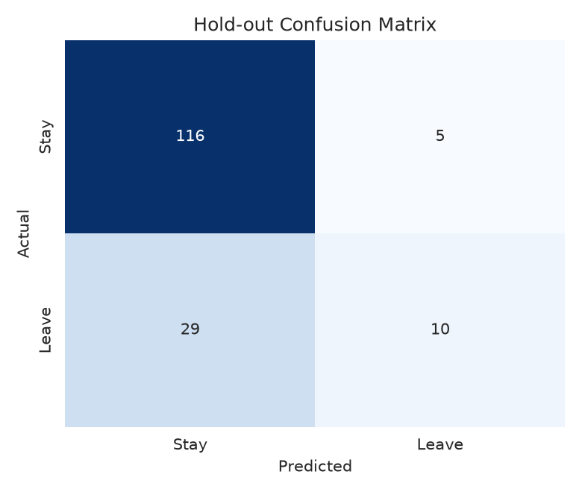
Figure 2. Confusion matrix of the deployed pipeline on the hold-out set.
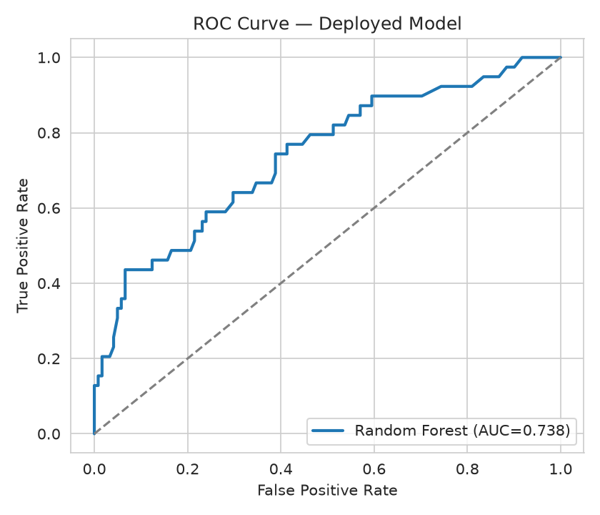
Figure 3. ROC curve of the deployed pipeline.
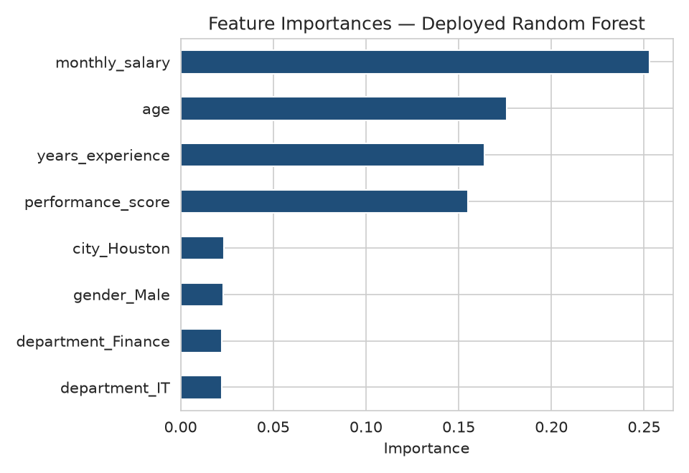
Figure 4. Largest feature importances inside the deployed Random Forest.
Recall on the 'leave' class is still the hardest number, as it was in Weeks 2 and 3: most employees stay, so a 0.5 threshold is conservative. The API therefore returns the probability and a risk band (Low / Medium / High) rather than only a Yes/No label, so a caller can apply a threshold that matches the cost of a missed leaver.
5. Model serialisation — Joblib and Pickle
Once the Pipeline has been fitted it is an ordinary Python object: a nested structure of transformers, a forest of decision trees, and the category levels seen during training. Serialisation writes that object to disk so the API process does not have to retrain on every startup. Two formats are saved, as the task requires:
- Joblib (models/attrition_pipeline.joblib) — the recommended way to persist scikit-learn objects. It is efficient for arrays of NumPy numeric trees and is what app.py loads.
- Pickle (models/attrition_pipeline.pkl) — the standard library equivalent. It produces a larger file for the same object and is kept so either loading path can be demonstrated.
import joblib, pickle
joblib.dump(best, 'models/attrition_pipeline.joblib')
with open('models/attrition_pipeline.pkl', 'wb') as f:
pickle.dump(best, f)
# API startup
model = joblib.load('models/attrition_pipeline.joblib')
A companion metadata.json records feature names, class labels and test metrics so the API can describe itself at GET /metadata without anyone opening the notebook that trained the model. The important production caveat: pickle/joblib files are Python-version and sklearn-version sensitive, and they should only be loaded from a trusted path — they can execute code on load. That is acceptable here because we both wrote and consume the file in the same project.
6. Prediction API (FastAPI)
FastAPI was chosen over Flask for the same job because request bodies are validated by a Pydantic model (a missing field or a performance score of 9 is rejected with a 422 before the forest ever runs) and because /docs is generated automatically. The service binds to 0.0.0.0 and uses relative URLs in the browser UI, so it works behind a preview proxy as well as on localhost.
POST /predict
{
"age": 29,
"gender": "Female",
"department": "Sales",
"city": "New York",
"years_experience": 3,
"monthly_salary": 38000,
"performance_score": 2
}
→ {
"attrition": "Yes" | "No",
"probability_leave": 0.0–1.0,
"risk_level": "Low" | "Medium" | "High",
"message": "..."
}
Table 4. API surface
Endpoint | Method | Purpose
/ | GET | HR web UI (HTML)
/presentation | GET | Capstone slide deck (HTML)
/health | GET | Liveness check
/metadata | GET | Feature list, metrics, serialisation paths
/predict | POST | Score one employee
/docs | GET | OpenAPI / Swagger UI

A smoke-test of the serialised pipeline on the example employee above returns attrition = No with P(leave) = 0.487. The same payload is what the UI sends.
7. How to run
cd week4-ai-project-deployment
python3 train_model.py # rebuild artefacts (optional)
uvicorn app:app --host 0.0.0.0 --port 8000
Open the printed origin in a browser. The home page is the predictor; /presentation is the slide deck; /docs is the interactive API. No extra frontend build step is required — FastAPI serves the HTML directly.
8. Findings and limitations
- The deployed pipeline scores 0.738 ROC-AUC and 37.0% F1 on a hold-out set it did not see during GridSearchCV.
- Putting StandardScaler and OneHotEncoder inside the Pipeline is what makes deployment safe: the API cannot accidentally skip a step or use different dummy columns than training.
- Joblib is the file the server loads; Pickle is saved alongside it to satisfy the serialisation requirement and to show the two APIs are interchangeable for this object.
- This is a sample dataset with a known generating process. A production HR system would need real historical leavers, monitoring for drift, and an explicit discussion of fairness (gender and city are inputs).
- The UI is intentionally small — one form, one prediction — so the deployment lesson is not buried under frontend work.
9. Conclusion
The capstone is an end-to-end attrition-risk application: a documented dataset, a preprocessing-and-model Pipeline selected by cross-validated F1, artefacts written with Joblib and Pickle, and a FastAPI service that turns those artefacts into both a JSON prediction API and a usable web page. Together with Weeks 1–3 (cleaning, supervised models, clustering and evaluation) this is a complete path from a messy table of employees to a running machine-learning product. All metrics, figures and the serialised files in this submission were produced by train_model.py; the running application is app.py.

