Python for Machine Learning &
Data Preprocessing
Week 1 Task Report
Submitted by | Vutukuri Yaswanth Ganesh Kumar
Date | August 9, 2026
Task | Week 1 — Python for Machine Learning & Data Preprocessing
Tools Used | Python, Pandas, NumPy, Matplotlib, Seaborn, scikit-learn

1. Objective
The objective of this task is to build a working understanding of the Machine Learning workflow in Python — specifically the data preprocessing stage that almost every ML project depends on. This report walks through loading a sample dataset, exploring it, cleaning it, handling missing values, detecting and treating outliers, selecting relevant features, encoding categorical variables, and normalizing numeric features, using the Pandas and NumPy libraries, with each step documented alongside the code and output it produced.

2. Tools & Libraries Used
- Python 3 — the programming language used for the entire pipeline
- Pandas — loading, cleaning, and transforming the tabular data
- NumPy — numerical operations and generating the sample dataset
- Matplotlib & Seaborn — visualizations used for exploratory data analysis
- scikit-learn (preprocessing module) — label encoding, one-hot encoding, and Min-Max scaling

3. Dataset Description
No dataset was supplied with this task, so a sample dataset was generated to work with — a synthetic HR/employee record set built to resemble the kind of data a data scientist meets in practice. It was deliberately given the same problems real datasets have — missing values, duplicate rows, inconsistent text formatting, and outliers — so that every preprocessing technique this task calls for could be applied to a genuine (if simulated) problem rather than just described. The raw file contains 266 rows and 9 columns:
Column | Description
EmployeeID | Unique identifier for each employee
Age | Employee's age, in years
Gender | Male / Female
Department | Sales, IT, HR, Finance, or Marketing
City | City the employee is based in
YearsExperience | Total years of professional experience
MonthlySalary | Gross monthly salary
PerformanceScore | Latest performance rating, on a 1–5 scale
Attrition | Whether the employee has left the company (Yes/No) — the target variable for a future classification model

4. Step 1 — Loading the Dataset
The dataset is loaded with pandas.read_csv() into a DataFrame:
import pandas as pd
df = pd.read_csv("employee_data.csv")
print(df.shape)
df.head()
A first look already reveals the issues this report deals with in later sections — the rows below were specifically chosen to show missing values (marked “Missing”) and inconsistent capitalization in City (e.g. “houston” vs “Houston”):
EmployeeID | Age | Department | City | MonthlySalary | Attrition
1001 | Missing | Finance | Los Angeles | 44,092.94 | No
1007 | Missing | Marketing | New York | 60,702.97 | No
1020 | 22 | Sales | houston | 70,797.29 | No
1043 | Missing | IT | phoenix | 56,234.26 | No
1002 | 49 | IT | Chicago | 51,287.22 | No

5. Step 2 — Initial Exploratory Data Analysis
Before changing anything, df.info(), df.describe(), df.isnull().sum() and df.duplicated().sum() were used to understand the data's structure and quantify its problems:
df.info()
df.describe(include="all")
df.isnull().sum()
df.duplicated().sum()
This showed 6 duplicate rows and 60 missing values spread across four columns (Age, MonthlySalary, YearsExperience, Department) — summarized in Figure 1.
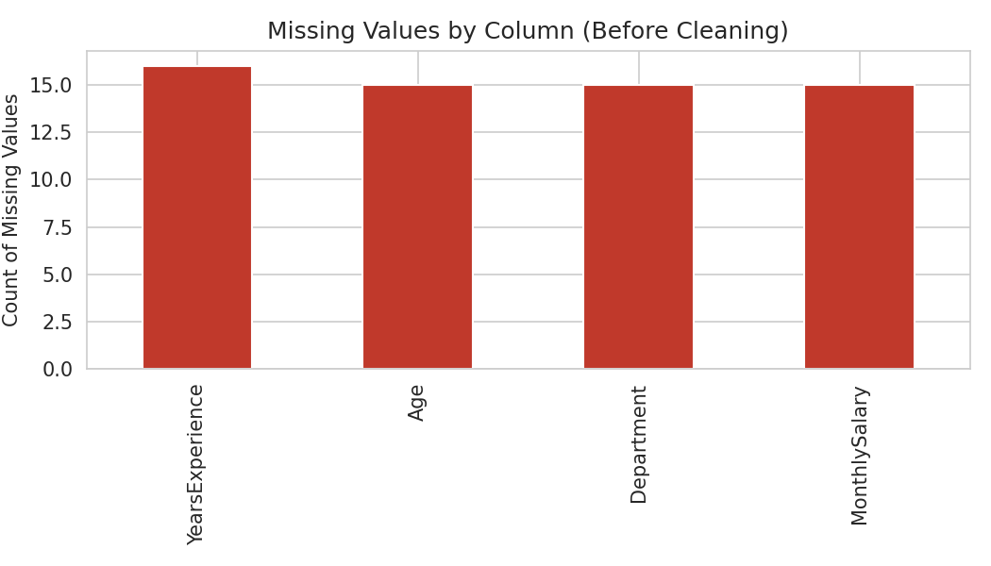
Figure 1. Missing values per column, before cleaning.
The numeric columns were also plotted to see their distributions before any cleaning. Age is fairly evenly spread across the working-age range (Figure 2), while Monthly Salary shows a few unusually high values sitting well above the rest of the distribution (Figure 3) — these are examined in Step 5.
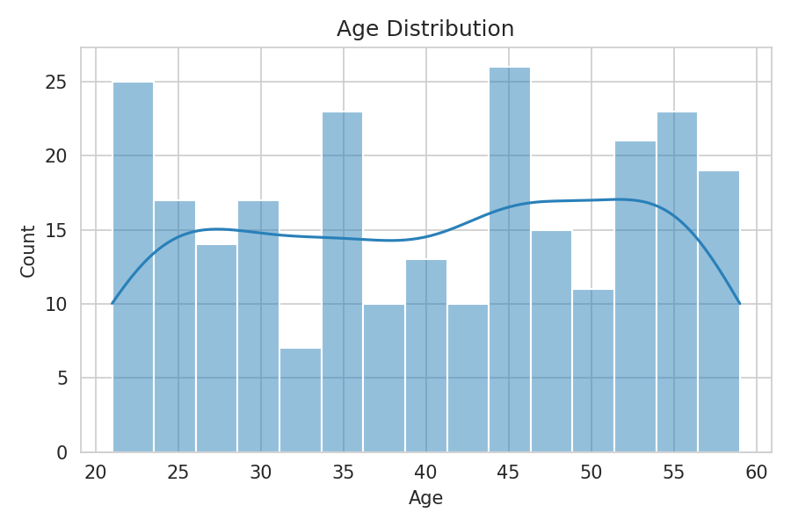
Figure 2. Distribution of Age.
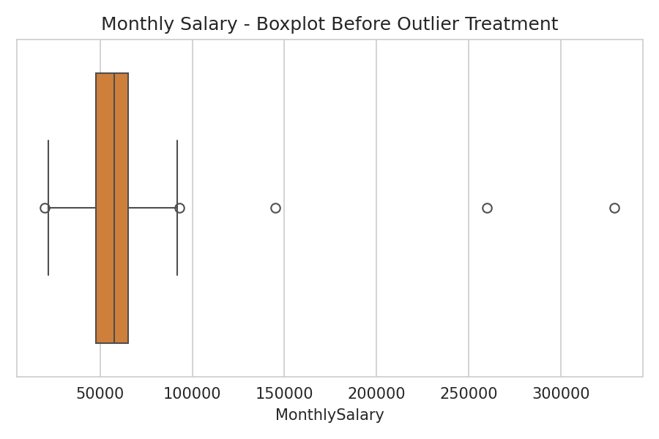
Figure 3. Monthly Salary before outlier treatment — points above the top whisker are candidate outliers.
Two categorical columns were checked for class balance: Department (Figure 4), and the target column Attrition (Figure 5). Attrition is imbalanced — 210 employees ("78.9%") are marked "No" against 56 ("21.1%") marked "Yes" — which would matter if this dataset were later used to train a classifier, since imbalanced classes usually need extra handling such as stratified sampling or class weighting.
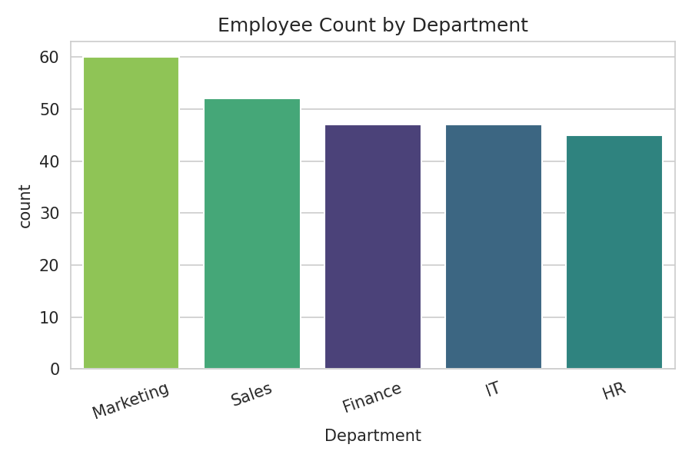
Figure 4. Employee count by department.
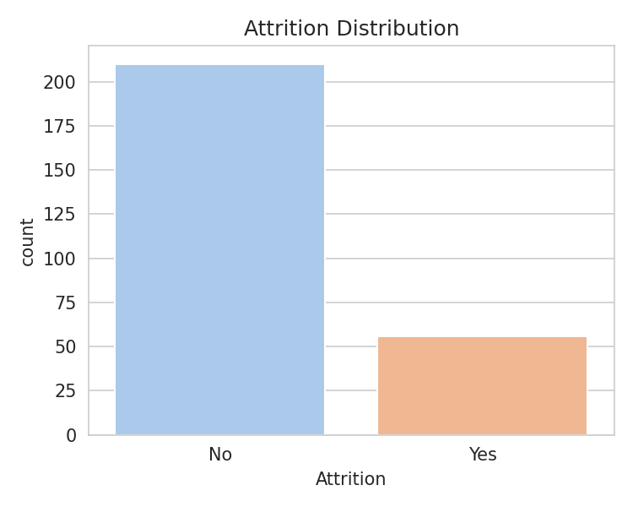
Figure 5. Attrition class distribution.

6. Step 3 — Data Cleaning
Two cleaning issues were fixed before touching missing values: exact duplicate rows, and inconsistent capitalization in City.
# Remove duplicate rows
df = df.drop_duplicates()
# Standardize text formatting
df["City"] = df["City"].str.strip().str.title()
Removing duplicates brought the row count from 266 down to 260 (6 duplicate rows were dropped). Before cleaning, City held 10 unique values because the same five cities appeared in more than one letter case (Chicago, Houston, Los Angeles, New York, Phoenix, chicago, houston, los angeles, new york, phoenix); after standardizing with .str.title(), it correctly collapsed to 5: Chicago, Houston, Los Angeles, New York, Phoenix.

7. Step 4 — Handling Missing Values
Each column was imputed using a strategy suited to its data type and distribution: the median was used for numeric columns because, unlike the mean, it isn't pulled around by skew or outliers, and the mode (most frequent value) was used for the one affected categorical column.
df["Age"] = df["Age"].fillna(df["Age"].median())
df["YearsExperience"] = df["YearsExperience"].fillna(df["YearsExperience"].median())
df["MonthlySalary"] = df["MonthlySalary"].fillna(df["MonthlySalary"].median())
df["Department"] = df["Department"].fillna(df["Department"].mode()[0])
The imputed values were: Age median = 41, Years of Experience median = 20, Monthly Salary median = 57,911.35, and Department mode = "Marketing". The table below confirms every missing value was resolved.
Column | Missing Before | Missing After
Age | 15 | 0
MonthlySalary | 15 | 0
YearsExperience | 15 | 0
Department | 15 | 0

8. Step 5 — Outlier Detection & Treatment
Outliers in Monthly Salary were identified with the IQR (Interquartile Range) method — a simple, distribution-free rule: any value further than 1.5×IQR below the first quartile or above the third quartile is flagged.
Q1 = df["MonthlySalary"].quantile(0.25)
Q3 = df["MonthlySalary"].quantile(0.75)
IQR = Q3 - Q1
lower = Q1 - 1.5 * IQR
upper = Q3 + 1.5 * IQR
df["MonthlySalary"] = df["MonthlySalary"].clip(lower=lower, upper=upper)
With Q1 = 48,004.10, Q3 = 64,939.19 and IQR = 16,935.10, values were expected to fall between 22,601.45 and 90,341.84. 7 values fell outside that range. Rather than deleting those rows — and losing every other useful field in them — they were capped (Winsorized) to the nearest boundary, which limits the outliers' influence while keeping every employee record. Figure 6 shows the effect.
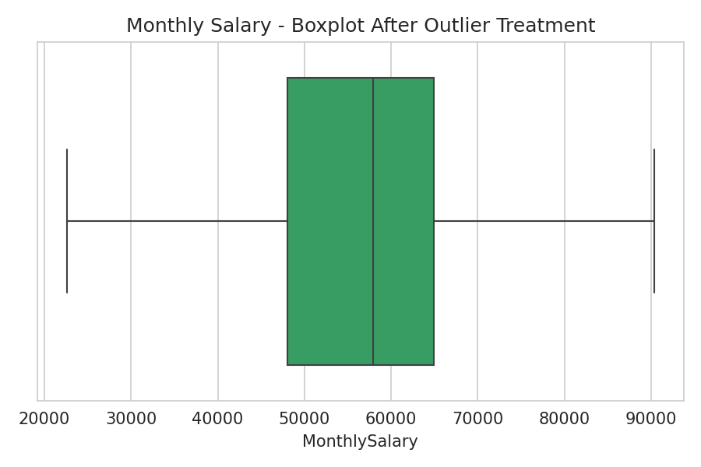
Figure 6. Monthly Salary after capping outliers to the IQR bounds.

9. Step 6 — Correlation Analysis
Before selecting features, it helps to check whether any numeric features are strongly related to each other, which would suggest redundancy. The heatmap below shows the Pearson correlation coefficient between every pair of numeric features.
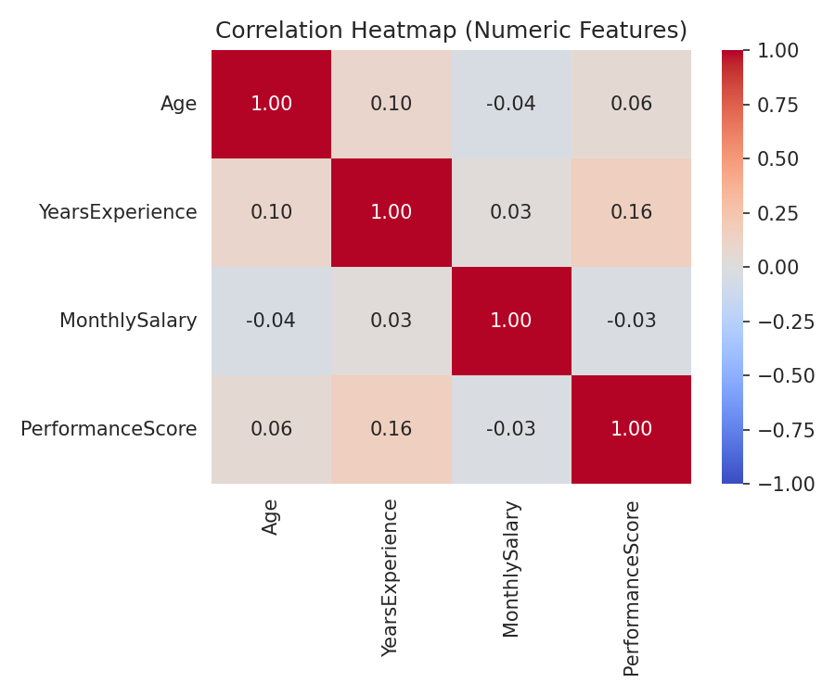
Figure 7. Correlation heatmap of numeric features.
 | Age | YearsExperience | MonthlySalary | PerformanceScore
Age | 1 | 0.1 | -0.04 | 0.06
YearsExperience | 0.1 | 1 | 0.03 | 0.16
MonthlySalary | -0.04 | 0.03 | 1 | -0.03
PerformanceScore | 0.06 | 0.16 | -0.03 | 1
None of the pairwise correlations are strong (every value sits close to 0), so each numeric feature is contributing largely independent information — none of them are redundant enough to drop on correlation grounds alone.

10. Step 7 — Feature Selection
EmployeeID is a unique identifier — a different value on every row — so it has no statistical relationship with any outcome and cannot help a model generalize. It was dropped before modeling.
df = df.drop(columns=["EmployeeID"])
This leaves 8 features: Age, Gender, Department, City, YearsExperience, MonthlySalary, PerformanceScore, Attrition.

11. Step 8 — Encoding Categorical Variables
Machine learning algorithms need numeric input, so the remaining categorical columns were converted using two different techniques depending on what they represent:
- Label Encoding for the two binary columns (Gender, Attrition) — a single 0/1 code is enough since there are only two categories.
- One-Hot Encoding for the multi-class nominal columns (Department, City) — so the model doesn't mistakenly treat the categories as ordered (e.g. IT > Finance), which a single label-encoded column would otherwise imply.
from sklearn.preprocessing import LabelEncoder
le = LabelEncoder()
df["Gender"] = le.fit_transform(df["Gender"])
df["Attrition"] = le.fit_transform(df["Attrition"])
df = pd.get_dummies(df, columns=["Department", "City"], dtype=int)
Gender was encoded as Female → 0, Male → 1, and Attrition as No → 0, Yes → 1. One-hot encoding Department and City expanded the dataset from 8 to 16 columns: 5 new indicator columns for Department (Dept_Finance, Dept_HR, Dept_IT, Dept_Marketing, Dept_Sales) and 5 for City (City_Chicago, City_Houston, City_Los Angeles, City_New York, City_Phoenix).

12. Step 9 — Feature Scaling / Normalization
Age, Years of Experience, Monthly Salary, and Performance Score sit on very different numeric scales — salary in the tens of thousands, performance on a 1–5 scale. Distance- and gradient-based algorithms (k-NN, logistic regression, neural networks, etc.) can end up weighting large-magnitude features like salary far more heavily than small-scale ones purely because of their scale, so all four were rescaled to a common 0–1 range with Min-Max scaling.
from sklearn.preprocessing import MinMaxScaler
scaler = MinMaxScaler()
cols = ["Age", "YearsExperience", "MonthlySalary", "PerformanceScore"]
df[cols] = scaler.fit_transform(df[cols])
Feature | Min (Before) | Max (Before) | Min (After) | Max (After)
Age | 21.00 | 59.00 | 0.00 | 1.00
YearsExperience | 0.00 | 34.00 | 0.00 | 1.00
MonthlySalary | 22,601.45 | 90,341.84 | 0.00 | 1.00
PerformanceScore | 1.00 | 5.00 | 0.00 | 1.00
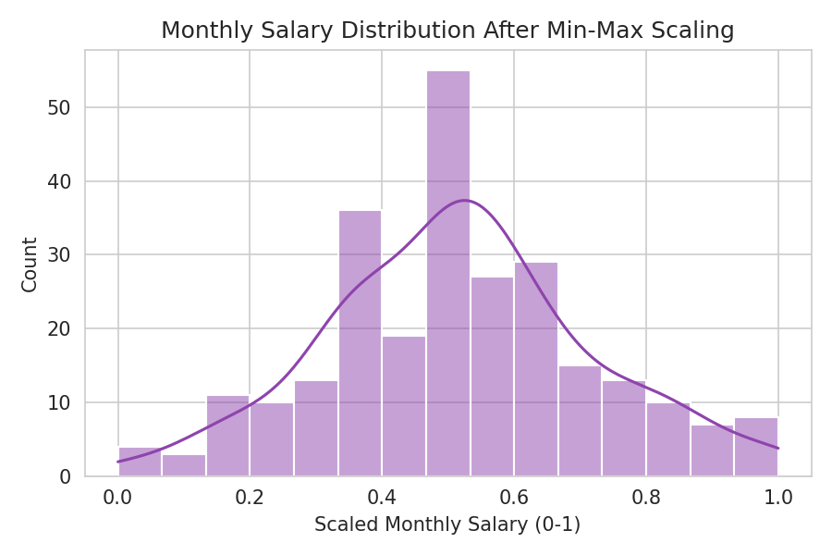
Figure 8. Monthly Salary distribution after Min-Max scaling — same shape, rescaled to 0–1.

13. Final Preprocessed Dataset
After cleaning, imputing, treating outliers, dropping the identifier column, encoding categorical variables, and scaling numeric features, the dataset is ready for modeling: 260 rows × 16 columns, fully numeric, with no missing values. A preview of a few processed columns:
Age | YearsExp | Salary | PerfScore | Gender | Attrition
0.526 | 0.382 | 0.317 | 0.75 | 0 | 0
0.737 | 0.147 | 0.423 | 0.75 | 0 | 0
0.368 | 0.588 | 0.462 | 0.75 | 0 | 1
0.184 | 0.059 | 0.616 | 0.75 | 1 | 1
0.526 | 0.176 | 0.518 | 0.75 | 1 | 0
This cleaned, encoded, and scaled table is the deliverable of the preprocessing pipeline — the same file a model-training task in a later week would load directly.

14. Conclusion
This exercise made concrete something that's easy to underestimate before actually doing it: most of the effort in a machine learning project happens before any model is trained. Working through this pipeline end-to-end — deciding how to impute missing values, choosing an outlier rule and a treatment for it, picking between Label and One-Hot encoding, and understanding why unscaled features can distort a model — was a practical, hands-on way to learn what “data preprocessing” actually involves, beyond its textbook definition. The resulting dataset is clean, fully numeric, consistently scaled, and ready to be used as input for a machine learning model in the coming weeks.

