Supervised Machine Learning Models
Week 2 Task Report
Submitted by | Vutukuri Yaswanth Ganesh Kumar
Date | August 21, 2026
Task | Week 2 — Supervised Machine Learning Models
Tools Used | Python, Pandas, NumPy, scikit-learn, Matplotlib, Seaborn

1. Objective
This task builds on the Week 1 preprocessing pipeline to cover the core supervised learning workflow in Python: splitting data correctly, training multiple model families, and evaluating and comparing them with appropriate metrics rather than accuracy alone. Two problems are tackled on the same underlying employee dataset — a classification problem (will an employee leave?) and a regression problem (what will they be paid?) — so that all five requested algorithm families get a meaningful, correctly-matched task: Logistic Regression, Decision Trees, Random Forest and K-Nearest Neighbors as classifiers, and Linear Regression (plus a Decision Tree Regressor for contrast) for the regression problem.

2. Tools & Libraries Used
- Python 3 — the programming language used throughout
- Pandas & NumPy — data generation, cleaning, and array operations
- scikit-learn — train/test splitting, all six models, and every evaluation metric
- Matplotlib & Seaborn — ROC curves, confusion matrices, and comparison charts

3. Dataset
This week uses a freshly generated sample dataset, built with the same schema and the same cleaning pipeline as Week 1 (duplicate removal, text standardization, median/mode imputation, IQR outlier capping, Label/One-Hot encoding — see the Week 1 report for the full walkthrough of that pipeline). The one deliberate change: Monthly Salary and Attrition are this time generated FROM the other features, with realistic noise mixed in, so the models trained below have genuine, learnable relationships to find, rather than the independently-random columns used to demonstrate cleaning technique in Week 1.
The raw file contained 610 rows; after removing 10 duplicate rows and encoding categorical variables, the model-ready dataset has 600 rows and 14 columns. One methodology refinement from Week 1: one-hot encoding here drops one reference category per feature (drop_first=True), avoiding the "dummy variable trap" that would otherwise make Linear/Logistic Regression coefficients hard to interpret — unnecessary in Week 1 since no linear model was being fit there.

4. Train/Test Split & Scaling
Both tasks use an 80/20 train-test split, holding out data the models never see during training so evaluation reflects genuine generalization rather than memorization. The classification split is stratified on Attrition so the same class balance appears in both the training and test sets, which matters here since Attrition is imbalanced.
from sklearn.model_selection import train_test_split
from sklearn.preprocessing import MinMaxScaler
X_train, X_test, y_train, y_test = train_test_split(
X, y, test_size=0.2, random_state=42, stratify=y)
scaler = MinMaxScaler()
X_train[scale_cols] = scaler.fit_transform(X_train[scale_cols])
X_test[scale_cols] = scaler.transform(X_test[scale_cols])
Note the order: the scaler is fit on the training data only, then used to transform both sets. Fitting it on the full dataset before splitting (as a simpler tutorial might) would let information about the test set leak into training through the scaling statistics — a subtle but real mistake worth avoiding.
Task | Train Rows | Test Rows
Classification (Attrition) | 480 | 120
Regression (Monthly Salary) | 480 | 120

5. Task A — Classification: Predicting Attrition
Attrition is imbalanced: 462 employees stayed and 138 left (23% of the dataset). This matters for evaluation — a model that always predicts "No" would already score 77% accuracy without learning anything, so accuracy alone is a misleading measure here and needs to be read alongside precision, recall, and ROC-AUC.

5.1 Models Trained
from sklearn.linear_model import LogisticRegression
from sklearn.tree import DecisionTreeClassifier
from sklearn.ensemble import RandomForestClassifier
from sklearn.neighbors import KNeighborsClassifier
models = {
"Logistic Regression": LogisticRegression(max_iter=1000, random_state=42),
"Decision Tree": DecisionTreeClassifier(max_depth=5, random_state=42),
"Random Forest": RandomForestClassifier(n_estimators=200, max_depth=6, random_state=42),
"K-Nearest Neighbors": KNeighborsClassifier(n_neighbors=7),
}
for name, model in models.items():
model.fit(X_train, y_train)
y_pred = model.predict(X_test)
y_proba = model.predict_proba(X_test)[:, 1]

5.2 Evaluation Metrics
Model | Accuracy | Precision | Recall | F1-score | ROC-AUC
Logistic Regression | 75.8% | 46.2% | 21.4% | 29.3% | 0.737
Decision Tree | 72.5% | 22.2% | 7.1% | 10.8% | 0.607
Random Forest | 80% | 70% | 25% | 36.8% | 0.764
K-Nearest Neighbors | 76.7% | 50% | 10.7% | 17.6% | 0.674
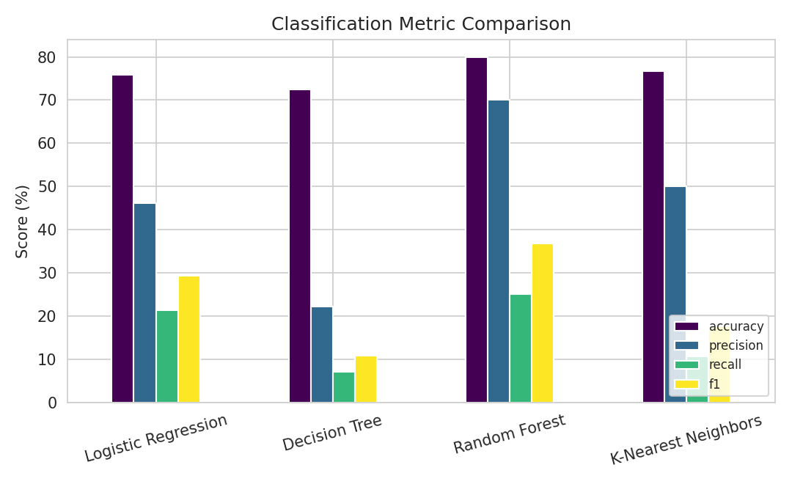
Figure 1. Accuracy, Precision, Recall and F1 across all four classifiers.

5.3 Confusion Matrices
Each matrix shows actual vs. predicted class on the held-out test set (rows = actual, columns = predicted):
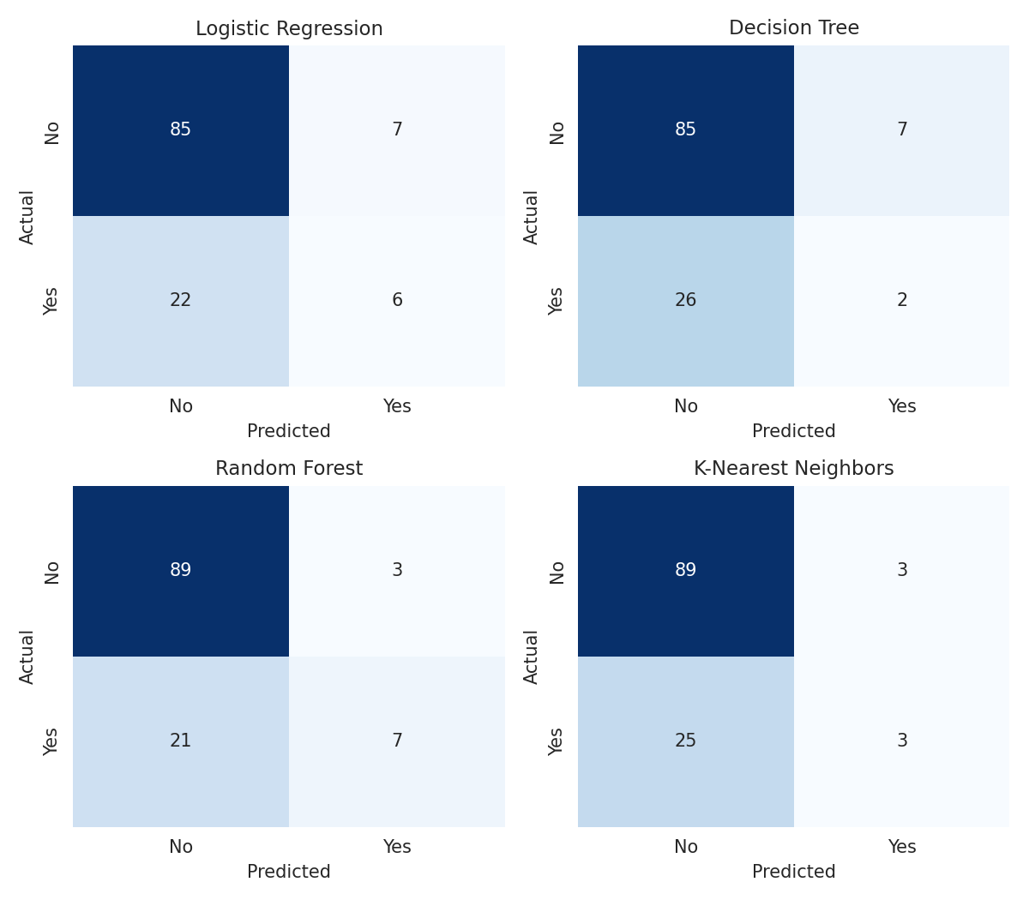
Figure 2. Confusion matrices for all four classifiers.

5.4 ROC Curves
Receiver Operating Characteristic curves plot true positive rate against false positive rate across every possible decision threshold, giving a threshold-independent view of how well each model ranks "Yes" cases above "No" cases; the dashed diagonal is what random guessing would look like.
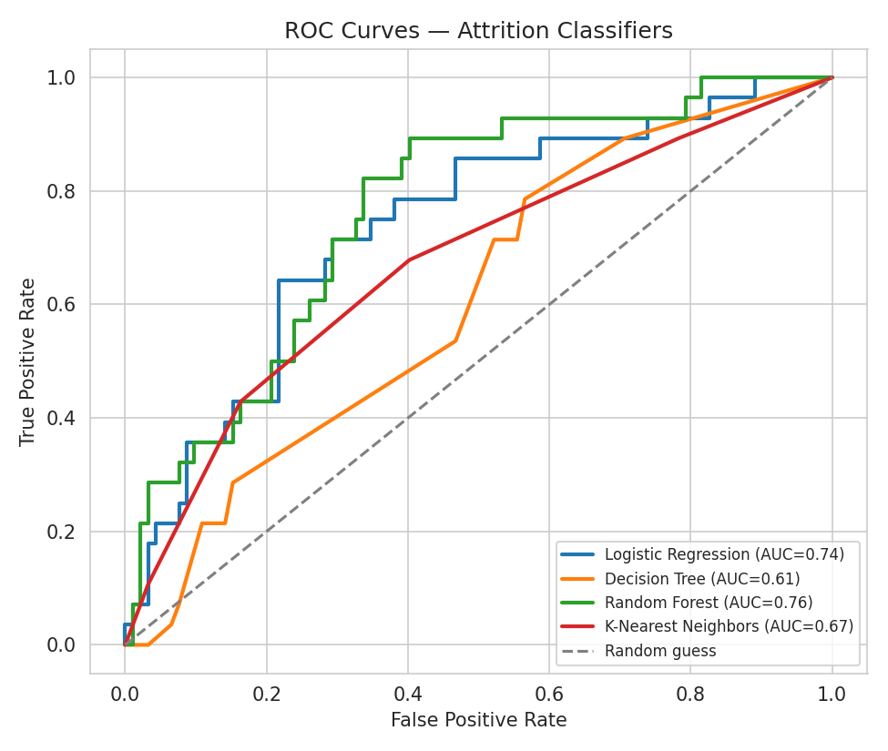
Figure 3. ROC curves for all four classifiers.

5.5 Feature Importance
Random Forest exposes which features it relied on most. MonthlySalary and PerformanceScore dominate, which lines up with how Attrition was generated (as a function of performance and tenure).
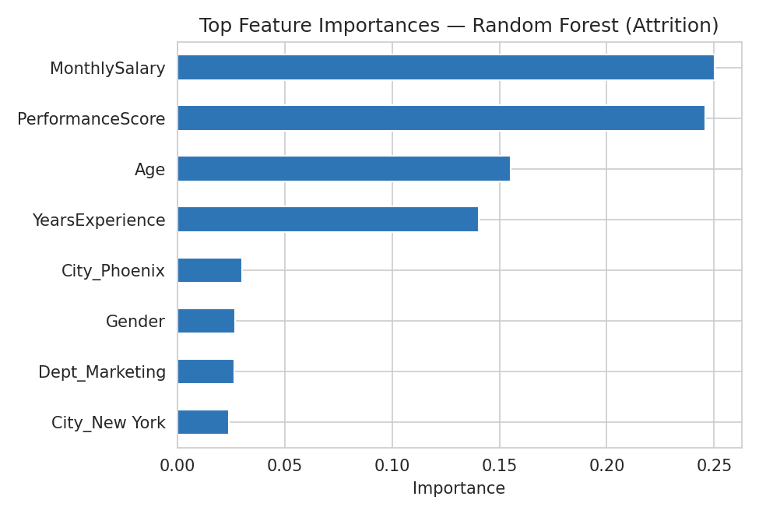
Figure 4. Top Random Forest feature importances for predicting Attrition.

5.6 Discussion
Random Forest came out on top on F1-score and ROC-AUC (0.764 AUC), which fits expectations — an ensemble of many trees is typically more robust than a single Decision Tree (AUC 0.607), which tends to overfit its specific training split even at a limited depth. Logistic Regression is a close second (AUC 0.737), reasonable given Attrition was generated from a logistic function of the features, which plays to its exact strength. Recall is low across every model (Logistic Regression 21.4%, Decision Tree 7.1%, Random Forest 25%, K-Nearest Neighbors 10.7%) — most actual leavers are still being missed at the default 0.5 probability threshold. In a real HR setting, deliberately lowering that threshold would catch more at-risk employees at the cost of more false alarms; which trade-off is "correct" depends on whether missing a leaver or over-flagging a stayer is more costly to the business.

6. Task B — Regression: Predicting Monthly Salary

6.1 Models Trained
from sklearn.linear_model import LinearRegression
from sklearn.tree import DecisionTreeRegressor
models = {
"Linear Regression": LinearRegression(),
"Decision Tree Regressor": DecisionTreeRegressor(max_depth=5, random_state=42),
}
for name, model in models.items():
model.fit(X_train, y_train)
y_pred = model.predict(X_test)

6.2 Evaluation Metrics
Model | MAE | MSE | RMSE | R²
Linear Regression | ₹3,915 | 2,38,09,048.89 | ₹4,879 | 0.705
Decision Tree Regressor | ₹4,765 | 3,64,32,250.81 | ₹6,036 | 0.549
MAE and RMSE are in the same units as salary (rupees), so they're directly interpretable as “typical prediction error”; R² is the share of variance in salary the model explains (1.0 = perfect, 0 = no better than predicting the average for everyone).
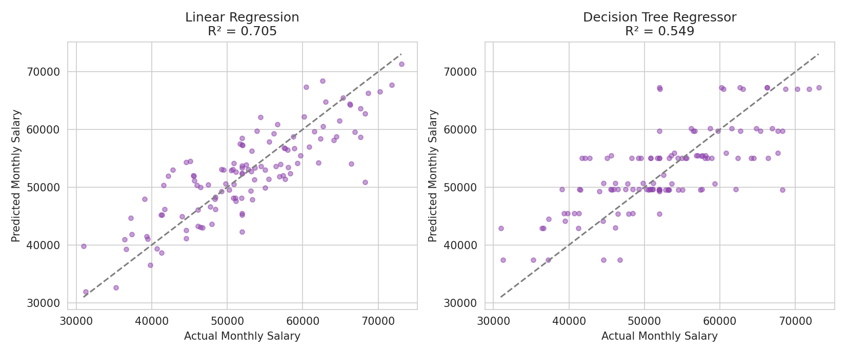
Figure 5. Predicted vs. actual Monthly Salary on the test set — the closer the points sit to the dashed diagonal, the better the prediction.

6.3 Linear Regression Coefficients
Because Linear Regression is directly interpretable, its fitted coefficients can be read off and sanity-checked against how the data was generated. The strongest coefficients:
Feature | Coefficient
YearsExperience | ₹22,782
PerformanceScore | ₹8,451
Age | ₹2,412
Dept_IT | ₹248
City_Houston | -₹149
City_Los Angeles | -₹353
City_New York | -₹938
Dept_Sales | -₹3,366
Dept_Marketing | -₹6,045
Dept_HR | -₹7,894
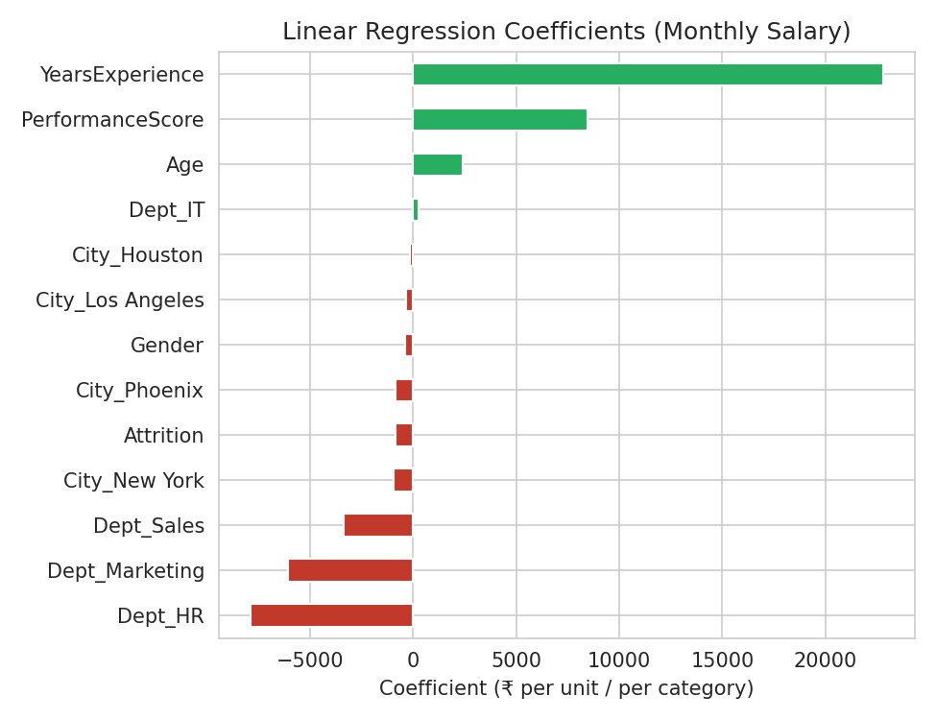
Figure 6. All Linear Regression coefficients for predicting Monthly Salary.
Years of Experience and Performance Score dominate with large positive coefficients, and Department shows the biggest swing between categories (HR lowest, IT/Finance highest) — both match the relationships actually used to generate salary in this dataset, which is a useful sanity check: when a model's coefficients make domain sense, that's independent evidence it has learned something real rather than fitting noise.

6.4 Discussion
Linear Regression (R² = 0.705) outperformed the Decision Tree Regressor (R² = 0.549) here. This is expected rather than a general rule about the two algorithms: salary was generated as a linear, additive combination of the features plus noise, which is exactly the shape Linear Regression is built to capture. A Decision Tree Regressor predicts by averaging within rectangular regions of feature space, which shows up in Figure 5 as visible "steps" rather than a smooth diagonal — it would have the advantage on a target with genuine non-linear thresholds or feature interactions, which this dataset doesn't have by construction.

7. Model Comparison Summary
Task | Best Model | Key Metric | Why
Classification | Random Forest | ROC-AUC = 0.764 | Ensemble of trees generalizes better than any single model here
Regression | Linear Regression | R² = 0.705 | Target is a genuinely linear function of the features
- Accuracy alone is a poor metric for imbalanced classification — precision, recall, F1 and ROC-AUC together tell a much more honest story.
- Scaling must be fit on the training split only; fitting it before the split leaks test information into training.
- Ensemble methods (Random Forest) traded a little interpretability for noticeably better, more stable predictions than a single Decision Tree.
- The “best” algorithm is task-dependent: Linear Regression won here because the underlying relationship was linear by construction, not because it's inherently stronger than tree-based models.

8. Conclusion
Where Week 1 was about getting data into a trainable shape, this task was about what happens after: splitting it correctly, fitting several different kinds of models to the same problem, and reading their evaluation metrics critically rather than taking a single accuracy number at face value. Comparing Logistic Regression, Decision Trees, Random Forest and KNN side by side on the same classification problem — and Linear Regression against a Decision Tree Regressor on the same regression problem — made the trade-offs between them concrete: interpretability vs. raw performance, bias vs. variance, and how well an algorithm's assumptions match the actual shape of the target variable. All six trained models, their metrics, and the plots in this report were produced by the accompanying Python script, included with this submission.

