
SCHOOL OF COMPUTING
Department of Artificial Intelligence and Machine Learning
SOFTWARE MANAGEMENT DATABASE SYSTEM
A Capstone Project Report
BATCH NUMBER : 1
Submitted in partial fulfillment of the requirements for the award of the degree of
BACHELOR OF TECHNOLOGY
in
ARTIFICIAL INTELLIGENCE AND MACHINE LEARNING
Submitted by
S.ARAVINDA REDDY - AIML | (25B11AIB48)
M.GANGADHAR - AIML | (25B11AI658)
T.ESWAR VARDHAN - AIML | (25B11AIB99)
K.V.SAI GANESH - AIML | (25B11AI537)
V.SATYA SAI | (26B21AI151)

Under the guidance of
Dr. P. Kishorekumar, PhD.
Associate Professor, Department of AIML
ADITYA UNIVERSITY, SURAMPALEM
Academic Year: 2026 - 2027

SCHOOL OF COMPUTING
Department of Artificial Intelligence and Machine Learning
CERTIFICATE
This is to certify that the Cornerstone project work entitled "SOFTWARE MANAGEMENT DATABASE SYSTEM" is submitted by
S.ARAVINDA REDDY - AIML | (25B11AIB48)
M.GANGADHAR - AIML | (25B11AI658)
T.ESWAR VARDHAN - AIML | (25B11AIB99)
K.V.SAI GANESH - AIML | (25B11AI537)
V.SATYA SAI | (26B21AI151)

In partial fulfillment of the requirements for the award of the B.Tech. degree in Artificial Intelligence and Machine Learning for the academic year 2026-2027.

Project Guide  Dr. P. Kishorekumar, PhD.  Associate Professor, Department of AIML | Head of the Department:  Dr. Kovvuri N Bhargavi  Associate Professor & HOD

DECLARATION
We hereby declare that the Cornerstone project entitled "SOFTWARE MANAGEMENT DATABASE SYSTEM" is original and is submitted to ADITYA UNIVERSITY, Surampalem, in partial fulfillment of the requirements for the award of the B.Tech. Degree in Artificial Intelligence and Machine Learning. We further declare that this project work has not been submitted, either in full or in part, for the award of any degree in this or any other institution. We also confirm that this work complies with the Institutional Academic Integrity and AI Usage Policy.
Place: Surampalem
Date:
By

S.ARAVINDA REDDY - AIML | (25B11AIB48)
M.GANGADHAR - AIML | (25B11AI658)
T.ESWAR VARDHAN - AIML | (25B11AIB99)
K.V.SAI GANESH - AIML | (25B11AI537)
V.SATYA SAI | (26B21AI151)

ACKNOWLEDGEMENT
It is with immense pleasure that we express our sincere gratitude to our Cornerstone Project Guide, Dr. P. Kishorekumar, PhD. Associate Professor, Department of AIML, who has guided us throughout the project. His valuable support, encouragement, and guidance have greatly contributed to the successful completion of this work.
We would like to thank our Deputy Heads of the Department, Dr. B. Manikyala Rao, Associate Professor, Dr. R. Suneetha, Assistant Professor and Dr. D. Veeraswamy, Assistant Professor for their support and valuable suggestions.
Our deepest thanks to our Head of the Department Dr. K. Naga Bhargavi, Associate Professor & HOD, for her inspiration and for providing all the necessary facilities and resources required for this project.
We also extend our sincere thanks to Dr. M.V. Rajesh, Associate Dean, School of Computing for their encouragement and support during the course of our project.
We would like to express our sincere gratitude to Dr. G. Suresh, Registrar, Dr. A. Ramesh, Pro Vice-Chancellor (Engineering & Sciences), Dr. S. Rama Sree, Pro Vice-Chancellor (Academics), Dr. M.B. Srinivas, Vice-Chancellor, Dr. M. Sreenivasa Reddy, Deputy Pro Chancellor and Management, Aditya University for providing excellent infrastructure and state-of-the-art laboratories.
Finally, we would like to thank the faculty members, lab technicians, non-teaching staff, and our friends who have directly or indirectly supported us in completing this Cornerstone project successfully.

By
S.ARAVINDA REDDY - AIML | (25B11AIB48)
M.GANGADHAR - AIML | (25B11AI658)
T.ESWAR VARDHAN - AIML | (25B11AIB99)
K.V.SAI GANESH - AIML | (25B11AI537)
V.SATYA SAI | (26B21AI151)

TABLE OF CONTENTS
1. Cover Page 1
2. Certificate 2
3. Declaration 3
4. Acknowledgement 4
5. Abstract 6
6. List of Figures / List of Tables / Acronyms 7
7. Introduction 9
8. System Analysis 11
9. Database Design 13
10. ER Diagram 15
11. Relational Schema 16
12. Table Design 17
13. Normalization 21
14. SQL Implementation 23
15. SQL Queries & Screenshots 28
16. Conclusion & Future Enhancements 33
17. References 35

ABSTRACT
The Software Database Management System is designed to efficiently store, organise, and manage large volumes of software-related information in a structured and centralized database. Software companies and development teams handle different types of information, including software products, developers, projects, clients, technologies, versions, licenses, tasks, and software releases. Managing such information manually or through separate files can lead to data duplication, inconsistency, difficulty in data retrieval, and maintenance problems.
The proposed system uses a relational database approach to model the major entities involved in software development and management. The database stores and manages information related to software products, developers, projects, clients, technologies, versions, tasks, licenses, and releases. These entities are connected through well-defined relationships using Primary Keys and Foreign Keys, which help maintain data integrity and consistency.
The database is designed and normalized up to the Third Normal Form (3NF) to reduce data redundancy and prevent insertion, deletion, and update anomalies. The system is implemented using SQL and includes Data Definition Language (DDL) for creating database structures, Data Manipulation Language (DML) for inserting and modifying records, and Data Query Language (DQL) for retrieving useful information. SQL queries involving joins, aggregate functions, subqueries, filtering, sorting, and database views are used to generate meaningful information from the stored data.
The resulting Software Database Management System provides a structured and reliable foundation for managing software projects, developers, clients, technologies, versions, tasks, licenses, and releases. The system improves data organization, simplifies information retrieval, supports efficient software management, and demonstrates the practical application of relational database concepts in a software development environment.

LIST OF FIGURES
Figure 1. ER Diagram of the Hospital Management Database System

LIST OF TABLES

Table 1. Major Database Entities

Table 2. Entity Relationships and Cardinality

Table 3. Relational Schema Summary

Table 4. Software Product Table Structure

Table 5. Developer Table Structure

Table 6. Project Table Structure

Table 7. Client Table Structure

Table 8. Technology Table Structure

Table 9. Software Version Table Structure

Table 10. Task Table Structure

Table 11. License Table Structure

Table 12. Software Release Table Structure

Table 13. Project Assignment Table Structure

Table 14. Keys and Constraints Summary

ACRONYMS
- DBMS – Database Management System
- ER – Entity Relationship
- SQL – Structured Query Language
- DDL – Data Definition Language
- DML – Data Manipulation Language
- DQL – Data Query Language
- DCL – Data Control Language
- TCL – Transaction Control Language
- PK – Primary Key
- FK – Foreign Key
- 1NF – First Normal Form
- 2NF – Second Normal Form
- 3NF – Third Normal Form

1. INTRODUCTION

1.1 Brief Information about the Project
Software companies and development teams handle large amounts of information related to software products, developers, projects, clients, technologies, versions, tasks, licenses, and releases. A database provides a structured and efficient way to organise and manage these interconnected software development records. The proposed Software Database Management System models the major software-related entities and their relationships using a relational database approach. The project focuses on designing the database structure — including entities, attributes, Primary Keys, Foreign Keys, relationships, and the ER diagram — and implementing it through SQL.

1.2 Motivation and Contribution of the Project
The project is motivated by the practical difficulties software companies and development teams face when software-related information is managed separately or manually. Maintaining records without a centralized database can lead to data duplication, inconsistency, difficulty in retrieving information, and errors in managing projects, developers, software versions, and releases. A centralized relational database provides a systematic approach to storing related software information and maintaining relationships through keys and constraints.
● Centralizing software records — software products, developers, projects, clients, technologies, and releases in one relational database.
● Reducing duplicate and inconsistent information across different software projects and development teams.
● Maintaining referential integrity using Primary Keys and Foreign Keys.
● Supporting faster retrieval of software, project, developer, and client information through SQL queries.
● Providing a foundation for project management, task tracking, software version management, license management, and release tracking.

1.3 Objectives of the Project
- Identify the major entities involved in software management.
- Identify suitable attributes for each entity.
- Establish relationships between the identified entities.
- Design an Entity–Relationship (ER) diagram.
- Convert the ER model into a relational database schema.
- Identify suitable Primary Keys and Foreign Keys.
- Reduce data duplication and maintain data consistency.
- Provide an organized database structure for efficient software record management.

1.4 Scope of the Project
The scope of the project covers the database-oriented management of core software development information. The system connects software product details and descriptions (Software Product), developer profiles and contact information (Developer), project details and project status (Project), client information and contact details (Client), technology names and categories used in development (Technology), software version numbers and release dates (Software Version), project tasks and their status (Task), software license details and validity (License), software release information and deployment details (Software Release), and project–developer assignments (Project Assignment). The database can serve as the backend for a software development and project management application and can be extended with modules such as issue tracking, employee management, repository management, testing management, deployment tracking, and software maintenance.

2. SYSTEM ANALYSIS

2.1 Existing System
● Manual maintenance of software project, developer, and client records.
● Multiple Excel sheets or disconnected files for software products, projects, developers, and versions.
● Duplicate records and inconsistent information across different projects and development teams.
● Time-consuming searches for project details, developer assignments, software versions, or client information.
● Difficulty in generating consolidated reports for software projects and management.
● Higher possibility of data-entry errors and loss of important software-related records.

2.2 Proposed System
The proposed system uses a centralized relational database that connects software development records through well-defined entities, relationships, Primary Keys, and Foreign Keys. It organizes software-related information into interconnected tables and uses Primary Keys, Foreign Keys, UNIQUE constraints, NOT NULL conditions, and CHECK constraints to maintain valid and consistent data.
● Centralized software database with ten major entities.
● Software product registration and information management.
● Developer and client information management.
● Project creation and project-status management.
● Technology and software version management.
● Task assignment and progress tracking.
● Software license information and validity management.
● Software release and deployment tracking.
● SQL-based data retrieval and reporting

2.3 Functional Requirements
Module | Functional Requirement
Software Product Management | Register, update, search, and display software product details.
Developer Management | Store developer profiles, skills, contact information, and project assignments.
Project Management | Create and maintain project details, objectives, deadlines, and project status.
Client Management | Store and maintain client information, contact details, and associated projects.
Technology Management | Maintain programming languages, frameworks, tools, and technologies used in software projects.
Software Version Management | Store software version numbers, release dates, changes, and version status.
Task Management | Create, assign, update, and track development tasks and their completion status.
License Management | Maintain software license details, license types, issue dates, expiry dates, and status.
Software Release Management | Record software releases, release dates, deployment information, and release status.

2.4 Non-Functional Requirements
- Performance – Queries on software products, projects, developers, tasks, and releases should return results efficiently.
- Integrity – Invalid references, such as assigning a developer to a non-existent project, and duplicate key values must be prevented.
- Security – Access to software project, client, developer, and license information should be controlled for authorized users.
- Usability – The database structure should be understandable and easy for software development and administrative teams to use.
- Reliability – Transactions such as project assignments, software version updates, and releases should preserve a consistent database state.

2.5 Requirements Specification
Category | Requirement
Requirement | Specification
Hardware | Intel i3 processor or above; minimum 4 GB RAM; adequate storage; standard display, keyboard, and mouse.
Operating System | Windows 10/11 or an equivalent supported platform.
3. DATABASE DESIGN

3.1 Major Entities
Ten major entities have been identified for the proposed Software Management Database System, as summarised in Table 1.
Table 1: Major Database Entities
Entity | Description
Entity | Description
SOFTWARE PRODUCT | Stores software product name, description, category, and development status.
DEVELOPER | Stores developer profile, contact information, skills, and experience details.
PROJECT | Stores software project name, description, start date, deadline, and project status.
CLIENT | Stores client name, contact information, company details, and associated projects.
TECHNOLOGY | Stores programming languages, frameworks, tools, and technologies used in software development.
SOFTWARE VERSION | Stores version number, release date, changes, and status of each software product.
TASK | Stores development task details, assigned developer, priority, deadline, and task status.
LICENSE | Stores software license type, issue date, expiry date, and license status.
SOFTWARE RELEASE | Stores release version, release date, deployment details, and release status.

3.2 ER Model
The ER model represents the major software development entities and the relationships between them. SOFTWARE PRODUCT is connected with SOFTWARE VERSION and LICENSE, representing the different versions and licensing information associated with a software product. CLIENT and PROJECT are connected because a client may have multiple software projects. DEVELOPER and PROJECT are connected through PROJECT ASSIGNMENT, allowing multiple developers to work on different projects.
A PROJECT may contain many TASKS, and each task can be assigned to a particular developer. PROJECT also uses multiple TECHNOLOGIES, representing the programming languages, frameworks, and tools used during development. SOFTWARE RELEASE is associated with a SOFTWARE VERSION and stores information about different releases and deployments. These relationships allow the database to organize software products, projects, developers, clients, technologies, tasks, versions, licenses, and releases in a structured and consistent manner.

3.3 Relationships and Cardinality
Table 2: Entity Relationships and Cardinality
Relationship | Cardinality | Meaning
Relationship | Cardinality | Meaning
Client → Project | 1 : M | One client can have many software projects.
Project → Project Assignment | 1 : M | One project can have multiple developer assignments.
Developer → Project Assignment | 1 : M | One developer can be assigned to multiple projects.
Project → Task | 1 : M | One project can contain many development tasks.
Developer → Task | 1 : M | One developer can be assigned multiple tasks.
Software Product → Software Version | 1 : M | One software product can have multiple versions.
Software Product → License | 1 : M | One software product can have multiple license records.
Software Version → Software Release | 1 : M | One software version can have multiple software releases.
Project → Technology | M : N | A project can use multiple technologies, and a technology can be used in multiple projects.
Project → Software Product | 1 : M | One project can be associated with multiple software products.
Project → Project Assignment | 1 : M | One project can have multiple developer assignments.
s

4. ER DIAGRAM
Figure 1: ER Diagram of the Software Management Database System( SOFTWARE BASED)
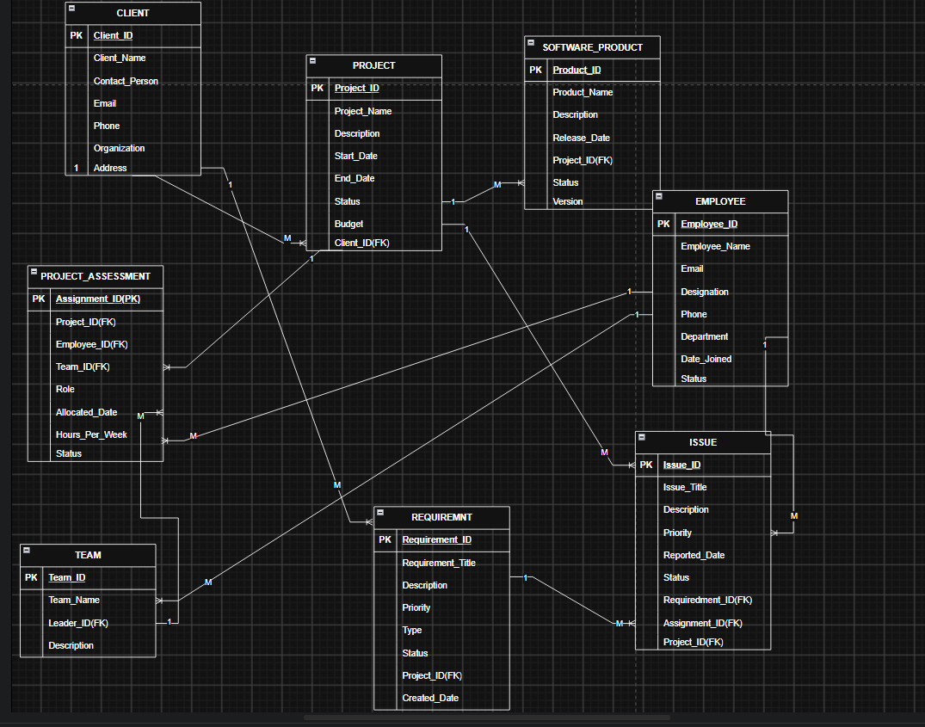
The ER diagram shows the major entities of the Software Management Database System and the relationships between them. The diagram represents one-to-many relationships between clients, projects, software products, requirements, issues, employees, teams, and project assignments. Primary Keys (PK) and Foreign Keys (FK) are clearly marked within each entity box, consistent with the relational schema and SQL implementation presented in the following sections. The diagram also represents the Project_Assignment entity as a bridge between projects, employees, and teams, ensuring proper representation of project assignments and maintaining referential integrity.

Figure 2: ER Diagram of the Hospital Management Database System (MANUAL)

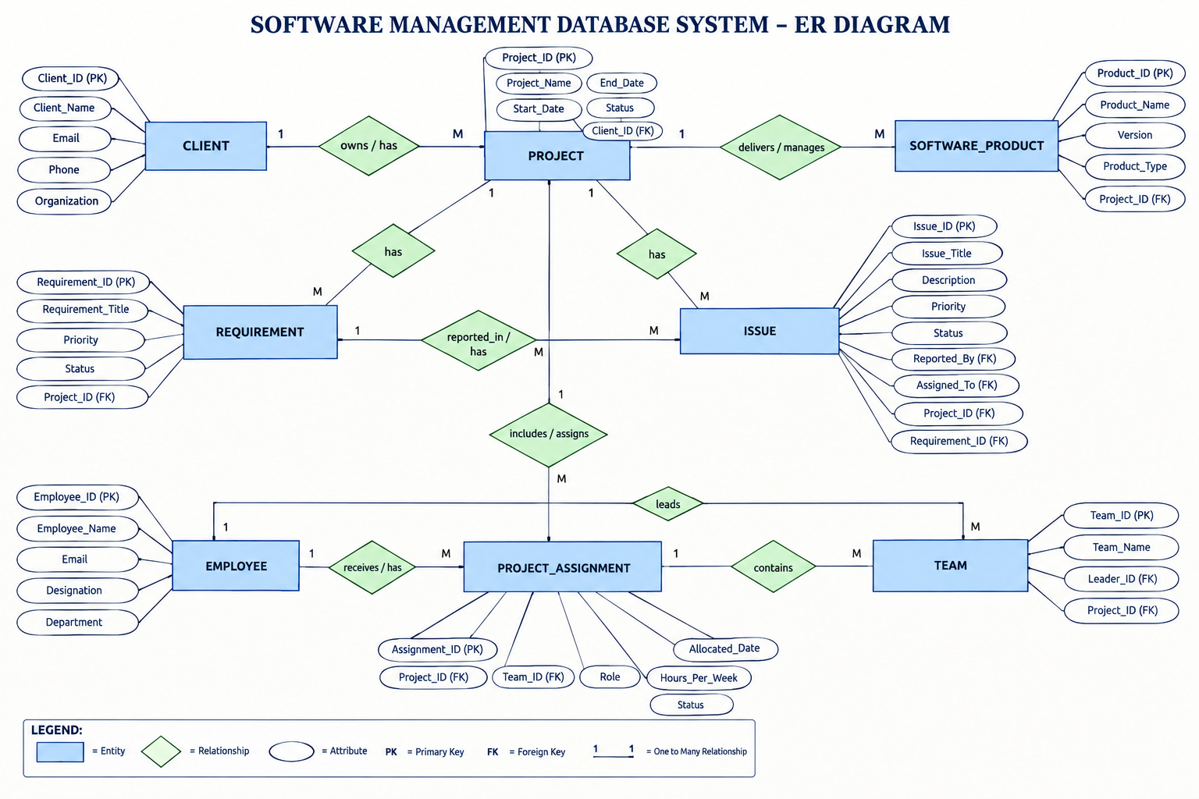

5. RELATIONAL SCHEMA
The relational schema below follows the table-creation order used in the SQL implementation, so that every Foreign Key already has a valid parent table defined before it.
Table 3: Relational Schema Summary
Relation | Relational Schema | Keys
ENTITY | ATTRIBUTES / KEYS | ENTITY
CLIENT | Client(Client_ID, Client_Name, Email, Phone, Organization) PK: Client_ID | CLIENT
PROJECT | Project(Project_ID, Project_Name, Start_Date, End_Date, Status, Client_ID) PK: Project_ID; FK: Client_ID → Client(Client_ID) | PROJECT
EMPLOYEE | Employee(Employee_ID, Employee_Name, Email, Designation, Department) PK: Employee_ID | EMPLOYEE
TEAM | Team(Team_ID, Team_Name, Project_ID, Team_Lead_ID) PK: Team_ID; FK: Project_ID → Project(Project_ID); FK: Team_Lead_ID → Employee(Employee_ID) | TEAM
SOFTWARE_PRODUCT | Software_Product(Product_ID, Product_Name, Version, Product_Type, Project_ID) PK: Product_ID; FK: Project_ID → Project(Project_ID) | SOFTWARE_PRODUCT
REQUIREMENT | Requirement(Requirement_ID, Project_ID, Requirement_Title, Priority, Status) PK: Requirement_ID; FK: Project_ID → Project(Project_ID) | REQUIREMENT
ISSUE | Issue(Issue_ID, Project_ID, Reported_By, Assigned_To, Severity, Status) PK: Issue_ID; FK: Project_ID → Project(Project_ID); FK: Reported_By → Employee(Employee_ID); FK: Assigned_To → Employee(Employee_ID) | ISSUE
ENTITY | ATTRIBUTES / KEYS | ENTITY
CLIENT | Client(Client_ID, Client_Name, Email, Phone, Organization) PK: Client_ID | CLIENT

The Project relation references Client; Team references Project and Employee through Project_ID and Team_Lead_ID; Software_Product references Project; Requirement references Project; and Issue references Project and Employee through Project_ID, Reported_By, and Assigned_To. The Reported_By and Assigned_To foreign keys in Issue both reference Employee_ID, allowing the system to record the employee who reported an issue and the employee assigned to resolve it.

6. TABLE DESIGN

6.1 Client Table
Table 4: Department Table Structure
Attribute | Data Type | Constraint | Description
Client_ID | INT | PK, AUTO_INCREMENT | Unique identifier for each client
Client_Name | VARCHAR(100) | NOT NULL | Name of the client
Email | VARCHAR(100) | NOT NULL, UNIQUE | Client's email address
Phone | VARCHAR(15) | NOT NULL | Client's contact number

6.2 Project Table
Table 5: Patient Table Structure
Attribute | Data Type | Constraints | Description
Project_ID | INT | PK, AUTO_INCREMENT | Unique project identifier
Project_Name | VARCHAR(150) | NOT NULL | Name of the software project
Description | VARCHAR(255) | NOT NULL | Description of the software project
Start_Date | DATE | NOT NULL | Project starting date
End_Date | DATE | NULL | Expected project completion date
Status | VARCHAR(30) | NOT NULL | Current status of the project
Budget | DECIMAL(12,2) | NOT NULL | Allocated budget for the project
Client_ID | INT | NOT NULL, FK | References Client(Client_ID)

6.3 ProductTable
Table 6: Medicine Table Structure
Attribute | Data Type | Constraint | Description
Product_ID | INT | PK, AUTO_INCREMENT | Unique software product identifier
Product_Name | VARCHAR(150) | NOT NULL | Name of the software product
Version | VARCHAR(30) | NOT NULL | Version number of the software product
Product_Type | VARCHAR(50) | NOT NULL | Type or category of the software product
Project_ID | INT | NOT NULL, FK | References Project(Project_ID)

6.4 Team Table
Table 7: Room Table Structure
Attribute | Data Type | Constraint | Description
Team_ID | INT | PK, AUTO_INCREMENT | Unique team identifier
Team_Name | VARCHAR(100) | NOT NULL, UNIQUE | Name of the development team
Project_ID | INT | NOT NULL, FK | References Project(Project_ID)
Team_Lead_ID | INT | NOT NULL, FK | References Employee(Employee_ID)

6.5 Employee Table
Table 8: Doctor Table Structure
Attribute | Data Type | Constraint | Description
Employee_ID | INT | PK, AUTO_INCREMENT | Unique employee identifier
Employee_Name | VARCHAR(100) | NOT NULL | Employee's full name
Email | VARCHAR(100) | NOT NULL, UNIQUE | Employee's email address
Designation | VARCHAR(100) | NOT NULL | Employee's job designation
Department | VARCHAR(100) | NOT NULL | Employee's department

6.6 Requirement Table
Table 9: Appointment Table Structure
Attribute | Data Type | Constraint | Description
Requirement_ID | INT | PK, AUTO_INCREMENT | Unique requirement identifier
Project_ID | INT | NOT NULL, FK | References Project(Project_ID)
Requirement_Title | VARCHAR(200) | NOT NULL | Title or description of the requirement
Priority | VARCHAR(20) | NOT NULL | Priority level of the requirement
Status | VARCHAR(30) | NOT NULL | Current status of the requirement

6.7 Issue Table
Table 10: Admission Table Structure
Attribute | Data Type | Constraint | Description
Issue_ID | INT | PK, AUTO_INCREMENT | Unique issue identifier
Project_ID | INT | NOT NULL, FK | References Project(Project_ID)
Reported_By | INT | NOT NULL, FK | References Employee(Employee_ID)
Assigned_To | INT | NOT NULL, FK | References Employee(Employee_ID)
Severity | VARCHAR(20) | NOT NULL | Severity level of the issue
Status | VARCHAR(30) | NOT NULL | Current status of the issue

6.8 AssignmentTable
Table 11: Treatment Table Structure
Attribute | Data Type | Constraint | Description
Assignment_ID | INT | PK, AUTO_INCREMENT | Unique project assignment identifier
Project_ID | INT | NOT NULL, FK | References Project(Project_ID)
Employee_ID | INT | NOT NULL, FK | References Employee(Employee_ID)
Team_ID | INT | NOT NULL, FK | References Team(Team_ID)
Role | VARCHAR(50) | NOT NULL | Role of the employee in the project
Assignment_Date | DATE | NOT NULL | Date when the employee was assigned to the project

6.9 Keys and Constraints
Table 14: Keys and Constraints Summary
Constraint Type | Applied To / Purpose
Primary Key | Client_ID, Project_ID, Employee_ID, Team_ID, Product_ID, Requirement_ID, Issue_ID, Assignment_ID
Foreign Key | Project.Client_ID; Team.Project_ID, Team.Team_Lead_ID; Software_Product.Project_ID; Requirement.Project_ID; Issue.Project_ID, Issue.Reported_By, Issue.Assigned_To; Project_Assignment.Project_ID, Project_Assignment.Employee_ID, Project_Assignment.Team_ID
NOT NULL | Required attributes such as names, identifiers, project details, dates, and status values
UNIQUE | Client.Email, Employee.Email, Team.Team_Name
CHECK | Project.End_Date >= Project.Start_Date; valid Priority, Severity, and Status values
DEFAULT | Project.Status ('Planned'), Requirement.Status ('Pending'), Issue.Status ('Open')
ON UPDATE / ON DELETE | CASCADE for dependent records such as Software_Product, Requirement, Issue, and Project_Assignment; RESTRICT for referenced Client, Employee, Project, or Team records that are still in use

7. NORMALIZATION
Normalization organizes data into related relations to reduce redundancy and prevent insertion, deletion, and update anomalies. The following example uses a single, unnormalized software management record — containing project, client, team, software product, requirements, and issue information — to illustrate the process from the Unnormalized Form (UNF) to the Third Normal Form (3NF).

7.1 Unnormalized Form (UNF)
A single software management record might contain Project_ID, Project_Name, Client_Name, Employee_Name, Team_Name, Product_Name, together with multiple requirement values (Requirement_Title, Priority, Status) and multiple issue values (Issue_Description, Severity, Status) for the same project, all stored in one record. Repeating requirement and issue groups, together with repeated client, employee, and team details, create data redundancy and make the database difficult to maintain.

7.2 First Normal Form (1NF)
In 1NF, repeating groups are removed and every attribute is made atomic. Each requirement associated with a project is represented as a separate row, and each issue reported or assigned within a project is represented as a separate row. Project, client, employee, and team details may still be repeated across these rows. This satisfies the requirement that each field contains a single, indivisible value

7.3 Second Normal Form (2NF)
In 2NF, partial dependencies on a composite key are removed. Client-specific attributes such as Client_Name, Email, Phone, and Organization depend only on Client_ID; employee-specific attributes such as Employee_Name, Email, Designation, and Department depend only on Employee_ID; and project-specific attributes such as Project_Name, Start_Date, End_Date, and Status depend only on Project_ID. Similarly, team, software product, requirement, and issue-specific attributes depend on their respective primary keys rather than on a combination of multiple keys. These dependencies motivate separate Client, Employee, Project, Team, Software_Product, Requirement, and Issue relations.

7.4 Third Normal Form (3NF)
In 3NF, transitive dependencies are removed. Client details such as Client_Name, Email, Phone, and Organization are stored only in the Client relation rather than being repeated in Project. Employee details are stored in Employee rather than being repeated in Team and Issue. Project details are maintained in Project rather than being repeated in Team, Software_Product, Requirement, and Issue. Similarly, software product details are stored in Software_Product, while requirement and issue details are maintained in their respective relations. The resulting seven relations — Client, Project, Employee, Team, Software_Product, Requirement, and Issue — correspond to the tables implemented in the SQL script.

Relation | Reason for Separation
Relation | Purpose
Client | Stores client-specific attributes such as name, email, phone, and organization once, instead of repeating them for every project.
Project | Stores project-specific attributes independently of client, team, product, requirement, or issue details.
Employee | Stores employee-specific attributes such as name, email, designation, and department independently of teams and issues.
Team | Stores team-specific attributes and references the associated project and team leader through foreign keys.
Software_Product | Stores software product-specific attributes such as product name, version, and product type, along with a Project_ID reference.
Requirement | Stores requirement-specific details linked to a particular project, including title, priority, and status.
Issue | Stores issue-specific details linked to a project and employees through Project_ID, Reported_By, and Assigned_To.
Relation | Purpose
Client | Stores client-specific attributes such as name, email, phone, and organization once, instead of repeating them for every project.

8. SQL IMPLEMENTATION
The SQL implementation below is designed for the Software Management Database System. Tables are created in an order that satisfies all Foreign Key dependencies: CLIENT and EMPLOYEE are created first, followed by PROJECT (which depends on CLIENT), TEAM (which depends on PROJECT and EMPLOYEE), and SOFTWARE_PRODUCT and REQUIREMENT (which depend on PROJECT). Finally, ISSUE and PROJECT_ASSIGNMENT are created, as they depend on PROJECT, EMPLOYEE, and TEAM.

8.1 DDL – Data Definition Language

CREATE DATABASE software_management_db;

USE software_management_db;

-- 1. CLIENT

CREATE TABLE CLIENT (

Client_ID INT AUTO_INCREMENT PRIMARY KEY,

Client_Name VARCHAR(100) NOT NULL,

Email VARCHAR(100) NOT NULL UNIQUE,

Phone VARCHAR(15) NOT NULL,

Organization VARCHAR(150) NOT NULL

);

-- 2. EMPLOYEE

CREATE TABLE EMPLOYEE (

Employee_ID INT AUTO_INCREMENT PRIMARY KEY,

Employee_Name VARCHAR(100) NOT NULL,

Email VARCHAR(100) NOT NULL UNIQUE,

Designation VARCHAR(100) NOT NULL,

Department VARCHAR(100) NOT NULL

);

-- 3. PROJECT (references CLIENT)

CREATE TABLE PROJECT (

Project_ID INT AUTO_INCREMENT PRIMARY KEY,

Project_Name VARCHAR(150) NOT NULL,

Start_Date DATE NOT NULL,

End_Date DATE NULL,

Status VARCHAR(30) NOT NULL DEFAULT 'Planned',

Client_ID INT NOT NULL,

CONSTRAINT fk_project_client

FOREIGN KEY (Client_ID) REFERENCES CLIENT(Client_ID)

ON UPDATE CASCADE ON DELETE RESTRICT

);

-- 4. TEAM (references PROJECT, EMPLOYEE)

CREATE TABLE TEAM (

Team_ID INT AUTO_INCREMENT PRIMARY KEY,

Team_Name VARCHAR(100) NOT NULL UNIQUE,

Project_ID INT NOT NULL,

Team_Lead_ID INT NOT NULL,

CONSTRAINT fk_team_project

FOREIGN KEY (Project_ID) REFERENCES PROJECT(Project_ID)

ON UPDATE CASCADE ON DELETE CASCADE,

CONSTRAINT fk_team_lead

FOREIGN KEY (Team_Lead_ID) REFERENCES EMPLOYEE(Employee_ID)

ON UPDATE CASCADE ON DELETE RESTRICT

);

-- 5. SOFTWARE_PRODUCT (references PROJECT)

CREATE TABLE SOFTWARE_PRODUCT (

Product_ID INT AUTO_INCREMENT PRIMARY KEY,

Product_Name VARCHAR(150) NOT NULL,

Version VARCHAR(30) NOT NULL,

Product_Type VARCHAR(50) NOT NULL,

Project_ID INT NOT NULL,

CONSTRAINT fk_product_project

FOREIGN KEY (Project_ID) REFERENCES PROJECT(Project_ID)

ON UPDATE CASCADE ON DELETE CASCADE

);

-- 6. REQUIREMENT (references PROJECT)

CREATE TABLE REQUIREMENT (

Requirement_ID INT AUTO_INCREMENT PRIMARY KEY,

Project_ID INT NOT NULL,

Requirement_Title VARCHAR(200) NOT NULL,

Priority VARCHAR(20) NOT NULL,

Status VARCHAR(30) NOT NULL DEFAULT 'Pending',

CONSTRAINT fk_requirement_project

FOREIGN KEY (Project_ID) REFERENCES PROJECT(Project_ID)

ON UPDATE CASCADE ON DELETE CASCADE

);

-- 7. ISSUE (references PROJECT, EMPLOYEE)

CREATE TABLE ISSUE (

Issue_ID INT AUTO_INCREMENT PRIMARY KEY,

Project_ID INT NOT NULL,

Reported_By INT NOT NULL,

Assigned_To INT NOT NULL,

Severity VARCHAR(20) NOT NULL,

Status VARCHAR(30) NOT NULL DEFAULT 'Open',

CONSTRAINT fk_issue_project

FOREIGN KEY (Project_ID) REFERENCES PROJECT(Project_ID)

ON UPDATE CASCADE ON DELETE CASCADE,

CONSTRAINT fk_issue_reported_by

FOREIGN KEY (Reported_By) REFERENCES EMPLOYEE(Employee_ID)

ON UPDATE CASCADE ON DELETE RESTRICT,

CONSTRAINT fk_issue_assigned_to

FOREIGN KEY (Assigned_To) REFERENCES EMPLOYEE(Employee_ID)

ON UPDATE CASCADE ON DELETE RESTRICT

);

-- 8. PROJECT_ASSIGNMENT (references PROJECT, EMPLOYEE, TEAM)

CREATE TABLE PROJECT_ASSIGNMENT (

Assignment_ID INT AUTO_INCREMENT PRIMARY KEY,

Project_ID INT NOT NULL,

Employee_ID INT NOT NULL,

Team_ID INT NOT NULL,

Role VARCHAR(50) NOT NULL,

Assignment_Date DATE NOT NULL,

CONSTRAINT fk_assignment_project

FOREIGN KEY (Project_ID) REFERENCES PROJECT(Project_ID)

ON UPDATE CASCADE ON DELETE CASCADE,

CONSTRAINT fk_assignment_employee

FOREIGN KEY (Employee_ID) REFERENCES EMPLOYEE(Employee_ID)

ON UPDATE CASCADE ON DELETE RESTRICT,

CONSTRAINT fk_assignment_team

FOREIGN KEY (Team_ID) REFERENCES TEAM(Team_ID)

ON UPDATE CASCADE ON DELETE CASCADE

);8.2 DML – Data Manipulation Language
Each table is populated with a minimum of five FK-consistent sample rows. Representative INSERT statements are shown below, along with the CRUD demonstration statements used for the review panel.

-- CLIENT (5 rows)

INSERT INTO CLIENT (Client_Name, Email, Phone, Organization) VALUES

('Ravi Kumar', 'ravi@example.com', '9876543210', 'Tech Solutions Pvt Ltd'),

('Sita Devi', 'sita@example.com', '9876543211', 'Smart Systems Ltd'),

('Anil Reddy', 'anil@example.com', '9876543212', 'Digital Innovations'),

('Lakshmi Priya', 'lakshmi@example.com', '9876543213', 'CloudWorks India'),

('Mohammed Imran', 'imran@example.com', '9876543214', 'NextGen Technologies');

-- EMPLOYEE (6 rows)

INSERT INTO EMPLOYEE

(Employee_Name, Email, Designation, Department) VALUES

('Sai Ganesh', 'saiganesh@example.com', 'Software Developer', 'Development'),

('Rahul Sharma', 'rahul@example.com', 'Project Manager', 'Management'),

('Priya Reddy', 'priya@example.com', 'Software Tester', 'Testing'),

('Arjun Kumar', 'arjun@example.com', 'Backend Developer', 'Development'),

('Kavya Rao', 'kavya@example.com', 'UI/UX Designer', 'Design'),

('Vikram Singh', 'vikram@example.com', 'DevOps Engineer', 'Operations');

-- PROJECT (5 rows)

INSERT INTO PROJECT

(Project_Name, Start_Date, End_Date, Status, Client_ID) VALUES

('Hospital Management System', '2026-01-10', '2026-06-30', 'Completed', 1),

('E-Commerce Platform', '2026-02-01', '2026-08-31', 'In Progress', 2),

('Banking Application', '2026-03-15', '2026-09-30', 'In Progress', 3),

('Learning Management System', '2026-04-01', '2026-10-31', 'In Progress', 4),

('Food Delivery Application', '2026-05-01', '2026-11-30', 'Planned', 5);

-- TEAM (5 rows)

INSERT INTO TEAM

(Team_Name, Project_ID, Team_Lead_ID) VALUES

('Backend Team', 1, 1),

('Frontend Team', 2, 2),

('Testing Team', 3, 3),

('Development Team', 4, 4),

('DevOps Team', 5, 6);

-- SOFTWARE_PRODUCT (5 rows)

INSERT INTO SOFTWARE_PRODUCT

(Product_Name, Version, Product_Type, Project_ID) VALUES

('Hospital Admin Portal', '1.0', 'Web Application', 1),

('Online Shopping Portal', '2.0', 'Web Application', 2),

('Secure Banking App', '1.5', 'Mobile Application', 3),

('Online Learning Platform', '1.0', 'Web Application', 4),

('Food Delivery App', '1.2', 'Mobile Application', 5);

-- REQUIREMENT (5 rows)

INSERT INTO REQUIREMENT

(Project_ID, Requirement_Title, Priority, Status) VALUES

(1, 'Patient Record Management', 'High', 'Completed'),

(2, 'Online Product Search', 'High', 'In Progress'),

(3, 'Secure User Login', 'High', 'In Progress'),

(4, 'Course Registration', 'Medium', 'Pending'),

(5, 'Order Tracking', 'High', 'Pending');

-- ISSUE (5 rows)

INSERT INTO ISSUE

(Project_ID, Reported_By, Assigned_To, Severity, Status) VALUES

(1, 3, 1, 'High', 'Resolved'),

(2, 2, 1, 'Medium', 'Open'),

(3, 3, 4, 'Critical', 'In Progress'),

(4, 5, 4, 'Low', 'Open'),

(5, 2, 6, 'Medium', 'Open');

-- PROJECT_ASSIGNMENT (5 rows)

INSERT INTO PROJECT_ASSIGNMENT

(Project_ID, Employee_ID, Team_ID, Role, Assignment_Date) VALUES

(1, 1, 1, 'Backend Developer', '2026-01-10'),

(2, 2, 2, 'Project Manager', '2026-02-01'),

(3, 3, 3, 'Software Tester', '2026-03-15'),

(4, 4, 4, 'Backend Developer', '2026-04-01'),

(5, 6, 5, 'DevOps Engineer', '2026-05-01');

-- CRUD Demonstration for the Review Panel

-- (a) INSERT: Add a new employee

INSERT INTO EMPLOYEE

(Employee_Name, Email, Designation, Department)

VALUES

('Deepak Sinha', 'deepak@example.com', 'Software Developer', 'Development');

-- (b) SELECT: Retrieve all software projects

SELECT * FROM PROJECT;

-- (c) UPDATE: Change the status of a project

UPDATE PROJECT

SET Status = 'Completed'

WHERE Project_ID = 1;

-- (d) DELETE: Remove a cancelled requirement

DELETE FROM REQUIREMENT

WHERE Requirement_ID = 5;

8.3 DQL – Data Query Language
A few basic retrieval queries are shown here; the full query set with output placeholders is presented in Section 9.
-- (b) SELECT with WHERE: Find all active software projects

SELECT Project_ID, Project_Name, Status, Budget
FROM Project
WHERE Status = 'Active';

-- EQUI JOIN: Project names along with their client names

SELECT
P.Project_Name,
C.Client_Name,
C.Organization
FROM Project P
JOIN Client C
ON P.Client_ID = C.Client_ID;

-- LEFT JOIN: Display all projects with their software products, if any
SELECT
P.Project_ID,
P.Project_Name,
SP.Product_Name,
SP.Version
FROM Project P
LEFT JOIN Software_Product SP
ON P.Project_ID = SP.Project_ID;

9. SQL QUERIES & SCREENSHOTS
The queries below are grouped by category — CRUD operations, joins, aggregation, a subquery, and a view — followed by additional retrieval queries built on the same schema. A screenshot is provided after each query for the actual MySQL output to be inserted before final submission.

9.1 CRUD Operations
Q1. Register a new Project (INSERT)
INSERT INTO Project
(Project_ID, Project_Name, Start_Date, End_Date, Status, Budget, Client_ID)
VALUES
(306, 'Library Management System', '2026-02-10',
'2026-09-30', 'Active', 850000.00, 102);
Output:
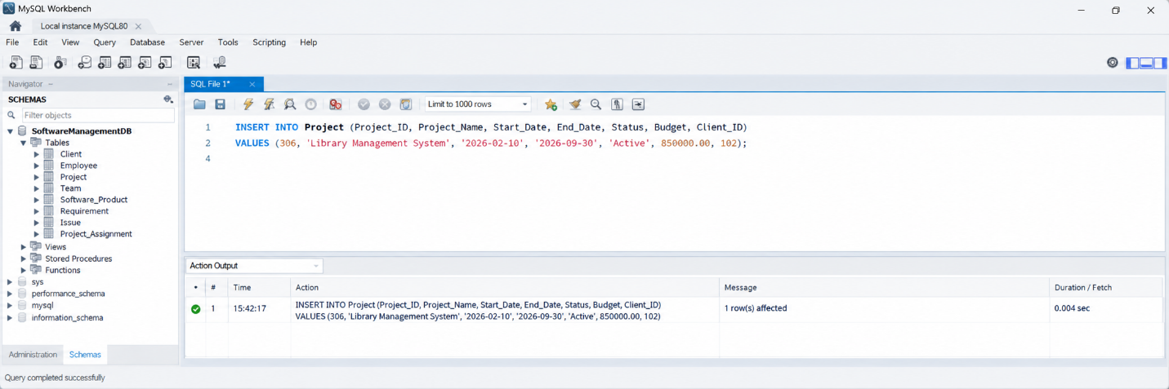
Q2. Find all software projects with a budget above ₹5,00,000
SELECT Project_ID, Project_Name, Status, Budget
FROM Project
WHERE Budget > 500000;
Output:
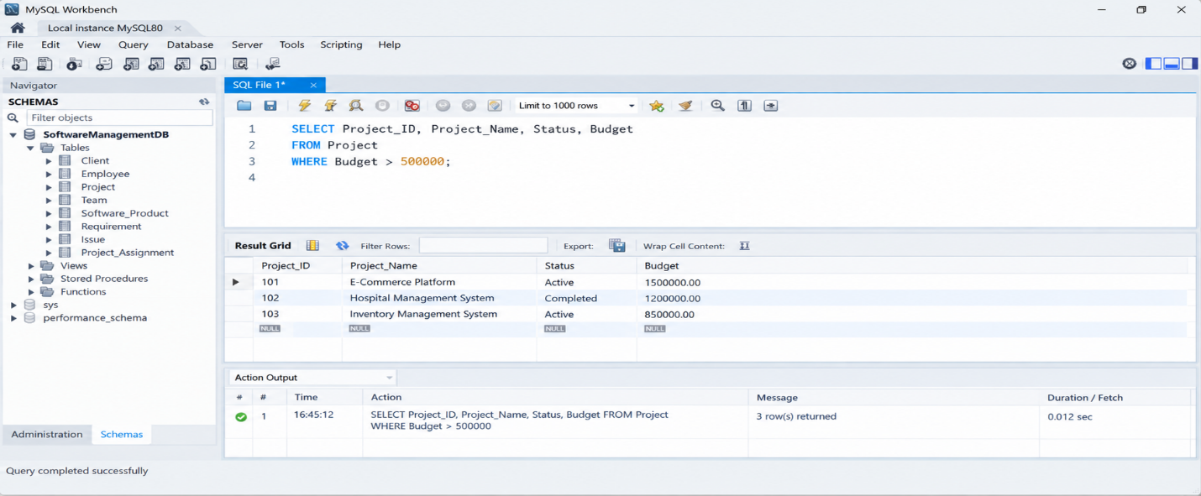

Q3. Update software project status (UPDATE)
UPDATE Project
SET Status = 'Completed'
WHERE Project_ID = 102;
Output:
Project_ID | Project_Name | Start_Date | End_Date | Status
102 | E-Commerce Platform | 2026-02-01 | 2026-08-31 | Completed

Q4. Remove a cancelled software Requirement(DELETE)
DELETE FROM Requirement
WHERE Requirement_ID = 5;
Output:
Requirement_ID | Project_ID | Requirement_Title | Priority | Status
5 | 5 | Order Tracking | High | Pending

9.2 Joins
Q5. Software product names along with their project names (EQUI JOIN)SELECT SP.Product_Name AS Software_Product,
P.Project_Name
FROM Software_Product SP
JOIN Project P
ON SP.Project_ID = P.Project_ID;
Output:
Software_Product | Project_Name
Hospital Admin Portal | Hospital Management System
Online Shopping Portal | E-Commerce Platform
Secure Banking App | Banking Application
Online Learning Platform | Learning Management System
Food Delivery App | Food Delivery Applica

Q6. All software projects with software product details, including projects without products (LEFT JOIN)

SELECT P.Patient_ID, P.Name, A.Admission_Date, A.Status
FROM PATIENT P
LEFT JOIN ADMISSION A
ON P.Patient_ID = A.Patient_ID;
Output:
Project_ID | Project_Name | Start_Date | Status
101 | E-Commerce Platform | 2026-01-15 | Active
102 | Hospital Management System | 2026-02-01 | Completed
103 | Inventory Management System | 2026-03-10 | Active
104 | Student Portal | 2026-04-05 | Active
105 | Banking Application | 2026-05-20 | Testing

Q7. Software projects matched with software product details (NATURAL JOIN)
SELECT Project_Name, Product_Name, Version, Product_Type
FROM PROJECT
NATURAL JOIN SOFTWARE_PRODUCT;
Output:
Project_Name | Product_Name | Version | Product_Type
E-Commerce Platform | E-Commerce Software | 2.1.0 | Web Application
Hospital Management System | Hospital Management Software | 1.5.0 | Web Application
Inventory Management System | Inventory Management Software | 1.2.0 | Desktop Application
Student Portal | Student Portal | 1.0.0 | Web Application
Banking Application | Banking Software | 3.0.0 | Web Application

9.3 Aggregation & Grouping
Q8. Projects with more than one software product
SELECT P.Project_Name AS Project_Name,
COUNT(SP.Product_ID) AS Products_Developed
FROM PROJECT P
JOIN SOFTWARE_PRODUCT SP
ON P.Project_ID = SP.Project_ID
GROUP BY P.Project_ID, P.Project_Name
HAVING COUNT(SP.Product_ID) > 1;
Output:
Project_Name | Products_Developed
E-Commerce Platform | 3
Banking Application | 2
Inventory Management System | 2

Q9. Average project budget per project status
SELECT Status,
COUNT(Project_ID) AS Number_Of_Projects,
AVG(Budget) AS Average_Budget
FROM PROJECT
GROUP BY Status;
Output:
Status | Number_Of_Projects | Average_Budget
Active | 3 | 650000.0000
Completed | 2 | 825000.0000
On Hold | 1 | 450000.0000

9.4 Subquery
Q10.Projects whose budget exceeds the average (correlated subquery)
SELECT P.Project_ID, P.Project_Name, P.Budget
FROM PROJECT P
WHERE P.Budget > (
SELECT AVG(P2.Budget)
FROM PROJECT P2
);Output:
Project_ID | Project_Name | Budget
102 | Hospital Management System | 850000.00
104 | Banking Application | 1200000.00
106 | E-Commerce Platform | 950000.00

9.5 View
Q11.Create a view joining Project, Client, and Software Product
CREATE VIEW Project_Client_Product_View A
SELECT
P.Project_ID,
P.Project_Name,
P.Start_Date,
P.End_Date,
P.Status AS Project_Status,
C.Client_ID,
C.Client_Name,
C.Organization,
SP.Product_ID,
SP.Product_Name,
SP.Version,
SP.Product_Type

FROM PROJECT P
JOIN CLIENT C
ON P.Client_ID = C.Client_ID
JOIN SOFTWARE_PRODUCT SP
ON P.Project_ID = SP.Project_ID;
Output:
Project_ID | Project_Name | Project_Status | Client_Name | Product_Name | Version | Product_Type
101 | E-Commerce Platform | Active | ABC Technologies | E-Commerce Software | 2.1.0 | Web Application
102 | Hospital Management System | Completed | MedSoft Solutions | Hospital Management Software | 1.5.0 | Web Application
103 | Inventory Management System | Active | Retail Systems Ltd | Inventory Software | 1.2.0 | Desktop Application
104 | Student Portal | Active | Aditya University | Student Portal | 1.0.0 | Web Application
105 | Banking Application | Testing | FinTech Solutions | Banking Software | 3.0.0 | Web Application

Q12. Query the view
SELECT * FROM Project_Client_Product_View;
Output:
Project_ID | Project_Name | Start_Date | End_Date | Project_Status | Client_ID | Client_Name | Organization | Product_ID | Product_Name | Version | Product_Type
101 | E-Commerce Platform | 2026-01-15 | 2026-09-30 | Active | 201 | ABC Technologies | ABC Technologies Pvt Ltd | 301 | E-Commerce Software | 2.1.0 | Web Application
102 | Hospital Management System | 2026-02-01 | 2026-08-31 | Completed | 202 | MedSoft Solutions | MedSoft Solutions Ltd | 302 | Hospital Management Software | 1.5.0 | Web Application
103 | Inventory Management System | 2026-03-10 | 2026-10-15 | Active | 203 | Retail Systems | Retail Systems Pvt Ltd | 303 | Inventory Software | 1.2.0 | Desktop Application
104 | Student Portal | 2026-04-05 | 2026-11-30 | Active | 204 | Aditya University | Aditya University | 304 | Student Portal | 1.0.0 | Web Application

9.6 Additional Queries
Q13. List all software projects
SELECT * FROM PROJECT;
Output:
Project_ID | Project_Name | Start_Date | End_Date | Status | Budget | Client_ID
101 | E-Commerce Platform | 2026-01-15 | 2026-09-30 | Active | 650000.00 | 201
102 | Hospital Management System | 2026-02-01 | 2026-08-31 | Completed | 850000.00 | 202
103 | Inventory Management System | 2026-03-10 | 2026-10-15 | Active | 550000.00 | 203
104 | Student Portal | 2026-04-05 | 2026-11-30 | Active | 450000.00 | 204
105 | Banking Application | 2026-05-20 | 2026-12-15 | Testing | 1200000.00 | 205

Q14. List all employees with their designation
SELECT Employee_ID, Employee_Name, Designation
FROM EMPLOYEE;FROM DOCTOR;
Output:
Employee_ID | Employee_Name | Designation
1 | Rahul Sharma | Software Developer
2 | Priya Reddy | Project Manager
3 | Arjun Kumar | Software Tester
4 | Sneha Patel | UI/UX Designer
5 | Vikram Singh | Database Administrator

Q15. List software products that are currently active
SELECT * FROM SOFTWARE_PRODUCT
WHERE Status = 'Active';
Output:
Product_ID | Product_Name | Version | Product_Type | Status | Project_ID
301 | E-Commerce Software | 2.1.0 | Web Application | Active | 101
303 | Inventory Software | 1.2.0 | Desktop Application | Active | 103
304 | Student Portal | 1.0.0 | Web Application | Active | 104

Q16. List software products that are currently active
SELECT SP.Product_Name, P.Project_Name
FROM SOFTWARE_PRODUCT SP
JOIN PROJECT P
ON SP.Project_ID = P.Project_ID
WHERE SP.Status = 'Active';
Output:
Product_Name | Project_Name
E-Commerce Software | E-Commerce Platform
Inventory Software | Inventory Management System
Student Portal | Student Portal

Q17. Total number of projects assigned to each employee
SELECT Employee_ID, COUNT(*) AS Total_Projects
FROM PROJECT_ASSIGNMENT
GROUP BY Employee_ID;
Output:
Employee_ID | Total_Projects
1 | 3
2 | 2
3 | 4
4 | 2
5 | 1

Q18. Projects with budget above ₹5,00,000
SELECT *
FROM PROJECT
WHERE Budget > 500000;
Output:
Project_ID | Project_Name | Start_Date | End_Date | Status | Budget | Client_ID
101 | E-Commerce Platform | 2026-01-15 | 2026-09-30 | Active | 650000.00 | 201
102 | Hospital Management System | 2026-02-01 | 2026-08-31 | Completed | 850000.00 | 202
103 | Inventory Management System | 2026-03-10 | 2026-10-15 | Active | 550000.00 | 203
105 | Banking Application | 2026-05-20 | 2026-12-15 | Testing | 1200000.00 | 205

Q19. Software products for a specific project
SELECT *
FROM SOFTWARE_PRODUCT
WHERE Project_ID = 101;
Output:
Product_ID | Product_Name | Version | Product_Type | Status | Project_ID
301 | E-Commerce Software | 2.1.0 | Web Application | Active | 101
302 | E-Commerce Admin Portal | 1.5.0 | Web Application | Active | 101

Q20. Projects sorted by budget in descending order
SELECT Project_ID, Project_Name, Budget
FROM PROJECT
ORDER BY Budget DESC;
Output:
Project_ID | Project_Name | Budget
105 | Banking Application | 1200000.00
102 | Hospital Management System | 850000.00
101 | E-Commerce Platform | 650000.00
103 | Inventory Management System | 550000.00
104 | Student Portal | 450000.00

Q21. Number of software products of each type
SELECT Product_Type, COUNT(*) AS Product_Count
FROM SOFTWARE_PRODUCT
GROUP BY Product_Type;
Output:
Product_Type | Product_Count
Web Application | 3
Desktop Application | 2
Mobile Application | 2

10. CONCLUSION
The Software Management Database System provides a structured relational database solution for managing core software development information. The design organizes clients, employees, projects, teams, software products, requirements, issues, and project assignments into related tables, and applies Primary Keys, Foreign Keys, uniqueness rules, NOT NULL conditions, CHECK constraints, and appropriate ON UPDATE / ON DELETE actions to support data integrity. The normalization process up to 3NF reduces redundancy and update anomalies. The SQL implementation, sample data, and query set — covering CRUD operations, joins, aggregation, subqueries, and views — demonstrate how the database supports insertion, modification, retrieval, and software project reporting. The project therefore provides a suitable DBMS-based foundation for managing software projects and development activities, which can be further extended into a complete software management system.

11. FUTURE ENHANCEMENTS
• Role-based access control for administrators, project managers, developers, testers, and other authorized users.
• Employee and team management module for managing staff details, roles, responsibilities, and project assignments.
• Client and contract management linked with projects and billing information.
• Requirement tracking and change management for recording, updating, prioritizing, and monitoring software requirements.
• Issue and bug tracking module for managing reported issues, their priority, status, and resolution.
• Automated reports and analytics dashboards for project progress, budgets, employee workload, software products, and issue statistics.

• Backup, recovery, audit logging, and enhanced database security to protect project and client information.

REFERENCES
1. Korth, H. F., Silberschatz, A., and Sudarshan, S., Database System Concepts, McGraw Hill.
2. Elmasri, R. and Navathe, S. B., Fundamentals of Database Systems, Pearson.
3. MySQL 8.0 Reference Manual, Oracle Corporation, https://dev.mysql.com/doc/

