Code and its Output:

1. Battery Storage Model:

This code first creates the artificial data and then plots the scatter plot for the input features and target variable. It then splits the data into training and test sets, trains a random forest regression model, and evaluates its performance using mean squared error and R-squared metrics. Finally, it plots the predicted SOC values versus the true SOC values.

Output:



1. Cold Storage Model

This code first creates the artificial dataset and then plots the scatter plot for the input features and target variable. It then splits the data into training and test sets, trains a linear regression model, and evaluates its performance using mean squared error and R-squared metrics.

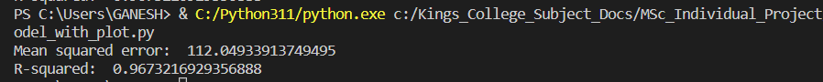

1. Heat Demand Model

In this code I am using linear regression model:

1. Cost Model

This code calculates the total costs of the battery storage and cold storage systems using the **total_cost()** function and then plots a bar chart to compare the two costs. The **plt.bar()** function is used to create the bar chart, and the **plt.title()** and **plt.ylabel()** functions are used to set the title and y-axis label of the chart.

NOTE:

I am currently using linear relationship between my variables, equation is in the form of

y=Ax+Bx …..+b. Each step may require additional preprocessing, feature engineering, validation, and optimization techniques to achieve accurate and reliable results. I need to spend time in understanding data and requirements, implementing the appropriate models, and fine-tuning their performance.

I will go through the cold hub’s report and modify my code accordingly. I would love to know the expectation of plots if possible. Also if you want me to plot other graphs, please let me know.