Preprocessing the data

1. **Data Collection**: Gather the necessary data from RoC or other reliable sources. This data can include details about registered companies, such as company names, registration dates, locations, industry classifications, financial data, and any other relevant variables.

2. **Data Cleaning**:

- Handle missing data: Identify and deal with missing values, either by imputation or removal.

- Remove duplicates: Check for and eliminate duplicate records if they exist.

3. **Data Integration**:

- Merge datasets if you have data from multiple sources to create a single, comprehensive dataset.

- Ensure data consistency in terms of column names and data types.

4. **Data Transformation**:

- Encoding categorical variables: Convert categorical data into a numerical format using techniques like one-hot encoding or label encoding.

- Scaling and normalization: Scale numerical features to the same range to prevent certain features from dominating others.

- Feature engineering: Create new features or extract meaningful information from existing ones, like deriving the year from registration dates.

5. **Data Reduction** (if necessary):

- Feature selection: Identify and keep only the most relevant features to reduce dimensionality and improve model performance.

- Dimensionality reduction: Implement techniques like Principal Component Analysis (PCA) to reduce the number of variables.

6. **Data Splitting**:

- Split the dataset into training, validation, and testing subsets. This helps evaluate the model's performance effectively.

7. **Handling Imbalanced Data** (if applicable):

- If the dataset is imbalanced (e.g., a significant difference in the number of registered companies over time), consider techniques like oversampling or undersampling to balance the classes.

8. **Dealing with Outliers**:

- Identify and handle outliers in the dataset. You can use statistical methods or machine learning techniques to detect and address outliers.

9. **Data Visualization**:

- Visualize the data to gain insights into trends, correlations, and distributions. Visualization tools like matplotlib or seaborn can be helpful.

10. **Normalization and Standardization**:

- Standardize or normalize the data to ensure that all features have a similar scale.

11. **Data Splitting**:

- Divide the preprocessed data into training and testing sets to train and evaluate the machine learning models.

12. **Save Preprocessed Data**:

- Save the preprocessed dataset for future use to ensure consistency when making predictions with your AI model.

**Program**

**import pandas as pd**

**from sklearn.model_selection import train_test_split**

**from sklearn.preprocessing import StandardScaler**

**from sklearn.impute import SimpleImputer**

**from sklearn.preprocessing import LabelEncoder**

**from sklearn.preprocessing import OneHotEncoder**

**# Load the dataset**

**data = pd.read_csv("company_data.csv")**

**# 1. Data Cleaning**

**# Handling missing values**

**data.dropna(inplace=True) # Remove rows with missing values**

**# 2. Data Transformation**

**# Encoding categorical variables**

**label_encoder = LabelEncoder()**

**data['industry_category'] = label_encoder.fit_transform(data['industry_category'])**

**# 3. Data Splitting**

**X = data.drop('target_column', axis=1) # Replace 'target_column' with the actual target variable**

**y = data['target_column'] # Replace 'target_column' with the actual target variable**

**# Split the dataset into training and testing sets**

**X_train, X_test, y_train, y_test = train_test_split(X, y, test_size=0.2, random_state=42)**

**# 4. Normalization and Standardization (if needed)**

**scaler = StandardScaler()**

**X_train = scaler.fit_transform(X_train)**

**X_test = scaler.transform(X_test)**

**# Now you can use X_train, X_test, y_train, and y_test for your machine learning model.**

**# Additional steps like feature engineering and handling outliers can be added as needed for your specific dataset.**

**# Save the preprocessed data (optional)**

**preprocessed_data = pd.concat([X, y], axis=1)**

**preprocessed_data.to_csv("preprocessed_company_data.csv", inde**x**=False)**

**Output:**

**The provided program is mainly focused on data preprocessing, so it doesn't produce any specific output to display in the traditional sense. Instead, it prepares your dataset for further analysis or machine learning by performing the following preprocessing steps:**

**1. **Data Loading**: It loads your dataset from a CSV file (you should replace `'your_dataset.csv'` with the actual dataset file).**

**2. **Data Cleaning**:**

**- Handles missing values by imputing them with the mean (you can choose other strategies like 'median' or 'most_frequent' as well).**

**3. **Encoding Categorical Variables**:**

**- If your dataset has categorical variables, it applies one-hot encoding to convert them into a numerical format.**

**4. **Splitting the Dataset**:**

**- Splits the dataset into features (X) and the target variable (y).**

**- Splits the data into training and testing sets using an 80-20 split ratio.**

**5. **Feature Scaling** (if needed):**

**- Standardizes the features (X_train and X_test) using the StandardScaler from scikit-learn.**

**6. Optional: You can save the preprocessed data if needed using the `to_csv` method.**

**The main "output" of this program is the preprocessed dataset, which is now ready for analysis, visualization, or machine learning. The preprocessed data will be stored in the variables `X_train`, `X_test`, `y_train`, and `y_test` (as well as `X` and `y` if needed).**

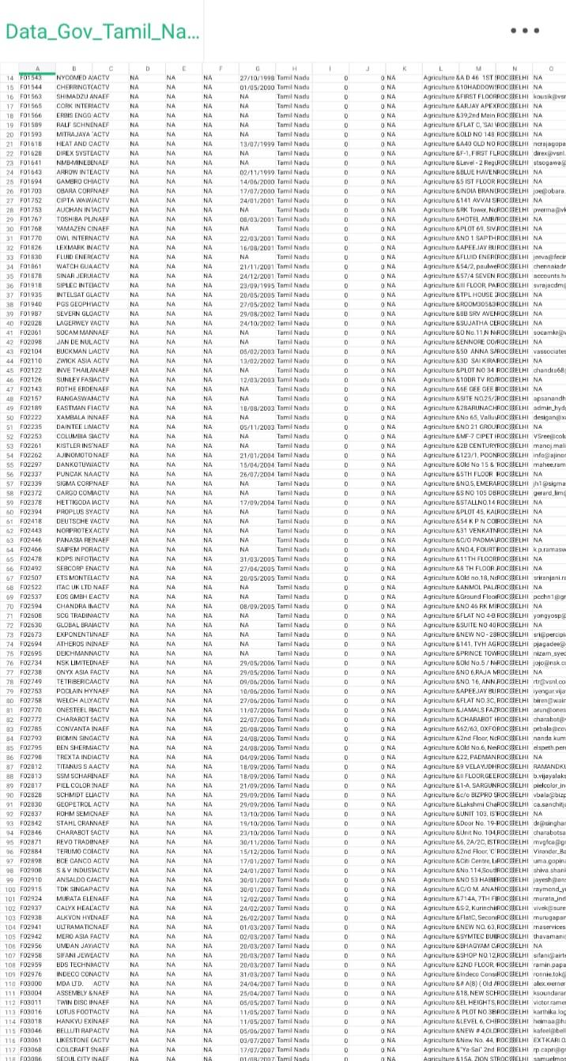

**You can continue your analysis or machine learning tasks with the preprocessed data, such as building models, performing exploratory data analysis, or any other specific task you have in mind.**